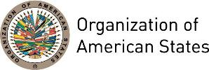

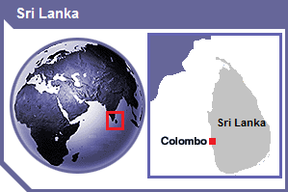
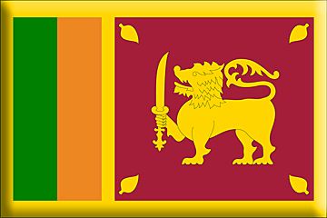

SRI LANKA
PERMANENT OBSERVER

Date of Entry: February 22, 1996
National Holiday: February 4
Capital: Sri Jayawardenepura Kotte
Type of Government: Republic
Head of State: Maithripala Yapa Sirisena (January 9, 2015)
Head of Government: Prime Minister Ranil Wickremesinghe (January 9, 2015)
Minister of External Affairs: Ravi Karunanayake (since 2010)
Permanent Observer: Chargé d’affaires Kankanamge Sarath Chandra Dissanayake

ECONOMIC INDICATORS | 2010 | 2011 | 2012 | 2013 | 2014 | 2015 | 2016
Population (in millions) | 20.12 | 20.27 | 20.43 | 20.59 | 20.78 | 20,97 | 21,20
GDP (US$ in billions) | 56.73 | 65.29 | 68.43 | 74.32 | 79.36 | 80.61 | 81.32
GDP per capita (US$) | 2,819.51 | 3,221.1 | 3,350.52 | 3,610.29 | 3,820.54 | 3,844.89 | 3,835.4
Source: www.tradingeconomics.com | The World Bank Group

FOREIGN RELATIONS POLICIES:
- The Government of Sri Lanka follows a non-aligned, free and progressive foreign policy. Priority is given in the political, defense, economic, trade and cultural spheres to the cordial and friendly relationships with countries in the Asian region including India, Japan, China and Pakistan.
- Sri Lanka participates in multilateral diplomacy, particularly at the United Nations, where it seeks to promote sovereignty, independence, and development in the developing world. Sri Lanka was a founding member of the Non-Aligned Movement (NAM). It is also a member of the Commonwealth of Nations, South Asian Association for Regional Cooperation (SAARC), World Bank, the International Monetary Fund (IMF), Asian Development Bank (ADB) and Colombo Plan. Sri Lanka continues its active participation in the NAM, while also stressing the importance it places on regionalism by playing a strong role in South Asian Association for Regional Cooperation (SAARC).

INVOLVEMENT WITH THE AMERICAS:
- Sri Lanka maintains embassies in Brazil, Cuba and the United States of America, and a High Commission in Canada.

SOURCES:
THE OFFICIAL WEBSITE OF THE DATA AND INFORMATION UNIT OF THE PRESIDENTIAL SECRETARIAT, SRI LANKA  http://www.priu.gov.lk/  MINISTRY OF EXTERNAL AFFAIRS OF SRI LANKA  http://www.mea.gov.lk/ | EMBASSY OF SRI LANKA - WASHINGTON DC,  http://slembassyusa.org/  WORLD BANK – TRADING ECONOMICS  www.tradingeconomics.com

This page was last updated on July 6, 2017.

