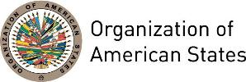

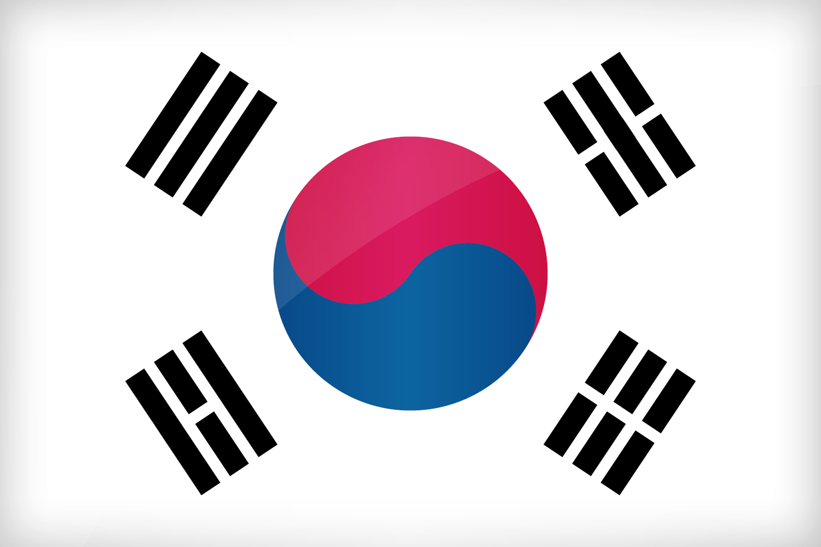
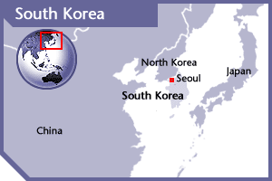

SOUTH KOREA
PERMANENT OBSERVER

Date of Entry: June 3, 1981
National Holiday: August 15
Capital: Seoul
Type of Government: Republic
Head of State: Moon Jae-in (May 10, 2017)
Head of Government: Lee Nak-Yeon (May 10, 2017)
Minister of Foreign Affairs: Kan Kyung-wha (May 31,2017)
Permanent Observer: Ambassador Ahn Ho-young (June 2013)

ECONOMIC INDICATORS | 2010 | 2011 | 2012 | 2013 | 2014 | 2015 | 2016
Population (in millions) | 49.55 | 49.93 | 50.19 | 50.42 | 50.74 | 51.01 | 51.24
GDP (US$ in trillions) | 1.094 | 1.202 | 1.223 | 1.306 | 1.411 | 1.383 | 1.411
GDP per capita (US$) | 22,086.9 | 24,079.7 | 24,356.7 | 25,890.02 | 27,811.3 | 27,105.07 | 27,538.80
Source: www.tradingeconomics.com World Bank

FOREIGN RELATIONS POLICIES:
- The foreign policy vision of the Republic of Korea seeks the realization of a happier Korean people, Korean Peninsula and global community. Under this vision, the Ministry aims at achieving and building peace and shared development of the Korean Peninsula and Northeast Asia, a dependable Korea that contributes to the advancement of humanity and a fascinating country with happier people. To these ends, the Foreign Ministry carries out trust-building diplomacies in partnership with the people, focusing on the following policy tasks:
- Providing an impetus for resolving the North Korean nuclear issue;
- Developing relations with major neighboring countries of the Korean Peninsula;
- Promoting the Northeast Asia Peace and Cooperation Initiative and expanding cooperation with Eurasia;
- Playing a role as a responsible middle power contributing to world peace and progress;
- Protecting the safety and rights of Korean nationals residing abroad and expanding both public diplomacy and jobs diplomacy; and
- Strengthening the capacity for economic cooperation.
- In 2012, Korea hosted the 2nd Nuclear Security Summit, and led negotiations on the 'Seoul Communiqué,' further expanding the horizon of nuclear security discussions. In addition, it was elected as a non-permanent member of the UN Security Council for the 2013-2014 period.

INTERNATIONAL DEVELOPMENT COOPERATION- KOREA INTERNATIONAL COOPERATION AGENCY (KOICA):
- The Korea International Cooperation Agency (KOICA), under the authority of the Ministry of Foreign Affairs and Trade (MOFAT), implements and administers the grant aid and technical cooperation programs provided by the Government of the Republic of Korea.
- The main goals of the Korean International Cooperation Agency (KOICA) include the assistance for the sustainable-economic development of developing countries; an active participation in alleviating poverty though the achievement of the Millennium Development Goals; and the promotion of humanitarian assistance and human security. To this end Korea has identified the following priority areas: achieving universal primary education; combating global health issues; good governance; the development of Information and Communication Technology (ICT); industry and energy development; agricultural enhancement; ensuring environmental sustainability; and climate action and development.

INVOLVEMENT WITH THE AMERICAS:
- The Republic of Korea has diplomatic relations with all OAS Member States, and maintains embassies in 23 countries: Argentina, Bolivia, Brazil, Canada, Chile, Colombia, Costa Rica, Dominican Republic, Ecuador, El Salvador, Guatemala, Honduras, Jamaica, Mexico, Nicaragua, Panama, Paraguay, Peru, Suriname, Trinidad and Tobago, United States of America, Uruguay, Venezuela.
- KOICA aid and development assistance in Latin America is designed to alleviate social inequality, improve the capacity of public administration and transparency, improve poverty reduction and self-sustaining abilities through the promotion of economic growth, and promote sustainable development.

CURRENT COOPERATION AGREEMENTS WITH THE OAS:
- Memorandum of Understanding between the Ministry of Foreign Affairs and Trade of the Republic of Korea and the GS/OAS implementing a joint Korea-GS/OAS Internship Program which will place young Korean professionals and students in internship positions for six month periods at GS/OAS headquarters in Washington, D.C. Signed on July 22, 2009, was agreed to be extended for a two-year period from 2011 to 2012 on September 15, 2011; and prolonged for an additional two-year period from the second semester of 2013 to 2015.
- The new Program extension will accommodate eleven participants for six month periods at GS/OAS headquarters in Washington, D.C., for a total amount of US$135,000 to be distributed in three installments, US$50,000 for 2013; US$50,000 for 2014; US$35,000 for 2015 respectively.

CASH CONTRIBUTIONS TO OAS 2005-2016:
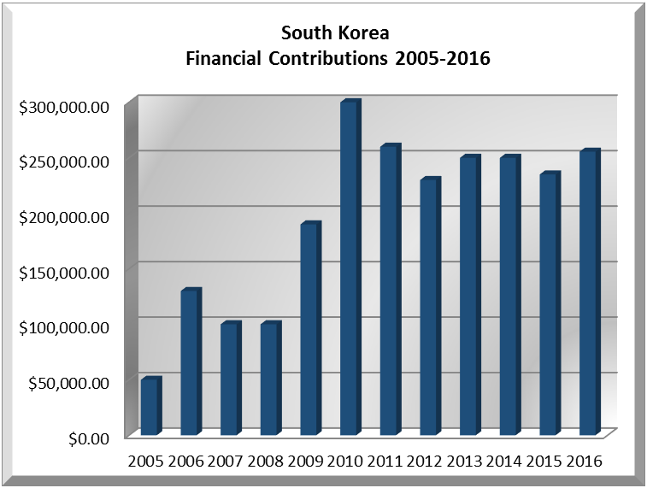
YEAR | KOREA | P.O. FINANCIAL CONTRIBUTIONS | %
2005 | $50,000.00 | $11,650,039.00 | 0.43%
2006 | $130,000.00 | $19,060,470.00 | 0.68%
2007 | $100,000.00 | $20,398,686.00 | 0.49%
2008 | $100,000.00 | $22,684,500.00 | 0.44%
2009 | $190,000.00 | $20,318,115.00 | 0.94%
2010 | $300,000.00 | $15,781,991.00 | 1.90%
2011 | $260,000.00 | $15,692,757.00 | 1.66%
2012 | $230,000.00 | $13,239,105.00 | 1.74%
2013 | $250,000.00 | $16,926,686.00 | 1.48%
2014 | $250,000.00 | $10,999,882.00 | 2.27%
2015 | $235,000.00 | $17,489,205.00 | 1.34%
2016 | $255,500.00 | $14,048,254.00 | 1.84%
Total US$ | $2,350,500.00 | $198,289,690.00 | 1.19%

KOREA CONTRIBUTIONS TO OAS PROGRAMS:
YEAR | PROJECTS |  | FINANCIAL CONTRIBUTIONS  IN US$ | IN-KIND CONTRIBUTIONS  IN US$
1999 | 18 Fellowships |  |  | $50,000.00
1999 | Interns in the General Secretariat |  |  | $30,000.00
1999 | Columbus Memorial Library- 76 books |  |  | $2,000.00
SUBTOTAL |  |  |  | $82,000.00
2000 | Unit for the Promotion of Democracy (UPD) |  |  | $50,000.00
2000 | Columbus Memorial Library |  |  | $757.16
2000 | Fellowships:Interns in the General Secretariat |  |  | $60,000.00
SUBTOTAL |  |  |  | $110,757.16
2001 | Department of Public Information- technical equipment |  |  | $25,000.00
2001 | Columbus Memorial Library- Computers |  |  | $12,500.00
2001 | Young Americas Business Trust (YABT) - computers |  |  | $12,500.00
2001 | Haiti and Dominican Republic-2 Jeeps and computers for the national offices |  |  | $50,000.00
2001 | Interns in the General Secretariat |  |  | $15,000.00
2001 | Inter-American Agency for Cooperation and Development (IACD) – Fellowships |  |  | $63,000.00
SUBTOTAL |  |  |  | $178,000.00
2002 | Department for Democratic Sustainability and Special Missions (DSDSM) - Peace Fund- General Fund |  | $20,000.00
2002 | Department for Democratic Sustainability and Special Missions (DSDSM) - Peace Fund- Belize/ Guatemala Subfund |  | $20,000.00
2002 | Department for Democratic Sustainability and Special Missions (DSDSM) - Peace Fund- Honduras/ Nicaragua Subfund |  | $10,000.00
2002 | Unit for the Promotion of Democracy (UPD) - Equipment for Demining Program (computers and trucks) |  |  | $46,623.00
2002 | Fellowships- E-business and investments in trade and development |  |  | $2,600.00
2002 | Fellowships- Program on Policies for Development of Information Technology for Latin America and the Caribbean |  |  | $10,500.00
2002 | Fellowships- Workshop on Educational Policies and Reforms |  |  | $33,600.00
SUBTOTAL |  |  | $50,000.00 | $93,323.00
2003 | Unit for the Promotion of Democracy (UPD) |  | $25,000.00
2003 | Department for Democratic Sustainability and Special Missions (DSDSM) - Peace Fund- Belize/ Guatemala Subfund |  | $20,000.00
2003 | Special Mission in Haiti- computers and equipment |  |  | $100,000.00
2003 | Inter-American Agency for Cooperation and Development (IADC)- Fellowships and training program |  |  | $63,346.00
SUBTOTAL |  |  | $45,000.00 | $163,346.00
2004 | Department for Democratic Sustainability and Special Missions (DSDSM) - Peace Fund- Belize/ Guatemala Subfund |  | $50,000.00
2004 | Department for Electoral Cooperation and Observation (DECO) -Inter-American Forum on Political Parties |  | $49,400.00
2004 | Inter-American Children’s Institute (IIN)- Computers for schools in Guatemala and Honduras |  |  | $100,000.00
2004 | 8 Fellowships-Department for Electoral Cooperation and Observation (DECO) -Electoral observers from Korea (sent to Panama and Dominican Republic) |  |  | $142,000.00
SUBTOTAL |  |  | $99,400.00 | $242,000.00
2005 | Department for Electoral Cooperation and Observation (DECO) -Electoral observation Mission Honduras 2005 |  | $20,000.00
2005 | Department for Electoral Cooperation and Observation (DECO) -Electoral observation Mission Venezuela 2005 |  | $30,000.00
2005 | Department for Democratic Sustainability and Special Missions (DSDSM)- MAPP/OAS Colombia (equipment) |  |  | $110,000.00
SUBTOTAL |  |  | $50,000.00 | $110,000.00
2006 | Department for Democratic Sustainability and Special Missions (DSDSM) - Inter-American Forum of Political Parties |  | $50,000.00
2006 | Department for Electoral Cooperation and Observation (DECO) -Promotion of Democracy MOE 2006 Peru- Presidential |  | $11,513.00
2006 | Department for Electoral Cooperation and Observation (DECO) -Promotion of Democracy MOE 2006 Peru- Regional |  | $28,487.00
2006 | Department for Electoral Cooperation and Observation (DECO)-Promotion of Democracy MOE 2006 Ecuador |  | $20,000.00
2006 | Department for Electoral Cooperation and Observation (DECO)- Panama Canal Referendum Electoral Observation Mission |  | $20,000.00
2006 | Inter-American Children’s Institute (IIN)- Computers for Schools in Panama and Nicaragua |  |  | $100,000.00
2006 | E-Trade and Export Promotion for OAS member countries |  |  | $50,000.00
SUBTOTAL |  |  | $130,000.00 | $150,000.00
2007 | Inter-American Commission on Human Rights (IACHR) |  | $30,000.00
2007 | Department of International Affairs (DIA) - MOAS |  | $20,000.00
2007 | Department for Electoral Cooperation and Observation (DECO)– Electoral Observation Mission in Guatemala and Costa Rica |  | $50,000.00
2007 | Course on E-commerce and Promotion of Exports for OAS Member States |  |  | $80,000.00
SUBTOTAL |  |  | $100,000.00 | $80,000.00
2008 | Inter-American Commission of Women (CIM) – Strengthening Access to Justice in the Americas 2008 |  | $25,000.00
2008 | Department of International Affairs (DIA)– MOAS |  | $21,000.00
2008 | Department for Electoral Cooperation and Observation (DECO)- Electoral Observation Mission in Paraguay |  | $30,000.00
2008 | Inter-American Commission on Women (CIM) -Course on Empowerment, HIV and Violence against Women in the Caribbean |  | $24,000.00
2008 | Department for Democratic Sustainability and Special Missions (DSDSM) – OAS Good Mission to Support the Peace Process in Colombia. (MAPP/OAS); OAS Good Offices Mission in Colombia and Ecuador (MIB/OAS) (5 Vehicles) |  |  | $150,000.00
SUBTOTAL |  |  | $100,000.00 | $150,000.00
2009 | Department for Democratic Sustainability and Special Missions (DSDSM)– OAS Peace Fund |  | $40,000.00
2009 | Department for Electoral Cooperation and Observation (DECO) – Electoral Observation Missions Fund |  | $60,000.00
2009 | Department of International Affairs (DIA) – Outreach Programs |  | $20,000.00
2009 | Secretariat for Administration and Finance / Department of Human Resources OAS - Internship Program |  | $70,000.00
SUBTOTAL |  |  | $190,000.00 | $0.00
2010 | Department for Electoral Cooperation and Observation (DECO) – Electoral Observation Mission to Colombia |  | $40,000.00
2010 | Department of Cultural Affairs – Youth Orchestra Program in Haiti |  | $100,000.00
2010 | Secretariat for Administration and Finance – OAS-Korea Internship Program |  | $100,000.00
2010 | Department for Electoral Cooperation and Observation (DECO)– Electoral Observation Mission Fund |  | $60,000.00
SUBTOTAL |  |  | $300,000.00 | $0.00
2011 | Department for Electoral Cooperation and Observation (DECO)– Electoral Observation Mission to Guatemala |  | $10,000.00
2011 | Secretariat for Administration and Finance / Department of Human Resources OAS - Internship Program |  | $60,000.00
2011 | Secretariat for External Relations / Art Museum of the Americas – Youth Orchestra Program in Haiti |  | $190,000.00
SUBTOTAL |  |  | $260,000.00 | $0.00
2012 | Secretariat for Administration and Finance / Department of Human Resources OAS - Internship Program |  | $30,000.00
2012 | Secretariat for Political Affairs / Department for Electoral Cooperation and Observation (DECO) - Electoral Observation Mission - Dominican Republic |  | $30,000.00
2012 | Secretariat for Political Affairs / Department for Electoral Cooperation and Observation (DECO) - Electoral Observation Mission - Bahamas |  | $10,000.00
2012 | Secretariat for Political affairs / Department of Effective Public management - Civil Registry and Identity Project of the Organization of Eastern Caribbean States (OECS) PUICA |  | $140,000.00
2012 | Department of Democratic Sustainability and Special Missions (DSDSM) – Mission To Support Political Dialogue In Paraguay |  | $20,000.00
SUBTOTAL |  |  | $230,000.00 | $0.00
2013 | Secretariat for Administration and Finance / Department of Human Resources OAS - Internship Program |  | $50,000.00
2013 | Secretariat for Political affairs / Department of Effective Public management - Civil Registry and Identity Project of the Organization of Eastern Caribbean States (OECS) PUICA |  | $115,000.00
2013 | Secretariat for Political Affairs / Department for Electoral Cooperation and Observation (DECO) - Electoral Observation Mission - Paraguay |  | $30,000.00
2013 | Secretariat for Political Affairs / Department for Electoral Cooperation and Observation (DECO) - Integration of the Gender Perspective in the Electoral Observation Missions – Phase II |  | $20,000.00
2013 | Secretariat for Political Affairs / Department for Electoral Cooperation and Observation (DECO) - Seminar – Strengthening Political Party and Campaign Finance Reform in the Caribbean Phase III, Country by Country |  | $20,000.00
2013 | Secretariat for Political Affairs / Department for Electoral Cooperation and Observation (DECO) - Creation of an OAS-sponsored Electoral Accreditation Body for Certification of Electoral Authorities in ISO Electoral Standard |  | $15,000.00
SUBTOTAL |  |  | $250,000.00 | $0.00
2014 | Secretariat for Administration and Finance / Department of Human Resources OAS - Internship Program |  | $50,000.00
2014 | Secretariat for Political Affairs / Department for Electoral Cooperation and Observation (DECO) - Creation of an OAS-sponsored Electoral Accreditation Body for Certification of Electoral Authorities against ISO Electoral Standard |  | $150,000.00
2014 | Secretariat for Political Affairs / Department for Electoral Cooperation and Observation (DECO) - Electoral Observation Mission Fund |  | $50,000.00
SUBTOTAL |  |  | $250,000.00 | $0.00
2015 | Secretariat for Administration and Finance / Department of Human Resources OAS - Internship Program |  | $35,000.00
 | Inter-American Social Protection Network - Exchanges with Member States |  | $50,000.00
 | Universal Civil Identify Program in the Americas (PUICA) |  | $50,000.00
 | OAS Fellowship on Open Government in the Americas |  | $50,000.00
 | OAS Electoral Observation Mission Fund |  | $50,000.00
SUBTOTAL |  |  | $235,000.00 | $0.00
2016 |  | Organizational Development Section (44F)  Korea/OAS Internship Program | $55,500
 |  | The Department of Social Inclusion (54B)  IASPN: Exchanges with M.S. | $25,000
 |  | The Department of Electoral Cooperation and Observation (64C)  Grenada Delegation | $10,000
 |  | The Department of Sustainable Democracy and Special Missions (64D)  OAS Office Adjacency Belize ‐ Guatemala, Support Peace Process Colombia | $100,000
 |  | The Department of Effective Public Management (94B)  OAS Fellowship Open Gov. Americas | $25,000
 |  | Unprogrammed Funds, EOM Unprogrammed Fund | $40,000
SUBTOTAL |  |  | $255,500.00 | $0
TOTAL |  |  | $2,544,900.00 | $988,669.00

SOURCES:
PRESIDENT OF THE REPUBLIC OF KOREA  http://english.president.go.kr/main.php  OFFICE FOR GOVERNMENT POLICY COORDINATION – PRIME MINISTER  http://eng.pmo.go.kr/pmo_eng/  MINISTRY OF FOREIGN AFFAIRS AND TRADE OF THE REPUBLIC OF KOREA  http://www.mofa.go.kr/ENG/main/index.jsp | KOREA INTERNATIONAL COOPERATION AGENCY  https://www.koica.go.kr/  EMBASSY OF THE REPUBLIC OF KOREA IN THE USA  http://usa.mofa.go.kr/english/am/usa/main/  WORLD BANK – TRADING ECONOMICS  www.tradingeconomics.com

This page was last updated on July 5, 2017.

