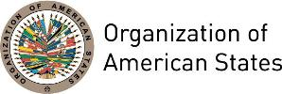

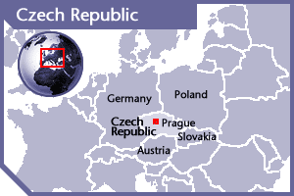
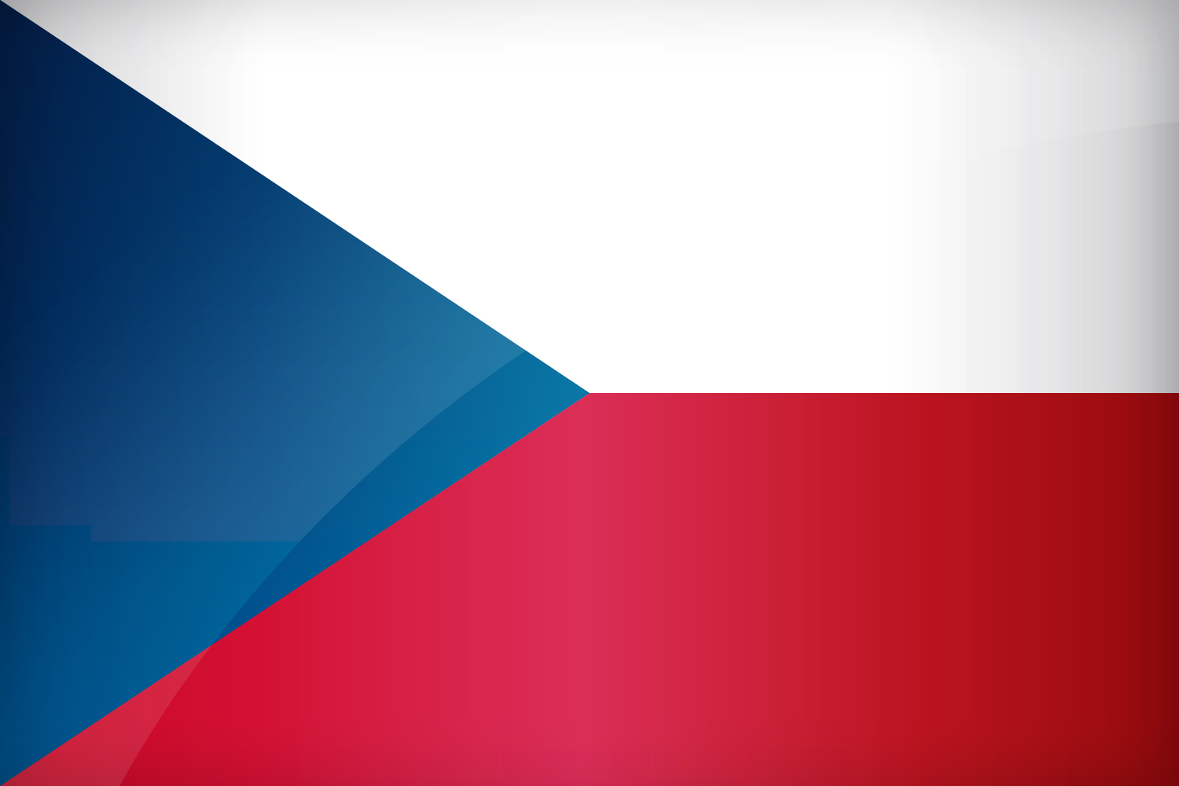

CZECH REPUBLIC
PERMANENT OBSERVER

Date of Entry: March 8, 1995
National Day: October 28
Capital: Prague
Type of Government: Parliamentary Democracy
Head of State: President Milos Zeman (March 8, 2013)
Head of Government: Prime Minister Bohuslav Sobotka (January 17, 2014);
Minister of Foreign Affairs: Lubomír Zaorálek (January 29, 2014)
Permanent Observer: Ambassador Hynek Kmonicek (April 24, 2017)

ECONOMIC INDICATORS | 2010 | 2011 | 2012 | 2013 | 2014 | 2015 | 2016
Population (in millions) | 10.47 | 10.49 | 10.51 | 10.51 | 10.52 | 10.54 | 10.56
GDP (US$ in billions) | 207.01 | 227.94 | 207.37 | 209.40 | 207.81 | 185.15 | 192.92
GDP per capita (US$) | 19,764.016 | 21,717.458 | 19,729.871 | 19,916.019 | 19,744.559 | 17,556.924 | 18,266.55
Source: www.tradingeconomics.com | The World Bank Group

FOREIGN RELATIONS POLICIES:
- The basic aim of Czech foreign policy is to ensure its security and prosperity of the country and its citizens and to protect the interests of Czech entities abroad. To achieve this, Czech’s foreign policy is active in three basic areas: political, security, and economic.
- Among the Czech Republic’s top priorities are the protection of external conditions for the autonomous development of democracy and rule of law which are based on freedom, equality, justice, human dignity, tolerance of diversity and solidarity with the weak, vulnerable and defenseless.
- The Czech Republic implements its foreign policy mainly within the context of the European integration process, the solid Euro‐Atlantic alliance and through its bilateral relations. The aim of its foreign policy efforts is to foster a level of political and economic cooperation that allows for peaceful and sustainable development.

Development Cooperation Strategy of the Czech Republic 2010-2017:
- Development cooperation is coordinated by the Ministry of Foreign Affairs and other ministries are represented within the Council on Development Cooperation, which is a supervisory body for all development cooperation activities.
- The Development Cooperation Strategy of the Czech Republic 2010-2017 strives to deepen understanding of development cooperation as an instrument of foreign policy with security, economic, environmental, social and migration aspects. It sets forth modalities used in Czech assistance, its key geographic and sectorial priorities.
- The country supports the implementation of development projects, offers scholarships enabling students to enroll at Czech universities, provides humanitarian aid, as well as a number of related activities.
- The principal goals of Czech development cooperation were defined in the Principles of the International Development Cooperation after the Accession of the Czech Republic to the European Union. These goals are:

- Poverty reduction;
- Economic and industrial development;
- Rural development;
- Good governance;
- Reinforcement of human rights;
- Sustainable development; and
- Post-conflict reconstruction.

Czech Republic Multilateral Cooperation:
- The Multilateral Development Cooperation Strategy of the Czech Republic 2013-2017 is based on the Policy Statement of the Government of the Czech Republic and on the fulfilment of priorities of individual ministries, as well as on the Foreign Policy Strategy of the Czech Republic and the Act on Development Cooperation and Humanitarian Aid. It also builds on the Development Cooperation Strategy of the Czech Republic for the period 2010–2017.
- In terms of Multilateral Development Cooperation, the Czech Republic actively participates in a number of international organisations that aim to achieve global development goals. It is involved in, and financially contributes to development activities of the United Nations (UN), the European Union (EU), the North Atlantic Treaty Organization (NATO), the Organization for Economic Co-operation and Development (OECD), international financial institutions and other intergovernmental organizations.
- It seeks to provide a more effective use of funding and capacities that are dedicated towards the development and humanitarian activities of multilateral organisations, to contribute towards optimising the representation of the Czech Republic in the management and executive structures of the various organisations and to boost the direct involvement of Czech entities in multilateral development projects, while also achieving increased territorial and sector diversification.
- The main thematic and territorial priorities for cooperation with international development organizations are:
- Supporting human rights, democracy and the rule of law
- Economic development of partner countries (including trade and energy)
- Sustainable agriculture and food security
- Social development, including education and social and health services
- Protection of environment.
- Territorial priorities of multilateral development cooperation of the Czech Republic include:
- Geographical priorities of bilateral development cooperation in accordance with the Development Cooperation Strategy of the Czech Republic 2010-2017 - Afghanistan, Bosnia and Herzegovina, Ethiopia, Moldova and Mongolia, as well as the project countries of Georgia, Cambodia, Kosovo, the Palestinian Autonomous Territories and Serbia
- Countries with a high humanitarian priority, and those included in the Ministry of Foreign Affairs’ transition cooperation programme (e.g. Burma/Myanmar), or that meet the priority requirement in accordance with the Foreign Policy Strategy of the Czech Republic
- Regions where the Czech Republic has a comparative advantage, given its transition experience (most notably including the regions of the West Balkans, countries of the Eastern Partnership and the former Soviet republics of Central Asia).

CZECH REPUBLIC DEVELOPMENT AGENCY (CzDA):
- The Czech development Agency (CzDA) was established by a decision of the Czech Ministry of Foreign Affairs in January 2008. It has taken up activities of the Czech Development Center. CzDA cooperates with the Ministry of Foreign Affairs on the establishment of an institutional framework of the Czech Development Cooperation and actively participates in the creation of development cooperation programs between the Czech Republic and priority countries as well as on the other stages of the project cycle management.
- Priority countries of Czech development cooperation are divided into three categories: program countries (Afghanistan, Bosnia and Herzegovina, Ethiopia, Moldova and Mongolia), project countries (Cambodia, Georgia, Kosovo, Palestine and Serbia) and 4 “phase-out” countries in which the Czech Development Cooperation ends gradually (Angola, Yemen, Vietnam and Zambia).

INVOLVEMENT WITH THE AMERICAS:
- The Czech Republic has formal diplomatic relations with all the OAS Member States and maintains embassies in Argentina, Brazil, Canada, Chile, Cuba, Mexico, Peru and the United States of America.

SOURCES:
PRESIDENT OF THE CZECH REPUBLIC  http://www.hrad.cz/en/index.shtml  CZECH REPUBLIC MINISTRY OF FOREIGN AFFAIRS  http://www.mzv.cz/jnp/en/index.html  EMBASSY OF THE CZECH REPUBLIC IN WASHINGTON, D.C.  http://www.mzv.cz/washington/ | CZECH DEVELOPMENT AGENCY  www.czda.cz/?lang=en  WORLD BANK – TRADING ECONOMICS  www.tradingeconomics.com

This page was last updated on July 10, 2017.

