NINTH REGULAR MEETING OF THE OEA/Ser.W/XIII.6.9
INTER-AMERICAN COMMITTEE ON EDUCATION CIDI/CIE/doc. 14/21
November 18-19, 2021 11 November 2021
Washington, D.C., United States of America Original: Spanish
VIRTUAL

EXECUTIVE SUMMARY

Virtual Roundtable “The Path to Bilingualism in Costa Rica: An Educational Experience with a National Approach”

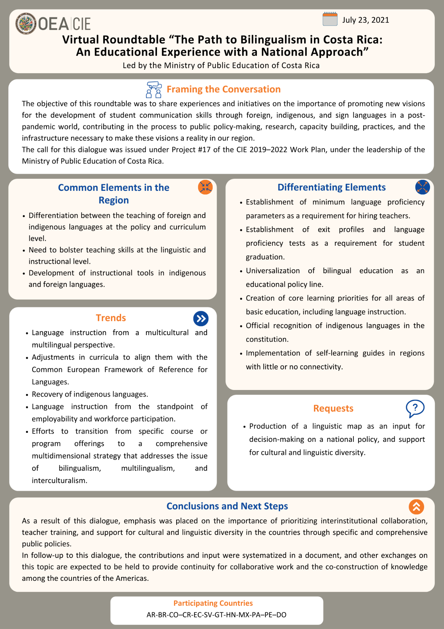

Access to the full document:
Spanish
English
CIDED00231E01

