CHAPTER II

THE SYSTEM OF PETITIONS AND CASES, FRIENDLY SETTLEMENTS, AND PRECAUTIONARY MEASURES

Introduction
- The IACHR has a unique mechanism for the protection of human rights in the region, which is the system of petitions, cases, friendly settlements, and precautionary measures. By filing a petition with the Inter-American Commission, individuals who have suffered human rights violations can obtain measures of justice and comprehensive reparation. To the extent that this mechanism operates properly, persons whose rights have been violated will be able to count on an instrument for the resolution of their claims, which will not only benefit them in their case, but will also provide States with an important tool for addressing structural situations of human rights violations, through effective implementation of IACHR recommendations or friendly settlement agreements approved by it, and compliance with precautionary measures. Such a system is a fundamental tool for achieving justice and reparation in individual cases, protecting individuals, combating impunity, and achieving structural reforms in laws, policies, and practices.
- The IACHR recalls the key part played by the system of petitions, cases, and precautionary measures in its mandate and its importance for the promotion and protection of human rights in the Hemisphere, at the individual, collective, and structural levels. The Commission's reports on cases and the judgments of the Inter-American Court, in addition to concrete reparation for victims, have promoted constitutional reforms and changes in jurisprudence, in addition to bringing hope for justice and reparation to victims of human rights violations. Since its inception, States have fostered this system and supported the Commission’s exercise of this mandate, which began with requests for information from States and became part of the processing of individual cases. The working tools developed by the IACHR were then recognized first in the Statute of 1965, then in its Rules of Procedure of May 2, 1967, and in 1969 with the adoption of the American Convention on Human Rights.
- The protection and defense pillar, which includes the system of petitions, cases, friendly settlements, and precautionary measures, is a fundamental tool for the IACHR and for all the inhabitants of the Hemisphere. It is a source of pride for the Americas, internationally recognized for its objectivity, seriousness, consistency, and legal quality. Given the core part played by this system, and the large procedural backlog that has accumulated since the 1990s, the Commission has prioritized a program to reduce the procedural backlog. After a consultation process that involved more than 500 people and 300 entities, the IACHR adopted its 2017-2021 Strategic Plan with 5 strategic objectives. Strengthening the system of petitions, cases, friendly settlements, and precautionary measures was identified as the first of these objectives, and the first program envisaged in the Plan is the Special Program to Address the Procedural Backlog.
- Objective 1 of the Strategic Plan of the IACHR seeks to contribute to the development of more effective and accessible inter-American justice, in order to overcome practices of impunity in the region and achieve comprehensive reparation for victims through decisive measures to strengthen the petitions and cases, friendly settlements, and precautionary measures system. Programs: 1. Special Procedural Backlog Reduction Program; 2. Program to Expand the Use of Friendly Settlements
- The Commission is aware that this is an ongoing process and that in order to confront and resolve this chronic backlog, it must continue to deepen and consolidate the measures adopted, apply the lessons learned in the process, and pursue additional decisive measures to achieve more effective, timely, and comprehensive inter-American justice. This is a process that requires the joint work of all the actors of the inter-American system, in which the member states have been and will continue to be fundamental. An important factor for achieving the results obtained was the doubling of the regular budget that the States granted to the Inter-American system in 2017. The Commission also recognizes the contributions and support of civil society, a structural pillar of the inter-American system, without which this progress would not have been possible.
- The Inter-American Commission was the first international body to process individual petitions and over the past 20 years it has accumulated a sizeable backlog in its petitions and cases system. This backlog had reached historical records regarding the number of petitions pending initial study (approximately 13,000, plus 5,000 deactivated petitions, plus the 3,000 on average that enter each year) and petitions at the admissibility and merits stages (average of 3,500). It had also meant a delay of more than 25 years at the merits stage; more than 15 years in admissibility; friendly settlement processes that had taken more than 20 years of negotiation; and processing with considerable delays.
- Faced with this enormous challenge, in these 5 years of implementing its Strategic Plan, the Commission has adopted various measures that have included new work methodologies, an internal reorganization of the Executive Secretariat, and strategic planning in its cases and petitions system. These measures notably included the creation of an Assistant Executive Secretariat dedicated exclusively to the cases and petitions system; reinforcement of the team; the strengthening of the processing section; the adoption of systematized admissibility and merits criteria; the adoption of models and thematic lines of work; and prioritization of the promotion of friendly settlements.
- The result of these measures, coupled with a clear, consistent, and transparent methodology, is as follows:
- The SEA/AES has 5 sections that cover the different procedural stages: initial study, admissibility, friendly settlements, cases, and the processing section. In addition, the Precautionary Measures Section and the Follow-up and Impact Section make up the structure of the Executive Secretariat's protection system reported in this chapter.
Methodology
- The Commission has prioritized the attention of petitions and cases in chronological order, that is, in the order in which the petitions were submitted to the Commission, in order to resolve the chronic backlog, especially of cases that had been delayed due to their volume and complexity. This has been the strict criterion applied to the examination of petitions, and, as a matter of priority, in the admissibility and merits stages, with a view to tackling one year after the other and eventually resolving all petitions and cases pending. Thus, during 2021, priority was attached to all cases prior to 2002, so as not to have a backlog of more than 19 years at the merits stage; and to 2014 in admissibility, so as not to have a backlog of more than 7 years at this stage. During 2022, the Commission expects to resolve all pre-2015 admissibilities and pre-2003 cases. This approach has ensured that everyone who resorts to the system receives a response.
- In the same vein, priority was attached to reaching a decision on the course of action to be taken in long-standing friendly settlement processes, so as to expedite a ruling in judicial proceedings. In this regard, cases such as Ramon Nicolás Guarino of Argentina; Cristiane Leite de Souza of Brazil; Teachers from Chañaral in Chile; Anibal Leonel Cabaleros of Guatemala; Norka Moya of Peru; Lucio Ortuño Rivas of Bolivia; A.N. and Aurora of Costa Rica; and Dylan Córdoba and Vicente Ariel Noguera of Paraguay, are some examples of how strategic and coordinated work to address the procedural backlog, both via litigation and in the friendly settlement procedure, in chronological order, has made it possible to advance towards decisions on admissibility, merits, or referral of cases to the Inter-American Court of Human Rights, thereby contributing to victims' access to comprehensive reparation and inter-American justice in a timely manner.
- In addition, based on the region’s needs, the Commission uses a series of criteria to prioritize its attention to cases and petitions:
- In the first place, petitions and cases that deal with current/short-term issues, or whose standards could help to address such situations. These petitions and cases are identified within the framework of the Rapid and Integrated Response Coordination Units (SACROI). For example, in 2021, the COVID-19 SACROI identified issues that led the IACHR to prioritize health-related cases, and migration and violence against girls and women. Also prioritized in this category are petitions and cases in follow-up mechanisms, such as the Follow-up Mechanism for Nicaragua (ESENI) and the Follow-up Mechanism for Venezuela (MESEVE).
- Second, priority has been given to petitions and cases involving urgent issues, such as those related to the application of the death penalty, those associated with a precautionary measure, or those involving children and adolescents or the elderly, in which resolution can help to address a situation that, due to the age of the victims, is exacerbated by the passage of time.
- Third, priority is given to petitions and cases that deal with structural issues of the States in the region, which make it possible to support national and international processes. Accordingly, priority has been given, inter alia, to issues of transitional justice, access to justice, review of judicial remedies, attacks against human rights defenders or social leaders.
- Finally, priority is attached to petitions and cases that develop standards related to the Commission's core concerns, reflected in its thematic Rapporteurships; thus, in 2020, the Commission worked on reports of racial discrimination and cases involving the rights of Amazonian peoples, violence against women and girls, international restitution of children, discrimination against migrants, discrimination against LGBTI persons, freedom of expression, economic, social, cultural and environmental rights, and others. In this way, the Commission applied different criteria to resolve the chronic procedural backlog, which it considers unacceptable, and at the same time, contribute to the resolution of both short-term and structurally embedded situations and the need to advance the development of standards.
- In addition, the Commission has adopted the practice of grouping cases by subject matter, which allows for more efficient work. Prior to 2019, administrative due process was observed, and for the past year the IACHR has approved work on series of cases prioritized according to the gravity of the human rights violations involved. In this way, the Commission applied different criteria to resolve the chronic procedural backlog, which it considers unacceptable, and at the same time, contribute to the resolution of both short-term and structurally embedded situations and the need to advance the development of standards. [TR: repetition].
- The Commission continues to develop criteria that will enable it to address urgent, short-term and structural situations.
- As part of the strategy, the processing section and its work have been strengthened and structured through the organization and systematization of case files; the creation of working groups, with a team of paralegals to do the processing; simplification of admissibility procedures (in accordance with Article 30 of the Rules of Procedure); prioritization of the processing of cases and petitions that are being worked on, especially cases forming part of the chronic backlog; annual exercises to identify inactivity of the petitioning party and notifications of accumulation in accordance with Resolution 1-16.
Coordination and strengthening of work with the States - transparency
- First, as part of its commitment to meeting the objectives outlined in its Strategic Plan 2017-2021, especially those referred to in SO1/P4: Transparency and Access to Information Program, in order to guarantee access to information related to the fulfillment of its mandate and to foster a culture of active transparency with respect to all information under its control, including information on petitions and cases in litigation, in 2021 the Commission provided information ex officio on the status of the portfolios of petitions and cases pending before the IACHR with respect to 14 member states with complex portfolios or in which there had been little interaction or compliance with regulatory requirements formulated by the Inter-American Commission. In so doing, the Commission’s intention had been to encourage the timely participation of the parties in the process and to diligently take the procedural actions envisaged in the American Convention on Human Rights, its Regulations and Statute, and other relevant instruments and practices.
- In addition, 10 requests filed by States for information on the status of their petitions and cases portfolio were answered in a timely manner, and 13 virtual and hybrid (virtual-face-to-face) meetings were held to review those portfolios.
- A total of 37 inputs on the status of the portfolios of petitions at the admissibility stage and cases on the merits, in litigation and/or friendly settlement proceedings, were provided to the States of Argentina, Bahamas, Barbados, Belize, Bolivia, Chile, Colombia, Costa Rica, Cuba, Dominican Republic, Ecuador, El Salvador, Guatemala, Guyana, Haiti, Honduras, Jamaica, Mexico, Nicaragua, Panama, Paraguay, Peru, Trinidad & Tobago, Suriname, Trinidad & Tobago, and the United States. That surpassed the 18 such interactions recorded for 2019 and 2020, respectively.
- The IACHR has strengthened its counselling on standards - especially in friendly settlements and cases in transition, in order to support the construction of concrete paths to compliance.
- As part of its efforts to promote the negotiation and implementation of friendly settlement agreements, in the course of the year, the IACHR closed 34 cases under the friendly settlement mechanism through 15 approvals, 16 closures of negotiations at the request of the parties, 1 archiving in a case at the negotiation phase and 2 archivings in the follow-up phase due to inactivity or at the request of the petitioning party. In addition, the Commission provided technical advice to the parties in 2 matters, briefing them on standards related to the rights of persons with disabilities and compliance with measures related to acts of redress. Finally, the Commission approved an arbitration award for the enforcement of financial compensation in a matter involving Argentina.
- During 2021, the Commission supported negotiation processes in amicable settlement agreements by facilitating 36 working meetings and 57 technical meetings to promote and/or prepare for mediation, opening up a total of 93 opportunities for dialogue in 2021 in a number of friendly settlement negotiation and follow-up processes, bringing the mechanism closer to more users in the region and achieving the strategic objective of expanding the friendly settlement mechanism. Likewise, in 2021, 15 meetings were held to periodically review the negotiation and follow-up of friendly settlement portfolios with Argentina (1); Bolivia (1); Chile (1); Colombia (2); Costa Rica (1); the Dominican Republic (1); Ecuador (2); Guatemala (1); Mexico (3); Panama (1); and Peru (1).
- As a result of the IACHR's facilitation and promotion efforts, 21 new friendly settlement agreements were signed in 2021 and, as regards compliance, implementation, and impact, 12 friendly settlement agreements were fully complied with and 12 were partially complied with. In addition, progress was made in the implementation of 132 measures, achieving total compliance with 94 reparation measures; substantial partial compliance with 12 reparation measures; and partial compliance with 26 reparation measures. Of the 132 measures in which progress was recorded in 2021, 42 are of a structural nature and 90 are of an individual nature.
- At the same time, with regard to activities to promote the friendly settlement mechanism, six training sessions were held on the procedure and emblematic cases, with mediation and alternative dispute resolution components for both States and civil society. In addition, 25 press releases were published on advances in friendly settlements in the region and two news reports were published on the IACHR Channel on background to emblematic cases involving friendly settlements, namely, Cases 13.011, Graciela Ramos Rocha of Argentina; 12.191, Maria Mamérita Mestanza of Peru; and Emilia Morales Campos of Costa Rica, with a view to drawing attention to the impacts of the friendly settlement mechanism, as described by the victims themselves and their representatives, with contributions also from States regarding their experience of those reparation processes.
- Finally, it should be noted that the Commission participated in 9 acts of signature and/or acknowledgement of responsibility in compliance with different friendly settlement agreements of Argentina, Chile and Colombia. In this regard, the Commission appreciates and welcomes the willingness of these States to implement these important measures of redress virtually, as well as their dissemination in the various media and networks.
Coordination and strengthening of work with the Inter-American Court
- Periodic meetings between Secretariats to discuss various issues, including possible measures to address the procedural backlog.

Petitions and cases
- The following is a description of the results obtained during 2021 from implementation of the aforementioned program, which represent historic advances in the Commission's work in the petitions and cases system. Upon finalizing its 2017-2021 Strategic Plan, the Commission reports the methodology used and its results.
- In the first stage of implementation of the Strategic Plan, the following measures were adopted to address the procedural backlog: 1. An Assistant Executive Secretariat exclusively devoted to petitions, cases, and friendly settlements;2. significant reinforcement of staff; 3. strengthening the job stability of existing staff; 4. creation of the Precautionary Measures Section; 5. creation of the Processing Section; and, 6. the creation of a working group to oversee the process of overcoming the procedural backlog made up of three Commissioners and the Executive Secretary of the IACHR.
- In addition, in a second stage and mainly as of 2019, the following additional measures were consolidated: 1. Reassignment of the most experienced professionals to the petitions and cases system and in particular to its initial review, admissibility, and merits sections; 2. Establishment of a special team to act as a task force to overcome the procedural backlog at the initial review stage; 3. Implementation of an archiving policy in order to reduce the period of inactivity of the parties from 4 to 3 years for issuing an archiving warning and for archiving cases at the merits stage for failure to submit observations by the petitioners in application of Articles 42.1(a) and (b); 4. Extension of the archiving policy to the initial study stage following two years of inactivity; 5. Reduction of the number of requests for observations in the admissibility and merits stages; 6. Implementation of serial decisions on the same issue at the admissibility stage and at the merits stage, based on model reports on similar issues; 7. Maintenance of the measure involving the joining of cases when the same parties are involved, or facts or patterns are similar, while always respecting the parties’ right to defense and equal treatment; and 8. Attention to all those petitions with no activity on the part of the petitioner.
- As a result of all these measures, the IACHR is now up to date with the initial study of petitions after having studied all the petitions received annually, plus those that remained with no activity on the part of the petitioners over the years. Likewise, in 2016 the IACHR approved 45 admissibility reports. Last year it approved 290 and more than 320 in 2021. In 2016 the IACHR approved 16 reports on the merits. Last year it approved 62 and, as we went to press, the projection for 2021 was 70. The year in which the IACHR sent most cases to the Court was 2019 (32 cases). As we went to press, we had already sent 40 cases to the Court.
- All this has enabled the Commission to achieve unprecedented results and institutional strengthening of its petitions and cases system, as detailed below.
- Initial study section
- The Initial Study Section (ISS) as a paradigm shift: The ISS was created in September 2018, tasked with the initial review or evaluation of petitions submitted to the IACHR. In addition, the ISS was assigned the key task of updating the immense number of petitions from different years that were pending a final decision at this first stage of the procedure.
- The ISS constituted a real change from the previous Registry Group, for two main reasons: (a) the evaluation of petitions is carried out exclusively by lawyers with extensive experience in international human rights law and (b) a much more expeditious working dynamic is ensured in which the supervisor works directly with the lawyers.
- The legal analysis is conducted in accordance with Articles 26 to 34 of the IACHR Rules of Procedure. The first aspect to be analyzed is compliance with Article 28 of the Rules of Procedure, which establishes the minimum content that a petition must have in order to be considered (Article 26.1); furthermore, according to Article 27 (and Article 26.1 itself) the "condition for considering the petition" is met "only when it fulfills the requirements established in such instruments [those of the Inter-American System that are applicable], in the Statute and in these Rules of Procedure."
- In other words, the initial study stage verifies compliance with the same requirements that would be examined in an admissibility report. The difference is that this initial review is preliminary, because it is carried out before there is a final report on admissibility or inadmissibility. In fact, now there is a regulated request for re-examination (Resolution 1/19); and it is more flexible than an admissibility/inadmissibility report, because only the position of the petitioning party is available, without the State's defense, and also because if deemed necessary we can request additional information from the petitioner (Article 26.2).
- Main figures for decisions: Received in 2021: of 2,327 petitions evaluated, 436 (18.7%) were opened for processing, 1823 (78.3%) have not been opened, and information was requested in 68 petitions (2.9 %).
- Number of notifications of initiation of proceedings: With the aim of reducing the waiting time between the decision to open a case and actual notification of that decision to the parties, the AES-PC Processing and Support Section focused on overcoming the chronic procedural backlog, prior to 2014, and adopted a series of measures to resolve the situation of petitions filed prior to 2014.
- Once the procedural delay in the initial study stage was overcome, the Inter-American Commission and its Executive Secretariat redirected their efforts to reducing the waiting time between the adoption of the decision to process a petition and the transmission of the relevant parts to the State concerned, in accordance with the provisions of Article 30 of the Rules of Procedure of the IACHR.
- Thanks to the constant evaluation of the processes as a result of the feedback received from the parties, and the strengthening of the teams, it was possible to implement more rigorous and efficient methodologies that increased the number of open for processing notifications from 261 in 2018, to 733 the following year. However, the impossibility of accessing physical files for digitization due to the closure of the Commission's headquarters as a result of the pandemic caused by the COVID-19 virus, had a negative effect on the dynamics of notifications, so that in 2020 there were 359 such notifications.
- Notwithstanding the above, the new conditions imposed by the pandemic in that year (2021) allowed the technical teams to examine the procedural situation of petitions under initial review, including those with a decision to open for processing and, based on that study, the IACHR decided to extend the application of the rules for archiving (closing), provided for in Article 42 of the Rules of Procedure, to petitions on such stage.
- Thus, during 2020, the Executive Secretariat requested the petitioning party in 1,136 petitions under initial review with a favorable decision, to report, within one month of notification, whether the grounds that gave rise to the filing of the complaint still exist and/or whether it was interested in the IACHR continuing with the processing of the case and, if so, to provide the information requested, in accordance with the requirements of Article 42(2) of the Commission's Rules of Procedure.
- As of September 2021, the Executive Secretariat examined the virtual case files of the 1,136 petitions in order to confirm the response of the petitioning party and found 648 (57%) petitions ready to be archived (closed). The decision to archive them was taken by the IACHR on November 8, 2021, based on the provisions of the same Article 42(2) of the Rules of Procedure. Processing went ahead with the remaining 488 (43%) petitions.
- With regard to notification of the initiation of processing, the relaxation of policies governing entry into IACHR headquarters as of the second half of 2021, adopted once the OAS General Secretariat had ensured the well-being of its staff, made it possible to resume the notification processes, with priority being given to the oldest petitions. As a result, 460 new petitions were notified with respect to 25 member states of the Organization, 21% of which corresponded to petitions with a chronic backlog (filed up to 2014).
- In conclusion, the Inter-American Commission reports to its users the reduction in 2021 of the procedural backlog of petitions at the initial study stage pending for notification to the parties, having doubled the number of decisions to open for processing resulting from the initial study of the petitions, adopted in accordance with Article 27 of the aforementioned Rules of Procedure. The IACHR and its Executive Secretariat, aware of the sheer size of the challenge that still persists and the resources available to address it, and mindful of inter-American norms and standards, are preparing to continue working on responses that will result in ensuring prompt notification of any decision on the processing of a petition, starting in 2022 with 1698 petitions under initial study, with a favorable decision, i.e. 29.4% fewer than the 2,405 reported at the end of 2020.
- As of 2021, the Commission has accumulated five years of experience with implementing the Resolution 1/16, On Measures to Reduce the Procedural Backlog in the Petitions and Cases System, adopted on October 18, 2016. Accordingly, in 2021, the IACHR reported 232 notifications in accordance with Article 36(3) of the Commission's Rules of Procedure, providing for the deferral of the processing of admissibility until the debate and decision on the merits, with respect to petitions that, while in the admissibility stage (litigation), were identified as falling under some of the six criteria set forth in that Resolution.
- Thus, at the end of the year covered by this report, there were 932 notifications of accumulation of the admissibility and merits stages^{1.}
- Archivings: the IACHR has been reducing the period of inactivity allowed to the petitioning party, from five years in 2015 to three in 2018. The IACHR also interpreted a petitioner's failure to submit additional observations on the merits, a requirement established in Article 37(1) of the IACHR Rules of Procedure, as a serious indication of disinterest in the processing of a case on the terms set forth in Article 42(1)(b) of the same instrument. Thus, having verified procedural inactivity and after issuing notification of the possibility of a decision to archive, as instructed by Article 42.2 of the Rules of Procedure, the IACHR adopted the decision to archive 77 cases in 2016, 109 in 2017, 152 in 2018, 308 in 2019, 148 in 2020, and 183 in 2021.
- Simplification of procedures: the Commission implemented, in accordance with the Rules of Procedure, the practice of making a single transfer [of information] to the parties at the admissibility stage. This measure is in the process of being implemented in the IACHR’s technology systems.

Admissibility and inadmissibility decisions
- During 2021, the increase in the preparation and approval of reports on the admissibility of petitions continued, in accordance with Article 36 of the IACHR Rules of Procedure. Thus, in 2021, the IACHR approved a total of 345 admissibility reports, 264 of which were admissibility decisions and 81 were inadmissibility decisions.
- In order to appreciate the impact of this year's results, it is worth comparing them with those of previous years. During 2016--the year prior to the implementation of the 2017-2021 Strategic Plan--the IACHR adopted a total of 45 admissibility reports (43 admissible and 2 inadmissible); that figure rose in 2017 to 120 reports (114 admissible and 6 inadmissible); in 2018 to 133 (118 admissible and 15 inadmissible); in 2019 it reached 146 (123 admissible and 23 inadmissible); and in 2020 it almost doubled with the adoption of 290 reports (246 admissible and 44 inadmissible).
- This steady increase has been achieved thanks to several measures, including an increase in the number of staff dedicated to legal work in the initial study and admissibility sections of the IACHR; the specialization of professionals in these areas; the improvement of work methodologies and the consistency of criteria, an area in which the adoption and application of the IACHR Digest on admissibility and competence criteria proved to be very important. Mention should also be made of the decisive collaboration provided to the legal team by the Processing and Support Section and the User Service and Information Management Section, respectively.
- In this way, quantitatively, the IACHR has addressed a broader universe of alleged victims. At the same time, it should be noted that a significant number of the petitions that reached the merits stage in 2021refer to serious human rights violations, structural situations in the region, or address various issues that merit new developments in jurisprudence in the inter-American system.
- The Inter-American Commission adopted reports on the termination of pregnancy in victims of sexual violence or in cases of therapeutic abortion for girls and adolescents; respect for the life and integrity of migrants detained by law enforcement officials; reparations for gross human rights violations perpetrated during dictatorships; same-sex marriage; extrajudicial executions in the context of armed conflicts; labor conditions of workers in the so-called maquilas (offshore processing industries) in Central America; due diligence in the investigation of human trafficking; regulation and monitoring of assisted reproduction clinics, and the duty to investigate and punish the fraudulent violation of the rights of persons who resort to those methods; the protection of trade union rights in a variety of contexts, among others. The following is a representative example of the summaries of some of the cases declared admissible and which are currently at the merits stage, due to the seriousness of the alleged facts, or because they deal with novel issues that have yet to be extensively addressed in inter-American system case law.
Report No. 211/21, P-1476-13 Graciela Antonia Kozache et al, Argentina
- The IACHR admitted the petition presented by female workers at two public hospitals in the city of Posadas, who allege the violation of their rights due to their prolonged exposure to a highly toxic gas that allegedly leaked persistently from the machines used to sterilize hospital instruments. They claim that the machines had been improperly handled and consequently caused accidental leaks, without the employees being provided with the necessary protective equipment; nor had any preventive or remedial measures been taken. This exposure allegedly caused serious health problems for a large number of female hospital employees and resulted in the death of two of them. The petitioning party also claims that the Argentine hospital, administrative, and judicial authorities failed to act in response to the serious situation described above. The IACHR declared the petition admissible in relation to the rights to life, personal integrity, judicial guarantees, judicial protection and economic, social, and cultural rights, including the rights to health and to work in decent conditions.
Report No. 90/21, P-2011-13 Alexandra Benado Vergara, Alejandra Gallo Poblete et al, Chile
- The case refers to two women who were allegedly discriminated against because of their sex and sexual orientation, since the state authorities denied one of them legal registration as the mother of their children. They complain that the Chilean State did not recognize the filial relationship between mothers and children conceived through assisted human reproduction techniques, differently from heterosexual couples. They consider that this results in unequal treatment, since domestic legislation does not contemplate the possibility that a person may be registered by two mothers at the same time, since maternity is determined by childbirth. At the merits stage, the IACHR will be able to analyze whether the situation denounced is part of a context of structural gender and sexual orientation-based discrimination in the country, including the lack of a regulatory framework for the right to filiation for persons of both sexes.
Report No. 254/21, P-1846-11 Giovanni Guzman Perez et al
- The Inter-American Commission admitted the petition presented by the relatives of nine persons who were allegedly victims of kidnapping, torture, extrajudicial execution, and forced disappearance during the so-called "Massacre of Puerto Patiño" in January 1995, in the town of the same name, located in the municipality of Aguachica, Department of Cesar. The petitioners present evidence that purportedly demonstrates that the massacre was perpetrated by a contingent of armed men, supposedly composed of paramilitaries and agents of the security forces, and therefore allege that the Colombian State is responsible for those events by virtue of the action, omission, and tolerance or acquiescence of its agents in the criminal conduct of the paramilitary groups in that region of the country. The petitioners also complain about the impunity surrounding the events, since, more than 25 years later, only some of the paramilitary leaders who committed the massacre -- and none of the army agents allegedly responsible -- have been convicted. The IACHR declared the petition admissible in relation to the rights to life, personal integrity, personal liberty, recognition of juridical personality, freedom of movement and residence, honor and dignity, judicial guarantees and judicial protection, recognized in the American Convention on Human Rights. The IACHR likewise declare the admissibility of the corresponding rights guaranteed by the Inter-American Convention to Prevent and Punish Torture and the Inter-American Convention on Forced Disappearance of Persons.
Report No. 255-21, P-225-12 Luis Felipe Velez and family, Colombia
- The IACHR admitted the petition presented by the relatives of Luis Felipe Vélez Herrera, a teacher, activist, and trade unionist whose murder in 1987 is attributed to agents of the security forces, and was reportedly part of a bloody pattern of violence against members of the Antioquia teachers' union (ADIDA) and teachers and students at the University of Antioquia, which continued for months following the murder with numerous other murders, threats, and persecutions. Reportedly, those acts formed part of the so-called "dirty war" against trade unionists, social leaders, and political opponents, and of the emergence of paramilitary organizations in Colombia; petitioners likewise protest the impunity still surrounding Vélez’s murder. The report declares the following rights admissible: to life, personal integrity, personal liberty, judicial guarantees, honor and dignity, freedom of thought and expression, freedom of association, family protection, and judicial protection.
Report No. 249/21, P-1185-17 Jorge Alberto Rodriguez Romero and Francisco Milton Romero Sequeira, El Salvador
- The petitioner Jimmy Francisco Ortiz Rodríguez claims that his rights and those of his relatives were violated by the Salvadoran State due to the forced disappearance of the brothers Jorge Alberto Rodríguez Romero and Francisco Milton Romero Sequeira during the armed conflict in that country; and due to the lack of a proper investigation and punishment of the facts, perpetrated forty years ago. He indicates that the disappearance of the youths was attributed to the Armed Forces of El Salvador following the granting of a habeas corpus nearly in favor of the youths on January 4, 2016 by the Supreme Court of Justice. Likewise, on November 25, 2016, the Office of the Human Rights Ombudsman issued a resolution declaring the forced disappearance of the two young men and classifying it as a crime against humanity. The petitioner concludes that the State has no interest in conducting a serious investigation, which would explain the unwarranted delay. The report concludes that this constitutes the exception established in Article 46.2(c) of the American Convention and the possible violation of the rights recognized in Articles 3, 4, 5, 7, 8, 11, 24 and 25 of the Convention.
Report No. 126/21, P-1529-13 Agustín Román Sánchez et al, Guatemala
- The complaint alleges that the Achí Mayan linguistic community had to move (i.e., be displaced) due to the extermination plan against it based on ethnicity by state agents in the context of the armed conflict in Guatemala. The petition was filed by the Association for the Integral Development of Victims in the Verapaces Maya Achí on behalf of eighty-one survivors of those events, nine of whom are now deceased. The main issue before the IACHR, to be resolved in the merits stage, consists of determining whether the recognition and return of the alleged victims to their territory is in harmony with applicable Inter-American standards; and whether the Guatemalan justice system has complied with its duty to investigate, punish and provide reparation, in a manner compatible with the American Convention.

Report No. 187/21, P-457-13 Gemma Mávil Hernández and family members, Mexico
- The case refers to the kidnapping for ransom of a young woman, as well as the lack of due diligence in the investigation of the facts, the disappearance of her remains, and the impunity regarding her alleged rape and femicide. The young woman was allegedly kidnapped in May 2011, after which her father was asked to pay for her release. The petitioner alleges that the facts were reported to the authorities, but that the Public Prosecutors' Office was negligent in releasing several persons captured in connection with the extortion. In August 2011, the remains of the young woman were found by the Public Prosecutors' Office and subsequently lost. The admissibility report reiterates the standards of enhanced due diligence in contexts of violence and the forced disappearance of women in Mexico. The Inter-American Commission will analyze in the merits stage the allegations regarding violation of the rights recognized in Articles 4, 5, 7, 8, 17, 24, and 25 of the American Convention.
Report No. 279/21, P-2106-12 Three communities of the Rarámuri Indigenous People, Mexico
- The IACHR admitted the complaint filed by three communities of the Rarámuri Indigenous People of Chihuahua alleging the implementation of a tourism project in their ancestral territory, without due prior consultation, as well as environmental damage due to the contamination of water wells for domestic use. The report analyzes the appeals filed by each of the communities with respect to the three main claims: lack of recognition and titling of indigenous collective property, lack of prior consultation, and lack of potable water. The Inter-American Commission finds that the exception of lack of due process of law with respect to the titling of the property is applicable. It also analyzes the creation of the Regional Advisory Council in the context of an amparo proceeding, reiterates the Inter-American standards on prior consultation and the right to water and a healthy environment, and concludes that there is still a controversy regarding compliance with those standards in the specific case.
Report No. 278/21, P-1234-18 Ángel Eduardo Gahona López, Nicaragua
- The case concerns the lack of effective investigation into the murder of journalist Ángel Eduardo Gahona López in connection with police repressions of protests carried out in Nicaragua in 2018. Although criminal proceedings were initiated against two demonstrators who were present at the time, the petitioner points out that the evidence suggests that the pellet that caused the journalist's death was fired by police officers. The Nicaraguan State affirms that investigations were carried out to clarify the facts, and that no evidence was found showing that the death had been caused by police officers. The main problem to be resolved by the IACHR at the merits stage consists of determining whether the investigations conducted by the State to throw light on the facts are compatible with Inter-American standards.
Report No. 322/21, P-1108-20 Members of CENIDH, Nicaragua
- The petition refers to the continuous threats, harassment, criminalization and attacks against members of the Nicaraguan Center for Human Rights (CENIDH) for their role as human rights defenders in that country. It also denounces the arbitrary cancellation of that organization’s legal standing, as well the raid and robbery perpetrated in its facilities, as a kind of revenge for defending victims of human rights violations. The attacks on CENIDH reportedly increased as a result of the repression of demonstrators, journalists, and human rights defenders in connection with the protests in the country in 2018. The State claims that the cancellation of CENIDH’s status as a legal entity was due to its noncompliance with specific requirements established in Nicaraguan law. At the merits stage, the Commission will seek to determine whether any form of protest by society in general, and human rights defenders in particular, has been criminalized and prosecuted.

Admissibility and inadmissibility decisions and archiving
- This section contains a total of 345 reports on admissibility; 264 admissibility and 81 inadmissibility reports. It also contains a list of 183 petitions and cases archived by the IACHR.

Admissibility reports
- Report No. 10/21, Petition 632-13, Marianela Jesica Villafañe and relatives (Argentina)
- Report No. 25/21, Petition 673-09, Claudio Alberto Ogolma and family (Argentina)
- Report No. 26/21, Petition 187-11, Roque Sebastián Villagra and family (Argentina)
- Report No. 44/21, Petition 1522-11, Esteban Braulio Bravo (Argentina)
- Report No. 57/21, Petition 2185-12, Celia de los Ángeles Martínez Chao and Priscilla de las Nieves Guido Martínez (Argentina)
- Report No. 58/21, Petition 1548-10, Eduardo Hugo Molina Zequeira (Argentina)
- Report No. 104/21, Petition 1331-08, Alejandro Marcos Cerviño (Argentina)
- Report No. 172/21, Petition 334-09, Diego Gabriel Lizardo (Argentina)
- Report No. 173/21, Petition 1365-09, Vicente Zizzetta (Argentina)
- Report No. 175/21, Petition 655-09, Gustavo Fabián Cardozo (Argentina)
- Report No. 189/21, Petition 1359-10, Carlos Arias Ordóñez (Argentina)
- Report No. 190/21, Petition 1516-10, Mariano Bejarano (Argentina)
- Report No. 211/21, Petition 1476-13, Graciela Antonia Kozache et al. (Argentina)
- Report No. 235/21, Petition 1507-10, Francisco Samuel Naishtat (Argentina)
- Report No. 270/21, Petition 1222-10, Mary Beatriz Guerra Peña (Argentina)
- Report No. 280/21, Petition 345-15, Praxedes Candelmo Correa (Argentina)
- Report No. 299/21, Petition 1781-10, Fanny Lea Mijalevich (Argentina)
- Report No. 300/21, Petition 19-11, Juana Belfer (Argentina)
- Report No. 301/21, Petition 107-11, Claudia Laura Kleinman and Ana María Kleinman (Argentina)
- Report No. 302/21, Petition 610-11, Alicia María Jardel (Argentina)
- Report No. 303/21, Petition 1320-11, Lilia Etcheverry (Argenitna)
- Report No. 304/21. Petition 1323-11, Graciela Edit Abecasis (Argentina)
- Report No. 305/21, Petition 1425-11, Álvaro Milburn Minelli (Argentina)
- Report No. 306/21, Petition 688-12, Carmen Sánchez Sánchez (Argentina)
- Report No. 307/21, Petition 182-13, Luis Carlos Abregu (Argentina)
- Report No. 315/21, Petition 1212-12, Antonio Quintana and daughters (Argentina)
- Report No. 338/21, Petition 673-14, Ana María Salas (Argentina)
- Report No. 339/21, Petition 775-14, Ricardo Mirabile (Argentina)
- Report No. 354/21, Petition 1310-14, Carlos Alberto Perlo (Argentina)
- Report No. 409/21, Petition 1679-10, Matías Gabriel Bres (Argentina)
- Report No. 410/21, Petition 1274-09, Benedicta Avedaño de Ogalde et al. (Argentina)
- Report No. 411/21, Petition 1565-09, Mario Alberto Fleisman (Argentina)
- Report No. 412/21, Petition 628-11, Lilia Ana Villagra (Argentina)
- Report No. 413/21, Petition 954-11, Lydia Cristina Vieyra (Argentina)
- Report No. 414/21, Petition 568-12, Elizabeth Eduviges Paller Rodriguez (Argentina)
- Report No. 415/21, Petition 1367-13, Edgardo Luis Pogonza (Argentina)
- Report No. 416/21, Petition 258-14, Angélica Esmeralda Toledo (Argentina)
- Report No. 417/21, Petition 638-14, Violeta del Carmen Artymyzyn (Argentina)
- Report No. 59/21, Petition 193-11, Gaby Esperanza Candia de Mercado, (Bolivia)
- Report No. 97/21, Petition 911-08, Manfred Reyes Villa Bacigalupi (Bolivia)
- Report No. 105/21, Petition 359-11, Asencio Cruz Nina (Bolivia)
- Report No. 117/21, Petition 1178-13, Ronald Enrique Castedo Allerding (Bolivia)
- Report No. 118/21, Petition 1311-04, Alejandro Gelafio Santiesteban Stroebel (Bolivia)
- Report No. 154/21, Petition 1985-15, Gonzalo Durán et al. (Bolivia)
- Report No. 215/21, Petition 564-13, José María Peñaranda Aramayo (Bolivia)
- Report No. 238/21, Petition 1418-14, Juan Carlos Santistevan López and relatives (Bolivia)
- Report No. 271/21, Petition 821-09, “MGAB” and family (Bolivia)
- Report No. 272/21, Petition 1627-10, Mario Adel Cossio Cortez (Bolivia)
- Report No. 155/21, Petition 151-15, Marcos Rebello Filho et al. (Brazil)
- Report No. 168/21, Petition 906-16, Fábio de Jesús Ribeiro (Brazil)
- Report No. 240/21, Petition 1204-10, Quilombola Saco Das Almas community (Brazil)
- Report No. 341/21, Petition 441-10 Persons deprived of their liberty in public prisons of Minas Gerais (Brazil)
- Report No. 357/21, Petition 1091-10, Tania Suely dos Santos Calixto (Brazil)
- Report No. 358/21, Petition 724-13, Daniel Nitzsche Starling (Brazil)
- Report No. 360/21, Petition 1111-12, Elias Gonçalves de Meura et al. (Brazil)
- Report No. 418/21, Petition 759-13, Cecy Tigre (Brazil)
- Report No. 419/21, Petition 1675-13, Paulo Roberto Moura e Isabela Silveira and Isabela Anita Katherine Juleff (Brazil)
- Report No. 420/21, Petition 1564-14, J.Z and S.Z. (Brazil)
- Report No. 28/21, Petition 309-08, Roberto Enrique González Morales (Chile)
- Report No. 90/21, Petition 2011-13, Alexandra Benado Vergara, Alejandra Gallo Poblete et al. (Chile)
- Report No. 150/21, Petition 172-15, Pueblo Rapa Nui (Chile)
- Report No. 191/21, Petition 902-10, Alfredo Rojas Castañeda’s relatives (Chile)
- Report No. 217/21, Petition 2532-12, Mario Fernández González’s relatives (Chile)
- Report No. 247/21, Petition 1373-12, Mauricio Edmundo Jorquera Encina (Chile)
- Report No. 248/21, Petition 1762-14, Gabriel Del Rosario Castillo Tapia’s relatives (Chile)
- Report No. 257/21, Petition 843-13, Juan Luis Quiñones Ibaceta’s relatives (Chile)
- Report No. 258/21, Petition 999-13, Carlos Enrique Gaete López’s relatives (Chile)
- Report No. 259/21, Petition 1240-13, Elsa Victoria Leuthner Muñoz’s relatives (Chile)
- Report No. 273/21, Petition 1242-13, Sergio Amador Pantoja Rivera’s relatives (Chile)
- Report No. 281/21, Petition 49-13, Rubén Eduardo Morales Jara’s relatives (Chile)
- Report No. 282/21, Petition 452-14, Antonio Rodrigo Lobos Cordano and Claudia Angélica Córdova Balboa (Chile)
- Report No. 342/21, Petition 113-14, Diego Fernando Muñóz Jara and family (Chile)
- Report No. 343/21, Petition 1824-13, María Isabel Porma Melin (Chile)
- Report No. 344/21, Petition 2160-13, Carolina Alejandra Rejas López and Juan Jesús Rejas López (Chile)
- Report No. 347/21, Petition 48-13, Leonardo Henrichsen (Chile)
- Report No. 421/21, Petition 772-09, Claudio Lavín Loyola and family (Chile)
- Report No. 422/21, Petition 1719-02, Julio Arturo Loo Prado’s relatives (Chile)
- Report No. 423/21, Petition 1273-13, Juan Antonio Molina Lazo (Chile)
- Report No. 424/21, Petition 390-13, Luis Gabriel Ramírez Gajardo (Chile)
- Report No. 12/21, Petition 1356-11, Orlando Gómez Rodríguez (Colombia)
- Report No. 13/21, Petition 383-09, Ángel Demetrio Casas and relatives (Colombia)
- Report No. 14/21, Petition 1575-09, Príncipe Gabriel González Arango (Colombia)
- Report No. 15/21, Petition 953-11, Humberto Builes Correa (Colombia)
- Report No. 31/21, Petition 721-10, Edilson Antonio Osorio (Colombia)
- Report No. 33/21, Petition 1327-11, Bautista Leguizamón Riaño and relatives (Colombia)
- Report No. 46/21, Petition 1165-11, Ciro Ramírez Pinzón (Colombia)
- Report No. 47/21, Petition 1260-11, Luis María Rojas Jara and relatives (Colombia)
- Report No. 48/21, Petition 1328-11, José Desiderio Montaña Humay and relatives (Colombia)
- Report No. 49/21, Petition 1474-11, Felipe Gerardo Medina Villafañe and relatives (Colombia)
- Report No. 55/21, Petition 1884-11, Rafael María Borrero Zambrano and relatives (Colombia)
- Report No. 60/21, Petition 1308-08, Judith Rodríguez Saavedra et al. (Colombia)
- Report No. 61/21, Petition 548-13, M.M.Y.D., D.A.N.Y. and relatives (Colombia)
- Report No. 63/21, Petition 1294-11, Jorge Castro Pachecho (Colombia)
- Report No. 64/21, Petition 337-10, José Enrique Caldas and relatives (Colombia)
- Report No. 76/21, Petition 139-10, Teobaldo Enrique Martínez Fuentes and family (Colombia)
- Report No. 77/21, Petition 332-10, Álvaro Castiblanco Delgado, Jhon James Castiblanco Rojas et al. (Colombia)
- Report No. 78/21, Petition 522-10, José de la Rosa Pinto Díaz and relatives (Colombia)
- Report No. 79/21, Petition 1050-10, Luis Eduardo Vives Lacouture (Colombia)
- Report No. 80/21, Petition 1527-11, Nelson Emilio Ospina Mora (Colombia)
- Report No. 88/21, Petition 572-14, Claudia Consuelo Aragón Sarmiento (Colombia)
- Report No. 107/21, Petition 791-08, Yisela Torres (Colombia)
- Report No. 108/21, Petition 87-10, Rodrigo Parra Vargas (Colombia)
- Report No. 109/21, Petition 446-11, Fabián Adolfo Sierra Cardona and family (Colombia)
- Report No. 119/21, Petition 847-09, Jesús Salvador Hernández et al. (Colombia)
- Report No. 121/21, Petition 336-12, Luis Ernesto Ramírez Correa et al. (Colombia)
- Report No. 122/21, Petition 482-12, Amparo Figueroa, and relatives and members of “ANTHOC” (Colombia)
- Report No. 123/21, Petition 190-15, N.C.V.C. and family (Colombia)
- Report No. 131, Petition 784-10, Wilson Mario Taborda Cardona and family (Colombia)
- Report No. 132/21, Petition 952-11, Mario Eduardo Infante (Colombia)
- Report No. 148/21, Petition 1595-09, Gabriel Gómez Jaramillo (Colombia)
- Report No. 153/21, Petition 1216-12, Ángel José Quintero Mesa, Claudia Patricia Monsalve Pulgarin and relatives (Colombia)
- Report No. 156/21, Petition 315-14, Claudia Beatriz Moreno Bonilla (Colombia)
- Report No. 157/21, Petition 1753-11, Julio Daniel Chaparro Hurtado and Jorge Enrique Torres Navas y familias (Colombia)
- Report No. 178/21, Petition 1956-12, Nicolás David Neira Álvarez and relatives (Colombia)
- Report No. 192/21, Petition 1522-10, Fernando Beulo López Arias (Colombia)
- Report No. 194/21, Petition 1882-10, José Edilberto Hurtado Acevedo and family (Colombia)
- Report No. 218/21, Petition 556-08, José Jair Franco Perdomo and relatives (Colombia)
- Report No. 219/21, Petition 710-10, Javier De Jesús Higuita Roldán and family (Colombia)
- Report No. 220/21, Petition 1374-11, Jaír Tarache Cruz and family (Colombia)
- Report No. 228/21, Petition 1529-14, Gilberto Ávila Bottia (Colombia)
- Report No. 236/21, Petition 1969-12, Simón Efraín González Ramírez and family (Colombia)
- Report No. 241/21, Petition 762-10, Geovanni Aguirre Soto (Colombia)
- Report No. 243/21, Petition 1791-10, Gonzalo García Angarita (Colombia)
- Report No. 245/21, Petition 123-12, Jorge Enrique Tovar Vanegas (Colombia)
- Report No. 254/21, Petition 1846-11, Giovanni Guzmán Pérez et al. (Puerto Patiño massacre) (Colombia)
- Report No. 255/21, Petition 225-12, Luis Felipe Vélez Herrera and family (Colombia)
- Report No. 274/21, Petition 329-10, Armando Amaris Pimienta and family (Colombia)
- Report No. 275/21, Petition 494-09, Alberto Velásquez Vélez (Colombia)
- Report No. 283/21, Petition 465-14, 467-14, Adelmo Vitonas Chilhueso et al. (Colombia)
- Report No. 284/21, Petition 165-14, José Joaquín Páez Monsalve (Colombia)
- Report No. 285/21, Petition 58-10, Jorge Humberto Gärtner López and family (Colombia)
- Report No. 309/21, Petition 984-10, J. A. V. V, (Colombia)
- Report No. 348/21, Petition 461-14, Soren Ulises Avilés Ángeles et al. (Colombia)
- Report No. 362/21, Petition 638-12, Elizabeth Navarro Pizarro et al. (Colombia)
- Report No. 363/21, Petition 1366-09, Edualdo Léon Díaz Salgado and family (Colombia)
- Report No. 364/21, Petition 909-11, José Roselino Granados et al. (Colombia)
- Report No. 366/21, Petition 1311-12, José Alirio Cañas Morales and family (Colombia)
- Report No. 367/21, Petition 1490-12, José Aníbal Garcerant Mejía, Julio Contreras Rincones et al. (Villanueva massacre) (Colombia)
- Report No. 368/21, Petition 1466-13, Cruz Maria Méndez Arana et al. ( San Salvador massacre) (Colombia)
- Report No. 369/21, Petition 1922-12, Alix Fabián Vargas Hernández et al. (Colombia)
- Report No. 370/21, Petition 1958-12, Dionila Vitonas Chulhueso (Colombia)
- Report No. 371/21, Petition 2011-12, Jorge Alexander Bustamante Goez et al. (Colombia)
- Report No. 372/21, Petition 439-13, José Orlando Muñoz Valencia, Roberto Enrique Bastidas Muñoz and relatives (Colombia)
- Report No. 373/21, Petition 590-13, Oscar Darío Soto Polo and relatives (Colombia)
- Report No. 374/21, Petition 1533-13, Cirilo Caldera Uriana and relatives (Colombia)
- Report No. 375/21, Petition 450-14, Diego Felipe Becerra Lizarazo and family (Colombia)
- Report No. 425/21, Petition 900-11, Olinto Arias Díaz and relatives (Colombia)
- Report No. 426/21, Petition 78-12, Óscar de Jesús López Cadavid (Colombia)
- Report No. 427/21, Petition 140-12, Odín Horacio Sánchez Montes de Oca (Colombia)
- Report No. 430/21, Petition 1846-12, Oscar Leonidas Wilchez Carreño (Colombia)
- Report No. 50/21, Petition 2208-12, Trabajadores del Sindicato UPINS (Costa Rica)
- Report No. 65/21, Petition 354-12, Evgeny Konstantinovich Otto (Costa Rica)
- Report No. 165/21, Petition 1183-08, Dennis Rodríguez Cadena (Costa Rica)
- Report No. 276/21, Petition 443-11, Ángel Domingo Ortiz Morales and Edvin Ortiz Torres (Costa Rica)
- Report No. 317/21, Petition 1842-14, M and C (Costa Rica)
- Report No. 34/21, Petition 1270-10, Marco Eugenio Bravo Sarmiento (Ecuador)
- Report No. 35/21, Petition 572-09, Milton Nelson Chacaguasay Flores (Ecuador)
- Report No. 124/21, Petition 341-09, María Fernanda Peñafiel Salgado et al. (Ecuador)
- Report No. 125/21, Petition 1869-12, Mónica Chuji Gualinga (Ecuador)
- Report No. 158/21, Petition 1855-16, Dayris Estrella Estévez Carrera (Ecuador)
- Report No. 179/21, Petition 1319-11, M.P.M. and N.E.M (Ecuador)
- Report No. 195/21, Petition 2377-17, Edwin Leonardo Jarrín Jarrín, Tania Elizabeth Pauker Cueva and Sonia Gabriela Vera García (Ecuador)
- Report No. 319/21, Petition 1726-15, Cesar Coronel (Ecuador)
- Report No. 320/21, Petition 986-11, Carlos Pérez Barriga (Ecuador)
- Report No. 376/21, Petition 833-09, Martha Cecilia Esparza, Abdón Napoleón Albán Alarcón et al. (Ecuador)
- Report No. 378/21, Petition 1835-14, Juan Antonio Miralles Fernández and E.L.M.F. (Ecuador)
- Report No. 431/21, Petition 1143-13, Integrantes de la Red Amazónica por la Vida (Ecuador)
- Report No. 432/21, Petition 1461-13, Wilson Arley Idarraga García and family (Ecuador)
- Report No. 452/21, Petition 460-14, Soren Ulises Avilés Ángeles et al. (Ecuador)
- Report No. 149/21, Petition 1699-13, José Salomón Padilla (El Salvador)
- Report No. 249/21, Petition 1185-17, Jorge Alberto Rodríguez Romero, Francisco Milton Romero Sequeira and relatives (El Salvador)
- Report No. 277/21, Petition 1555-11, Félix Antonio Ulloa (El Salvador)
- Report No. 349/21, Petition 1557-11, Francisco Arnulfo Ventura Reyes and José Humberto Mejía (El Salvador)
- Report No. 379/21, Petition 1530-11, Roque Antonio García Dalton, Aída Cañas, Jorge Dalton Cañas and Juan José Dalton Cañas (El Salvador)
- Report No. 66/21, Petition 1939-13, Mostafa Seyed Mirmehdi, Mohammad-Reza Mirmehdi, Mohsen Seyed Mirmehdi, and Mojtaba Seyed Mirmehdi (United States)
- Report No. 67/21, Petition 654-11, Navajo Communities of Crownpoint and Church Rock (United States)
- Report No. 126/21, Petition 1529-13, Agustín Román Sánchez et al. (Guatemala)
- Report No. 133/21, Petition 1184-12, Carlos Rodríguez-Cerna (Guatemala)
- Report No. 196/21, Petition 466-13, Indigenous communities Maya Achí, Qéqchi and K'iche (Guatemala)
- Report No. 321/21, Petition 1416-13, Indigenous People’s of Maya y Xinka (Guatemala)
- Report No. 434/21, Petition 440-14, Josefina Soto Pérez de Martín y otros pobladores de la Aldea Chiabal del Municipio de Todos Santos Cuchumatán (Guatemala)
- Report No. 435/21, Petition 001-09, Vecinos de las comunidades del pueblo maya achí del municipio de Rabinal (Guatemala)
- Report No. 159/21, Petition 566-15, Félix Cruz Cabrera (Honduras)
- Report No. 160/21, Petition 974-17, Gabrie Mass Cáceres (Honduras)
- Report No. 180/21, Petition 707-15, Marco Tulio Sosa Peralta (Honduras)
- Report No. 197/21, Petition 1364-11, Puebo Garífuna (Honduras)
- Report No. 198/21, Petition 1167-14, Oscar Reyes, Gloria Flores and son (Honduras)
- Report No. 222/21, Petition 103-16, José Fernando Menjivar Hernández and family (Honduras)
- Report No. 381/21, Petition 209-15, Ana Rosa Novoa Alvarez et al. (Honduras)
- Report No. 382/21, Petition 100-10, José Manuel Zelaya Rosales et al. (Honduras)
- Report No. 436/21, Petition 1516-14, (Honduras)
- Report No. 68/21, Petition 1080-14, Omar Evans and family (Jamaica)
- Report No. 19/21, Petition 1617-11, Rolando Omar Pimentel Mora (Mexico)
- Report No. 20/21, Petition 256-10 y 690-10, Ángel Israel Crespo Rueda et al. (Mexico)
- Report No. 21/21, Petition 950-11, René Antonio Chávez Martínez (Mexico)
- Report No. 36/21, Petition 447-09, Elpidio Vargas Briones, (Mexico)
- Report No. 52/21, Petition 1405-11, L.F.G.V. (Mexico)
- Report No. 69/21, Petition 1231-11, Roberto Vinicio Guizar López (Mexico)
- Report No. 71/21, Petition 874-09, Rubi Yazmín Chan Sulub (Mexico)
- Report No. 81/21, Petition 1401-09, Luis Alejandro Bustos Olivares et al. (Mexico)
- Report No. 83/21, Petition 674-08, Luis Morales Villanueva (Mexico)
- Report No. 89/21, Petition 5-12, Trabajadores Mineros de Cananea y sus familiares (Mexico)
- Report No. 110/21, Petition 869-09, Víctor Hugo Martínez Nicolás (Mexico)
- Report No. 182/21. Petition 290-10, Carlos Arias Ordóñez (Mexico)
- Report No. 183/21, Petition 313-10, Víctor Manuel Pérez Ibarra (Mexico)
- Report No. 184/21, Petition 81-11 Francisco Javier Espinoza Almanza y Hugo Alberto López Vidal (Mexico)
- Report No. 186/21, Petition 1795-11, David Jiménez Fragoso and family (Mexico)
- Report No. 187/21, Petition 457-13, Gemma Mávil Hernández and relatives (Mexico)
- Report No. 188/21, Petition 1075-09, Gerardo Velásquez Navarrete (Mexico)
- Report No. 224/21, Petition 922-10, Rafael Macedo Vargas and Heliodoro Batalla Martinez (Mexico)
- Report No. 225/21, Petition 469-12, Jorge Leonardo Espinosa Pérez and family (Mexico)
- Report No. 239/21, Petition 1313-09, Eva González Zendejas (Mexico)
- Report No. 252/21, Petition 1755-10, Paul Ochoa Flores (Mexico)
- Report No. 279/21 Petition 2106-12, CHuitosachi, Mogótavo and Bacajípare communities from Rarámuri indigenous Peoples (Mexico)
- Report No. 310/21 Petition 707-13, Manuel Antonio Quintana Gallegos (Mexico)
- Report No. 311/21 Petition 307-10, Miguel Ángel Diez García (Mexico)
- Report No. 350/21 Petition 1105-09, Gerardo Sánchez Martínez (Mexico)
- Report No. 384/21 Petition 1388-12, Elías Álvarez Torres (Mexico)
- Report No. 385/21 Petition 1929-12, Fernando Hernández Santoyo (Mexico)
- Report No. 437/21, Petition 273-17, Luis Fernando García Muñoz et al. (Mexico)
- Report No. 199/21, Petition 1256-14, Agustín Jarquin Anaya (Nicaragua)
- Report No. 200/21, Petition 176-13, Gabriel Eduardo Martínez Páez (Nicaragua)
- Report No. 201/21, Petition 2192-15, Santos Sebastián Flores Castillo (Nicaragua)
- Report No. 237/21, Petition 491-14, Frank Oviedo Fuentes et al. (Nicaragua)
- Report No. 278/21, Petition 1234-18, Ángel Eduardo Gahona López (Nicaragua)
- Report No. 322/21, Petition 1108-20, Integrantes del CENIDH (Nicaragua)
- Report No. 85/21, Petition 1292-14, Neldka Druspkia Navas Reyes (Panama)
- Report No. 323/21, Petition 1841-14, M y C (Panama)
- Report No. 146/21, Petition 292-15, Alan Robert Martínez Martínez (Paraguay)
- Report No. 286/21, Petition 1267-11, Alan Alberto Flores Cabrera and Teodoro Ronal Orrego Verdún (Paraguay)
- Report No. 324/21, Petition 1950-14, Rubén Villalba et al. (Paraguay)
- Report No. 351/21, Petition 1453-12, Santiago Caparroso Chaves, S. and F. (Paraguay)
- Report No. 352/21, Petition 90-14, Néstor Marcos Martínez Rolón and relatives (Paraguay)
- Report No. 387/21, Petition 35-13, Fernando Armindo Lugo Méndez (Paraguay)
- Report No. 37/21, Petition 368-11, Iris Yolanda Quiñones Colchado and family (Peru)
- Report No. 38/21, Petition 1534-08, Segundo Leovigildo Yoplac Requejo et al. (Peru)
- Report No. 53/21, Petition 729-13, Enrique Roberto Duchicela Hernandez and their relatives (Peru)
- Report No. 54/21, Petition 893-11, Víctor Ariza Mendoza (Peru)
- Report No. 87/21, Petition 2023-12, José Eduardo Pasache Contreras (Peru)
- Report No. 112/21, Petition 66-12, Humberto Jesús Tempesta Herrada (Peru)
- Report No. 127/21, Petition 1197-12, Luz Gricelda Monge Talavera (Peru)
- Report No. 128/21, Petition 331-09, Iris Victoria Adriano Romero et al. (Peru)
- Report No. 129/21, Petition 894-09, Alcira Pérez Melgar et al. (Peru)
- Report No. 134/21, Petition 367-12, Alejandro Pío Rueda and relatives (Peru)
- Report No. 145/21, Petition 1959-12, Marvin Killer Paredes Tuesta (Peru)
- Report No. 147/21, Petition 1124-09, Ángel Armando Torreblanca de Velasco (Peru)
- Report No. 163/21, Petition 1328-13, Alan Michael Azizollahoff Gate (Peru)
- Report No. 202/21, Petition 486-11, Beltrán Alonso Chivigorre Santos (Peru)
- Report No. 227/21, Petition 864-11, Hernán Martorell De Feudis et al. (Peru)
- Report No. 246/21, Petition 1060-12, Jorge Ángel Pozo Chipana et al. (Peru)
- Report No. 353/21, Petition 1846-14, Andrea Dayna Medina Stein and daughter (Peru)
- Report No. 440/21, Petition 55-08, Daniel García Chávez (Peru)
- Report No. 1/21, Petition 1934-13, Silvia Mabel Fregueiro Yacobazzo (Uruguay)
- Report No. 230/21, Petition 1517-12, Ricardo Hougham Guerrero (Uruguay)
- Report No. 231/21, Petition 245-10, Gastón Ramón Pesce Echeverz (Uruguay)
- Report No. 392/21, Petition 1250-09, Higinio Pérez Miguel and Alberto Pérez Delgado (Uruguay)
- Report No. 441/21, Petition 1559-13, Juan Ignacio Freira Reyes (Uruguay)
- Report No. 7/21, Petition 1320-10, Julio Martín Herrera Velutini (Venezuela)
- Report No. 8/21, Petition 992-10, Guillermo Zuloaga Núñez (Venezuela)
- Report No. 56/21, Petition 1547-12, Miguel Faverola Fumero (Venezuela)
- Report No. 86/21, Petition 1750-11, José Sánchez Montiel (Venezuela)
- Report No. 152/21, Petition 1180-12, Humberto Paesano Galindo (Venezuela)
- Report No. 312/21, Petition 961-10, Nelson José Mezerhane Gosen (Venezuela)
- Report No. 463/21, Petition 882-14, María Corina Machado (Venezuela)

Inadmissibility reports
- Report No. 2/21, Petition 1549-10, Carlos Alfredo Yanicelli (Argentina)
- Report No. 11/21, Petition 632-11, Wilder Mauricio Rosales (Argentina)
- Report No. 43/21, Petition 1310-11, Jorge Víctor Penela Dorado (Argentina)
- Report No. 45/21, Petition 543-11, Dante Celso Ferrer Basuald (Argentina)
- Report No. 116/21, Petition 2382-12, Carlos Guillermo Suárez Mason (Argentina)
- Report No. 164/21, Petition 347-13, Carlos María Romero Pavón (Argentina)
- Report No. 174/21, Petition 10-10, Rolando Coronel y Marta Herminia Coronel Azar (Argentina)
- Report No. 176/21, Petition 147-09, Oscar Javier Ortega Osorio and Rubén Antonio Ortega (Argentina)
- Report No. 209/21, Petition 1526-10, Jorge Alberto Rodríguez (Argentina)
- Report No. 210/21, Petition 778-10, José Domingo Cánepa (Argentina)
- Report No. 234/21, Petition 571-10, Andrea Cristina Di Gregorio (Argentina)
- Report No. 251/21, Petition 1790-10, Rúben Omar Rivero (Argentina)
- Report No. 340/21, Petition 1694-12, Orestes Valentín Padovan (Argentina)
- Report No. 233/21, Petition 267-10, José Ramón Emeterio Gutiérrez (Argentina)
- Report No. 212/21, Petition 861-13 Andrea Karina Vasquez et al. (Argentina)
- Report No. 213/21, Petition 1027-11, Kathia Bertha Aguilar Flores and family (Bolivia)
- Report No. 214/21, Petition 559-12, Roberto Claros Flores et al. (Bolivia)
- Report No. 316/21, Petition 1517-14, Mustafa Selin Ortiz Havivi (Bolivia)
- Report No. 356/21, Petition 1616-13, Juan Carlos Pedraza Cuéllar and Richard Germán Márquez Campero (Bolivia)
- Report No. 359/21, Petition 682-10, Luiz Eduardo Auricchio Bottura (Brazil)
- Report No. 361/21, Petition 379-12, Ecio Carlos Cristofani and family (Brazil)
- Report No. 27/21, Petition 897-11, Leonidas Medina Álamos (Chile)
- Report No. 106/21, Petition 115-08, Héctor Raúl Garcés González (Chile)
- Report No. 216/21, Petition 1863-12, Rubén Ramírez Muñoz (Chile)
- Report No. 244/21, Petition 1833-11, Familiares de Humberto Salas Salas (Chile)
- Report No. 261/21, Petition 1979-14, Alejandro Marcial Cuéllar Segovia (Chile)
- Report No. 308/21, Petition 2245-13, Abdón Vera Contreras (Chile)
- Report No. 16/21, Petition 1028-11, Libardo Parra Vargas (Colombia)
- Report No. 29/21, Peticiones 1274-07, 1273-09 y 759-10 (Colombia)
- Report No. 30/21, Petition 2016-13, Fernando Vasquez Botero et al. (Colombia)
- Report No. 32/21, Petition 1041-11, Heder Gómez Ibarra, Jair Quiroga Torres and Luis Fernando Zuluaga Castrillón (Colombia)
- Report No. 62/21, Petition 358-10, Luis María Cifuentes, et al. (Colombia)
- Report No. 91/21, Petition 1599-11, Meki Amoura (Colombia)
- Report No. 92/21, Petition 2098-13, Jesús María Lemos Bustamante y otra (Colombia)
- Report No. 93/21, Petition 2106-13, Bertha Lucía Ramírez de Páez (Colombia)
- Report No. 94/21, Petition 2175-13, María Del Rosario González Muñoz (Colombia)
- Report No. 120/21, Petition 861-09, Jaime Rodríguez Carvajal (Colombia)
- Report No. 151/21, Petition 1878-11, Joven XY (Colombia)
- Report No. 177/21, Petition 1354-09, Martha Virginia del Carmen Mesa Ruiz (Colombia)
- Report No. 193/21, Petition 1833-12, Alfonso Rafael López Lara et al. (Colombia)
- Report No. 345/21, Petition 379-10, Héctor Eladio Maury Arguello et al. (Colombia)
- Report No. 346/21, Petition 1013-12, Alma Mireya Ávila Amaya et al. (Colombia)
- Report No. 365/21, Petition 125-12, Familiares de José Ancizar Ferreira Cedeño (Colombia)
- Report No. 428/21, Petition 419-12, Wilder González Ocampo and family (Colombia)
- Report No. 429/21, Petition 1419-12, Rubén Darío Quintero Villada (Colombia)
- Report No. 221/21, Petition 254-13, Joyce Zurcher Blen (Costa Rica)
- Report No. 17/21, Petition 1160-11, Juan Alfredo Lewis Moreira and Eduardo Augusto Moreira (Ecuador)
- Report No. 51/21, Petition 1789-12, Sara Mercedes Yépez Guillen (Ecuador)
- Report No. 70/21, Petition 1120-10, Ruben Augusto Andino Jiménez (Ecuador)
- Report No. 318/21, Petition 58-12, Critobal Tamayo (Ecuador)
- Report No. 377/21, Petition 1364-12, Radio Morena FM y otras (Ecuador)
- Report No. 433/21, Petition 2010-13, Juan Benigno Moncayo Aguiar e Inés María Andrade Segarra (Ecuador)
- Report No. 242/21, Petition 816-11, Miguel Gerardo Villeda Kattán (El Salvador)
- Report No. 250/21, Petition 1873-14, María Eva Sagastume (El Salvador)
- Report No. 4/21, Petition 797-12, Savoy Robinson (UNITED STATES)
- Report No. 18/21, Petition 1302-08, Alvaro Erik Montes Echeverría (Guatemala)
- Report No. 380/21, Petition 1604-14, Jorge Abigail Torres Jiménez (Guatemala)
- Report No. 223/21, Petition 1938-16, Juan Ramón Flores Cantor (Honduras)
- Report No. 82/21, Petition 1014-12, Regina Campos (Mexico)
- Report No. 167/21, Petition 1166-10, Rafael González Castillo (Mexico)
- Report No. 181/21, Petition 472-07, Jorge Francisco Islas Negrete (Mexico)
- Report No. 185/21, Petition 294-11, Fernando Beulo López Arias (Mexico)
- Report No. 253/21, Petition 237-12, Alfredo Rangel Buendía (Mexico)
- Report No. 383/21, Petition 701-09, Angélica Trujillo Pacheco (Mexico)
- Report No. 438/21, Petition 1357-12, Gilberto Montgomeri Lerman (Mexico)
- Report No. 439/21, Petition 1361-12, José Luis Esquer Ayala (Mexico)
- Report No. 161/21, Petition 1542-16, Roger Doña Angulo (Nicaragua)
- Report No. 260/21, Petition 1731-14, Narciso Díaz Larios (Nicaragua)
- Report No. 256/21, Petition 1463-12, Víctor Rubén Gómez Viedma (Paraguay)
- Report No. 5/21, Petition 401-09, Víctor Ciro Torres Salcedo (Peru)
- Report No. 6/21, Petition 1345-11, Nelly Socorro Florencia Paredes Huerta (Peru)
- Report No. 95/21, Petition 549-14, Eddie Manuel Ramos Díaz, Miguel Ángel Manzanilla Quijaite y Héctor Máximo Isla Rivera (Peru)
- Report No. 111/21, Petition 13-12, Bernabé Sullca Sullca (Peru)
- Report No. 113/21, Petition 849-09, Denise Belmont Sangüesa et al. (Peru)
- Report No. 130/21, Petition 868-12, César Wenceslao Gamarra Ferrer (Peru)
- Report No. 135/21, Petition 1309-14, Rubén Larios Cabadas y Joseph Iván Gutiérrez León (Peru)
- Report No. 162/21, Petition 2502-12, Esteban Urbano Minaya Guerrero (Peru)
- Report No. 229/21, Petition 177-14, César Luis Gálvez Vera (Peru)
- Report No. 203/21, Petition 916-11, Rubén Alfredo González Bertolino (Uruguay)
- Report No. 96/21, Petition 546-13, Rafael de Jesús Gómez Gómez (Venezuela)
- Report No. 232/21, Petition 62-11, Omar Orlaineta y Juan José Romo (Venezuela)

Decisions at the merits stage
- In accordance with the provisions of Article 50 of the American Convention on Human Rights and Article 20 of its Statute, the Commission adopts reports on the merits of the cases submitted for its consideration, in which it examines the international responsibility of the OAS member states based on the international instruments over which it has jurisdiction. In those reports, the Commission issues a series of recommendations to fully repair the damage caused as a consequence of the State's responsibility.
- During 2021, the Commission adopted a total of 75 reports on the merits. The Commission has been identifying cases dealing with similar issues in order to achieve greater standardization in the reports, for example, with respect to cases related to serious violations such as forced disappearances, extrajudicial executions, or torture. The IACHR has continued the specialization of the technical team in work portfolios and the adoption of measures to address the procedural backlog. The above has had significant results reflected in an increase in the production of reports on the merits since the 2017-2021 Strategic Plan was adopted. Thus, while in 2016, prior to the adoption of the Strategic Plan, Thus, in 2021, the IACHR adopted 75 reports, which is equivalent to almost 500% of those produced in 2016, when only 16 merits reports were approved.
- Through these decisions on the merits, the IACHR has responded to cases that had been pending for a long time and which, due to their volume or various procedural aspects, were awaiting a decision on the merits. In addition, the Commission has developed its jurisprudence in certain cases on various issues relevant to inter-American public order. Among them, during 2021, the Commission ruled, on the right to reparation for serious human rights violations, access to justice and the effects of the statute of limitations; maternity leave for adoptive mothers in light of the right to equality and non-discrimination; the rights of pregnant women in the context of deprivation of liberty; the right to non-discrimination based on sexual orientation by companies, and the state obligations involved and the duty to prevent and punish violence against women.
- Once all the merits reports approved in 2021 are notified, the Commission will have more than 90 cases in the transition stage, which are periodically reviewed to decide whether to send them to the Inter-American Court or to publish them. In particular, in 2021, the Commission adopted a total of more than 200 decisions on extensions, publications or referrals of cases to the Inter-American Court.
- At the same time, in order to promote compliance with the merits reports at this stage, or to verify that in the event of non-compliance, the case should be sent to the Court, the Commission held a total of 19 working meetings. This initiative, which has been promoted since the end of 2019, has contributed to a greater rapprochement between States, victims, and the petitioning party, generating opportunities for dialogue to identify challenges and progress in the implementation of the recommendations, as well as the chances that exist for compliance, or the need to submit matters to the jurisdiction of the Inter-American Court. Additionally, the IACHR has sent written communications at this stage requesting specific information or remitting technical notes aimed at promoting compliance with the recommendations contained in its reports on the merits, thereby ensuring reparations that are comprehensive and, therefore, compatible inter-American system standards. In 2021, the IACHR decided not to refer 5 cases to the Inter-American Court in view of the advances achieved towards the fulfillment of recommendations.
- The Commission continued to exercise its mandate before the Inter-American Court through the submission of cases, participation in both the written and oral stages of contentious cases under way, and by submitting its observations on the judgments handed down. Likewise, the Commission continued to participate in the processes of requesting advisory opinions before the Court related to differentiated approaches to persons deprived of their liberty.
- In 2021, the Commission decided to refer a total of 40 cases to the jurisdiction of the Inter-American Court. Inter-American public order issues raised in the cases that were referred to the Court in 2021 included the guarantees that migration procedures must meet, particularly in cases of expulsion of foreigners and children who are lawfully present in the country; the use of force in connection with protests, particularly protests by rural workers regarding land claims/distribution; the obligation of due diligence in the investigation and prosecution of cases of violence against journalists who, in the exercise of their right to freedom of expression, investigate and/or report facts and news of public interest in dangerous areas; the international obligations of States with respect to the right to health, life, and personal integrity of pregnant women, particularly with respect to obstetric services and care during childbirth; the right to non-discrimination of persons with disabilities in the workplace; the duties imposed by international human rights law on States in the fight against terrorism; the incompatibility of the concept of "arraigo" (precautionary detention) with the American Convention, particularly with the right to personal liberty; international obligations regarding the prohibition of discrimination based on sexual orientation in the private business sphere; the right to equal access to political office; the protection of whistleblowers, particularly with respect to their right to freedom of expression, when they, by reason of their employment, the work they perform or their institutional position, warn of and expose irregularities, acts of mismanagement, acts of corruption, or human rights violations; and the international obligations of the State with respect to protection of the right to a healthy environment, and the scope of the duties of regulation, supervision, and oversight of public or private activities that may cause harm to the environment and to the health of persons.
- The Commission participated in 30 hearings before the Inter-American Court, 17 of which were related to ongoing contentious cases, 12 to compliance monitoring, and 1 to a request for an advisory opinion. The Commission sent more than 200 briefs to the Court related to contentious cases under way and regarding the supervision of sentences.
- The Commission adopted 75 reports. The following is a description of some of the pronouncements and advances made in reports on the merits adopted during 2021. It should be noted that, pursuant to Article 50 of the American Convention and 43 of its Rules of Procedure, the reports on the merits related to such decisions are not published after their adoption until the Commission decides whether to send them to the Inter-American Court in respect of those States that have recognized its jurisdiction, or to publish them in accordance with Article 51 of the same instrument and 47 of the Rules of Procedure of the IACHR.
- Access to justice and proportionality of punishment for crimes against humanity
- In a case related to the investigation and prosecution of crimes against humanity, the Commission established that States violate their duty to punish such crimes when they apply legal concepts that allow for a substantial reduction in the amount of the penalty/sentence based on the time elapsed between the commission of the acts and the handing down of the judgment. As indicated in that case, the rationale for such a reduction in the penalty was supposedly that, the longer the period of time in which the penalty has not been imposed, the shorter the sentence should be. Here, the Commission notes that the idea of a progressive reduction of criminal law penalties for crimes against humanity merely because of the passage of time or alleged legal certainty concerns is clearly incompatible with the obligations to adequately punish those responsible for gross human rights violations. The Commission also highlighted how problematic it is to assert that the State's own failure to investigate and individualize those responsible should be the determining factor in the reduction of punishment.
- Women's rights in the context of deprivation of liberty
- In two cases involving pregnant women deprived of their liberty, the Commission considered that, in contexts of deprivation of liberty, in order to ensure that pregnant, breastfeeding, and postpartum women do not face discrimination and violence, States should adopt specific measures that respond to their special conditions. These measures include, among other things, preparation and supervision of their diet, dietary counseling, and food storage, the provision of adequate pre- and post-natal medical care, as well as ensuring adequate clothing for pregnant women. The IACHR noted that the specific obligations of States should focus on providing medical care that adequately responds to the needs of these women, derived from their pregnancy, breastfeeding, or postpartum status, and that is comparable to the care they would receive in the community. Otherwise, these women would suffer a differentiated impact due to their particular condition, which could impair their life, personal integrity, and health.
- Right to reparation due to corporate liability in connection with gross human rights violations
- In a case related to, among other aspects, the lack of reparation by a company in connection with serious human rights violations during a dictatorship, the Commission established that the application of the statute of limitations to civil suits for reparation in labor matters, linked to the effects of crimes against humanity in circumstances in which the employer was involved in such violations, violates the right of access to justice and reparation, since, according to the legal framework, such suits were the only way available to demand corporate liability.
- The Commission determined that the right to a judicial remedy to obtain reparation for serious human rights violations does not undermine the principle of legal certainty derived from the statute of limitations, but rather strengthens it and contributes to its optimization. This is due to the duty to guarantee access to remedies so that the victims of serious violations of their rights are fully compensated and those responsible are punished, even if the acts are committed by private parties, such as a company. It determined that reparation for crimes against humanity, given their gravity and impact on society, has even greater weight vis-à-vis legal certainty.
- In relation to a legal amendment that recognized the non-applicability of statutes of limitations to civil suits without retroactive application, the Commission considered that the rule entailed unjustifiably differentiated treatment, since, in cases of crimes against humanity, two categories of persons are generated facing two different legal responses to the possibility of access to a remedy, restricting access to it based on a merely temporal aspect, without having demonstrated in the case that the victims who filed their appeals before the amendment had any other means to exercise that right.
- The obligation to prevent torture and sexual violence against missing women in contexts of violence against women
- The Commission addressed cases related to the disappearance of women in proven contexts of gender-based violence, and the subsequent discovery of their lifeless bodies with signs of sexual violence. It considered the State's obligations in relation to the search for them, in light of the United Nations Guiding Principles for the Search for Disappeared Persons. It also highlighted the content of the principle of strict or enhanced due diligence in the investigation, especially in the first hours following the report of a missing woman; and characterized the importance of those actions for determining responsibility for prevention with respect to violations of rights such as the right to life and integrity. In particular, the Commission took into consideration that in cases of women whose lifeless bodies were found with signs of sexual violence and regarding whom it was determined that no search had been conducted using strict due diligence despite the proven context of violence and the risk it posed to their integrity, the State's omission after the women and girls were reported missing entailed a breach of its duty to prevent acts of torture, especially since it was fully aware of the context of violence against women proven in the case, and of the possibility that missing young women and girls were subjected to sexual violence and subsequent execution. That violated the obligations established in the Belem Do Para Convention and the Inter-American Commission to Prevent and Punish Torture.
- Maternity leave for adoptive mothers
- The Commission analyzed a case involving a claim by an adoptive mother to obtain maternity leave from her job that the State had recognized exclusively for biological mothers. In its analysis, the Commission referred to the ILO Maternity Protection Convention and Conference Recommendation 191 on equal access to the system for adoptive and biological parents. It also referred to a European Court decision which addressed a similar issue and concluded that the distinction between adoptive and biological mothers is contrary to equality and privacy. It also described the legislation of the States Parties to the Convention, most of which recognize leave of absence for women who adopt children. Subsequently, when analyzing the difference in treatment in light of the right to equality, it found that such difference in treatment violated not only the right to equality of women, but also the rights of the child and family life. It also considered that the restriction reinforced a stereotype of motherhood associated only with biological motherhood and, as a form of discrimination, constituted a form of violence against women.
- The right to property of indigenous peoples and the application of administrative silence
- In a case related to a process of purchase and sale of land between the community and a foreign businessman, the Commission highlighted the duty of the judicial authorities to ensure that decisions regarding the disposition of ancestral property are made in accordance with the traditional procedures of the indigenous peoples, and that this situation does not result in an infringement of their rights as a people, their self-determination, and the ownership of their collective property. Specifically, the Commission determined that as part of the obligation to guarantee property and provide judicial protection, the State should ensure that established forms and methods for the transmission of land rights are respected. The Commission concluded that, in view of the above omission, the authorities violated the right to collective property when they automatically applied an administrative law notion, such as administrative silence or tacit consent that would give rise to recognition of the sale of the indigenous property.
- The right to health of older adults in geriatric institutions
- In a case involving the mistreatment of an elderly person suffering from Alzheimer's disease while in a public geriatric institution, the Commission determined the State's obligations in relation to the rights of older adults with disabilities in the area of health care and its duty as guarantor with respect to persons in its custody in geriatric institutions. The Commission established that in this case it was not proven that the medical personnel who treated the victim in the public institution fulfilled their obligation to care for her in an adequate manner, in accordance with her situation as an older adult with a progressive degenerative mental illness. The Commission also noted that the State did not provide information regarding its regulation or oversight of the geriatric center. It also considered that the judicial authorities did not act with the special diligence required to guarantee the victim's rights by providing her with effective protection.
- The obligations to regulate and oversee public policies related to reproductive health and family planning programs
- In a case related to the sterilization of a woman as a result of the implementation of a public reproductive health and family planning program, the Commission emphasized that in view of the impact it may have on the rights of individuals, the State has the obligation to monitor and regulate it. In this case, it found that the reproductive health program set goals that responded to gender stereotypes about the role of women in society as reproductive entities and had a discriminatory impact, inasmuch as it focused on women of childbearing age and living in poverty, for whom it offered sterilization as the main alternative. The Commission noted that the State failed to comply with the aforementioned obligations, as well as its duty to obtain full and Reported consent for the sterilization, by not allowing the victim a reasonable period of time to reflect and consciously exercise her consent.

Published reports
- During 2021, in accordance with the provisions of Article 47 of its Rules of Procedure and Article 51 of the American Convention, the Commission decided to publish the following 14 reports:

Case 12.681, Report No. 268/21, Marcos Alejandro Martín (Argentina)

Case 13,639, Report No. 297/21, Yoani María Sánchez Cordero (Cuba)

Case 12.931, Report No. 328/21, Daría Olinda Puertocarrero Hurtado (Ecuador)

Case 12,871, Report No. 333/21, Virgilio Maldonado Rodríguez (United States)

Case 13,339, Report No. 453/21, Manuel Valle (United States)

Case 13,478, Report No. 454/21, José Trinidad Loza Ventura (United States)

Case 12,832, Report No. 455/21, Gregory Thompson (United States)

Case 13,829, Report No. 456/21, Ramiro Ibarra Rubi (United States)

Case 11,444, Report No. 457/21, Amparo Constante Merizalde (Ecuador)

Case 12,880, Report No. 458/21, Edmundo Alex Lemún et al.

Case 12,071, Report No. 459/21, Cuban and Haitian nationals detained at and deported from the Carmichael Road Detention Center (The Commonwealth of the Bahamas)

Case 12,721, Report No. 460/21, Pedro Angel Falanga (Argentina)

Case 13,394, Report No. 461/21, Pete Carl Rogovich (United States)

Case 12,505, Report No. 462/21, Marlin Gray (United States)

Hearings and working meetings
- During 2021, in accordance with the provisions of Article 64 of the Rules of Procedure, the Commission held a total of 15 hearings of pending cases. In such hearings, the Commission received testimonial or expert evidence and heard the arguments of the parties involved. The Commission will analyze the information received and deliberate on such cases in due course. The following hearings were held:
In the 179th Period of Sessions:

Case 12.895 - José Julio Tulio Carrillo Hernández (Guatemala)
Case No. 13.752 - Celia Edith Ramos Durand (Peru)
Case No. 13,004 - Camp Massacre (Colombia)
Case No. 13.678 - Ana Matilde Gómez (Panama)

In the 180th Period of Sessions:

Case 12.920 - Spencer Friend Montehermoso and Walter Panezzo (Guatemala)
Case 14.483 - Claudia Andrea Amigo Bravo, Claudia Margarita Calderón Esquivel and Gabriela Andrea Amigo (Chile)
Case 13.541 -Mirta Elizabeth Canelo Castaño and family (Argentina)
Case 13.163 - Carlos Arturo Ibarra Bernal et al.

In the 181st Period of Sessions:

Case 14.059 - María and her son (Argentina)
Case 13,021 - Luiza Melinho (Brazil)
Case 12.881 - Antonio María Rivera Movilla (Colombia)
Case 13.662 - Nadia Alejandra Muciño Márquez and Family (Mexico)

In the 182nd Period of Sessions:

Case 14.196 - Oswaldo Payá, Harold Cepero et al.
Case 12.934-A - Patients of the psychiatry service of the Santo Tomás Hospital (Panama)
Case 13.108 - Paula Albanese and others (Argentina)

- Additionally, during 2021, the Commission held 19 working meetings to follow up on compliance with the recommendations in relation to cases that already have a report on the merits and regarding which the Commission will adopt a decision on their eventual submission to the Inter-American Court of Human Rights.
- The holding and promotion of working meetings for cases at this stage seeks to bolster opportunities for compliance with their recommendations as well as the effectiveness of the decisions adopted by the IACHR through its reports on the merits. Such meetings have also made it possible to identify obstacles that may affect compliance with the recommendations, find ways to overcome them, or consider that the criteria for deciding to send the case to the Inter-American Court have been met. The Commission acknowledges the participation of the States of Argentina, Brazil, Chile, Colombia, Ecuador, Honduras, Mexico, and Peru, as well as the victims and their representatives, at such meetings. In view of the progress made in complying with the recommendations or with reaching agreements for compliance, the IACHR decided to move forward with the publication of 4 reports on the merits.

Archival decisions
- Archive decisions in process
Nº | State | Petition number | Case number | Year | Name | Procedural stage
1 | ARGENTINA | Partial archiving (closing) with regard to petitions: 672-00, 378 CA, 99-00, 576-99, 131-01 | 12.926 | CA | Leandro Héctor Parpaglione y otros  Archivo parcial:  P-672-00 - Enrique Luis Saccella  P-378-CA - Marcelo Darío Posadas  P-99-00 - María Alejandra Torres  P-576-99 - María Marta Susana Ábalo  P-131-01 - Jaime Amado Burgos | Merit
2 | ARGENTINA | P-202-01 | 13.359 | 1 | Amado Alejandro Vecchi. | Merit
3 | ARGENTINA | P-4476-02 | 13.065 | 2 | Beatriz Leticia Basoalto. | Merit
4 | ARGENTINA | P-208-04 | 13.446 | 4 | Fernando Daniel Giraldi. | Merit
5 | ARGENTINA | P-1062-06 | 13.568 | 6 | A. A. P., Cristina Beatriz Mamani. | Merit
6 | ARGENTINA | P-1415-06 | 13.762 | 6 | Yamil Aaron Saunders Comaschi et al. | Merit
7 | ARGENTINA | P-656-08 | 13.542 | 8 | Emilio Peón and family. | Merit
10 | ARGENTINA | P-270-11 | 14.034 | 11 | Mateo Amelia Griselda. | Merit
19 | ARGENTINA | P-1172-13 | 13.830 | 13 | María Elena Segurola, Raúl Bettiga , José Luis Bettiga , Alicia Candia. | Merit
29 | ARGENTINA | P-365-CA  (Partial withdrawal) | 12.128 | 99 | Horacio Verbitsky and Tomás Sanz  (Partial withdrawal) | Merit
30 | ARGENTINA | P-399-99 | 12.630 | 99 | Mariano Gerpe. | Merit
31 | BOLIVIA | P-1519-08 | 13.544 | 8 | Juan Carlos Encinas Mariaca and family. | Merit
32 | BOLIVIA | P-1520-08 | 13.545 | 8 | Carlos Quispe Quispe and family. | Merit
36 | Brazil | P-62-02 | 12.567 | 2 | Indigenous communities of Ananás and other religious indigenous communities. | Merit
37 | Brazil | P-1113-06 | 12.613 | 6 | Pessoas privadas de liberdade na carceragem da 76ª Delegacia de Polícia (76ª DP). | Merit
38 | Brazil | P-683-08 | 13.731 | 8 | Sidney da Silva et al. | Merit
39 | Brazil | P-354-10 | 13.757 | 10 | Elizabeth Semann. | Merit
43 | Brazil | P-69-99 | 12.200 | 99 | José Henrique Trindade and Juvenal Ferreira Trindade | Merit
44 | CHILE | P-174-02 | 13.426 | 2 | Patricio Fernando Suárez Tichauer. | Merit
45 | CHILE | P-1468-05 | 13.130 | 5 | Osvaldo Washington Richards Conde. | Merit
46 | CHILE | P-1240-06 | 13.135 | 6 | Adela Breems Vargas et al. | Merit
47 | COLOMBIA | P-1329-06 | 13.172 | 6 | Johan Paolo Herrera Gaviria. | Merit
48 | COLOMBIA | P-1481-06 | 13.569 | 6 | Amanda Rodríguez Romero , María del Pilar Rodríguez Vivas, Rosa María Beltrán, María Josefa Medina Castellanos, Yomali Bulla Latorre, Luz Marina Riveros Baquero, Miriam Rosa Morales Morales. | Merit
49 | COLOMBIA | P-466-06 | 13.520 | 6 | Martha Lucía Delgado Martínez, Jesús María Urrea Amezquita, José María Sarmiento y Antonio Álvaro Mejía Grijalba, José María Sarmiento Ortíz y Antonio Álvaro Mejía Grijalba. | Merit
50 | COLOMBIA | P-691-06 | 13.530 | 6 | Margarita Patricia Forero Rincón , Clara Esperanza Salazar Arango, Martha Lucia Varela Angarita, Fabio Hernan Corchuelo Buitrago, Jorge Alcides Hernández Hernández, Francy Milena García Bedoya, Luz Marina Rodríguez Sánchez, Carmen Elisa Balaguera Reyes, Jairo Alberto Barros Sierra, Luding del Carmen Pérez Name. | Merit
51 | COLOMBIA | P-1484-07 | 13.384 | 7 | Carmen Luz Cuchimba Vallejo et al. | Merit
52 | COLOMBIA | P-239-07 | 13.096 | 7 | Nicanor Alfonso Terreros Londoño and family. | Merit
53 | COLOMBIA | P-42-07 | 13.150 | 7 | Jenner Alfonso Mora Moncaleano y otros. | Merit
54 | COLOMBIA | P-766-07 | 13.210 | 7 | Joaquín Guillermo Campillo Restrepo. | Merit
55 | COLOMBIA | P-1194-08 | 13.322 | 8 | Javier Rodríguez Baena. | Merit
56 | COLOMBIA | P-1197-08 | 13.323 | 8 | José Rubián Gómez Martínez et al. | Merit
57 | COLOMBIA | P-221-08 | 13.677 | 8 | Delis Palacio Herrón et al. | Merit
59 | COLOMBIA | P-722-10 | 13.779 | 10 | Hawin Parra Rentería and relatives. | Merit
60 | COLOMBIA | P-186-11 | 13.993 | 11 | S.A.S. | Merit
70 | COLOMBIA | P-1623-14 | 13.580 | 14 | Iván Cepeda Castro and his voters | Merit
71 | COLOMBIA | P-456-16 | 13.845 | 16 | Family Ulcue Perdomo. | Merit
72 | COLOMBIA | P-1196-CA | 11.026-B | CA | Vladimir Hincapié Galeano . | Merit
73 | COLOMBIA | P-391-CA | 10.522 | CA | Juan Fernando Porras Martínez | Merit
74 | COSTA RICA | P-604-04 | 13.428 | 4 | Francisco Miralles Lewis. | Merit
75 | COSTA RICA | P-723-04 | 13.182 | 4 | José Gilbert Ángulo Méndez. | Merit
77 | COSTA RICA | P-127-05 | 13.189 | 5 | Errol Aguero Chacon. | Merit
78 | COSTA RICA | P-655-05 | 13.457 | 5 | Cristian Portocarrero Friedman. | Merit
79 | COSTA RICA | P-1157-06 | 13.767 | 6 | Jandrey Arroyo Chacón. | Merit
87 | CUBA | P-2206-15 | 14.224 | 15 | Independent union leaders | Merit
88 | ECUADOR | P-1103-03 | 12.485 | 3 | Ricardo Juan Noboa Bejarano. | Merit
89 | ECUADOR | P-708-05 | 12.974 | 5 | Alejandro Ponce Martínez. | Merit
90 | ECUADOR | P-171-06 | 12.911 | 6 | Yadira Guadalupe Sarango Acacho, Yadira Guadalupe Sarango Acacho, Benildo De Jesús Sarango Jumbo y María Raquel Acacho Anchari. | Merit
91 | ECUADOR | P-74-08 | 13.791 | 8 | Claudio Roberto Fossati. | Merit
92 | ECUADOR | P-1113-11 | 14.057 | 11 | Oswaldo Senén Paredes. | Merit
95 | UNITED STATES | P-1907-11 | 13.358 | 11 | Héctor Rolando Medina. | Merit
97 | UNITED STATES | P-98-15 | 13.444 | 15 | Moath al-Alwi. | Merit
98 | GUATEMALA | P-282-05 | 13.312 | 5 | Reina Isabel Herrarte Molina de Cajón y otros. | Merit
99 | GUATEMALA | P-818-06 | 12.959 | 6 | Felipe Matías Calmo, Faustino Mejía Bautista et al. (Inhabitants of Tres Cruces village). | Merit
100 | GUATEMALA | P-677-15 | 14.345 | 11 | Hugo Ernesto Mazariegos Santizo | Merit
104 | GUATEMALA | P-711-14 | 14.318 | 14 | Román Enrique Pérez Maldonado. | Merit
112 | GUYANA | P-353-07 | 13.009 | 7 | Kamla Patricia Panday, Anthony Williams, Anesa Williams, Orie Udho and Reita Bhagwandin, Anthony Williams, Anesa Williams, Orie Udho and Reita Bhagwandin. | Merit
113 | HONDURAS | P-1220-06 | 13.225 | 6 | Christopher Reyes Gómez y Ana María Hernández Cambar. | Merit
114 | HONDURAS | P-1063-07 | 12.933 | 7 | Buzo Jesús Flores Satuye de la Comunidad Garífuna de Cayos Cochinos. | Merit
115 | HONDURAS | P-606-08 | 13.332 | 8 | E.J.M. y family. | Merit
117 | HONDURAS | P-266-16 | 13.826 | 16 | Nelly Lizeth Martínez Martínez and family. | Merit
121 | MEXICO | P-1213-12 | 13.864 | 12 | S.D.C.G. y D.G.R. | Merit
140 | NICARAGUA | P-1437-11 | 13.659 | 11 | Luciano Rafael García Mejía. | Merit
141 | NICARAGUA | P-1720-11 | 13.675 | 11 | Ana Margarita Vijil Gurdián. | Merit
146 | NICARAGUA | P-1238-17 | 14.233 | 17 | Alvaro Antonio Davila Martinez | Merit
149 | PARAGUAY | P-733-CA | 12.849 | CA | Juan de los Santos Giménez Marecos | Merit
150 | PERU | P-373-01 | 13.260 | 1 | Américo Rodríguez Zabalbeascoa, Fernando Rodríguez Zabalbeascoa. | Merit
151 | PERU | P-1072-05 | 13.281 | 5 | Julio Salvador Vega Erausquin. | Merit
152 | PERU | P-236-05 | 13.275 | 5 | Braulio Gabriel Guillén Ccápa. | Merit
153 | PERU | P-334-05 | 13.276 | 5 | Luis Hernán Carranza Valdivieso y Glicerio Jorge Camino Mendivil. | Merit
154 | PERU | P-625-06 | 13.686 | 6 | Javier Gonzalo Luna García. | Merit
155 | PERU | P-835-06 | 13.296 | 6 | Wilbert Gonzalez Aguilar. | Merit
156 | PERU | P-895-06 | 13.008 | 6 | Antonio de la Torre Echeandía. | Merit
157 | PERU | P-155-08 | 13.749 | 8 | Rodrigo Díaz La Torre. | Merit
158 | PERU | P-239-08 | 13.715 | 8 | Asociación Nacional de Magistrados Cesantes y Jubilados del Poder Judicial . | Merit
159 | PERU | P-403-08 | 13.798 | 8 | Juan Carlos Tafur Rivera. | Merit
160 | PERU | P-627-08 | 13.418 | 8 | María del Pilar Sulca Berrocal. | Merit
162 | PERU | P-2364-12 | 13.877 | 12 | Yolanda Gallegos Canales. | Merit
166 | PERU | P-320-CA | 11.789 | CA | Peter David Cárdenas Schulte. | Merit
167 | PERU | P-777-CA | 11.167 | CA | Francisco Xavier Morales Zapata. | Merit
168 | PERU | P-782-CA | 11.188 | CA | Juan Jesus Pecho Arias et al. | Merit
169 | DOMINICAN REPUBLIC | P-2211-13 | 13.657 | 13 | Plácida Marte Mora. | Merit
170 | SURINAME | P-490-06 | 13.306 | 6 | Celeste Florine Samuels, Denny Ronald Pajé Jr., Gracielle Dulcine Pajé, Renzo Cario Samuels. | Merit
171 | SURINAME | P-214-08 | 12.748 | 8 | Koempai et al.. | Merit
172 | TRINIDAD AND TOBAGO | P-43-05 | 12.796 | 5 | Haroon Khan. | Merit
173 | TRINIDAD AND TOBAGO | P-364-09 | 13.115 | 9 | Ronald John. | Merit
175 | VENEZUELA | P-2609-02 | 12.987 | 2 | Chacín Richardt Family | Merit
176 | VENEZUELA | P-2611-02 | 12.583 | 2 | Gerson Revanales. | Merit
177 | VENEZUELA | P-70-08 | 12.898 | 8 | Pedro César Marcano Urriola. | Merit
178 | VENEZUELA | P-1607-09 | 13.690 | 9 | Alicia Margarita Torres-Rivero Valenotti. | Merit
179 | VENEZUELA | P-824-12 | 13.053 | 12 | Tamara Mariana Adrián Hernández. | Merit
180 | VENEZUELA | P-789-17 | 13.823 | 17 | Johonnys Armando Hernández. | Merit
181 | VENEZUELA | P-2345-18 | 14.448 | 18 | Larissa Ortigoza Monsalve | Merit
182 | VENEZUELA | P-2346-18 | 14.449 | 18 | María Eugenia Monagas De Paris | Merit
183 | VENEZUELA | P-2350-18 | 14.451 | 18 | Gina Vittoria Massimo Alcalde | Merit

- Decisions to archive petitions under initial review stage
Nº | State | Petition number | Year | Procedural stage
1 | ARGENTINA | P-1060-14 | 14 | Initial review
2 | ARGENTINA | P-2241-17 | 17 | Initial review
3 | ARGENTINA | P-969-17 | 17 | Initial review
4 | ARGENTINA | P-957-17 | 17 | Initial review
5 | ARGENTINA | P-956-17 | 17 | Initial review
6 | ARGENTINA | P-944-17 | 17 | Initial review
7 | ARGENTINA | P-644-17 | 17 | Initial review
8 | ARGENTINA | P-582-17 | 17 | Initial review
9 | ARGENTINA | P-510-15 | 15 | Initial review
10 | ARGENTINA | P-813-16 | 16 | Initial review
11 | ARGENTINA | P-1586-17 | 17 | Initial review
12 | ARGENTINA | P-1092-14 | 14 | Initial review
13 | ARGENTINA | P-1450-14 | 14 | Initial review
14 | ARGENTINA | P-99-14 | 14 | Initial review
15 | ARGENTINA | P-717-14 | 14 | Initial review
16 | ARGENTINA | P-1844-11 | 11 | Initial review
17 | ARGENTINA | P-1349-14 | 14 | Initial review
18 | ARGENTINA | P-273-16 | 16 | Initial review
19 | ARGENTINA | P-487-17 | 17 | Initial review
20 | ARGENTINA | P-606-17 | 17 | Initial review
21 | ARGENTINA | P-1813-17 | 17 | Initial review
22 | ARGENTINA | P-1223-14 | 14 | Initial review
23 | ARGENTINA | P-1611-14 | 14 | Initial review
24 | ARGENTINA | P-1658-14 | 14 | Initial review
25 | ARGENTINA | P-1993-15 | 15 | Initial review
26 | ARGENTINA | P-685-16 | 16 | Initial review
27 | ARGENTINA | P-876-15 | 15 | Initial review
28 | ARGENTINA | P-27-15 | 15 | Initial review
29 | ARGENTINA | P-1565-15 | 15 | Initial review
30 | ARGENTINA | P-1609-16 | 16 | Initial review
31 | ARGENTINA | P-175-15 | 15 | Initial review
32 | ARGENTINA | P-1393-15 | 15 | Initial review
33 | ARGENTINA | P-14-15 | 15 | Initial review
34 | ARGENTINA | P-1211-14 | 14 | Initial review
35 | ARGENTINA | P-1699-17 | 17 | Initial review
36 | ARGENTINA | P-1034-16 | 16 | Initial review
37 | ARGENTINA | P-755-16 | 16 | Initial review
38 | ARGENTINA | P-1400-14 | 14 | Initial review
39 | BAHAMAS | P-543-14 | 14 | Initial review
40 | BOLIVIA | P-169-14 | 14 | Initial review
41 | BOLIVIA | P-1910-14 | 14 | Initial review
42 | BOLIVIA | P-1381-15 | 15 | Initial review
43 | BOLIVIA | P-1596-14 | 14 | Initial review
44 | Brazil | P-914-17 | 17 | Initial review
45 | Brazil | P-290-17 | 17 | Initial review
46 | Brazil | P-2337-17 | 17 | Initial review
47 | Brazil | P-2296-13 | 13 | Initial review
48 | Brazil | P-2275-13 | 13 | Initial review
49 | Brazil | P-867-16 | 16 | Initial review
50 | Brazil | P-1790-17 | 17 | Initial review
51 | Brazil | P-1286-17 | 17 | Initial review
52 | Brazil | P-2302-17 | 17 | Initial review
53 | Brazil | P-1599-17 | 17 | Initial review
54 | Brazil | P-1360-17 | 17 | Initial review
55 | Brazil | P-1275-17 | 17 | Initial review
56 | Brazil | P-1783-14 | 14 | Initial review
57 | Brazil | P-991-15 | 15 | Initial review
58 | Brazil | P-1641-15 | 15 | Initial review
59 | Brazil | P-1938-17 | 17 | Initial review
60 | Brazil | P-382-17 | 17 | Initial review
61 | Brazil | P-1733-17 | 17 | Initial review
62 | Brazil | P-1774-17 | 17 | Initial review
63 | Brazil | P-2248-17 | 17 | Initial review
64 | Brazil | P-554-14 | 14 | Initial review
65 | Brazil | P-1047-15 | 15 | Initial review
66 | Brazil | P-365-14 | 14 | Initial review
67 | Brazil | P-1059-14 | 14 | Initial review
68 | Brazil | P-1734-14 | 14 | Initial review
69 | CHILE | P-252-15 | 15 | Initial review
70 | CHILE | P-582-09 | 9 | Initial review
71 | CHILE | P-1011-16 | 16 | Initial review
72 | CHILE | P-2413-12 | 12 | Initial review
73 | CHILE | P-2450-12 | 12 | Initial review
74 | CHILE | P-2242-13 | 13 | Initial review
75 | CHILE | P-2481-12 | 12 | Initial review
76 | CHILE | P-2470-12 | 12 | Initial review
77 | CHILE | P-1514-17 | 17 | Initial review
78 | CHILE | P-1441-17 | 17 | Initial review
79 | CHILE | P-108-17 | 17 | Initial review
80 | CHILE | P-2447-12 | 12 | Initial review
81 | CHILE | P-2455-12 | 12 | Initial review
82 | CHILE | P-2412-12 | 12 | Initial review
83 | CHILE | P-2239-13 | 13 | Initial review
84 | CHILE | P-2238-13 | 13 | Initial review
85 | CHILE | P-2240-13 | 13 | Initial review
86 | CHILE | P-2434-12 | 12 | Initial review
87 | CHILE | P-2436-12 | 12 | Initial review
88 | CHILE | P-2484-12 | 12 | Initial review
89 | CHILE | P-2432-12 | 12 | Initial review
90 | CHILE | P-2428-12 | 12 | Initial review
91 | CHILE | P-2423-12 | 12 | Initial review
92 | CHILE | P-2419-12 | 12 | Initial review
93 | CHILE | P-2417-12 | 12 | Initial review
94 | CHILE | P-2415-12 | 12 | Initial review
95 | CHILE | P-1443-18 | 18 | Initial review
96 | CHILE | P-2452-12 | 12 | Initial review
97 | CHILE | P-2451-12 | 12 | Initial review
98 | CHILE | P-2480-12 | 12 | Initial review
99 | CHILE | P-2446-12 | 12 | Initial review
100 | CHILE | P-2422-12 | 12 | Initial review
101 | CHILE | P-1196-15 | 15 | Initial review
102 | CHILE | P-2414-12 | 12 | Initial review
103 | CHILE | P-2463-12 | 12 | Initial review
104 | CHILE | P-2460-12 | 12 | Initial review
105 | CHILE | P-2465-12 | 12 | Initial review
106 | CHILE | P-2472-12 | 12 | Initial review
107 | CHILE | P-2416-12 | 12 | Initial review
108 | CHILE | P-2485-12 | 12 | Initial review
109 | CHILE | P-170-12 | 12 | Initial review
110 | CHILE | P-2406-12 | 12 | Initial review
111 | CHILE | P-2241-13 | 13 | Initial review
112 | CHILE | P-2464-12 | 12 | Initial review
113 | CHILE | P-2473-12 | 12 | Initial review
114 | CHILE | P-2410-12 | 12 | Initial review
115 | CHILE | P-2483-12 | 12 | Initial review
116 | CHILE | P-2496-12 | 12 | Initial review
117 | CHILE | P-501-13 | 13 | Initial review
118 | CHILE | P-2181-12 | 12 | Initial review
119 | CHILE | P-2458-12 | 12 | Initial review
120 | CHILE | P-1462-16 | 16 | Initial review
121 | CHILE | P-2396-12 | 12 | Initial review
122 | CHILE | P-2402-12 | 12 | Initial review
123 | CHILE | P-2411-12 | 12 | Initial review
124 | CHILE | P-1383-16 | 16 | Initial review
125 | CHILE | P-2486-12 | 12 | Initial review
126 | CHILE | P-2474-12 | 12 | Initial review
127 | CHILE | P-2477-12 | 12 | Initial review
128 | CHILE | P-2490-12 | 12 | Initial review
129 | CHILE | P-2442-12 | 12 | Initial review
130 | CHILE | P-2243-13 | 13 | Initial review
131 | CHILE | P-2478-12 | 12 | Initial review
132 | CHILE | P-1532-13 | 13 | Initial review
133 | CHILE | P-2398-12 | 12 | Initial review
134 | CHILE | P-2359-12 | 12 | Initial review
135 | CHILE | P-1401-11 | 11 | Initial review
136 | CHILE | P-767-15 | 15 | Initial review
137 | CHILE | P-2488-12 | 12 | Initial review
138 | COLOMBIA | P-816-14 | 14 | Initial review
139 | COLOMBIA | P-822-14 | 14 | Initial review
140 | COLOMBIA | P-201-14 | 14 | Initial review
141 | COLOMBIA | P-1511-14 | 14 | Initial review
142 | COLOMBIA | P-465-11 | 11 | Initial review
143 | COLOMBIA | P-1243-16 | 16 | Initial review
144 | COLOMBIA | P-1456-16 | 16 | Initial review
145 | COLOMBIA | P-299-16 | 16 | Initial review
146 | COLOMBIA | P-481-14 | 14 | Initial review
147 | COLOMBIA | P-1805-17 | 17 | Initial review
148 | COLOMBIA | P-1929-17 | 17 | Initial review
149 | COLOMBIA | P-1319-17 | 17 | Initial review
150 | COLOMBIA | P-202-14 | 14 | Initial review
151 | COLOMBIA | P-2446-16 | 16 | Initial review
152 | COLOMBIA | P-1225-14 | 14 | Initial review
153 | COLOMBIA | P-742-16 | 16 | Initial review
154 | COLOMBIA | P-968-14 | 14 | Initial review
155 | COLOMBIA | P-1882-17 | 17 | Initial review
156 | COLOMBIA | P-1493-17 | 17 | Initial review
157 | COLOMBIA | P-1511-17 | 17 | Initial review
158 | COLOMBIA | P-153-07 | 7 | Initial review
159 | COLOMBIA | P-2465-17 | 17 | Initial review
160 | COLOMBIA | P-1293-14 | 14 | Initial review
161 | COLOMBIA | P-1046-14 | 14 | Initial review
162 | COLOMBIA | P-2333-17 | 17 | Initial review
163 | COLOMBIA | P-931-17 | 17 | Initial review
164 | COLOMBIA | P-803-17 | 17 | Initial review
165 | COLOMBIA | P-221-17 | 17 | Initial review
166 | COLOMBIA | P-1923-17 | 17 | Initial review
167 | COLOMBIA | P-956-14 | 14 | Initial review
168 | COLOMBIA | P-1726-14 | 14 | Initial review
169 | COLOMBIA | P-585-14 | 14 | Initial review
170 | COLOMBIA | P-1235-14 | 14 | Initial review
171 | COLOMBIA | P-148-14 | 14 | Initial review
172 | COLOMBIA | P-530-14 | 14 | Initial review
173 | COLOMBIA | P-1951-16 | 16 | Initial review
174 | COLOMBIA | P-1338-14 | 14 | Initial review
175 | COLOMBIA | P-2298-17 | 17 | Initial review
176 | COLOMBIA | P-2199-16 | 16 | Initial review
177 | COLOMBIA | P-1791-16 | 16 | Initial review
178 | COLOMBIA | P-38-14 | 14 | Initial review
179 | COLOMBIA | P-945-16 | 16 | Initial review
180 | COLOMBIA | P-939-15 | 15 | Initial review
181 | COLOMBIA | P-1638-17 | 17 | Initial review
182 | COLOMBIA | P-2086-15 | 15 | Initial review
183 | COLOMBIA | P-644-16 | 16 | Initial review
184 | COLOMBIA | P-58-16 | 16 | Initial review
185 | COLOMBIA | P-1820-17 | 17 | Initial review
186 | COLOMBIA | P-765-16 | 16 | Initial review
187 | COLOMBIA | P-875-16 | 16 | Initial review
188 | COLOMBIA | P-1181-17 | 17 | Initial review
189 | COLOMBIA | P-1163-17 | 17 | Initial review
190 | COLOMBIA | P-1072-17 | 17 | Initial review
191 | COLOMBIA | P-1865-17 | 17 | Initial review
192 | COLOMBIA | P-2006-17 | 17 | Initial review
193 | COLOMBIA | P-62-17 | 17 | Initial review
194 | COLOMBIA | P-648-17 | 17 | Initial review
195 | COLOMBIA | P-2247-17 | 17 | Initial review
196 | COLOMBIA | P-2513-17 | 17 | Initial review
197 | COLOMBIA | P-2348-17 | 17 | Initial review
198 | COLOMBIA | P-331-15 | 15 | Initial review
199 | COLOMBIA | P-467-15 | 15 | Initial review
200 | COLOMBIA | P-2008-15 | 15 | Initial review
201 | COLOMBIA | P-42-16 | 16 | Initial review
202 | COLOMBIA | P-1076-17 | 17 | Initial review
203 | COLOMBIA | P-847-17 | 17 | Initial review
204 | COLOMBIA | P-2357-17 | 17 | Initial review
205 | COLOMBIA | P-342-17 | 17 | Initial review
206 | COLOMBIA | P-1351-17 | 17 | Initial review
207 | COLOMBIA | P-885-17 | 17 | Initial review
208 | COLOMBIA | P-407-16 | 16 | Initial review
209 | COLOMBIA | P-2467-16 | 16 | Initial review
210 | COLOMBIA | P-2035-15 | 15 | Initial review
211 | COLOMBIA | P-1814-17 | 17 | Initial review
212 | COLOMBIA | P-110-17 | 17 | Initial review
213 | COLOMBIA | P-2075-17 | 17 | Initial review
214 | COLOMBIA | P-1684-17 | 17 | Initial review
215 | COLOMBIA | P-2097-17 | 17 | Initial review
216 | COLOMBIA | P-1413-17 | 17 | Initial review
217 | COLOMBIA | P-1350-17 | 17 | Initial review
218 | COLOMBIA | P-977-17 | 17 | Initial review
219 | COLOMBIA | P-882-17 | 17 | Initial review
220 | COLOMBIA | P-2144-17 | 17 | Initial review
221 | COLOMBIA | P-2054-17 | 17 | Initial review
222 | COLOMBIA | P-2093-17 | 17 | Initial review
223 | COLOMBIA | P-198-17 | 17 | Initial review
224 | COLOMBIA | P-1900-17 | 17 | Initial review
225 | COLOMBIA | P-863-17 | 17 | Initial review
226 | COLOMBIA | P-595-17 | 17 | Initial review
227 | COLOMBIA | P-334-16 | 16 | Initial review
228 | COLOMBIA | P-2346-17 | 17 | Initial review
229 | COLOMBIA | P-2355-17 | 17 | Initial review
230 | COLOMBIA | P-731-17 | 17 | Initial review
231 | COLOMBIA | P-20-17 | 17 | Initial review
232 | COLOMBIA | P-796-16 | 16 | Initial review
233 | COLOMBIA | P-2118-16 | 16 | Initial review
234 | COLOMBIA | P-1092-17 | 17 | Initial review
235 | COLOMBIA | P-2280-16 | 16 | Initial review
236 | COLOMBIA | P-1574-17 | 17 | Initial review
237 | COLOMBIA | P-1846-17 | 17 | Initial review
238 | COLOMBIA | P-970-17 | 17 | Initial review
239 | COLOMBIA | P-2090-17 | 17 | Initial review
240 | COLOMBIA | P-669-16 | 16 | Initial review
241 | COLOMBIA | P-1634-16 | 16 | Initial review
242 | COLOMBIA | P-1096-15 | 15 | Initial review
243 | COLOMBIA | P-671-16 | 16 | Initial review
244 | COLOMBIA | P-1078-15 | 15 | Initial review
245 | COLOMBIA | P-571-16 | 16 | Initial review
246 | COLOMBIA | P-1512-17 | 17 | Initial review
247 | COLOMBIA | P-1216-17 | 17 | Initial review
248 | COLOMBIA | P-309-17 | 17 | Initial review
249 | COLOMBIA | P-1307-17 | 17 | Initial review
250 | COLOMBIA | P-1306-17 | 17 | Initial review
251 | COLOMBIA | P-1101-16 | 16 | Initial review
252 | COLOMBIA | P-924-15 | 15 | Initial review
253 | COLOMBIA | P-490-18 | 18 | Initial review
254 | COLOMBIA | P-1020-18 | 18 | Initial review
255 | COLOMBIA | P-1878-16 | 16 | Initial review
256 | COLOMBIA | P-1458-14 | 14 | Initial review
257 | COLOMBIA | P-399-17 | 17 | Initial review
258 | COLOMBIA | P-320-14 | 14 | Initial review
259 | COLOMBIA | P-1928-15 | 15 | Initial review
260 | COLOMBIA | P-1163-15 | 15 | Initial review
261 | COLOMBIA | P-2164-16 | 16 | Initial review
262 | COLOMBIA | P-1792-16 | 16 | Initial review
263 | COLOMBIA | P-1794-16 | 16 | Initial review
264 | COLOMBIA | P-1325-14 | 14 | Initial review
265 | COLOMBIA | P-712-17 | 17 | Initial review
266 | COLOMBIA | P-443-16 | 16 | Initial review
267 | COLOMBIA | P-905-14 | 14 | Initial review
268 | COLOMBIA | P-1410-16 | 16 | Initial review
269 | COLOMBIA | P-732-16 | 16 | Initial review
270 | COLOMBIA | P-1224-14 | 14 | Initial review
271 | COLOMBIA | P-323-14 | 14 | Initial review
272 | COLOMBIA | P-6-14 | 14 | Initial review
273 | COLOMBIA | P-400-15 | 15 | Initial review
274 | COLOMBIA | P-1042-17 | 17 | Initial review
275 | COLOMBIA | P-1203-14 | 14 | Initial review
276 | COLOMBIA | P-870-14 | 14 | Initial review
277 | COLOMBIA | P-197-17 | 17 | Initial review
278 | COLOMBIA | P-825-18 | 18 | Initial review
279 | COLOMBIA | P-2042-15 | 15 | Initial review
280 | COLOMBIA | P-1043-15 | 15 | Initial review
281 | COLOMBIA | P-498-16 | 16 | Initial review
282 | COLOMBIA | P-1290-16 | 16 | Initial review
283 | COLOMBIA | P-1303-16 | 16 | Initial review
284 | COSTA RICA | P-1980-17 | 17 | Initial review
285 | COSTA RICA | P-252-17 | 17 | Initial review
286 | COSTA RICA | P-1687-17 | 17 | Initial review
287 | COSTA RICA | P-2528-12 | 12 | Initial review
288 | COSTA RICA | P-1139-12 | 12 | Initial review
289 | COSTA RICA | P-160-14 | 14 | Initial review
290 | COSTA RICA | P-82-14 | 14 | Initial review
291 | COSTA RICA | P-272-17 | 17 | Initial review
292 | COSTA RICA | P-772-17 | 17 | Initial review
293 | COSTA RICA | P-1101-12 | 12 | Initial review
294 | COSTA RICA | P-1460-11 | 11 | Initial review
295 | COSTA RICA | P-1217-11 | 11 | Initial review
296 | COSTA RICA | P-815-10 | 10 | Initial review
297 | COSTA RICA | P-1004-14 | 14 | Initial review
298 | COSTA RICA | P-2351-16 | 16 | Initial review
299 | COSTA RICA | P-1112-07 | 7 | Initial review
300 | COSTA RICA | P-1822-11 | 11 | Initial review
301 | COSTA RICA | P-993-10 | 10 | Initial review
302 | CUBA | P-187-14 | 14 | Initial review
303 | ECUADOR | P-1045-18 | 18 | Initial review
304 | ECUADOR | P-1108-11 | 11 | Initial review
305 | ECUADOR | P-642-15 | 15 | Initial review
306 | ECUADOR | P-370-17 | 17 | Initial review
307 | ECUADOR | P-843-15 | 15 | Initial review
308 | ECUADOR | P-2456-16 | 16 | Initial review
309 | ECUADOR | P-472-17 | 17 | Initial review
310 | ECUADOR | P-831-16 | 16 | Initial review
311 | ECUADOR | P-1159-16 | 16 | Initial review
312 | ECUADOR | P-681-16 | 16 | Initial review
313 | ECUADOR | P-1525-14 | 14 | Initial review
314 | United States | P-1310-17 | 17 | Initial review
315 | United States | P-1981-17 | 17 | Initial review
316 | United States | P-107-17 | 17 | Initial review
317 | United States | P-1400-15 | 15 | Initial review
318 | United States | P-1157-14 | 14 | Initial review
319 | United States | P-2466-17 | 17 | Initial review
320 | United States | P-782-16 | 16 | Initial review
321 | United States | P-1951-14 | 14 | Initial review
322 | United States | P-2262-13 | 13 | Initial review
323 | United States | P-2390-16 | 16 | Initial review
324 | United States | P-1484-16 | 16 | Initial review
325 | GUATEMALA | P-1990-18 | 18 | Initial review
326 | GUATEMALA | P-2076-17 | 17 | Initial review
327 | GUATEMALA | P-2273-17 | 17 | Initial review
328 | GUATEMALA | P-1020-14 | 14 | Initial review
329 | GUATEMALA | P-2539-12 | 12 | Initial review
330 | HAITI  Haïti | P-209-13 | 13 | Initial review
331 | HONDURAS | P-851-09 | 9 | Initial review
332 | HONDURAS | P-102-16 | 16 | Initial review
333 | HONDURAS | P-1057-08 | 8 | Initial review
334 | HONDURAS | P-850-09 | 9 | Initial review
335 | HONDURAS | P-1486-14 | 14 | Initial review
336 | HONDURAS | P-2182-15 | 15 | Initial review
337 | HONDURAS | P-131-11 | 11 | Initial review
338 | HONDURAS | P-679-17 | 17 | Initial review
339 | HONDURAS | P-1741-14 | 14 | Initial review
340 | HONDURAS | P-1724-09 | 9 | Initial review
341 | JAMAICA | P-1922-15 | 15 | Initial review
342 | MEXICO | P-10-14 | 14 | Initial review
343 | MEXICO | P-1733-14 | 14 | Initial review
344 | MEXICO | P-1063-16 | 16 | Initial review
345 | MEXICO | P-1467-15 | 15 | Initial review
346 | MEXICO | P-1554-16 | 16 | Initial review
347 | MEXICO | P-1727-15 | 15 | Initial review
348 | MEXICO | P-1725-15 | 15 | Initial review
349 | MEXICO | P-1614-15 | 15 | Initial review
350 | MEXICO | P-1959-13 | 13 | Initial review
351 | MEXICO | P-1596-15 | 15 | Initial review
352 | MEXICO | P-1556-14 | 14 | Initial review
353 | MEXICO | P-1608-15 | 15 | Initial review
354 | MEXICO | P-1622-15 | 15 | Initial review
355 | MEXICO | P-1615-15 | 15 | Initial review
356 | MEXICO | P-1304-13 | 13 | Initial review
357 | MEXICO | P-545-15 | 15 | Initial review
358 | MEXICO | P-1399-09 | 9 | Initial review
359 | MEXICO | P-1712-15 | 15 | Initial review
360 | MEXICO | P-502-15 | 15 | Initial review
361 | MEXICO | P-2-15 | 15 | Initial review
362 | MEXICO | P-697-15 | 15 | Initial review
363 | MEXICO | P-627-15 | 15 | Initial review
364 | MEXICO | P-1958-16 | 16 | Initial review
365 | MEXICO | P-78-15 | 15 | Initial review
366 | MEXICO | P-1020-16 | 16 | Initial review
367 | MEXICO | P-110-16 | 16 | Initial review
368 | MEXICO | P-202-16 | 16 | Initial review
369 | MEXICO | P-46-13 | 13 | Initial review
370 | MEXICO | P-653-15 | 15 | Initial review
371 | MEXICO | P-691-15 | 15 | Initial review
372 | MEXICO | P-2529-16 | 16 | Initial review
373 | MEXICO | P-209-16 | 16 | Initial review
374 | MEXICO | P-2222-15 | 15 | Initial review
375 | MEXICO | P-230-16 | 16 | Initial review
376 | MEXICO | P-1676-15 | 15 | Initial review
377 | MEXICO | P-2185-15 | 15 | Initial review
378 | MEXICO | P-968-15 | 15 | Initial review
379 | MEXICO | P-458-15 | 15 | Initial review
380 | MEXICO | P-135-14 | 14 | Initial review
381 | MEXICO | P-383-14 | 14 | Initial review
382 | MEXICO | P-2380-16 | 16 | Initial review
383 | MEXICO | P-1786-15 | 15 | Initial review
384 | MEXICO | P-318-12 | 12 | Initial review
385 | MEXICO | P-1568-15 | 15 | Initial review
386 | MEXICO | P-1018-14 | 14 | Initial review
387 | MEXICO | P-740-13 | 13 | Initial review
388 | MEXICO | P-1788-15 | 15 | Initial review
389 | MEXICO | P-1833-14 | 14 | Initial review
390 | MEXICO | P-415-16 | 16 | Initial review
391 | MEXICO | P-2331-16 | 16 | Initial review
392 | MEXICO | P-423-16 | 16 | Initial review
393 | MEXICO | P-1160-14 | 14 | Initial review
394 | MEXICO | P-44-17 | 17 | Initial review
395 | MEXICO | P-1174-14 | 14 | Initial review
396 | MEXICO | P-268-14 | 14 | Initial review
397 | MEXICO | P-1924-14 | 14 | Initial review
398 | MEXICO | P-422-16 | 16 | Initial review
399 | MEXICO | P-252-16 | 16 | Initial review
400 | MEXICO | P-596-16 | 16 | Initial review
401 | MEXICO | P-500-16 | 16 | Initial review
402 | MEXICO | P-476-16 | 16 | Initial review
403 | MEXICO | P-2417-17 | 17 | Initial review
404 | MEXICO | P-2536-16 | 16 | Initial review
405 | MEXICO | P-717-16 | 16 | Initial review
406 | MEXICO | P-1627-16 | 16 | Initial review
407 | MEXICO | P-1864-14 | 14 | Initial review
408 | MEXICO | P-1763-15 | 15 | Initial review
409 | MEXICO | P-176-14 | 14 | Initial review
410 | MEXICO | P-1589-14 | 14 | Initial review
411 | MEXICO | P-169-15 | 15 | Initial review
412 | MEXICO | P-547-15 | 15 | Initial review
413 | MEXICO | P-2102-15 | 15 | Initial review
414 | MEXICO | P-416-17 | 17 | Initial review
415 | MEXICO | P-2426-16 | 16 | Initial review
416 | MEXICO | P-1463-17 | 17 | Initial review
417 | MEXICO | P-315-13 | 13 | Initial review
418 | MEXICO | P-1599-16 | 16 | Initial review
419 | MEXICO | P-405-15 | 15 | Initial review
420 | MEXICO | P-41-15 | 15 | Initial review
421 | MEXICO | P-568-14 | 14 | Initial review
422 | MEXICO | P-1420-16 | 16 | Initial review
423 | MEXICO | P-2136-16 | 16 | Initial review
424 | MEXICO | P-793-16 | 16 | Initial review
425 | MEXICO | P-75-14 | 14 | Initial review
426 | MEXICO | P-1171-15 | 15 | Initial review
427 | MEXICO | P-1962-18 | 18 | Initial review
428 | MEXICO | P-1199-16 | 16 | Initial review
429 | MEXICO | P-798-18 | 18 | Initial review
430 | MEXICO | P-2393-17 | 17 | Initial review
431 | MEXICO | P-2116-15 | 15 | Initial review
432 | MEXICO | P-649-15 | 15 | Initial review
433 | MEXICO | P-1543-14 | 14 | Initial review
434 | MEXICO | P-1439-16 | 16 | Initial review
435 | MEXICO | P-2020-16 | 16 | Initial review
436 | MEXICO | P-411-15 | 15 | Initial review
437 | MEXICO | P-1017-15 | 15 | Initial review
438 | MEXICO | P-1193-16 | 16 | Initial review
439 | MEXICO | P-1545-15 | 15 | Initial review
440 | MEXICO | P-1444-15 | 15 | Initial review
441 | MEXICO | P-1456-15 | 15 | Initial review
442 | MEXICO | P-239-18 | 18 | Initial review
443 | MEXICO | P-1133-15 | 15 | Initial review
444 | MEXICO | P-1647-14 | 14 | Initial review
445 | MEXICO | P-483-11 | 11 | Initial review
446 | MEXICO | P-1541-16 | 16 | Initial review
447 | MEXICO | P-766-16 | 16 | Initial review
448 | MEXICO | P-604-16 | 16 | Initial review
449 | MEXICO | P-69-16 | 16 | Initial review
450 | MEXICO | P-710-14 | 14 | Initial review
451 | MEXICO | P-1084-13 | 13 | Initial review
452 | MEXICO | P-799-09 | 9 | Initial review
453 | MEXICO | P-1074-09 | 9 | Initial review
454 | MEXICO | P-894-18 | 18 | Initial review
455 | MEXICO | P-1369-16 | 16 | Initial review
456 | MEXICO | P-1244-17 | 17 | Initial review
457 | MEXICO | P-1232-17 | 17 | Initial review
458 | MEXICO | P-123-17 | 17 | Initial review
459 | MEXICO | P-1067-17 | 17 | Initial review
460 | MEXICO | P-917-16 | 16 | Initial review
461 | MEXICO | P-437-16 | 16 | Initial review
462 | MEXICO | P-2075-16 | 16 | Initial review
463 | MEXICO | P-1731-17 | 17 | Initial review
464 | MEXICO | P-521-17 | 17 | Initial review
465 | MEXICO | P-926-17 | 17 | Initial review
466 | MEXICO | P-152-17 | 17 | Initial review
467 | MEXICO | P-2557-16 | 16 | Initial review
468 | MEXICO | P-1693-17 | 17 | Initial review
469 | MEXICO | P-208-17 | 17 | Initial review
470 | MEXICO | P-848-17 | 17 | Initial review
471 | MEXICO | P-1886-17 | 17 | Initial review
472 | MEXICO | P-514-17 | 17 | Initial review
473 | MEXICO | P-2359-16 | 16 | Initial review
474 | MEXICO | P-2008-17 | 17 | Initial review
475 | MEXICO | P-121-17 | 17 | Initial review
476 | MEXICO | P-419-17 | 17 | Initial review
477 | MEXICO | P-1660-17 | 17 | Initial review
478 | MEXICO | P-958-17 | 17 | Initial review
479 | MEXICO | P-727-17 | 17 | Initial review
480 | MEXICO | P-728-17 | 17 | Initial review
481 | MEXICO | P-1648-17 | 17 | Initial review
482 | MEXICO | P-788-17 | 17 | Initial review
483 | MEXICO | P-1194-17 | 17 | Initial review
484 | MEXICO | P-1766-16 | 16 | Initial review
485 | MEXICO | P-683-15 | 15 | Initial review
486 | MEXICO | P-1428-14 | 14 | Initial review
487 | MEXICO | P-1513-17 | 17 | Initial review
488 | MEXICO | P-11-17 | 17 | Initial review
489 | MEXICO | P-282-14 | 14 | Initial review
490 | MEXICO | P-1246-17 | 17 | Initial review
491 | MEXICO | P-1427-17 | 17 | Initial review
492 | MEXICO | P-1416-14 | 14 | Initial review
493 | MEXICO | P-1131-17 | 17 | Initial review
494 | MEXICO | P-503-14 | 14 | Initial review
495 | MEXICO | P-810-16 | 16 | Initial review
496 | MEXICO | P-519-14 | 14 | Initial review
497 | MEXICO | P-1426-14 | 14 | Initial review
498 | MEXICO | P-784-16 | 16 | Initial review
499 | MEXICO | P-1466-14 | 14 | Initial review
500 | MEXICO | P-802-14 | 14 | Initial review
501 | MEXICO | P-2140-16 | 16 | Initial review
502 | MEXICO | P-494-15 | 15 | Initial review
503 | MEXICO | P-135-15 | 15 | Initial review
504 | MEXICO | P-1775-15 | 15 | Initial review
505 | MEXICO | P-1363-15 | 15 | Initial review
506 | MEXICO | P-1762-15 | 15 | Initial review
507 | MEXICO | P-1774-15 | 15 | Initial review
508 | MEXICO | P-129-14 | 14 | Initial review
509 | MEXICO | P-130-14 | 14 | Initial review
510 | MEXICO | P-305-14 | 14 | Initial review
511 | MEXICO | P-930-14 | 14 | Initial review
512 | MEXICO | P-1252-14 | 14 | Initial review
513 | MEXICO | P-2277-13 | 13 | Initial review
514 | MEXICO | P-1127-16 | 16 | Initial review
515 | MEXICO | P-1504-17 | 17 | Initial review
516 | MEXICO | P-908-17 | 17 | Initial review
517 | MEXICO | P-2508-16 | 16 | Initial review
518 | MEXICO | P-2125-17 | 17 | Initial review
519 | MEXICO | P-2467-17 | 17 | Initial review
520 | MEXICO | P-1425-17 | 17 | Initial review
521 | MEXICO | P-1308-17 | 17 | Initial review
522 | MEXICO | P-2295-13 | 13 | Initial review
523 | MEXICO | P-2287-13 | 13 | Initial review
524 | MEXICO | P-2279-13 | 13 | Initial review
525 | MEXICO | P-1250-14 | 14 | Initial review
526 | MEXICO | P-394-14 | 14 | Initial review
527 | MEXICO | P-372-13 | 13 | Initial review
528 | MEXICO | P-548-14 | 14 | Initial review
529 | MEXICO | P-535-14 | 14 | Initial review
530 | MEXICO | P-572-15 | 15 | Initial review
531 | MEXICO | P-973-14 | 14 | Initial review
532 | MEXICO | P-1061-14 | 14 | Initial review
533 | MEXICO | P-2270-15 | 15 | Initial review
534 | MEXICO | P-1768-15 | 15 | Initial review
535 | MEXICO | P-1701-15 | 15 | Initial review
536 | MEXICO | P-1690-15 | 15 | Initial review
537 | MEXICO | P-2033-14 | 14 | Initial review
538 | MEXICO | P-373-15 | 15 | Initial review
539 | MEXICO | P-1755-15 | 15 | Initial review
540 | MEXICO | P-504-15 | 15 | Initial review
541 | MEXICO | P-288-14 | 14 | Initial review
542 | MEXICO | P-1767-15 | 15 | Initial review
543 | MEXICO | P-1764-15 | 15 | Initial review
544 | MEXICO | P-1702-14 | 14 | Initial review
545 | MEXICO | P-1579-14 | 14 | Initial review
546 | MEXICO | P-2569-16 | 16 | Initial review
547 | MEXICO | P-48-17 | 17 | Initial review
548 | MEXICO | P-6-17 | 17 | Initial review
549 | MEXICO | P-836-17 | 17 | Initial review
550 | MEXICO | P-2142-15 | 15 | Initial review
551 | MEXICO | P-1574-14 | 14 | Initial review
552 | MEXICO | P-783-15 | 15 | Initial review
553 | MEXICO | P-1963-17 | 17 | Initial review
554 | MEXICO | P-1934-17 | 17 | Initial review
555 | MEXICO | P-2669-18 | 18 | Initial review
556 | MEXICO | P-1659-17 | 17 | Initial review
557 | MEXICO | P-742-17 | 17 | Initial review
558 | MEXICO | P-839-17 | 17 | Initial review
559 | MEXICO | P-2063-17 | 17 | Initial review
560 | MEXICO | P-1767-17 | 17 | Initial review
561 | MEXICO | P-393-16 | 16 | Initial review
562 | MEXICO | P-1964-17 | 17 | Initial review
563 | MEXICO | P-2519-17 | 17 | Initial review
564 | MEXICO | P-2279-17 | 17 | Initial review
565 | MEXICO | P-411-17 | 17 | Initial review
566 | MEXICO | P-1357-14 | 14 | Initial review
567 | MEXICO | P-730-17 | 17 | Initial review
568 | MEXICO | P-545-16 | 16 | Initial review
569 | MEXICO | P-1785-17 | 17 | Initial review
570 | MEXICO | P-1786-17 | 17 | Initial review
571 | MEXICO | P-1766-15 | 15 | Initial review
572 | MEXICO | P-1022-17 | 17 | Initial review
573 | MEXICO | P-738-16 | 16 | Initial review
574 | MEXICO | P-1205-17 | 17 | Initial review
575 | MEXICO | P-1123-16 | 16 | Initial review
576 | MEXICO | P-366-15 | 15 | Initial review
577 | MEXICO | P-553-16 | 16 | Initial review
578 | MEXICO | P-593-15 | 15 | Initial review
579 | MEXICO | P-424-16 | 16 | Initial review
580 | MEXICO | P-862-16 | 16 | Initial review
581 | MEXICO | P-310-16 | 16 | Initial review
582 | MEXICO | P-1373-14 | 14 | Initial review
583 | MEXICO | P-161-14 | 14 | Initial review
584 | MEXICO | P-484-17 | 17 | Initial review
585 | MEXICO | P-468-14 | 14 | Initial review
586 | MEXICO | P-2225-17 | 17 | Initial review
587 | MEXICO | P-2391-17 | 17 | Initial review
588 | MEXICO | P-474-17 | 17 | Initial review
589 | MEXICO | P-2339-17 | 17 | Initial review
590 | MEXICO | P-1658-17 | 17 | Initial review
591 | MEXICO | P-1361-14 | 14 | Initial review
592 | MEXICO | P-2396-18 | 18 | Initial review
593 | MEXICO | P-2288-17 | 17 | Initial review
594 | MEXICO | P-552-15 | 15 | Initial review
595 | MEXICO | P-506-15 | 15 | Initial review
596 | MEXICO | P-635-14 | 14 | Initial review
597 | MEXICO | P-2287-17 | 17 | Initial review
598 | MEXICO | P-532-14 | 14 | Initial review
599 | MEXICO | P-65-14 | 14 | Initial review
600 | MEXICO | P-1813-16 | 16 | Initial review
601 | MEXICO | P-79-16 | 16 | Initial review
602 | MEXICO | P-1508-13 | 13 | Initial review
603 | MEXICO | P-839-16 | 16 | Initial review
604 | MEXICO | P-603-17 | 17 | Initial review
605 | NICARAGUA | P-1457-14 | 14 | Initial review
606 | NICARAGUA | P-1028-15 | 15 | Initial review
607 | NICARAGUA | P-2110-12 | 12 | Initial review
608 | NICARAGUA | P-1063-18 | 18 | Initial review
609 | PANAMA | P-2219-17 | 17 | Initial review
610 | PANAMA | P-2600-16 | 16 | Initial review
611 | PANAMA | P-1818-14 | 14 | Initial review
612 | PANAMA | P-515-14 | 14 | Initial review
613 | PANAMA | P-700-17 | 17 | Initial review
614 | PARAGUAY | P-1140-16 | 16 | Initial review
615 | PARAGUAY | P-713-10 | 10 | Initial review
616 | PARAGUAY | P-1218-07 | 7 | Initial review
617 | PERU | P-1407-14 | 14 | Initial review
618 | PERU | P-1014-17 | 17 | Initial review
619 | PERU | P-646-17 | 17 | Initial review
620 | PERU | P-1510-14 | 14 | Initial review
621 | PERU | P-1573-17 | 17 | Initial review
622 | PERU | P-680-17 | 17 | Initial review
623 | PERU | P-2259-13 | 13 | Initial review
624 | PERU | P-1434-16 | 16 | Initial review
625 | PERU | P-1106-15 | 15 | Initial review
626 | PERU | P-1758-14 | 14 | Initial review
627 | PERU | P-1273-15 | 15 | Initial review
628 | PERU | P-2505-16 | 16 | Initial review
629 | PERU | P-1483-14 | 14 | Initial review
630 | PERU | P-554-15 | 15 | Initial review
631 | PERU | P-1958-11 | 11 | Initial review
632 | PERU | P-1002-14 | 14 | Initial review
633 | PERU | P-1903-17 | 17 | Initial review
634 | PERU | P-1036-15 | 15 | Initial review
635 | PERU | P-824-14 | 14 | Initial review
636 | PERU | P-1315-15 | 15 | Initial review
637 | PERU | P-838-10 | 10 | Initial review
638 | PERU | P-1552-16 | 16 | Initial review
639 | DOMINICAN REPUBLIC | P-689-13 | 13 | Initial review
640 | URUGUAY | P-669-17 | 17 | Initial review
641 | URUGUAY | P-873-14 | 14 | Initial review
642 | URUGUAY | P-2530-16 | 16 | Initial review
643 | URUGUAY | P-534-14 | 14 | Initial review
644 | URUGUAY | P-558-14 | 14 | Initial review
645 | VENEZUELA | P-369-08 | 8 | Initial review
646 | VENEZUELA | P-2256-13 | 13 | Initial review
647 | VENEZUELA | P-2257-13 | 13 | Initial review
648 | VENEZUELA | P-2283-18 | 18 | Initial review

Advances and regressions on negotiation and implementation of friendly settlements

Introduction
- The Inter-American Commission on Human Rights, presents for the first time an independent chapter dedicated to the work of promoting negotiations and compliance with friendly settlement agreements, as well as for the visibility of the efforts made by the IACHR in the framework of its Strategic Plan 2017-2021, to potentiate the friendly settlement mechanism, as an effective tool for the attention of matters that fall under the system of individual petitions and cases, as well as for obtaining full reparation by victims of human rights violations and to expand the use of the friendly settlement procedure as a strategy to address the procedural backlog.
- The Commission addresses in this chapter first the relevant results in the negotiation processes and implementation of friendly settlement agreements, including the agreements fully complied with in 2021; the specific advances in the implementation of measures of friendly settlement agreements; the new agreements signed during the year; and the new friendly settlement follow up processes. On the other hand, the activities for the promotion of friendly settlement agreements carried out during the year are addressed, including activities to promote negotiations and compliance with agreements; activities to promote the exchange and dissemination of good practices on the mechanism and the development of tools for access to information for users of the IACHR regarding friendly solutions. Likewise, the compliance status of the friendly settlement reports approved by the Commission is presented in the light of Article 49 of the American Convention and the good practices and setbacks observed in 2021 regarding friendly solutions are raised.
- Finally, it must be noted that pursuant to Article 17.2.a of the IACHR’s Rules of Procedure, the President of the Commission, Commissioner President Antonia Urrejola Noguera, a Chilean national, did not participate in the deliberations or conclusions of the reports that refer to Chile; just as Commissioners and First and Second Vice Presidents Julissa Mantilla and Flavia Piovesan, nationals of Peru and Brazil, respectively, did not participate in the deliberations or conclusions regarding their respective countries: and successively for Commissioners Joel Hernández, in the matters regarding Mexico, Margaret Macaulay, in the matters regarding Jamaica; Esmeralda Arosemena de Troitiño, in the matters regarding Panama, and Edgar Stuardo Ralón Orellana, in the matters regarding Guatemala.

Relevant results on negotiation and implementation of friendly settlement agreements

Friendly settlement agreements fully implemented in 2021
- The Commission observes with satisfaction that in 2021 progress was made in the total implementation of 11 friendly settlement agreements. In that sense, this year the Commission approved four friendly settlement agreements that have met with total compliance. Accordingly, in 2021 the Commission decided to stop supervising them. In this respect, it should be indicated that in 2021 the Commission approved two friendly settlement agreements on arbitrary dismissal of police agents in Honduras, in the context of the issuance of Decree 58-2001, which attained total compliance prior to its approval by the Commission. Specifically, in Case 12.961 E, Ecar Fernando Zavala Valladares et al., and Case 12.961 J, Faustino García Cárdenas et al., the Honduran State paid economic compensation to the victims, thus the Commission found that those agreements had met with total compliance. In the context of Case 12.961E, the Commission reported in its Report No. 42/21 that the State paid economic compensation to the 58 beneficiaries of the friendly settlement agreement in the full amount of 20,580,000 L (twenty million five hundred eighty thousand lempiras), i.e. approximately US$854,495.59 (eight hundred fifty-four thousand four hundred ninety-five dollars and fifty-nine cents). In the second matter, in Report No. 205/21, the Commission reported that the State paid economic compensation to the two beneficiaries of the friendly settlement agreement in the total amount of 1,020,000 L (one million twenty thousand lempiras), or approximately US$42,961.19 (forty-two thousand nine hundred sixty-one dollars and nineteen cents). In light of the foregoing, both agreements were approved with total compliance.
- Along the same lines, with respect to Honduras, the Commission approved the friendly settlement agreement related to Case 12.960 Ronald Jared Martínez et al. The case is related to the international responsibility of the State of Honduras stemming from the alleged disproportionate use of force and abuse of authority by the police agents and officers of the National Army that led the child Ronald Jared Martínez to acquire a physical disability (irreversible paraplegia) and the child Marlón Fabricio Hernández Fúnez to be injured and with a temporary disability of twenty-one days. On September 22, 2020, the parties signed a friendly settlement agreement, in which the Honduran State undertook to make an economic reparation payment to the beneficiaries, that is, to Ronald Jared Martínez Velásquez, José Roberto Martínez, and Marlon Fabricio Hernández. In this regard, in its Report No. 269/21 the Commission assessed total compliance with the sixth clause of the agreement, referring to the payment of economic reparation to the beneficiaries of the agreement. In light of the foregoing, the IACHR considered that the agreement has met with total compliance and, accordingly, ordered that monitoring end and that the matter be closed.
- In addition, with respect to Argentina, on March 19, 2021, the Commission approved the friendly settlement agreement on Petition 245-03, Walter Mauro Yáñez, signed November 3, 2009, by the representatives of the victim’s family members and the Argentine State. The case is related to the international responsibility of the Argentine State for the arbitrary execution of Walter Yáñez, who is said to have died on March 11, 2001, as the result of a gunshot wound, purportedly perpetrated by an Infantry Agent of the Mendoza Police, as well as by the lack of investigation and punishment of the persons responsible. In the friendly settlement agreement the Argentine State recognized its international responsibility for the human rights violations committed to the detriment of youth Walter Mauro Yáñez and the parties ratified compliance with all the measures of reparation agreed upon for the successors of Walter Mauro Yáñez, among which special mention is made of the establishment of a Prosecutorial Human Rights Unit (Unidad Fiscal de Derechos Humanos), entrusted with carrying out the preparatory criminal investigation into crimes committed by members of the security forces and the prison personnel. In this respect, the Commission found, in its Friendly Settlement Report No. 39/21, total compliance with the measures of reparation contained in the friendly settlement agreement related to holding a public ceremony to apologize to the victim’s family members, training of the members of the security forces and prison personnel, and economic reparation for the victim’s mother, as well as the measure mentioned for a high structural impact, referring to the establishment of a specialized Prosecutorial Human Rights Unit. In view of the foregoing, the Commission found that the agreement had met with total compliance.
- In the context of monitoring friendly settlement agreements approved by the Commission, in 2021 major progress was observed in terms of total compliance with seven friendly settlement agreements that were already subject to that monitoring mechanism, in the following terms, the details of which can be found in the respective country data sheets with the corresponding findings:
- Petition 242-03, Report No. 160/10, Inocencia Luca Pegoraro (Argentina);
- Case 13.011, Report No. 197/20, Graciela Ramos Rocha and family (Argentina);
- Case 12.957, Report No. 167/18, Luis Bolívar Hernández Peñaherrera (Ecuador);
- Case 12.847, Report No. 16/16, Vicenta Sánchez Valdivieso (Mexico);
- Case 12.627, Report No. 92/17, Maria Nicolasa García Reynoso (Mexico);
- Case 12.915, Report No. 2/20, Angel Díaz Cruz et al. (Mexico);
- Case 12.374, Report No. 85/20, Jorge Enrique Patiño Palacios (Paraguay).

- The Commission considers that this progress is very important, and commends the states of Argentina, Ecuador, Honduras, Mexico, and Paraguay for advancing in the full implementation of friendly settlement agreements and urges them to continue making use of the mechanism for resolving matters that are pending in the system of individual petitions and cases by having recourse to this non-contentious procedure.

Progress toward Implementing Friendly Settlement Agreements in 2021
- The Commission is pleased to observe progress in the implementation of measures in 50 friendly settlement agreements. In addition, it was observed in the Commission’s analysis that in 2021, 11 petitions and cases reached total compliance and 12 cases met with partial compliance.
- Additionally, the Commission observes that progress was made in implementing 132 measures, attaining total compliance with respect to 94 measures of reparation; partial substantial compliance with respect to 12 measures of reparation; and partial compliance with respect to 26 measures of reparation. Of the 132 measures that saw progress in 2021, 42 are structural and 90 are individual in nature.
- In this respect, the Commission observes that the countries that saw the most progress in implementing measures were, first, Colombia, with 27 measures on which progress was made in 2021, 15 of which attained total compliance, 3 with partial substantial compliance, and 9 attained partial compliance. In addition, Paraguay made progress in compliance with 24 measures (22 with full compliance and 2 with partial compliance); Mexico made progress in 21 measures, with total compliance of 15 measures, partial substantial compliance with 3 clauses, as well as partial compliance with another 3 clauses. In the case of Argentina, it was observed that said State was able to move forward in the implementation of 20 measures of reparation (16 with total compliance; 3 with partial substantial compliance and partial compliance in 1 clause).
- Other states that showed gains in implementing friendly settlement agreements were Brazil, which made progress in compliance with 14 measures (7 with total compliance, 2 with partial substantial compliance, and 5 with partial compliance); Honduras, which also achieved compliance with 14 clauses (10 with total compliance and 4 with partial compliance); and Guatemala, which made gains in 9 clauses (7 with total compliance and 2 with partial compliance). Finally, Ecuador made progress with total compliance of 2 measures and Peru in partial substantial compliance with 1 measure.

- The following is a detail of the specific progress in each case by country in total, substantial partial, and partial compliance with the clauses of the friendly settlement agreements as of 2021:
PROGRESS REPORT ON THE IMPLEMENTATION OF FRIENDLY SETTLEMENT AGREEMENTS
2021
No. | Matter | Impact | Clause or measure |  | Level of compliance achieved
ARGENTINA
 | Case 12.080, Report No.102/05, Sergio Schiavini and Maria Teresa Schnack  (Argentina) | Structural | Clause B Measures of non- monetary reparation. 1. a) Legislative reform: a) Draft legislative reform bill making it mandatory, with no exceptions, to perform and autopsy in all cases of violent or criminally suspicious deaths. It will also prohibit members of the security forces from being involved in this process with respect to facts in which they have participated;  b) Draft reform of the Criminal Procedures Code of the Nation granting a victim’s relatives the right to choose to designate their own expert before the autopsy is performed;  c) Analysis of the legislation in force on the procedures followed by the forensic medical office to evaluate possible modifications that could contribute to ensuring transparency and effectiveness in its performance. |  | Total 2021
 |  | Structural | Clause B Measures of non-monetary reparation. 1. d) Legislative reforms: Draft reform of the Criminal Procedures Code of the Nation to incorporate the violation of human rights as grounds for review. |  | Total 2021
 |  | Structural | Clause B Measures of non-monetary reparation. 1. f): Evaluation of domestic law concerning hostage-taking and the use of force to bring it into harmony with international standards in accordance with principle N° 3 of U.N. Resolution 1989/65. |  | Total 2021
 | Petition 242/03, Report No.160/10, Inocencia Luca de Pegoraro (Argentina) | Structural | Clause 2. Non-monetary reparation measures. 2.3.b) On the training of judicial actors: The National Executive Branch of the Argentine Republic agrees to urge the Council of the Judiciary of the Nation to plan training courses for judges, functionaries, and employees of the Judicial Branch in the appropriate handling of the victims of these serious crimes (see. Art. 7(11) of Law No. 24.937, o.t. Art. 3 of Law No. 26.080). |  | Total 2021
 | Case 12.532, Report No.84/11, Inmates of Mendoza Penitentiaries (Argentina) | Structural | Clause III. Measures of non-pecuniary reparation. 2. Other Measures of Satisfaction. C. Plan of Action and Budget. 1.c: Improve the health-care service of the Provincial Penitentiary in collaboration with the Ministry of Health and make the necessary investments for effective provision of the service to every person deprived of liberty. |  | Total 2021
 |  | Structural | Clause III. Measures of non-pecuniary reparation. 2. Other Measures of Satisfaction. C. Plan of Action and Budget. 1.d: Ensure access to a job for all inmates in the Prisons of Mendoza who should so request one. |  | Total 2021
 |  | Structural | Clause III. Measures of non-pecuniary reparation. 2. Other Measures of Satisfaction. D. Ratification and dissemination: The Government of the Province of Mendoza and the petitioners agree that the report produced by the Monitoring Commission should be disseminated in two provincial circulation newspapers and one national circulation newspaper. |  | Partial 2021
 | Case 12.306, Report No.85/11, Juan Carlos De la Torre (Argentina) | Structural | Clause B. The Argentine State undertakes to make a detailed review of the legislation in force on this subject (federal and provincial) to foster the adaptation of those provisions that may contain provisions that effectuate illegitimate discrimination based on the status of a person as a foreigner or on their immigration status to the international and constitutional standards on the subject. In this regard, the parties note the approval of the “National Plan against Discrimination,” which includes a chapter specifically devoted to migrants and refugees. |  | Partial substantial 2021
 | Petition 21/05, Report No.101/14, Ignacio Cardozo et al (Argentina) | Individual | Clause III. b. Non-pecuniary measures of reparation. 4: The Government of the Argentine Republic undertakes to coordinate with the competent areas for the purposes of forming a technical working group to the effect of continuing to carry out the studies and steps necessary for evaluating the socio-environmental and health situation of the victims and their immediate families, which, independent of and prior to the pecuniary reparations, should provide concrete solutions to their basic material needs and ensure the victims access to adequate control and attention to their physical and mental health. |  | Total 2021
 | Case 12.854, Report No.36/17, Ricardo Javier Kaplun and Family (Argentina) | Individual | Clause II. Non-pecuniary reparation measures. A. Commission of Inquiry: The parties agree to set up a commission comprised of a representative for the petitioner and another for the state, which would report on the performance of the duties pertaining to civil servants of the police force, judiciary system, and Office of the Attorney General (Ministerio Público Fiscal) in connection with the incidents referred to in the case and arising from the administrative and/or judiciary case files. The costs required for the operation of the above-mentioned commission shall be paid by the Government of the Republic of Argentina, which shall also provide the physical premises, materials, and equipment needed to carry out the task entrusted to it […] |  | Partial substantial 2021
 |  | Structural | Clause III. Measures for non-repetition. 1. Training: The Government of the Republic of Argentina pledges to provide more in-depth training activities to officers, non-commissioned officers, and cadets of the Federal Security Forces and also for medical and nursing staff who perform their duties in said institutions, which would focus on fulfilling obligations that have been accepted internationally, regarding the rules for the use of force by the police, especially the Basic Principles on the Use of Force and Firearms by Law Enforcement Officials adopted at the Eighth United Nations Congress on the Prevention of Crime and Treatment of Offenders, as well as rules for the treatment of prisoners and principles for the protection of all persons under any form of detention or imprisonment. |  | Total 2021
 |  | Structural | Clause III. Measures for non-repetition. 2. Initiatives. 1.1. Security matters: Make progress in drawing up a draft bill of law for regulating and implementing a comprehensive external audit, with the authority to receive whistleblowing reports and investigate possible breaches of the disciplinary system currently in force by members of the Federal Security Forces and promote the corresponding administrative penalties depending on the case. |  | Partial substantial 2021
 | Case 13.011, Report No.197/20, Graciela Ramos Rocha (Argentina) | Individual | Clause A. Housing situation. Point 1: The Government of the Province of Mendoza undertakes to hand over to Mrs. Graciela Ramos Rocha possession and ownership of the home [in the] Province of Mendoza, consisting of a total area of ONE HUNDRED FORTY-SIX SQUARE METERS FORTY SQUARE CENTIMETERS (146, 40), AS PER CADASTRAL NOMENCLATURE No. XXX, which was awarded by means of Resolution No. XXX, dated September 11, 2018. The property will be turned over to the petitioner by right, without or her family group being responsible for any kind of payment, and with no type of debts or encumbrances. |  | Total 2021
 |  | Individual | Clause A. Housing situation. Point 2: The Government of the Province of Mendoza turns over the renovated and refurbished property, in accordance with the guidelines duly indicated in the architectural technical report prepared by the National Public Defender’s Office (Defensoría General de la Nación), which is attached hereto. These guidelines are aimed at ensuring living conditions that are satisfactory for the family and adequate for the health of C.M. |  | Total 2021
 |  | Individual | Clause A. Housing situation. Point 4: Mrs. Graciela Ramos Rocha must initiate the procedures for the registration and transfer of ownership of the aforementioned property with the I.P.V. The processing of the deed will be done at no cost to the petitioner, and the provincial government must collaborate so that the deed can be processed in the shortest time possible. Once these procedures have been completed and the IACHR’s adoption of the report under Article 49 of the American Convention on Human Rights has been notified, the Government of Mendoza will provide the deed to the petitioner. |  | Total 2021
 | Petition 245/03, Report No.39/21, Walter Mauro Yañez (Argentina) | Individual | Clause 3. a) Act of public acknowledgement: By the highest authorities of the Province of Mendoza making a public request for an apology to the next of kin of the victim. |  | Total 2021
 |  | Structural | Clause 3. b) Creation of a Human Rights Prosecutor's Office: Initiate the corresponding procedures to create a Human Rights Prosecution Unit at the Office of the Public Prosecutor, which would be in charge of conducting the preparatory criminal investigation of crimes committed by members of the Security and Prison Forces and Penitentiaries. |  | Total 2021
 |  | Structural | Clause 3. c) Trainings: Permanently train members of the Security and Prison Forces on Human Rights. |  | Total 2021
 |  | Individual | Clause 3. d) Economic compensation: Provide compensation in the amount of $ 135.000 (one hundred and thirty-five thousand pesos) to Ms. Norma del Carmen Yañez for material and moral damages resulting from the violation of the right to fair trial and judicial protection during the investigation over the death of her son Walter Mauro Yañez. |  | Total 2021
 |  | Individual | Clause 3. e) Costs and expenses: Pay Ms. Norma del Carmen Yañez the sum of $ 40.000 (forty thousand pesos) for professional fees and legal costs and expenses. |  | Total 2021
Number of measures where progress was achieved: 20 (8 individual and 12 structural)
Total compliance: 16
Partial substantial: 3
Partial compliance: 1
BRAZIL
 | Case 12.277,  Report No.136/21,  Fazenda Ubá (Brazil) | Individual | Clause I. 5. Recognition of responsibility: The public acknowledgment of international responsibility by the Brazilian State and the request for an apology will be expressed in a public ceremony, where both the relatives of the victims and the petitioners will be able to speak, which will be held once the payment of compensation provided for in clauses 11 and 13 has been made. Said ceremony will take place in the Ubá Settlement, municipality of São João do Araguaia, Pará, on the occasion of the inauguration of a plaque honoring the victims, and will be attended by federal and state authorities, the petitioners and, if they so wish, the next of kin of the victims. |  | Total 2021
 |  | Structural | Clause I. 6. Publication: The Brazilian State, through the Human Rights Secretariat of the Presidency of the Republic and the state of Pará, will order the disclosure of this agreement in the Official Gazette of the Union and of the State of Pará. |  | Total 2021
 |  | Individual | Clause II. 8. Criminal and civil liability: The state of Pará will work actively in relation to the criminal action proposed for the person who ordered the crime (already convicted in two instances) and will activate all its institutions (Military Police, Civil Police, Public Ministry, Public Defender, Public Security Secretariat, among others. ) so that, in collaboration with federal institutions and in full respect of the respective competencies, as appropriate, they locate, process and judge the other people involved in the process, who are currently fugitives. |  | Partial 2021
 |  | Individual | Clause II. 9. Criminal and civil liability: The state of Pará, through the State Public Defender's Office, will promote, at the request of the victims' relatives, a civil action for compensation against the perpetrators of the crimes, in accordance with the interest shown in the attached table (ANNEX I). |  | Partial 2021
 |  | Individual | Clause III. 2. 11. Monetary reparation measures: The state of Pará, as compensation for the moral and material damages suffered by the victims' next of kin due to the already recognized violations, will pay the sum of R $ 38,400.00 (thirty-eight thousand four hundred reais) to a representative of each of the families of the victims, through the publication of a state law promoted by the Executive Power of the state of Pará. |  | Total 2021
 |  | Individual | Clause III. 2. 12. Prescription: In each specific case, and to give effect to this Agreement, the state of Pará undertakes to waive the prescription in favor of the representatives indicated by the families of the victims (ANNEX II), in accordance with the provisions of Article 191 of the Brazilian Civil Code. |  | Total 2021
 |  | Individual | Clause III. 2. 13. Lifetime pension: The state of Pará will grant a legal, lifetime, exclusive and non-transferable pension, with a special character, estimated at a monthly amount equal to 1.5 minimum wage (one and a half minimum wage), to a representative of each of the families of the victims, in accordance with the bill promoted by the Executive Power, which must be approved by the Legislative Assembly of the State. The readjustment of said pension will be carried out using the same index that is applied to the salary readjustment of basic level state public officials. |  | Partial substantial 2021
 |  | Individual | Clause III. 2. 16. Bill for compensation and pensions: The bill mentioned in clauses 11 and 13 of this Agreement (Annex D1) will be sent by the Executive Power to the Legislative Assembly of the State of Pará no later than one week after the date of signature of this Agreement. |  | Total 2021
 |  | Individual | Clause III.3. 17. Inclusion in state programs and projects (assistance and educational programs): The state of Pará will guarantee the effective inclusion of the victims' families in assistance and educational programs and projects once the pertinent legal requirements have been met. The amounts of compensation that are the object of this Agreement will not be considered for the purposes of restricting entry or permanence in said programs. |  | Partial substantial 2021
 |  | Individual | Clause III.3. 18. Inclusion in state programs and projects (rural communities): The Brazilian State, through the Ministry of Agrarian Development and the State of Pará, in coordination, will guarantee the access of the victims' relatives to rural settlements, in a place close to their current residence, with guaranteed access to rural credits, subject to compliance with the legal requirements, in addition to all the benefits of the agrarian reform program, in the event that the relatives of the victims are interested in it, as expressed in the attached table (ANNEX IV). |  | Partial 2021
 |  | Structural | Clause III.3. 20. Inclusion in state programs and projects (public ombudsmen): The state of Pará will install five agrarian public ombudsmen in the following municipalities: Marabá, Redenção, Altamira, Santarém and Castanhal. |  | Total 2021
 |  | Structural | Clause IV.21. Prevention measures (work of the state commission): The state of Pará will facilitate the work of the state commission aimed at clarifying and fighting against homicides committed in the context of conflicts over land possession and will endeavor to promote the participation of federal bodies dedicated to this matter. |  | Total 2021
 |  | Structural | Clause IV.22. Prevention measures (conflict resolution training): The Brazilian State, through the National Agrarian Audit of the Ministry of Agrarian Development, in association with other public bodies, will promote, in 2010, a course on the resolution of agrarian conflicts aimed at military, civil, federal, and federal highway police personnel, with 40 hours / class, nationwide. In that same year 2010, courses will also be given for mediators of agrarian conflicts, whose target audience will be made up of members of agrarian leagues, agrarian justice promotion entities, agrarian public defenders, state, and regional agrarian audits, of the state land institutes, the agrarian civil and military police and INCRA (National Institute of Colonization and Agrarian Reform), also with 40 hours / class and nationwide. |  | Partial 2021
 |  | Individual | Clause V.23. Follow-up Mechanism: The Brazilian State and the petitioners undertake to submit to the IACHR / OAS, as of the date of execution of this Agreement, semi-annual reports on compliance with its terms, and will also endeavor to hold working meetings, with the intermediation of the IACHR / OAS, with the same periodicity. |  | Partial 2021
Number of measures where progress was achieved: 14 (10 individual and 4 structural)
Total compliance: 7
Partial substantial: 2
Partial compliance: 5
COLOMBIA
 | Case 12.756, Report No.10/15, El Aracatazzo Bar Massacre (Colombia) | Individual | Clause 3. Measures of satisfaction and rehabilitation: The State undertakes to support and assist the victims in the present case, in order to help them to gain access to reparation plans, programs and projects offered by the Colombian State using a model of comprehensive care, assistance and reparation of victims, as implemented by the Unit for Comprehensive Victim Support and Reparation. |  | Total 2021
 | Case 12.538, Report No.43/16, Herson Javier Caro  (Colombia) | Individual | Clause 3.4. Measures of satisfaction and rehabilitation: Through its model for comprehensive care, assistance, and reparation for victims implemented by the Unit, the State undertakes to provide support for the victims in this case, so that they may gain access to the reparation plans, programs, and projects offered by the Colombian state. A differentiated approach shall be given to the mother of Herson Javier Caro, bearing in mind that she is an older adult. |  | Total 2021
 | Case 12.714, Report No.136/17, Belen-Altavista Massacre  (Colombia) | Individual | Clause 4. Economic compensation: Once this friendly settlement agreement is approved through the adoption of the corresponding report under Article 49 of the American Convention of Human Rights, the State undertakes to enforce Law 288 of 1996 in order to provide reparation for such material and nonpecuniary injuries as may be proven in favor of the groups of victims' relatives that have not received compensation in the administrative jurisdiction. |  | Partial substantial 2021
 | Case 11.990A, Report No.34/19, Oscar Orlando Bueno Bonnet et al  (Colombia) | Individual | Clause 5. Economic compensation: Once this friendly settlement agreement is approved through the adoption of the corresponding report under Article 49 of the American Convention of Human Rights, the State undertakes to enforce Law 288 of 1996 in order to provide reparation for such material and non-material injuries as may be proven in favor of the victims' relatives listed in the Annex, provided that they have been accredited as legitimate and have not received compensation in the administrative jurisdiction. The Ministry of Defense will be the entity responsible for applying the procedures established in Law 288 of 1996. |  | Partial 2021
 | Case 13.776, Report No.1/20, German Eduardo Giraldo Agudelo and Family  (Colombia) | Individual | Clause 3.b. Granting of a University Scholarship: Through the Ministry of National Education and ICETEX, the State of Colombia commits to providing financial assistance to Daniel Camilo Giraldo Morales, the son of Mr. German Eduardo Giraldo, with a view to financing his university education and to provide half-yearly living expenses in an amount equivalent to three (3) legally established minimum monthly wages (SMMLV). The beneficiary of the measure must ensure that he remains enrolled in the Institute of Higher Education and attempt to achieve an adequate level of academic performance. The financial assistance shall cover the cost of registering for semesters to be completed under the academic program and a half-yearly maintenance allowance of up to three (3) minimum monthly wages (SMMLV). |  | Partial 2021
 |  | Individual | Clause 4. Health Measures: The Ministry of Health and Social Protection shall implement the health rehabilitation measures in the form of medical, psychological and psycho-social care through the General Social Security Health System and the Psycho-Social Care and Comprehensive Health Care for Victims Program (PAPSIVI), and through the General Social Security Health System shall provide appropriate, timely, and priority treatment (based on medical criteria) to the victims with whom this friendly settlement agreement is signed. |  | Partial 2021
 |  | Structural | Clause 5. Guarantees of non-repetition: The Executive Directorate of the Military Criminal Justice System, of the Ministry of National Defense, commits to continuing training courses in human rights and the gathering, custody, and assessment of evidence for the judges, prosecutors, and magistrates of the Military Criminal Justice Jurisdiction. It also commits to including the facts set forth in this petition as a topic to be studied and analyzed in one of those training courses, which the victims' representatives shall have a guaranteed right to attend. |  | Total 2021
 |  | Individual | Clause 6. Economic compensation: It has been accredited that those involved suffered harm in the form of the violations of the rights to family, the truth, (and) to effective judicial recourse, for which reason the State shall furnish a measure of satisfaction designed to restore the dignity, honor, good name and reputation of the Giraldo Agudelo family and, accordingly, shall agree to pay 100 legal minimum monthly wages (SMLMV) to each member of Mr. German Eduardo Giraldo's immediate nuclear family, that is to say, to his spouse and relatives up to the first degree of consanguinity, and 50 SMLMV to each of his three (3) siblings. The aforementioned amounts shall be subject to approval by the Public Prosecutors' Office (Ministerio Público) and the corresponding judicial oversight, in accordance with the internal regulations in effect. |  | Partial 2021
 | Case 13.728, Report No.21/20, Amira Guzmán de Alonso and Family  (Colombia) | Structural | Clause 3. C. Publication of the facts: The Colombian State commits to posting the report issued by the Inter-American Commission on Human Rights pursuant to Article 49 of the American Convention that approves the final friendly settlement agreement on the web pages of the Offices of the Presidential Advisor for Human Rights and International Affairs and the National Legal Defense Agency of the State. |  | Total 2021
 |  | Individual | Clause 4. Economic compensation: The State commits to applying Law 288 of 1996 once the present Friendly Settlement Agreement is approved by issuance of the report envisaged in Article 49 of the American Convention on Human Rights, its purpose being to provide reparation for such material and immaterial injuries as may be proven in favor of the victims' relatives that have not received compensation in the administrative jurisdiction, or, if they have, discounting the amounts recognized for administrative reparation. To that end, recourse shall be had to the criteria and amounts recognized in current Council of State case law. |  | Partial 2021
 | Case 12.909, Report No.22/20, Gerardo Bedoya Borrero  (Colombia) | Structural | Clause 3. E. Establishment of the Honor Award in tribute to Gerardo Bedoya Borrero: To honor the memory of journalist Gerardo Bedoya Borrero, each year the National Ministry of Education shall grant the Gerardo Bedoya Honor Award, at the "Night of the Best" ceremony to the student scoring the highest marks in the Professional Knowledge (Saber Pro) exams in the journalism and social communication program. This Honor Award shall not entail additional financial support or allowances. |  | Total 2021
 |  | Structural | Clause 3. F. Publication of the facts: The Colombian State commits to posting the report issued by the Inter-American Commission on Human Rights pursuant to Article 49 of the American Convention that approves the final friendly settlement agreement on the web pages of the Offices of the Presidential Advisor for Human Rights and International Affairs and the National Legal Defense Agency of the State. |  | Total 2021
 | Case 13.370, Report No.80/20, Luis Horacio Patiño and Family  (Colombia) | Individual | Clause 2. B. Making of banners: The National Penitentiary and Prison Institute (INPEC) shall have banners made measuring 1.5 x 2.0 meters, bearing the photograph of Mr. Luis Horacio Patiño Agudelo and a brief biographical sketch. Which shall be hung in five of INPEC's second-generation national prison establishments. |  | Partial 2021
 |  | Structural | Clause 2. C. Publication of the facts. The Colombian State commits to posting the report issued by the Inter-American Commission on Human Rights pursuant to Article 49 of the American Convention that approves the final friendly settlement agreement on the web pages of the Offices of the National Penitentiary and Prison Institute (INPEC) and the National Legal Defense Agency of the State. |  | Total 2021
 |  | Structural | Clause 3. Guarantees of non-repetition: Through the National Penitentiary and Prison Institute (INPEC), the State commits to include what happened on January 17, 1996 in the "El Barne" National Penitentiary as a subject matter of a "lesson learned" exercise that will serve as a tool for evaluating and improving penitentiary services to be addressed in human rights training courses delivered by the National School of Penitentiary Studies [Escuela Penitenciaria Nacional in Spanish].. |  | Partial substantial 2021
 | Petition 595/09, Report No.84/20, Jorge Alberto Montes Gallego and Family  (Colombia) | Individual | Clause 2.1 Act of acknowledgment of responsibility: The State commits to conducting a private ceremony of Acknowledgment of Responsibility, during which it will deliver a letter of apology to the victim's family. The ceremony will be chaired by the Director General or the Director of the National Agency for International Legal Defense of the State and will be coordinated with the victims' representatives. |  | Total 2021
 |  | Structural | Clause 2.2 Publication of the facts. The Colombian State commits to posting the report approving the friendly settlement agreement, as instructed under American Convention on Human Rights, on the website of the National Agency for Legal Defense of the State, for six months. |  | Total 2021
 | Case 13.319, Report No.213/20, William Fernández Becerra and Family  (Colombia) | Structural | Clause 2.2 Publication of the facts. The Colombian State commits to posting the report issued by the Inter-American Commission on Human Rights pursuant to Article 49 of the American Convention that approves the friendly settlement agreement on the web pages of the Ministry of National Defense and the National Legal Defense Agency of the State. |  | Partial 2021
 |  | Individual | Clause 3. Health Measures. Psycho-social care component. a. Contactability: Using the victims database for case 13.319 of the Inter-American Commission on Human Rights (IACHR), contact shall be made with each one of them in order to verify their location and target their needs and subsequently determine whether they are within the municipalities where the program is operating (Ministry - Territorial Entity Operators), as well as to check their willingness to receive psycho-social care through the Psycho-Social Care and Comprehensive Health Care for Victims Program (PAPSIVI). |  | Partial 2021
 |  | Individual | Clause 4.1. Economic compensation: The State shall implement a satisfaction measure geared to restoring the dignity of the family of the young WILLAM FERNANDEZ BECERRA and agree to pay 100 minimum monthly legal wages (SMLMV) to each member of his immediate nuclear family, that is to say, his parents, and 50 SMLMV to each of his two (2) siblings. |  | Partial 2021
 |  | Individual | Clause 6. Judicial Measure: The National Agency for Legal Defense of the State shall ask the Procurator-General of the Nation (PGN) to examine the feasibility of filing an Action for Reconsideration (Acción de Revisión) with respect to the proceedings conducted on account of the events of August 26, 1996, in the vicinity of the El Cardo village in the municipality of Mercaderes (Cauca), in which Mr. William Fernández Becerra lost his life. |  | Total 2021
 | Case 13.421, Report No.333/20, Geminiano Gil Martinez and Family  (Colombia) | Structural | Clause 3. C. Publication of the facts: The Colombian State commits to posting the report issued by the Inter-American Commission on Human Rights pursuant to Article 49 of the American Convention that approves the friendly settlement agreement on the web page of the National Legal Defense Agency of the State for a period of six months. |  | Partial substantial 2021
 | Case 13.642, Report No.41/21, Edgar José Sánchez Duarte and Family  (Colombia) | Individual | Clause 5. Satisfaction and rehabilitation measures. 1.1 Act of redress. Colombia undertakes to carry out a public act of acknowledgment of responsibility and apology led by a high official of the State, with the participation of public authorities, the families of the victims and their representatives, which will be disseminated through the mass media. The act will be carried out in accordance with the acknowledgment of responsibility indicated in this Agreement. |  | Total 2021
 | Case 13.171, Report No.115/21, Luis Argemiro Gómez Atehortua (Colombia) | Individual | Clause 1.1. Act of redress: A Virtual Act of Responsibility Recognition will be held with the active participation of the next of kin and the representatives of the victims. In this Act, state responsibility will be recognized in the terms established in this Agreement. The National Agency for the Legal Defense of the State will oversee the measure. |  | Total 2021
 |  | Individual | Clause 1. 4. Justice Measures: The National Agency for Legal Defense of the State will request the Office of the Attorney General of the Nation to study the feasibility of filing a Review Action against the process initiated by the events that occurred on February 5, 1999, in the Gaula cells of the Medellín Police, in the context of which Mr. Luis Argemiro Gómez Atehortua lost his life. |  | Total 2021
 | Case 13.571, Report No.336/21, Carlos Mario Muñoz (Colombia) | Individual | Clause 5.1.1. Act of redress. A virtual Act of Acknowledgment of Responsibility. The act of acknowledgment of responsibility will be carried out with the active participation of the next of kin and the representatives of the victims. In it, state responsibility will be recognized in the terms established in this agreement. This measure will be in charge of the National Legal Defense Agency of the State. |  | Total 2021
 | Case 13.758, Report No.337/21, Franklin Bustamante Restrepo (Colombia) | Individual | Clause 5.1 Measures of Satisfaction. Act of Acknowledgement of Responsibility: The Colombian State is to perform a Public Act of Acknowledgement of Responsibility, which is to be conducted in a virtual manner with the participation of the family of Mr. Franklin Bustamante and their representatives. The act shall be performed pursuant to the acknowledgement of responsibility mentioned in this Agreement. |  | Total 2021
Number of measures where progress was achieved: 27 (18 individual and 9 structural)
Total compliance: 15
Partial substantial: 3
Partial compliance: 9
ECUADOR
 | Case 12.631, Report No.61/13, Karina Montenegro et al  | (Ecuador) | Structural | Clause 3.b. Supply of inputs. Provision of staff and inputs to enforce the guarantee of house arrest |  | Total 2021
 | Case 12.957, Report No.167/18, Luis Bolívar Hernández Peñaherrera (Ecuador) | Individual | Clause 7. Reparation measures: Following the negotiation process, […] the President of the Republic will award Luis Bolivar Hernandez Peñaherrera the rank of brigadier general and in the same act order the military discharge of the beneficiary of this agreement. |  | Total 2021
Number of measures where progress was achieved: 2 (1 individual and 1 structural)
Total compliance: 2
Partial substantial: n/a
Partial compliance: n/a
GUATEMALA
 | Case 11.197, Report No.68/03, San Vicente de los Cimientos Community  (Guatemala) | Individual | Clause 2. Economic reactivation projects: The community of Los Cimientos, through the Community Association of Residents of Los Cimientos Xetzununchaj civic association, and the Government, shall identify and negotiate, within sixty days following the settlement of the community, urgent projects to reactivate its productive, economic, and social capacities, with a view to fostering the community’s development and wellbeing, and in consideration of the agrological study carried out and the record of the landmarks and limits of the San Vicente Osuna estate and its annex, the Las Delicias estate. |  | Partial 2021
 |  | Structural | Clause 3. Land Fund: The individual land owners, land holders, and assigns of the estates comprising the Los Cimientos community, as a part of the commitments arising from the government’s purchase on their behalf of the estates known as San Vicente Osuna and its annex, the Las Delicias estate, shall cede their current rights of ownership, holding, and inheritance to the Land Fund, in compliance with the provisions of Article 8(h) of the Land Fund Law, Decree No. 24-99. |  | Total 2021
 | Case 9.168, Report No. 29/04, Jorge Alberto Rosal Paz  (Guatemala) | Individual | Clause 5. Investigation and punishment of those responsible: In conformity with Guatemala’s constitutional and legal provisions and with its international obligations, the State of Guatemala undertakes to reopen its investigations of the acts through the Office of the Attorney General and to the extent possible to bring civil, criminal and administrative charges against those persons who, in the discharge of State functions or relying on their public authority, are presumed to have participated in the acts that led to the disappearance of the agronomist Jorge Alberto Rosal Paz y Paz, acts that have been acknowledged in this agreement and/or in the event that the investigations do not prove the participation of elements or agents of the State in these violations, to determine the criminal and civil responsibilities of the private individuals that participated and carried out the illegal acts in question. Moreover, to the degree that it is able and in function of the nature and circumstances of the case, the State of Guatemala undertakes to institute legal proceedings against those persons who, through their omissions, negligence or inexperience, have delayed the administration of justice in this case. |  | Total 2021
 | Petition 133/04, Report No.99/05, José Miguel Mérida Escobar  (Guatemala) | Structural | Clause VI. a Measures to honor the memory of the victim: The Government of the Republic pledges to make appropriate arrangements with the Ministry of the Interior and International Cooperation to establish a fellowship for police studies abroad. |  | Total 2021
 | Case 11.422, Report No.1/12, Mario Alioto López Sánchez  (Ecuador) | Individual | Clause 3.e. Measures to pay tribute to the memory of the victim: he State pledges to make arrangements with the University of San Carlos de Guatemala, to obtain books and videos documenting the history of Mario Alioto López Sánchez’ struggle, which will be turned over to the victim’s relatives for preservation |  | Total 2021
 | Case 12.732, Report No.86/20, Richard Conrad Solórzano Contreras  (Ecuador) | Individual | Clause 2. Justice: The State commits to set up a Promotion Committee, which will be formed by all bodies of justice involved in the process of investigation resulting from the death of the young student, Richard Conrad Solórzano Contreras, for the purposes of promoting such process and follow-up on administrative procedures against the employees and government officials identified by the petitioner as responsible for the negligence during the first investigatory acts. |  | Partial 2021
 | Case 12.737, Report No.114/21, Carlos Raúl Morales Catalan (Guatemala) | Individual | Clause 2. Economic compensation: The parties of this Friendly Settlement Agreement recognize the mutual willingness demonstrated in agreeing on an amount that will allow economic compensation to the petitioner and his family, for the material damage caused, according to the facts of the case brought to the attention of the Inter-American Commission on Human Rights, and to this effect, the State of Guatemala, after an actuarial study carried out by an expert, OBLIGATES to pay the liquid and enforceable amount of ONE MILLION TWO HUNDRED TWENTY-NINE THOUSAND TWO HUNDRED NINETY-EIGHT QUETZALS AND FIVE CENTS (Q 1,229,298.05), as economic compensation in favor of Carlos Raúl Morales Catalan and his family. Said amount shall be paid in legal tender. |  | Total 2021
 |  | Individual | Clause 3.b. University Scholarships (in favor of Jose Raul Morales Vera): The State of Guatemala undertakes to take the necessary steps before the General Secretariat of Planning and Programming of the Presidency of the Republic SEGEPLAN-, so that the petitioner's sons, José Raúl Morales Vera, and Javier Ernesto Vera, may each obtain a one-time scholarship for undergraduate studies at a private university in the country, respectively, through the National Trust Fund for Scholarships and Educational Credit - FINABECE. For the granting of undergraduate scholarships, this commitment will be fulfilled when each of the beneficiaries acquires the necessary academic degree for such purpose […] |  | Total 2021
 |  | Individual | Clause 3. d. Creation of a driver education program: The State of Guatemala undertakes to make the necessary arrangements with the Municipality of Guatemala so that the road safety education program will be named (sic) José Raúl and Javier Ernesto Morales Vera. If the Municipality of Guatemala denies the processing of the respective denomination, the petitioner agrees to identify another program established by the same Municipality of Guatemala. |  | Total 2021
Number of measures where progress was achieved: 9 (7 individual and 2 structural)
Total compliance: 7
Partial substantial: n/a
Partial compliance: 2
HONDURAS
 | Case 12.891, Report No.212/20, Adan Guillermo Lopez Lone et al (Honduras) | Individual | Clause 5. A Measures of satisfaction: The State of Honduras, via the State Secretariat for Security of the Public Prosecution Ministry, undertakes to continue to investigate and, as the case may be, capture and bring criminal actions against the agents of the State of Honduras who caused harm to the victims ADÁN GUILLERMO LÓPEZ LONE, EDWIN LÓPEZ LONE, GILDA MARÍA RIVERA SIERRA, ANA SUYAPA RIVERA SIERRA, MARLENE IRASEMA JIMÉNEZ PUERTO, MILTON DANILO JIMÉNEZ PUERTO, and RAFAEL RIVERA TORRES. In all phases, the victims and their families will have the right to be informed about the actions taken, as well as the outcomes thereof. |  | Partial 2021
 | Case 11.562,  Report No.40/21, Dixie Miguel Urbina Rosales (Honduras) | Individual | Clause 5. 1. Investigation of the facts: The State of Honduras compromises to continue with the investigation of the forced disappearance of Mr. Dixie Miguel Urbina Rosales, including the location of his remains. The respective investigation will be carried out under the responsibility of the Security Office of the Secretary of State, through the Investigative Unit of the corresponding Police Directorate responsible for cases related to Human Rights, and the Public Ministry in its character of public officer that exercises this criminal persecution actions, as well as the technical and legal direction of the investigation of any illegal acts. |  | Partial 2021
 |  | Structural | Clause 5.3. Dissemination of public acknowledgment of responsibility: The State of Honduras undertakes to publish for one time only a summary of the Human Rights violation acts committed to the detriment of Dixie Miguel Urbina Rosales, along with the text of the public acknowledgment of responsibility made on November 4, 2004, by the then President of the Republic of Honduras, Mr. Ricardo Maduro, in the Official Gazette La Gaceta, and in the newspaper La Tribuna published in Tegucigalpa. |  | Total 2021
 |  | Structural | Clause 5.4. Contribution of the State to the Memorial Building: Home Against Forgetfulness”. The State of Honduras provided documentation for the verification of the transfer dated November 24, 2017 of an amount of forty thousand dollars of the United States of America ($40,000USD), through check No. 5023, made out to Mrs. Bertha Oliva de Nativi, as a contribution for the construction of a module for reflection, training and analysis, in the Historical Memory Center Property of COFADEH called "Hogar contra el Olvido" which was built and is located in Aldea la Joya Municipality of Santa Ana Francisco Morazán. |  | Total 2021
 |  | Individual | Clause 5.5 Physical and psychological rehabilitation measures: The State of Honduras undertakes to provide comprehensive medical, psychiatric, and psychological care to the families of the victims, free of charge and through its public health institutions when the victims deem it necessary.  To this end, the Honduran State undertakes to provide, free of charge and through public health officials, the adequate treatment required by said persons, after a medical evaluation and issuance of the consent of the victim's family members for this purpose. |  | Partial 2021
 |  | Individual | Clause 6.1 Pecuniary repair measures (amounts): The State of Honduras recognizes the right of the relatives of Mr. Dixie Miguel Urbina Rosales to receive financial compensation for the violations suffered on the occasion of his forced disappearance. For the definition of the corresponding amounts, the standards developed in the matter by the organs of the Inter-American Human Rights System have been considered. |  | Total 2021
 | Case 12.961E,  Report No.42/21, Ecar Fernando Zavala Valladares et al (Honduras) | Individual | Clause 6. Satisfaction of petitioners through pecuniary reparation: The Petitioner considers that compliance with the economic commitments undertaken through this friendly settlement agreement implies satisfaction of its claims in the case of Juan González et al (IACHR Case No. 12.961). |  | Total 2021
 |  | Individual | Clause 7. Method of payment of pecuniary repair: Following the petitioner’s request that the amount offered to be paid in a single payment, the State undertakes to pay the aforementioned amount through the Secretariat of State in the Office of Security in a single payment no later than August 30, 2021, which includes the amount of the financial compensation agreed upon and, therefore, with the payment thereof, the State of Honduras is completely released from any compensation for the alleged facts and any subsequent claim […] |  | Total 2021
 | Case 11.545,  Report No.204/21, Martha María Saire (Honduras) | Individual | Fourth Clause. Letter a. Health rehabilitation. Maintain the necessary Personnel assigned to the Child and Adolescent Unit of the Santa Rosita Psychiatric Hospital where MARTHA MARIA ZAIRE and other similar cases are located, following an occupational, pharmacological, psychological, and progressive social reintegration treatment. |  | Total 2021
 |  | Individual | Fourth Clause. Letter b. Keep the IACHR informed. Maintain a periodicity in the monitoring of the case and that the reports thereof are sent annually to the Petitioners and the Commission. |  | Total 2021
 |  | Individual | Second clause of the Memorandum of Understanding of the Friendly Settlement Agreement of March 26, 2021. Due to the above, the first point of the friendly settlement agreement signed on June 30, 2003, has become abstract. Instead, the parties agree that the State of Honduras will continue to provide care for Martha Saire and guard her with a comprehensive approach, in relation to the standards of the rights of women living with disabilities, self-determination and social integration in the place of care “Fundación Hogar Los Ángeles”, where she has resided since August 16, 2017. Likewise, the State undertakes to maintain the necessary personnel assigned to the care of Martha María Saire at the Fundación Hogar Los Ángeles. |  | Partial 2021
 | Case 12.961J,  Report No.205/21, Faustino García Cárdenas (Honduras) | Individual | Sixth Clause. Satisfaction of the petitioners. The Petitioner considers that compliance with the economic commitments undertaken through this friendly settlement agreement implies satisfaction of its claims in the case of Juan González et al (IACHR Case No. 12.961).  The State of Honduras and the petitioners, through their legal representatives, taking as a reference the scale to which the dismissed personnel belonged at the time Decree 58- 2001 was issued, recognize, and accept as the amount to be compensated the individual sum detailed below, in favor of the petitioners:  Police and Administrative: L. 320,000.00  Classes: L. 400,000.00  Officers: L. 700.000.00  The amount set forth above shall be made in a single payment to the petitioners who have elected to avail themselves of this agreement. As for the percentage of professional fees, these shall be borne by the petitioners based on the agreement they have reached with their attorney. |  | Total 2021
 |  | Individual | Seventh Clause. Method of payment of economic reparation: Following the petitioner’s request that the amount offered to be paid in a single payment, the State undertakes to pay the aforementioned amount through the Secretariat of State in the Office of Security in a single payment no later than August 30, 2021, which includes the amount of the financial compensation agreed upon and, therefore, with the payment thereof, the State of Honduras is completely released from any compensation for the alleged facts and any subsequent claim […] |  | Total 2021
 | Case 12.960, Report No.269/21, Ronald Jared Martínez (Honduras) | Individual | Sixth Clause. Satisfaction of the petitioners. The petitioner considers that compliance with the financial commitments undertaken through this friendly settlement agreement implies satisfaction of its claims in the case of Ronald Jared Martínez and his family, and Marlon Fabricio Hernández Fúnez (IACHR Case No. 12.960). The State of Honduras and the petitioners acknowledge and accept as the amount to be compensated the sum of [XXX] […]. |  | Total 2021
Number of measures where progress was achieved: 14 (12 individual and 2 structural)
Total compliance: 10
Partial substantial: n/a
Partial compliance: 4
MEXICO
 | Case 11.822,  Report No.24/09, Reyes Penagos Martínez et al (Mexico) | Individual | Clause 3.b. Investigation and punishment of the persons responsible: In addition, the State undertakes to continue the investigations until attaining the sanction of the persons responsible for those crimes, through a serious and impartial investigation according to the international human rights standards, for the purpose of avoiding their re-victimization due to lack of access to justice. |  | Partial substantial 2021
 | Petition N.1117/09,  Report No.15/16, Ananias Laparra and Family (Mexico) | Structural | Clause VIII.2.7. Publication of the IACHR Report: The Mexican State agrees to publish one time only in the Official Gazette of the Federation, the Official Gazette of the State of Chiapas, and a broadly distributed national and local newspaper a summary of the facts in the case recognized by the Mexican State and the human rights violations recognized and established in the report of the IACHR, as agreed upon in advance with the victims and their representatives. |  | Partial 2021
 | Case 12.847,  Report No.16/16, Vicenta Sánchez Valdivieso (Mexico) | Individual | Clause 3.4. Inclusion in Oaxaca government programs: Housing improvement support. |  | Total 2021
 | Case 12.627,  Report No.92/17, María Nicolasa García Reynoso (Mexico) | Individual | Clause VIII.2.1 Investigation of the facts of the case and punishment of those responsible: The Office of the Attorney General of the Republic, through the Unit Specializing in Terrorism and the Stockpiling of, and Trafficking in, Firearms, commits to keeping the investigation open in the AC/PGR/SIEDO/UEITA/131/20D7, and to continue pursuing any lines that result from it, on account of the possible commission of federal offenses: an investigation that it has conducted diligently and that it will continue in a prompt and expeditious manner, till the matter is resolved in accordance with law. |  | Total 2021
 | Petition N.1014/06,  Report No.35/19, Antonio Jacinto Lopez (Mexico) | Structural | Clause III. C. 3.9 Dissemination of the public ceremony for recognition of responsibility. The ceremony will be disseminated just one time in two media outlets, the newspapers La Jornada and Contralínea. The communique will be produced with the consent of the victim and his representative. The parties shall issue a release to the press generally to attend the ceremony.  At the same time, a stenographic version of the ceremony of recognition of responsibility will be published at the websites of the Ministry of Foreign Affairs and the Government of the state of Oaxaca, in both Spanish and the Triqui language. |  | Total 2021
 |  | Structural | Clause III. D. 3.15. Bill of law: The Government of the state of Oaxaca undertakes to submit to the state legislature a bill, with the participation of the representative in the instant case, for the purpose of establishing a procedure for implementing precautionary measures issued by national and international bodies, as per international human rights standards, as soon as possible. |  | Partial substantial 2021
 | Case 12.915,  Report No.2/20, Angel Díaz Cruz et al (Mexico) | Individual | Clause II.A.3.2 Obligation to investigate the facts of the case: " "THE PARTIES" recognize that "THE MEXICAN STATE" conducted punitive proceedings against those responsible for the incidents in the instant case under the jurisdiction of the armed forces, pursuant to Mexican law in force at the time of the incidents. "THE PARTIES" recognize that, at present, the jurisdiction of the armed forces is not suitable for judging human rights violations. Nevertheless, "THE PARTIES" also recognize the limitations that the principle of double jeopardy (no bis in idem) entails for the present case. In accordance with the above, "THE MEXICAN STATE" pledges to hold an informative meeting with "THE VICTIMS" and "THE REPRESENTATIVE" in order to inform them of the jurisdictional proceedings conducted in the jurisdiction of the armed forces, the punitive sanctions given to those responsible, and the measures implemented by the State’s security forces to prevent the repetition of a similar action […] |  | Total 2021
 |  | Individual | Clause II.B.3.8 Employment for the victims. The "MEXICAN STATE" shall take the respective steps to include José Leonardo López Hernández and Ricardo López Hernández in the firefighting brigades of the National Forest Commission in San Cristóbal de las Casas beginning in March 2016. |  | Total 2021
 |  | Structural | Clause II. C. 3.11. Health center and unveiling of a commemorative plaque. The "MEXICAN STATE," through the Health Secretariat of the state of Chiapas, shall name the community clinic of El Aguaje, in the municipality of San Cristóbal de las Casas, Chiapas, "Ángel Díaz Cruz," in tribute to the child who lost his life. In addition, the following actions shall be undertaken:  - A person for the nursing area shall be hired.  - Change of status of the community health center so that it will become a Mononuclear Clinic.  In said clinic, the plaque shall be unveiled by the state of Chiapas. |  | Total 2021
 |  | Individual | Clause II. E. 3.15. Delivery of the Production Project: As a measure of compensation, the "MEXICAN STATE,” through the government of the state of Chiapas, the "SG OF CHIAPAS" pledges to implement a production project for each one of "THE VICTIMS” from among the current programs in various competent state entities in conformity with the applicable law and regulatory framework. |  | Total 2021
 | Petition 735/07,  Report No.110/20, Ismael Mondragon Molina  (Mexico) | Individual | Clause II.A 3.2 Rehabilitation measures regarding health: The "MEXICAN STATE" undertakes to provide each one of "THE VICTIMS" priority, free, and adequate medical and psychological care services, by designing personally tailored health roadmap that takes into consideration the information of each one of the beneficiaries, as well as their place of residence and their accessibility to existing services depending on the distance. |  | Total 2021
 |  | Individual | Clause III.B.3.5 Unveiling of commemorative plaque and bust in the Children’s Hospital of the State of Sonora. For the purpose of rendering tribute to the memory of Ismael Mondragon Molina, the "MEXICAN STATE," in particular the health authorities of "THE ENTITY,” shall take steps to install a commemorative plaque and bust at Children’s Hospital of the state of Sonora, which shall include a commemorative text.  The specific contents of the present clause shall be incorporated into the present agreement in Annex 3 and shall be agreed upon by consensus by "THE PARTIES" within than six months, at the latest, as of the signing of the present agreement. |  | Partial 2021
 |  | Individual | Clause III.D.3.10. Delivery of the Productive Project. As a measure of compensation, the "MEXICAN STATE," through the SEGOB, pledges to take steps to secure access to possible support for “productive projects” for "THE VICTIMS." Awarding these projects shall be subject to the regulations and provisions which have been established for this purpose by the institutions that can award them in the federative entities in which the victims are residents.  The number of productive projects to be provided, after previously established requirements have been duly met, can in no way be more than one for each one of the indirect victims. |  | Total 2021
 | Case 12.610, Report No.208/21, Faustino Jiménez Álvarez (Mexico) | Individual | Clause VIII. 1. Economic compensation: The State will hand over the equivalent, in national currency, of compensation in equity for the overall amount of $3,098,400.00 (three million ninety-eight thousand four hundred pesos 00/100 M.N.) |  | Total 2021
 |  | Individual | Clause VIII.2.2 Public acknowledgement of the crimes. In keeping with the best practices in cases where international responsibility of the Mexican State has been established by the bodies of the Inter-American human rights system, and for the purpose of making full reparation to the victims, after entering into a free and informed agreement with the victims and the petitioners, the Mexican State undertakes to hold a ceremony of public acknowledgment of responsibility and public apology for the violations of the human rights committed in this case […] |  | Total 2021
 |  | Individual | Clause VIII.2.3 Medical and psychological care for the beneficiaries. The government of the state of Guerrero undertakes to provide free of charge any medical treatment required by the victims through the specialized state health institutions. The treatment will be provided for as long as it is necessary and will include providing any medications that the victims require, in keeping with their medical conditions […]. |  | Total 2021
 |  | Individual | Clause VIII.3.1 Educational support. The Government of the State of Guerrero shall provide a scholarship to Ricardo Jiménez Cervantes to continue his studies until he completes the highest level, and, for this purpose, the state education authorities will closely monitor the case of the young man Mr. Jiménez, facilitating the respective registration process.  With respect to the young woman Julieta Jiménez Cervantes, the Government of the State of Guerrero shall award an academic scholarship once she resumes her higher education studies, in addition to facilitate access for her to the public school of her choice within that state. |  | Total 2021
 |  | Individual | Clause VIII.3.3 Income-producing project support. The Government of the State of Guerrero will award to Mrs. Enedina Cervantes aid in order to develop an income-producing project of her liking. It is known that Mrs. Enedina Cervantes used to have a commercial establishment for the sale of food and other consumer goods and, therefore, the aid could be channeled for this purpose. |  | Total 2021
 |  | Individual | Clause VIII.3.4 Economic support. The Government of the State of Guerrero will award the young lady Julieta Jiménez Cervantes, in her status of single mother, monthly economic support through the program “Guerrero Cumple"[…]. |  | Total 2021
 |  | Individual | Clause VIII.3.2 Housing support. Given that the results of the socioeconomic studies carried out on Mrs. Enedina Cervantes Salgado show that she does not own her own house, the Government of the State of Guerrero will provide Mrs. Cervantes with the benefit of a house through one of the state housing programs […]. |  | Partial substantial 2021
 |  | Individual | Clause VIII.2.1 Investigation of the facts of the case and punishment of those responsible: The State undertakes to diligently conduct and continue with the necessary investigations to find the whereabouts of Mr. Faustino Jiménez Álvarez; punish those persons responsible for the crimes perpetrated against him and impose the appropriate administrative or disciplinary sanctions against the persons who, despite their link to the commission of the human rights violations committed in the case, continue to hold public positions, or perform public functions […]. |  | Partial 2021
Number of measures where progress was achieved: 21 (17 individual and 4 structural)
Total compliance: 15
Partial substantial: 3
Partial compliance: 3
PARAGUAY
 | Case 12.374, Report No. 85/20, Jorge Enrique Patiño Palacios (Paraguay) | Structural | Third Clause. Point 1. Guarantees of non-repetition: The Paraguayan State undertakes to request on a semiannual basis, through the Supreme Court of Justice, reports on the status of the proceedings of the cases of all courts in the country, in order to verify strict compliance with the time periods and deadlines established in procedural laws, and in the event that violations of these principles are observed, to apply the corresponding sanctions and, according to the seriousness of the incident, to file a report with the Magistrates’ Trial Jury, and it must report on this, until there is full compliance with the other clauses of the Agreement. |  | Total 2021
 |  | Structural | Third Clause. Point 3. Guarantees of non-repetition: Implement, within a period of one year counted from the date of the signing of the instant friendly settlement agreement, for the Magistrates of the Criminal Jurisdiction, the members of the Public Prosecutor’s Office and the Department of Criminal Investigation, a course or seminar on international due diligence standards in investigations, the gathering and weighing of forensic evidence in the framework of specialized courses on State responsibility for negligence or mala praxis of its judicial bodies, which is to be implemented throughout the Republic of Paraguay. |  | Total 2021
 |  | Structural | Fifth Clause: The State undertakes to publish the full text of the Friendly Settlement Agreement on the website portal of the Ministry of Foreign Affairs and the Judiciary, with an announcement on the webpage of the Office of the President of the Republic, and keep it posted for a period of one year. Once full compliance is attained, the text will be published in the Official Gazette.  Once the instant Friendly Settlement Agreement has been fully implemented, the corresponding report of the Inter-American Commission on Human Rights, pursuant to the provisions of Article 49 of the American Convention on Human Rights, will be published in the Official Bulletin of the State (Official Gazette) and the Internet web Portal of the Judiciary and of the Ministry of Foreign Affairs. |  | Total 2021
 | Petition 747/05, Report No. 256/20, Yaka Marangatú Indigenous Community of the Mbyan People (Paraguay) | Individual | Fourth Clause: The State accepts the commitment to follow-up on the formal complaint brought by the Environmental Unit of the Public Prosecutor’s Office, for alleged situations which amount to the commission of environmental crimes on the aforementioned territory. |  | Total 2021
 |  | Individual | Seventh Clause: The Paraguayan State undertakes to take the necessary measures to investigate the alleged damages caused to the Community and that were reported by their legal representatives, so that, should such damages be proven, those responsible for the acts can be individually identified, and the appropriate actions could be pursued for those responsible to eventually redress the damages to the Indigenous Community. |  | Partial 2021
 |  | Individual | Eight Clause: The State undertakes to provide regular medical assistance to the Indigenous Community, as well as endow it with the necessary equipment and supplies for this purpose. |  | Total 2021
 | Case 12.330, Report No.206/21, Marcelino Gómez and Other (Paraguay) | Individual | Second Clause. Letter a. The State of Paraguay, within three months of the signing of this agreement, shall make an act of public apology and recognition of international responsibility concerning the human rights violations recognized above. |  | Total 2021
 |  | Individual | Second Clause. Letter b. The text of the apology and acknowledgment shall be drawn up by mutual agreement between the State and the victims’ representatives. The acknowledgment mentioned above shall be made in a public act in the Minister of Defence’s presence as well as the Commander of the Army and a representative of the Commander of the Military Forces and other high-level authorities. The State shall guarantee the presence of the victims’ families at the ceremony and shall inform their representatives, human rights organizations, and the media at least 15 days in advance. |  | Total 2021
 |  | Individual | Second Clause. Letter c. The act of apology and recognition will be widely broadcast on Radio Nacional (in Spanish and Guaraní), as well as in other mass media. |  | Total 2021
 |  | Structural | Second Clause. Letter d. At the same time, the State undertakes to publish the full text of the Friendly Settlement Agreement in a newspaper of national circulation and the Official Gazette. In addition, it will be posted on the websites of the Presidency of the Republic and the Ministry of Foreign Affairs and will remain online for at least six months. |  | Total 2021
 |  | Individual | Third Clause. Letter a. To take all measures within its power to investigate the facts and punish all those responsible for the violations committed to the detriment of the children Marcelino Gómez Paredes and Cristian Ariel Núñez. |  | Partial 2021
 |  | Individual | Third Clause. Letter b. Without prejudice to the foregoing, and without this implying that it replaces the functions of the Judiciary and the Public Prosecutor’s Office, in accordance with Article 3 of the National Constitution, the State undertakes to establish within 30 days a Commission whose purpose is to determine the circumstances in which the child soldiers disappeared and their fate. |  | Total 2021
 |  | Individual | Third Clause. Letter b.1. Membership: It shall be composed of (1) a representative of the following institutions: Ministry of Foreign Affairs, Ministry of the Interior, Secretariat for Children and Adolescents, Ministry of National Defense, Vice-Ministry of Justice and Human Rights, and (2) two representatives of civil society with recognized experience in human rights appointed by the petitioners. |  | Total 2021
 |  | Individual | Third Clause. Letter b.2. Summons: To fulfill its objective, the Commission shall interview and gather from any person, authority, official, or public servant who may be related to the facts of the case all the information it deems pertinent. To this end, it shall summon military and civilian officials and authorities and those who may contribute to the clarification of the facts. In the case of the military and public officials summoned, the respective hierarchical authority shall ensure their appearance. In any case, the statements made before the Commission and the information gathered shall be confidential. |  | Total 2021
 |  | Individual | Third Clause. Letter b.3. Participation: Mothers of the missing children, or their representatives, may participate in any steps, hearings, or proceedings taken to clarify the circumstances in which their children disappeared. |  | Total 2021
 |  | Individual | Third Clause. Letter b.4. Institutional Support: The State, through the Ministry of Defense and the Armed Forces, should make available all necessary means and funding for the proper functioning of the Commission. If the mothers of the disappeared children deem it appropriate, the necessary means should be provided to carry out at least one exploratory visit to where the child soldiers disappeared, with the assistance of forensic experts and those who can contribute to the search for the bodies, if any. If the mothers express an interest in participating in such a visit, their transportation, accommodation, and food should be ensured during the visit. |  | Total 2021
 |  | Individual | Third Clause. Letter b.5. Term and Report: At the end of its mission, which should be concluded within six months, extendable for another six months if deemed necessary by the parties to this agreement, the Commission shall issue a report giving an account of the steps taken and the conclusions of the investigation. This report shall be given to the families of the missing children. |  | Total 2021
 |  | Individual | Fourth Clause. Measures of satisfaction. The State shall install a commemorative plaque in the military detachment where the children disappeared, with a text agreed between the parties alluding to the disappearance of the child soldiers. In addition, a street will be named after the children in the city of Caaguazú. |  | Total 2021
 |  | Individual | Fifth Clause. Primary and integrated healthcare measures. The Republic of Paraguay undertakes to provide free medical and psychological assistance to the victims’ parents and siblings and the provision of medicines to treat the conditions from which they suffer. Such care shall be provided at the hospital or health center closest to the victims’ homes and which offers the services and medication appropriate to the precise treatment required in each case. |  | Total 2021
 |  | Individual | Sixth Clause. Security measures: The Republic of Paraguay undertakes to provide security to the victims’ families utilizing patrols by the National Police in the city of Caaguazú, or wherever the victims establish their domicile, during the day and at night, on at least two rounds per day. The State shall identify and inform the victims of the nearest police station in charge of the patrols and provide immediate assistance at their request. In addition, an authority of the Ministry of the Interior shall be specially designated to ensure that this obligation is faithfully fulfilled. The respective police station shall report periodically to that authority on implementing the protection measure. |  | Total 2021
 |  | Structural | Seventh Clause. Guarantees of non-repetition. Letter a. Bill of law. Present a Bill through the Executive, adapting domestic legislation to the commitments assumed by the State of Paraguay as a Party to the ACHR and the Inter-American Convention on Forced Disappearance of Persons with the modification of Art. 236 (forced disappearance) of the Criminal Code, based on the following wording: “any person or group of persons acting with the authorization, support or acquiescence of the State, who deprives one or more persons of their liberty, in any form whatsoever, followed by the omission to provide information or acknowledge such deprivation of liberty or by not providing information on the whereabouts of the person, thus preventing the exercise of the relevant legal remedies and procedural guarantees, shall be punished by deprivation of liberty (...)” |  | Total 2021
 |  | Structural | Seventh Clause. Guarantees of non-repetition. Letter b. Documentary exhibition. To exhibit within three months of signing this agreement, the documentary video “Body to Earth. The Child Soldiers of Paraguay” ["Cuerpo a Tierra. Los Niños Soldados del Paraguay" in Spanish] filmed by the petitioners at the Mariscal Francisco Solano López Military Academy of the Armed Forces in the presence of high-ranking military authorities. The relatives of the victims and the petitioners may attend the screening, and they must be notified of the date of the screening at least 15 days in advance. |  | Total 2021
 |  | Individual | Eighth Clause. Pecuniary reparations. Letter a. To pay 25,000 U.S $ (twenty-five thousand U.S. dollars) as compensation, which shall be paid to the victim’s mothers within five months of signing this agreement. |  | Total 2021
 |  | Individual | Clause Eighth. Pecuniary reparations. Letter b. Grant a pension for the victims’ families within one year of the signing of this agreement. To this end, the relevant bill must be submitted within one month of signing this instrument. |  | Total 2021
Number of measures where progress was achieved: 24 (18 individual and 4 structural)
Total compliance: 22
Partial substantial: n/a
Partial compliance: 2
PERU
 | Case 12.095, Report No. 3/20, Mariela Barreto Riofano  (Peru) | Individual | Third Clause. Investigation and sanction: The Peruvian State undertakes to carry out an exhaustive investigation of the facts and apply the legal sanctions against any person who is determined to be a participant in the facts, whether as intellectual, material, mediate or other condition, even in the case of civil servants or public servants, whether civil or military. |  | Partial substantial 2021
Number of measures where progress was achieved: 1 (1 individual)
Total compliance: n/a
Partial substantial: 1
Partial compliance: n/a
Number of measures where progress was achieved |  |  |  | 132
Total number of measures where total compliance was achieved |  |  |  | 94
Total number of measures where partial substantial compliance was achieved |  |  |  | 12
Total number of measures where partial compliance was achieved |  |  |  | 26
Total number of structural measures where progress was achieved |  |  |  | 42
Total number of individual measures where progress was achieved |  |  |  | 90

- The Commission values the efforts of the states of Argentina, Brazil, Colombia, Ecuador, Guatemala, Honduras, Mexico, Paraguay, and Peru, and welcomes the progress they have made with implementing the clauses in the friendly settlement agreements that contain commitments to victims and their next of kin and on their compliance with the settlement agreements approved by the Inter-American Commission on Human Rights. The Commission reiterates that said compliance is vital for legitimization of the friendly settlement mechanism and for forging trust in the agreements and in the good faith of States wishing to comply with their international commitments. At the same time, the Commission wishes to take this opportunity to urge all States using the friendly settlement mechanism to complete compliance with measures currently being implemented, so that the IACHR can certify total compliance with the friendly settlement agreements and stop monitoring them.

Charts on progress with friendly settlement agreements
- Based on the above, following is a graphic description of progress observed with the implementation of friendly settlement agreements in 2021:

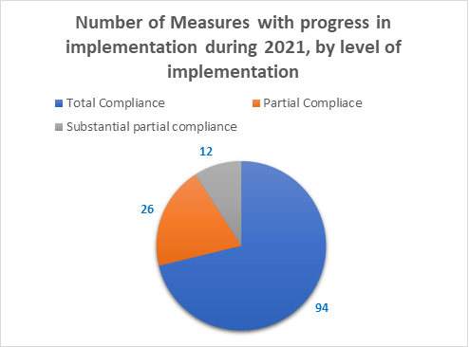

New friendly settlement agreements signed
- In 2021, a total of 21 new friendly settlement agreements were signed. They are listed next, in chronological order by the date they were signed:
No. | Case or Petition Number | Name | Country | Date of signature
 | 13.571 | Carlos Mario Muñoz Gómez | CO | 2021.03.04
 | 12.289 | Guillermo Santiago Zaldívar | AR | 2021.03.18
 | 13.654 | Juan Simón Cantillo Raigoza, Keyla Sandrith and Family | CO | 2021.06.29
 | 13.595 | Amanda Graciela Encaje | AR | 2021.07.12
 | 12.956 | F.S. | CH | 2021.08.03
 | 13.226 | Dora Inés Meneses | CO | 2021.08.04
 | 12.961 J | Faustino Garcia Cárdenas, et.al. | HO | 2021.06.29
 | 535-17 | Luis Gerardo Bermúdez | CO | 2021.08.27
 | 514-11 | Luis Hernando Morera Garzón | CO | 2021.08.25
 | 13.775 | Gabriel Ángel Gomez Martinez and Family | CO | 2021.09.07
 | 13.758 | Franklin Bustamante Restrepo and Family | CO | 2021.09.13
 | P-1391-15 | Mario Cardona | CO | 2021.09.23
 | P-1256-05 | Ivana Emilce Rosales | AR | 2021.09.23
 | 14.291 | Captain N | CO | 2021.10.25
 | 12.490 | Asmeth Yamith Salazar Palencia | CO | 2021.11.11
 | 14.312 | Juan Carlos de la Calle Jiménez, et.al. | CO | 2021.11.26
 | P-1617-12 | Domingo José Rivas Coronado | CO | 2021.12.20
 | 14.036 | José Ramón Ochoa Salazar y Familia | CO | 2021.12.21
 | 13.964 | Darío Gómez Cartagena y Familia | CO | 2021.12.23
 | 13.436 | José Oleaguer Correa Castrillón | CO | 2021.12.23
 | P-1279-19 | Zury Mayte Ríos Sosa e hija | GU | 2021.12.25

- The Commission commends the states of Argentina, Chile, Colombia, and Honduras for their openness to engage with dialogue with the various victims and their representatives to find, together, formulas for making reparation to the victims of human rights violations in the aforementioned matters, taking account of their needs and interests by reaching a friendly settlement.

New Friendly Settlement Monitoring Processes
- The Commission announces with satisfaction that in 2021 15 reports approving friendly settlements were published, four of which, as noted above (Report 39/21, in Petition 245-03, Walter Mauro Yáñez Report; Report No. 42/21, in Case 12.961E, Ecar Fernando Zavala Valladares; Report 205/2, in Case12.961 J, Faustino García Cárdenas and Others and Report No. 269/21, in Case 12.960, Ronald Jared Martínez and Other), as detailed supra, were published with total compliance, thus they will not be subject to supervision by the IACHR. Accordingly, 11 new matters came to be monitored for the first time, in the Annual Report of the IACHR on this occasion. They are listed next, in alphabetical order by the state concerned and chronological order based on the date the Commission’s decisions were issued:
- Report No. 207/21, Case 13.595, Amanda Graciela Encaje and family (Argentina)
- Report No. 136/21, Case 12.277, Fazenda Ubá (Brazil)
- Report No. 41/21, Case 13.642, Edgar José Sánchez Duarte and family (Colombia)
- Report No. 115/21, Case 13.171, Luis Argemiro Gómez Atehortua (Colombia)
- Report No. 336/21, Case 13.571, Carlos Mario Muñoz (Colombia)
- Report No. 337/21, Case 13.758, Franklin Bustamante Restrepo and family (Colombia)
- Report No. 114/21, Case 12.737, Carlos Raúl Morales Catalan (Guatemala)
- Report No. 40/21, Case 11.562, Dixie Miguel Urbina Rosales (Honduras)
- Report No. 269/21, Case 12.960. Ronald Jared Martínez et al. (Honduras)
- Report No. 204/21, Case 11.545, Martha María Saire (Honduras)
- Report No. 208/21, Case 12.610, Faustino Jiménez Álvarez (Mexico)
- Report No. 206/21, Case 12.330, Marcelino Gómez and one other (Paraguay)

- Next is a summary of the factual aspects of those matters and the relevant aspects of these friendly settlement processes:
- Case 13.595 Amanda Graciela Encaje, Argentina: the case is related to the assassination of Amanda Graciela Encaje, on April 8, 1992, in the vicinity of the company where she worked, without an effective judicial investigation to identify and punish the persons responsible. On July 12, 2021, the parties signed a friendly settlement agreement in which the Argentine State recognized its international responsibility for the violations of the human rights of Amanda Graciela Encaje indicated therein; and in which specific measures were established to guarantee reparation for the harm caused to the victim’s family members. Among the measures agreed upon in the context of this friendly settlement agreement are the commissioning of a sculpture as a tribute to the victims and their family members; an analysis of the viability of reopening the criminal case into the homicides of Amanda Encaje and Nestor Vivo; establishing the position of Official Defender of Victims, dedicated exclusively to working with crime victims; establishment of the Observatory of Crime Victims; the adoption of protocols to preserve the crime scene and to guarantee the chain of custody of evidence and personal effects sequestered so as to optimize and expedite the investigation into complex criminal cases; implementing the Provincial Genetic Bank (Banco Genético Provincial); and measures for disseminating the friendly settlement agreement. In its Report No. 207/21, the Commission valued the recognition of international responsibility by the Argentine State for the violations caused, and indicated that all of the measures agreed upon are still pending compliance given the joint decision of the parties to defer their implementation after the issuance of the report approving the agreement.

- Case 12.277, Fazenda Ubá, Brazil: the case is related to the international responsibility of the Federative Republic of Brazil for violation of the human rights to life, judicial guarantees, and judicial protection, all protected by the American Convention on Human Rights, to the detriment of rural workers, one of them a pregnant woman, who were allegedly assassinated in the area of the Ubá estate, municipality of São João de Araguaia, state of Pará, by a group of armed men during a rural eviction on June 13, 1985. On July 19, 2010, the parties signed a friendly settlement agreement in which the Brazilian State recognized its international responsibility for violating the rights to life, judicial protection, and judicial guarantees to the detriment of rural workers João Evangelista Vilarins, Francisco Ferreira Alves, Januário Ferreira Lima, Luis Carlos Pereira de Souza, Francisca de Tal, José Pereira da Silva, Valdemar Alves de Almeida, and Nelson Ribeiro; and in which specific measures were established to guarantee reparation for those victims’ family members for the material and moral damages suffered. Among the measures agreed upon in the context of this friendly settlement, special mention should be made of the payment of economic reparation, public recognition of responsibility, and apologies in a public ceremony; judicial measures to prosecute the persons involved in the facts; a civil action for compensation against the perpetrators of the crimes, brought by the state public defender’s office; a monument in memory of the facts and the victims; the effective inclusion of the victims’ family members in social service and educational programs and projects; access for the victims’ family members to rural settlements; and the adoption of measures of non-repetition, among other measures. As regards the degree of compliance with the agreement, in its Report No. 136/21 the Commission assessed progress in relation to each of the clauses and decided to declare the total compliance of clauses 5 (act of recognition of international responsibility), 6 (publication of the friendly settlement agreement), 11 (compensation), 12 (waiver of the statute of limitations), 16 (bill for compensation), 20 (agrarian legal aid offices) and 21 (incentive for work of the state commission on land conflicts). In addition, the Commission decided to find partial substantial compliance with clauses 13 (lifetime statutory pension) and 17 (inclusion in state programs and projects) while finding partial compliance with clauses 8 and 9 (criminal and civil prosecution), 18 (access to rural settlements), 22 (trainings), and 23 (monitoring mechanism). Finally, the Commission found that clauses 10 (monument) and 19 (construction of an information center) were still pending compliance.

- Case 13.642 Edgar José Sánchez Duarte and family, Colombia: on March 20, 2021, the Commission approved the friendly settlement agreement in this case, which is related to the international responsibility of the Colombian State for the extrajudicial execution of Mr. Edgar Sánchez Duarte by members of now disbanded Anti-kidnapping and Extortion Unit [Unidad Antisecuestro y Extorsión -UNASE- in Spanish] in the city of Valledupar, Cesar, as well as for the failure to investigate and punish the persons responsible for the facts. The petitioners alleged the purported violation of the right to life, humane treatment, and personal liberty, as well as the lack of judicial guarantees, judicial protection, and equality before the law. On July 14, 2020, the parties signed a friendly settlement agreement in which the Colombian State recognized its international responsibility for the human rights violations committed to the detriment of Edgar Sánchez Duarte, in the terms agreed upon by the parties. In addition, the State undertook to hold a public ceremony for reparation and public apologies, to provide medical and psychosocial care to the family members of Mr. Edgar Sánchez Duarte, to grant economic assistance to Edgar José Sánchez Fuentes, the victim’s son, for the purpose of financing an academic program for technical-professional, technological, university or graduate-level studies and to pay a monetary reparation through the mechanism established in Law 288 of 1996. In this regard, the Commission, in its Friendly Settlement Report No. 41/2021, found total compliance with the commitments related to the act of redress and its dissemination on the website of the National Agency of Legal Defense, as well as in various social networks and media outlets. At the same time, the Commission considered that the measures related to medical and psychosocial care had not begun to be implemented and that the monetary compensation should be implemented after the issuance of the report approving the friendly settlement. Accordingly, it declared that these measures were still pending implementation. The friendly settlement agreement was approved, noting that there has been partial compliance.

- Case 13.171, Luis Argemiro Gómez, Colombia: the case is related to the international responsibility of the Colombian State for violation of the right to life of Mr. Luis Argemiro Gómez Atehortua as a consequence of the lack of diligence of state officials at a detention center of the National Police in Medellín, in their surveillance duties, which resulted in the death of the victim while in custody. On June 9, 2020, the parties signed a memorandum of understanding to seek a friendly settlement, which was materialized with the signing of an agreement on December 2, 2020, in which the Colombian State recognized its international responsibility for omission in its duty to guarantee the right to life recognized in the American Convention on Human Rights, to the detriment of Mr. Luis Argemiro Gómez Atehortua. Similarly, the State undertook to hold a public ceremony for reparation and public apologies, and to publish the friendly settlement report at the official websites of the Ministry of Defense and of the National Police; provide training geared to the police corps involved in the case; study the possibility of filing an action for review (acción de revisión) of the process for the facts that surrounded the death of Mr. Gómez Atehortua, and to pay a monetary reparation through the mechanism established in Law 288 of 1996. In this respect, the IACHR in its Friendly Settlement Report No. 115/2021 found total compliance with the commitments related to the act of redress and apologies and its dissemination at the website of the National Agency for Legal Defense, and in several social networks and media outlets. The Commission also recognized total compliance with the commitment to evaluate the viability of an action for review with respect to the process, for the facts that surrounded the death of Mr. Gómez Atehortua. The Commission also considered that the measures related to the publication of the report at the websites of the Ministry of Defense and the National Police, trainings, and monetary compensation should be implemented after the issuance of the report approving the friendly settlement. Accordingly, it found that these measures were pending compliance.

- Case 13.571, Carlos Mario Muñoz, Colombia: the case is related to the international responsibility of the Colombian State for the violations enshrined in articles 4 (life), 5 (humane treatment), 7 (personal liberty), 8 (judicial guarantees), 11 (protection of honor and dignity), and 25 (judicial protection) of the American Convention on Human Rights, stemming from the detention, disappearance, and subsequent extrajudicial execution of Mr. Carlos Mario Muñoz Gómez by members of the National Police, as well as for the failure to conduct speedy investigations into these facts and the failure to make full reparation to his family members. In the friendly settlement agreement signed on March 4, 2021, the State recognized its responsibility for what happened and undertook to hold a public ceremony (virtually) to recognize its responsibility, as well as to publish the report approving the friendly settlement, issued by the IACHR, and to grant an economic compensation in the context of the mechanism established in Law 288 of 1996. In addition, as a measure of non-repetition, the State undertook to include the case in the trainings held at the Ministry of Defense in the context of Permanent Directive No. 11 of 2019, related to the “Guidelines for strengthening the annual plans for extracurricular training for the Military Forces and National Police in Human Rights and International Humanitarian Law.” In its Report No. 336/21, the Commission found total compliance with the measure of the act of redress, while the rest of the obligations in the agreement persist and require monitoring of their implementation. Accordingly, it was approved with partial compliance.

- Case 13.758, Franklin Bustamante Restrepo, Colombia: the case is related to the international responsibility of the Colombian State for the violation of the rights enshrined in articles 4 (life), 5 (humane treatment), 8 (judicial guarantees), 11 (protection of honor and dignity), and 25 (judicial protection) of the American Convention on Human Rights, stemming from the alleged extrajudicial execution of the child Franklin Bustamante, 14 years of age, purportedly by agents of the Administrative Security Department (DAS: Departamento Administrativo de Seguridad), as well as the subsequent failure to effectively investigate the events that occurred on July 28, 1989. In the friendly settlement agreement, signed on September 13, 2021, the State recognized its responsibility for failing to diligently investigate the facts; it undertook to hold a public ceremony, virtually, to recognize its responsibility, to publish the report approving the friendly settlement agreement to be issued by the IACHR, and to grant an economic compensation in the context of the mechanism established in Law 288 of 1996. In its Report No. 337/21 the Commission found total compliance with the measure of the act of redress, while the rest of the obligations in the agreement persist and require monitoring of their implementation. Accordingly, it was approved with partial compliance.

- Case 12.737, Carlos Raúl Morales Catalan, Guatemala: the case is related to the international responsibility of the Guatemalan State for denial of judicial guarantees and the right to an effective judicial remedy to the detriment of Mr. Carlos Raúl Morales Catalan in the context of the criminal proceeding and civil action for compensation for the negligent injuries suffered by his children José Raúl and Javier Ernesto Morales Vera as the result of a traffic accident. In the friendly settlement agreement signed by the parties the Guatemalan State recognized its international responsibility for the human rights violations committed to the detriment of Carlos Raúl Morales Catalan and his family members and undertook to implement the following measures of reparation: (1) Make economic reparation to the petitioner and his family, for the material harm caused; (2) hold a private ceremony to recognize the international responsibility of the State and to apologize to Mr. Carlos Raúl Morales Catalan and his family; (3) grant José Raúl and Javier Ernesto Morales Vera scholarships for undergraduate studies, in a lump sum, at a private university in the country, through the National Trust for Scholarships and Educational Loans (FINABECE); (4) to provide, on a permanent basis, medical, physical, and psychological care for the beneficiaries of the friendly settlement agreement; (5) name a roadway education program after José Raúl and Javier Ernesto Morales Vera; and (6) give impetus to the necessary actions vis-à-vis the institutions of the justice sector for the enforcement and effective implementation of the judgment on damages handed down by the Court of First Instance for Criminal, Drug-trafficking, and Crimes against the Environment, against Mr. Santiago Quidiello Valenzuela and Ms. Laura Patricia Toron Torres De Luna. On November 23, 2020, the petitioner asked the Commission, in the context of the implementation of Resolution 3/20 on differentiated actions to address the procedural backlog in friendly settlement processes, to approve and publish the friendly settlement agreement reached in this case. In this respect, the Commission considered in its Friendly Settlement Report No. 114/21 that there had been total compliance with clauses 2, 3(b), and 3(d) of the agreement, related to the payment of economic reparation, the university scholarship for José Raúl Morales Vera, and the naming of a roadway education program. In addition, the IACHR declared pending for compliance clauses 3(a), 3(c), and 3(e), related to the private ceremony for recognition of international responsibility; medical care, both physical and psychological, and the justice-related measure, regarding the enforcement of the judgment ordering Santiago Quidiello Valenzuela to pay civil reparations. In view of the foregoing the IACHR will continue supervising compliance with sections 3(a), (c) and (e) of the friendly settlement agreement until they meet with total compliance. Finally, the Commission declared clauses 3(b) and 3(e), regarding the university scholarship for Javier Ernesto Morales Vera and enforcement of the judgment of civil reparations with respect to Laura Patricia Toron Torres de Luna, to be inoperative. This last one in light of the signing of an agreement among the parties domestically.

- Case 11.562, Dixie Miguel Urbina Rosales, Honduras: the case is related to the international responsibility of the State of Honduras for violations of the rights to life, humane treatment, judicial guarantees, and judicial protection, stemming from the forced disappearance of Dixie Miguel Urbina Rosales, who was reportedly detained on October 22, 1995, by a patrol of the Public Security Force [Fuerza de Seguridad Pública -FUSEP- in Spanish]. To date his whereabouts have not been determined, nor have the persons responsible been identified, prosecuted, or punished. In the friendly settlement agreement signed by the parties, the Honduran State recognized its international responsibility for the human rights violations committed to the detriment of Dixie Urbina Rosales and it undertook to implement the following measures of reparation: (I) Continue investigating the facts and locating his remains; (II) create and implement a Registry of Detainees or adapt those that already exist in the terms established in the judgment by the Inter-American Court of Human Rights in the Case of Juan Humberto Sánchez v. Honduras, of June 7, 2003; (III) publish a summary of the facts and the text of public recognition of responsibility in the official gazette (Diario Oficial La Gaceta) and in the daily newspaper La Tribuna, which is published in Tegucigalpa; (IV) contribute economically to the construction of a new module on the property of “El Hogar Contra El Olvido” (“The Home against Forgetting’), which will have the name “Space for reflection, analysis, and training,” as a measure to preserve memory; (V) provide comprehensive medical, psychiatric, and psychological care to the victim’s family members, free of charge and through its public health institutions; and (VI) make economic reparation for the material and moral damages suffered by the victim’s family members, including an amount to compensate the procedural costs and expenses incurred. In this respect, the Commission considered, in its Friendly Settlement Report No. 40/21, that there had been total compliance with clauses 3, 4, and 6 of the agreement, related to the dissemination of the public recognition of responsibility; the contribution of the State to the “Hogar contra el Olvido”; and the payment corresponding to economic reparation, costs, and expenses, respectively. It also found partial compliance with clauses 1 and 5 of the agreement, related to the investigation into the facts and measures of physical and psychological rehabilitation, respectively. Finally, the Commission declared pending for compliance point 2 of the friendly settlement agreement, related to the registry of detainees. Accordingly, the friendly settlement agreement was approved with partial compliance.

- Case 11.545, Martha María Saire, Honduras: the case relates to the international responsibility of the Honduran State for the alleged violation of the human rights to humane treatment, judicial guarantees, the rights of the child, and judicial protection, protected by the American Convention on Human Rights, to the detriment of the girl Martha María Saire, 11 years old at the time, and who lives with mental disability, due to a brain injury. On April 9, 1994, Martha María Saire was said to be the victim of rape by the guards at the Women and Girl’s Center for Social Adaptation [Centro Femenino de Adaptación Social -CEFAS- in Spanish], who belonged to the Special Tactical Group [Agrupamiento Táctico Especial in Spanish] of the Honduran Army; they had been assigned as guards at two children’s homes facilities and the women’s prison that was in the same place, including the Youth Orientation Home of Támara [Hogar de Orientación Juvenil de Támara in Spanish], where Martha María Saire had been taken in, given that when she was initially found in San Pedro Sula she was homeless. On June 30, 2003, the parties signed a friendly settlement agreement in which the Honduran State recognized its international responsibility for the violations of the rights to humane treatment and the rights of the child to the detriment of Martha Saire. However, later the Honduran State ratified the Inter-American Convention on the Elimination of All Forms of Discrimination against Persons with Disabilities and the Convention on the Rights of Persons with Disabilities came into force. Therefore, the parties identified the need to adjust the content of the friendly settlement agreement to the updated standards on protecting the rights of persons living with disabilities; during the 179th Regular Period of Sessions of the IACHR they signed a memorandum of understanding to that end.

In that agreement the Honduran State undertook to grant a birth certificate to Martha Saire; to prosecute and punish the persons responsible for those acts of sexual violence; to maintain the personnel necessary for the care of Martha Saire, as well as to adopt measures of medical, psychological, and social rehabilitation and the gradual social reinsertion of Martha Saire by creating a Comprehensive Support Plan, with her active participation to guarantee her autonomy in making decisions that affect her, in light of the principles of respect for the dignity, autonomy, independence, self-determination, and social inclusion. Said plan considered the creation of the Accompaniment Committee to monitor the implementation of Martha Saire’s Comprehensive Care Plan; conducting a mental health assessment; developing a capacity-building plan; and creating a support network with her involvement. In its decision the Commission observed that multiple factors of vulnerability converge in the case of Martha Saire, as she is a woman, with a mental disability, and a victim of (repeated) sexual violence, who lived in extreme poverty and homeless, in addition to the different violations of her rights to health and to informed consent during the friendly settlement process, especially as she has been subject to prolonged institutionalization in a psychiatric hospital. Accordingly, the Commission established in its Friendly Settlement Agreement Report No. 204/21 that the treatment that Martha Saire will receive as a result of the friendly settlement should be preferential and specially appropriate for her condition, respecting her dignity, autonomy, independence, self-determination, and social inclusion, with a focus on satisfying her economic, social, and cultural rights. As regards the degree of compliance with the agreement, in its report the Commission assessed the progress made in relation to each clause of both the original friendly settlement agreement and the memorandum of understanding subsequently signed, and it decided to find that there has been total compliance with sections (a) of point four of the friendly settlement agreement of June 30, 2003 (measures of medical, psychological, and social rehabilitation, and progressive social reinsertion) and section (b) (keep the Commission informed). In addition, the Commission decided to find partial compliance with the second clause of the memorandum of understanding of March 26, 2021 (maintain the necessary personnel for the attention and care of Martha Saire). Finally, the Commission considered that still pending compliance was the third clause of the memorandum of understanding of March 26, 2021, related to (a) establishing the Accompaniment Committee to monitor the implementation of the Comprehensive Care Plan for Martha Saire; (b) conducting the mental health assessment; (c) developing the capacity-building plan; (d) creating a support network with her participation, and fifth clause (creation of the Accompaniment Committee).
- Case 12.960 Ronald Jared Martínez and one other, Honduras: the case is related to the international responsibility of the Honduran State for the purported violation of the rights contained in articles 5 (right to humane treatment), 8 (judicial guarantees), 19 (rights of the child), and 25 (judicial protection) of the American Convention, stemming from the alleged disproportionate use of force and abuse of authority by police agents and officers of the National Army, which caused the child Ronald Jared Martínez to have acquired a physical disability (irreversible paraplegia) and the child Marlón Fabricio Hernández Fúnez to have suffered an injury and a temporary disability that lasted 21 days. On September 22, 2020, the parties signed a friendly settlement agreement. In the friendly settlement agreement signed by the parties the Honduran State undertook to make an economic reparation payment to the beneficiaries of the agreement, namely Ronald Jared Martínez Velásquez, José Roberto Martínez, and Marlon Fabricio Hernández. In this respect, in its Report No. 269/21 the Commission found total compliance with the sixth clause of the agreement, referring to the payment of economic reparation to the beneficiaries. Accordingly, the IACHR considered that the agreement has met with total compliance and consequently ordered the cessation of the monitoring and closure of the case.

- Case 12.610 Faustino Jiménez Álvarez, Mexico: the case is related to the international responsibility of the United Mexican States for the violation of the rights of Faustino Jiménez Álvarez, who allegedly had been illegally detained, disappeared, and tortured by police agents of the state of Guerrero, Mexico. On September 27, 2012, the parties signed a friendly settlement agreement in which the Mexican State recognized its international responsibility for the human rights violations stemming from the facts established Admissibility Report No. 31/07 of the IACHR. Similarly, the State undertook to provide economic compensation, undertake an investigation into the facts of the case to punishing the persons responsible, make a statement of public acknowledgement on the facts, and provide the measures of rehabilitation consisting of medical and psychological care, educational support, support for a productive project, economic, support, and housing support for the family members of Mr. Faustino Jiménez. In this respect, the Commission found, in its Friendly Settlement Report No. 208/21, total compliance with the commitments related to economic compensation, the public acknowledgement of the facts of the case, medical and psychological care, educational support, support for a productive project, and economic support. It considered that the measure related to housing support had a partial substantial level of implementation, and that the investigation into the facts of the case and punishment of the persons responsible had met with partial compliance. Accordingly, the friendly settlement agreement was approved with a partial substantial compliance. The Commission will continue monitoring these aspects of the agreement until their total implementation and urges the State to take the necessary actions for that to happen.

- Case 12.330, Marcelino Gómez Paredes, Paraguay: the case is related to the international responsibility of the State of Paraguay for violations of the rights to personal liberty, humane treatment, life, special measures of protection for children, judicial protection, and judicial guarantees, established in the American Convention on Human Rights, stemming from the disappearance of the children Marcelino Gómez Paredes and Cristian Ariel Núñez, 14 years of age, illegally recruited for compulsory military service and disappeared while under the custody of the Army. On November 4, 2009, the parties signed a friendly settlement agreement in which the Paraguayan State recognized its international responsibility for the human rights violations committed to the detriment of the children Marcelino Gómez Paredes and Cristian Ariel Núñez and undertook to implement the following measures of reparation: (1) Public ceremony of apologies and acknowledgement of international responsibility in the presence of the country’s high-level authorities, published and widely disseminated by various media outlets; (2) guarantees of justice aimed at investigating the facts and punishing those responsible which includes, inter alia, the creation of a truth commission; (3) measures of satisfaction by installing a commemorative plaque and the naming of streets with the children’s names; (4) primary and comprehensive health care measures; (5) measures of security; (6) guarantees of non-repetition by amending Article 236 of the Paraguayan Criminal Code, which defined the crime of forced disappearance and for the definition of a penalty proportional to the seriousness of the crime, and the showing of the documentary “Cuerpo a Tierra: los Niños Soldados del Paraguay” at the Mariscal Francisco Solano López Military Academy; and, (7) economic compensation. On June 21, 2021, the petitioner requested that the Commission, in the context of Resolution 3/2020 of the IACHR on differentiated actions for addressing the procedural backlog in friendly settlement procedures, approve the friendly settlement agreement signed in this case. In this respect, the Commission found in its Friendly Settlement Report No. 206/21, full compliance with clauses 2(a), 2(b), 2(c), and 2(d) (public ceremony of apologies and its dissemination, and publication of the agreement, respectively); 3(b), at 3(b)(1), 3(b)(2), 3(b)(3), 3(b)(4), and 3(b)(5) (truth commission); 4 (plaque and naming of streets); 5 (primary and comprehensive health care); 6 (security measures); 7 (guarantees of non-repetition); and 8 (monetary reparation). In addition, the IACHR found partial compliance with clause 3(a) (guarantees of justice). Accordingly, the IACHR will continue supervising compliance with clause 3(a) of the friendly settlement agreement until it is totally implemented.

- Consequently, the Commission commends the states of Argentina, Brazil, Colombia, Guatemala, Honduras, Mexico, and Paraguay and urges them to continue taking actions to comply with those friendly settlement agreements, for the next Annual Report in 2022.

Activities undertaken to foster friendly settlements in 2021

Activities to foster the negotiation and implementation of FSAs
- As regards the line of work that involves actively facilitating the negotiation of and compliance with friendly settlement agreements, in 2021 the Commission held 36 working meetings to foster the negotiation and implementation of friendly settlement agreements in different matters from Argentina, Bolivia, Brazil, Chile, Colombia, Honduras, Mexico, Panama, and Paraguay. Moreover, the Commission facilitated 57 technical meetings to foster friendly settlement efforts and/or preparatory meetings over the year, in various matters from Argentina, Bolivia, Brazil, Chile, Colombia, the Dominican Republic, Honduras, Mexico, Panama, Paraguay, and Peru. Accordingly, in 2021 a total of 93 dialogues tables were facilitated with the parties to advance in friendly settlements.
- Throughout 2021 the Commission held 15 periodic meetings to review the portfolios of negotiation and monitoring of friendly settlements with Argentina (1); Bolivia (1); Chile (1); Colombia (2); Costa Rica (1); the Dominican Republic (1); Ecuador (2); Guatemala (1); Mexico (3); Panama (1); and Peru (1).
- In 2021, the Commission issued 25 press releases on friendly settlements and maintained the practice of making visible the progress in the implementation of friendly settlement agreements in the negotiation phase, as long as both parties agree, due to the confidential nature of the negotiations of friendly settlements before issuing the respective homologation report. The Commission also maintained the practice of publishing press releases when signing and approving friendly settlement agreements and making visible the compliance with the measures in the friendly settlement agreements whose total compliance has been attained during the monitoring phase so as to encourage the authorities in charge of the execution of those measures to follow through on the commitments assumed by the States in friendly settlement agreements.
- In 2021, the Commission published 15 reports approving friendly settlement agreements pursuant to Article 49 of the American Convention. In this regard, over the year the IACHR cleared up 34 matters under the friendly settlement mechanism through 15 homologations, 16 instances of ending negotiations at the request of the parties, 1 matter archived in the negotiation phase, and 2 matters archived in the monitoring phase due to inactivity or at the request of the petitioner.
- In application of Resolution 3/20, on differentiated actions to address the procedural backlog in friendly settlement procedures, the Commission played a more active role in deciding the course of action for matters under the mechanism, and, mainly, progress was made with early identification of the unfeasibility of a friendly settlement process. In that regard, the Commission determined the course of action of the negotiation in the context of Petition P-861-13, Andrea Karina Vásquez, Argentina, related to the international responsibility of the Argentine State for the alleged violations of the rights to humane treatment, due process, judicial protection, rights of the child, and protection of the family, in the context of a custody proceeding on behalf of a child, as well as with respect to the establishment of a custody regime living with his mother. In the context of the friendly settlement process the Commission observed the incompatibility of the petitioner’s claims with the standards of protection of the rights of the child, as they entail an interest related to the cessation of the judicial proceedings under way. In this respect, the Commission considered that the negotiation of a friendly settlement agreement that sought to intervene in the determination that must be made by the domestic courts of justice would not be compatible with the standards established by the Commission and the Inter-American Court, and therefore concluded the friendly settlement process. Hence, the matter has returned to the litigation and the Commission will continue considering this complaint giving priority to the assessment of admissibility.
- In addition, the Commission provided technical assistance to the parties in 2 matters. First, technical assistance was provided to the parties in Case 11.545 Martha Saire, Honduras, providing the parties with standards on the protection of the rights of persons with disabilities, to amend a friendly settlement agreement originally signed in 2003 that was not in line with the relevant updated standards in the subject. Based on the work of active facilitation and advising the parties the technical obstacles were overcome, a memorandum of understanding was signed in the context of the 179th regular period of sessions, and progress was made with the approval of the agreement. In addition, a technical assistance was prepared to foster compliance with the act of recognition of responsibility and redress clause regarding the friendly settlement agreements, approved by the Commission in Friendly Settlement Reports 20/07, 71/07, 20/08, and 22/11, which are subject to monitoring, on the issue of the unratified judges in Peru, and in which that would be the only point pending of compliance with respect to 97 persons of the universe of 188 beneficiaries in this context. In this regard it should be noted that the rest of the measures of the friendly settlement agreements have met total compliance as regards the other measures to reinstate the victims in the judicial branch, recognition of the time of service, and payment of expenses and costs., it should be noted that in general the Commission, through its Friendly Settlements and Monitoring Section, provided constant support to the users for the design and total implementation of the friendly settlement agreements.
- The Commission also assessed and approved the arbitration award issued in compliance with the friendly settlement agreement signed in petition P-21-05 Ignacio Cardozo of Argentina for the determination of economic compensation in favor of the beneficiaries of the friendly settlement agreement. The case refers to the events of December 17, 1999, when heavily armed members of the national gendarmerie, violently removed “hundreds of demonstrators” who had been occupying the General Manuel Belgrano Bridge in the context of a protest in the province of Corrientes. According to the petitioners’ account, two persons lost their lives and about 50 people suffered injuries in those events. The petitioners alleged that up to the filing of the petition, in January 2005, there had been no progress in the investigation, for which they argued that through the judicial delay on the part of the State the perpetrators of the violations were not being held accountable before the justice system.
- In 2021, the Commission published two press reports, at its channel Canal CIDH, on the antecedents of emblematic cases of friendly settlement agreements, namely, Cases 13.011, Graciela Ramos Rocha, Argentina; 12.191, María Mamérita Mestanza, Peru; and 12.942 Emilia Morales Campos, Costa Rica, with the aim of make visible the impacts of the friendly settlement mechanism, in the words of the victims themselves and their representatives, and including as well the views of the States regarding said reparation processes.
- Finally, the Commission participated in nine acts for signing and/or acknowledgement of responsibility in compliance with different friendly settlement agreements of Argentina, Chile and Colombia. In this respect, the Commission values and welcomes the good will of these States for the implementation of these important redress measures in virtual mode, as well as for disseminating them across different media and networks.

Activities to promote the sharing and dissemination of best practices in friendly solutions and to develop tools to facilitate access to information regarding the friendly settlement procedure for users of the inter-American human rights system
- Regarding the IACHR’s line of action of promoting and disseminating good practices about friendly settlements, it is highlighted in a positive vein that in 2021 different training activities were carried out, and good practices related to friendly settlement were shared.
- For example, on May 13, 2021, a workshop was held geared to public servants of the Presidential Commission for Peace and Human Rights [Comisión Presidencial para la Paz y los Derechos Humanos -COPADEH- in Spanish] and the Office of the Human Rights Ombudsperson of Guatemala on the practical and procedural aspects to be considered when using the friendly settlement mechanism. This workshop included theoretical and practical procedural aspects of the friendly settlement mechanism considering the legal framework that regulates it, including technical tools for negotiation and practical application of the information provided, as well as a practical simulation of the activities required to reach a friendly settlement.
- On July 7, 2021, a training was conducted on “Tools for investigating cases of violence, torture, and deaths in custody,” aimed to the forensic medical corps of Argentina, in which the Commission participated with a presentation on “International Human Rights Law. Normative hierarchy of international treaties. The Istanbul and Minnesota Protocols,” this training was part of the compliance with the friendly settlement agreement in Case 12.854 Ricardo Javier Kaplún of Argentina, which is currently being monitored by the Commission, and which is related to the use of police force in the context of the detention and death of the victim in circumstances that have not been clarified while deprived of liberty in a police station. The Vice President of the IACHR and Rapporteur for Argentina, Commissioner Julissa Mantilla, participated in the training with the technical support of the Friendly Settlements and Monitoring Section.
- On August 11, 2021, a course was held on “Investigating cases of appropriation of children during the period of State terrorism” (held in the context of compliance of the friendly settlement agreement in Petition P-242-03 Inocencia Luca de Pegoraro of Argentina). It included the participation of Commissioners Antonia Urrejola and Julissa Mantilla, in their capacities as President and Rapporteur of the IACHR on Memory, Truth, and Justice, and First Vice-President and Rapporteur of the IACHR for Argentina, respectively, and with the technical support of the Friendly Settlements and Monitoring Section. This event prompted the total compliance with the friendly settlement agreement signed in Petition 242-03, which had been subject to monitoring by the Commission for the last 11 years.
- From September 3 to 11, 2021, a course was held geared to public servants of the Chihuahua State Commission for Human Rights [Comisión Estatal de Derechos Humanos -CEDH- in Spanish] on the subject of comprehensive reparation for the harm caused due to human rights violations. The training sought to provide the personnel in attendance with practical tools for performing their functions in the different stages of action of the CEDH, which begin with receiving a complaint for an alleged violation of human rights and can continue to monitor the recommendations issued by the CEDH to make reparation for violations that have been found, if appropriate.
- In addition, on September 14, 2021, a training was held with students from the international course on public policy and human rights in the context of the specialization program in the Inter-American human rights system that is part of a cooperation agreement between the IACHR and the Institute for Public Policy on Human Rights of MERCOSUR.
- On September 28, 2021, a training was held on “Investigating human rights violations” for the personnel of the Office of the Attorney General [Fiscalía General de la Nación] and the Office of the Solicitor General [Procuraduría General del Estado] of Ecuador, for the purpose of providing state agents information and tools needed for the total compliance of the recommendations made by international agencies, as well as the clauses of friendly settlement agreements entered into before those agencies, in particular with respect to those investigative clauses that pose material difficulties. As part of the training topics were analyzed such as the components of full reparation, and the challenges and good practices in implementing justice measures stemming from friendly settlement agreements in the Region, among others.
- On October 4, 2021, an informal meeting was held with personnel from the Petitions and Urgent Actions Section of the Committee on Economic, Social and Cultural Rights of the Office of the United Nations High Commissioner, at its request, to answer some questions regarding the workings of the friendly settlement process and the Commission’s mediation in that framework with the aim of applying the good practices that the Inter-American Commission on Human Rights has identified in its role as facilitator of negotiations, for them to produce a guide for pursuing friendly settlements within the Optional Protocol to the International Covenant on Economic, Social and Cultural Rights framework. As a result of all the efforts made by the IACHR to strengthen and expand the friendly settlement mechanism it has become a benchmark on the matter for the universal human rights system.
- Finally, in the trainings that were organized theoretical-practice elements of the friendly settlement mechanism were incorporated considering the legal framework that regulates it, including technical tools for negotiating and practical application of the information provided, and in some of them even a practical simulation of the activities that should be pursued to reach a friendly settlement.

Status of Compliance with Reports on Friendly Settlement Agreements, Approved pursuant to Article 49 of the American Convention on Human Rights
- In compliance with its conventional and statutory attributes, and in accordance with Article 48 of the Rules of Procedure, the IACHR makes the follow-up to its own decisions regarding friendly settlements. This Commission practice began in 2000 and from this moment onwards, information has been requested annually from parties of different petitions and cases, to follow-up on friendly settlement reports published in light of Article 49 of the American Convention and update the status of compliance of each of the matters under the supervision of the IACHR. Additionally, the IACHR receives information at hearings or working meetings held during the year, and which takes into consideration for the analysis of the state of compliance with friendly settlement proceedings as appropriate in each case.
- For the elaboration of this Chapter, the Commission requested information to the users of the follow up of friendly settlement tool, and considered in this report the information submitted by the parties until October 15, 2020. Any information received thereafter did not make it into the Chapter but will be taken into consideration for the 2021 Annual Report. This taking into account the change in the composition of the Commission that on this occasion took place on December 31, 2019. The parties were duly advised of this information in the context of the requests for information for the preparation of this Chapter of the Annual Report. It should also be noted that the Commission took into consideration on exceptional basis information received after the closing date in those cases, where working meetings were held in the framework of the working meeting days as well as during the Period of Sessions that generated subsequent actions carried out based on the work lines developed in those meetings or in those matters in which the parties sent partial information within the term provided and after the period they added complementary or clarifying information.
- The Inter-American Commission on Human Rights continues to make efforts to communicate more clearly the progress made toward implementing friendly settlement agreements. To that end, the Commission prepared detailed compliance monitoring sheets on each active case, identifying both the individual and structural impacts in each case. In the table listed below the link to the record analysis of compliance with each one of the friendly settlement agreements that are currently under follow up stage can be accessed, and the level of general compliance of each case can be observed along with the percentage of execution of the agreements. This allows the parties to see the level of implementation of the agreement beyond the most categories of compliance, partial and pending. Finally, it should be pointed out that in this opportunity the Commission maintained the categories of analysis of the information supplied by the parties, as well as the categories for the individualized analysis of the clauses of the friendly settlement and the categories of the general analysis of the fulfillment of the friendly settlement agreements traditionally used.
- In light of the above, the commission observes that the status of compliance with friendly settlement agreements as of December 31, 2021, is as follows:
CASE/PETITION | MONITORING SHEET | FULL COMPLIANCE | PARTIAL COMPLIANCE | PENDING COMPLIANCE | COMPLIANCE PERCENTAGE | STATUS OF COMPLIANCE
- Case 11.307, Report No. 103/01, María Merciadri de Morini (Argentina) | Link to monitoring sheets on matters related to reports of friendly settlement agreements of Argentina that are subject to monitoring | X |  |  | 100% | Closed
- Case 11.804, Report No. 91/03, Juan Angel Greco (Argentina) |  |  | X |  | 63% | Active
- Case 12.080, Report No. 102/05, Sergio Schiavini and María Teresa Schnack (Argentina) |  |  | X |  | 50% | Active
- Case 12.298, Report No. 81/08, Fernando Giovanelli (Argentina) |  |  | X |  | 60% | Closed
- Case 12.159, Report No. 79/09, Gabriel Egisto Santillan Reigas (Argentina) |  |  | X |  | 75% | Active
- Case 11.758, Report No. 15/10, Rodolfo Correa Belisle (Argentina) |  | X |  |  | 100% | Closed
- Case 11.796, Report No. 16/10, Mario Humberto Gómez Yardez (Argentina) |  | X |  |  | 100% | Closed
- Case 12.536, Report No. 17/10, Raquel Natalia Lagunas and Sergio Antonio Sorbellini (Argentina) |  |  | X |  | 80% | Active
- Petition 242-03, Report No. 160/10, Inocencia Luca Pegoraro (Argentina) |  | X |  |  | 100% | Closed 2021
- Petition 4554-02, Report No. 161/10, Valerio Castillo Báez (Argentina) |  | X |  |  | 100% | Closed
- Petition 2829-02, Report No. 11/19, Inocencio Rodríguez (Argentina) |  | X |  |  | 100% | Closed
- Case 11.708, Report No. 20/11, Anibal Acosta and L. Hirsch (Argentina) |  | X |  |  | 100% | Closed
- Case 11.833, Report No. 21/11, Ricardo Monterisi (Argentina) |  | X |  |  | 100% | Closed
- Case 12.532, Report No. 84/11, Penitentiaries of Mendoza (Argentina) |  |  | X |  | 73% | Active
- Case 12.306, Report No. 85/11, Juan Carlos de la Torre (Argentina) |  |  | X |  | 33% | Active
- Case 11.670, Report No. 168/11, Menéndez and Caride (Argentina) |  | X |  |  | 100% | Closed
- Case 12.182, Report No. 109/13, Florentino Rojas (Argentina) |  |  | X |  | 90% | Active
- Petition 21-05, Report No. 101/14, Ignacio Cardozo et al. (Argentina) |  |  | X |  | 20% | Active
- Case 12.710, Report No. 102/14, Marcos Gilberto Chaves and Sandra Beatríz Chaves (Argentina) |  | X |  |  | 100% | Closed
- Case 12.854, Report No. 36/17, Ricardo Javier Kaplun (Argentina) |  |  | X |  | 40% | Active
- Case 13.011, Report No. 197/20, Graciela Ramos Rocha, and family (Argentina) |  | X |  |  | 100% | Closed 2021
- Petition 245-03, Report No. 39/21, Walter Mauro Yañez (Argentina) |  | X |  |  | 100% | Closed 2021
- Case 13.595, Report No. 207/21, Amanda Graciela Encaje and Family (Argentina) |  |  |  | X | 0% | Active
- Case 12.475, Report No. 97/05, Alfredo Díaz Bustos (Bolivia) |  | X |  |  | 100% | Closed
- Case 12.516, Report No. 98/05, Raúl Zavala Málaga and Jorge Pacheco Rondón (Bolivia) |  | X |  |  | 100% | Closed
- Petition 269-05, Report No. 82/07, Miguel Angel Moncada Osorio and James David Rocha Terraza (Bolivia) |  | X |  |  | 100% | Closed
- Petition 788-06, Report No. 70/07, Víctor Hugo Arce Chávez (Bolivia) |  | X |  |  | 100% | Closed
- Case 12.350, Report No. 103/14, M.Z. (Bolivia) |  | X |  |  | 100% | Closed
- Case 11.289, Report No. 95/03, José Pereira (Brazil) | Link to monitoring sheets on matters related to reports of friendly settlement agreements of Brazil that are subject to monitoring |  | X |  | 73% | Active
- Cases 12.426 and 12.427, Report No. 43/06, Raniê Silva Cruz, Eduardo Rocha da Silva and Raimundo Nonato Conceição Filho (Brazil) |  | X |  |  | 100% | Closed
- Case 12.674, Report No. 111/20, Marcio Lapoente Da Silveira (Brazil) |  |  | X |  | 75% | Active
- Case 12.277, Report No. 136/21, Fazenda Ubá (Brazil) |  |  | X |  | 44% | Active
- Case 11.715, Report No. 32/02, Juan Manuel Contreras San Martín et al. (Chile) | Link to monitoring sheets on matters related to reports of friendly settlement agreements of Chile that are subject to monitoring | X |  |  | 100% | Closed
- Case 12.046, Report No. 33/02, Mónica Carabantes Galleguillos (Chile) |  | X |  |  | 100% | Closed
- Petition 4617/02, Report No. 30/04, Mercedes Julia Huenteao Beroiza et al. (Chile) |  |  | X |  | 33% | Active
- Case 12.337, Report No. 80/09, Marcela Andrea Valdés Díaz (Chile) |  | X |  |  | 100% | Closed
- Petition 490-03, Report No. 81/09 "X" (Chile) |  | X |  |  | 100% | Closed
- Case 12.281, Report No. 162/10, Gilda Rosario Pizarro et al. (Chile) |  | X |  |  | 100% | Closed
- Case 12.195, Report No. 163/10, Mario Alberto Jara Oñate (Chile) |  | X |  |  | 100% | Closed
- Case 12.232, Report No. 86/11, María Soledad Cisternas (Chile) |  | X |  |  | 100% | Closed
- Petition 687-11, Report No. 138/19, Gabriela Blas Blas and her daughter C.B.B. (Chile) |  |  | X |  | 75% | Active
- Case 12.190; Report No. 37/19, Jose Luis Tapia, and Other Members of the Carabineros (Chile) |  | X |  |  | 100% | Closed
- Case12.233, Report No. 137/19, Víctor Améstica Moreno and Others (Chile) |  | X |  |  | 100% | Closed
- Petition 1275-04 A, Report No. 23/20, Juan Luis Rivera Matus (Chile) |  | X |  |  | 100% | Closed
- Case 11.141, Report No. 105/05, Massacre of Villatina (Colombia) | Link to monitoring sheets on matters related to reports of friendly settlement agreements of Colombia that are subject to monitoring | X |  |  | 100% | Closed
- Case 10.205, Report No. 53/06, Germán Enrique Guerra Achuri (Colombia) |  | X |  |  | 100% | Closed
- Petition 477-05, Report No. 82/08 X and relatives (Colombia) |  | X |  |  | 100% | Closed
- Petition 401-05, Report No. 83/08 Jorge Antonio Barbosa Tarazona et al. (Colombia) |  |  | X |  | 67% | Active
- Case 12.376, Report No. 59/14, Alba Lucía, Rodríguez (Colombia) |  |  | X |  | 29% | Active
- Case 12.756, Report No. 10/15, Massacre El Aracatazzo Bar (Colombia) |  |  | X |  | 80% | Active
- Petition 108-00, Report No. 38/15, Massacre of Segovia (28 family groups) (Colombia) |  |  | X |  | 40% | Active
- Petition 577-06, Report No. 82/15, Gloria González and family (Colombia) |  |  | X |  | 50% | Active
- Case 11.538, Report No. 43/16, Herson Javier Caro (Colombia) |  |  | X |  | 88% | Active
- Case 12.541, Report No. 67/16, Omar Zúñiga Vásquez and Amira Isabel Vásquez de Zúñiga (Colombia) |  |  | X |  | 22% | Active
- Case 11.007, Report No. 68/16, Massacre of Trujillo (Colombia) |  |  | X |  | 50% | Active
- Case 12.712, Report No. 135/17,  Rubén Darío Arroyave (Colombia) |  |  | X |  | 50% | Active
- Case 12.714, Report No. 136/17,  Belén Altavista Massacre (Colombia) |  |  | X |  | 60% | Active
- Case 12.941, Report No. 92/18, Nicolasa and Family (Colombia) |  |  | X |  | 14% | Active
- Petition 799-06, Report No. 93/18, Isidoro León Ramírez, Pompilio De Jesús Cardona Escobar, Luis Fernando Velásquez Londoño and Others (Colombia) |  |  | X |  | 33% | Active
- Case 11.990 A, Report No. 34/19, Oscar Orlando Bueno Bonnet et al. (Colombia) |  |  | X |  | 31% | Active
- Case 11.144, Report No. 109/19, Gerson Jairzinho González Arroyo (Colombia) |  |  | X |  | 56% | Active
- Case 13.776, Report No. 1/20, German Eduardo Giraldo and family (Colombia) |  |  | X |  | 33% | Active
- Case 13.728, Report No. 21/20, Amira Guzmán Alonso (Colombia) |  |  | X |  | 75% | Active
- Case 12.909, Report No. 22/20, Gerardo Bedoya Borrero (Colombia) |  |  | X |  | 60% | Active
- Case 13.370, Report No. 8/20, Luis Horacio Patiño and family (Colombia) |  |  | X |  | 40% | Active
- Petition 595-09, Report No. 84/20, Jorge Alberto Montes Gallego and family (Colombia) |  |  | X |  | 67% | Active
- Case 13.319. Report No. 213/20, William Fernández Becerra and family (Colombia) |  |  | X |  | 9% | Active
- Case 13.421, Report No. 333/20, Geminiano Gil Martinez and family (Colombia) |  |  | X |  | 50% | Active
- Case 13.642, Report No. 41/21, Edgar José Sánchez Duarte and Family (Colombia) |  |  | X |  | 25% | Active
- Case 13.171, Report No. 115/21, Luis Argemiro Gómez Atehortua (Colombia) |  |  | X |  | 40% | Active
- Case 13.571, Report 336/21, Carlos Mario Muñoz Gómez, (Colombia) |  |  | X |  | 25% | Active
- Case 13.758, Report 337/21, Franklin Bustamante Restrepo (Colombia) |  |  | X |  | 33% | Active
- Case 12.942, Report No. 71/19, Emilia Morales Campos (Costa Rica) |  | X |  |  | 100% | Closed
- Case 11.421, Report No. 93/00, Edison Patricio Quishpe Alcívar (Ecuador) | Link to monitoring sheets on matters related to reports of friendly settlement agreements of Ecuador that are subject to monitoring |  | X |  | 67% | Closed
- Case 11.439, Report No. 94/00, Byron Roberto Cañaveral (Ecuador) |  |  | X |  | 67% | Closed
- Case 11.445, Report No. 95/00, Ángelo Javier Ruales Paredes (Ecuador) |  | X |  |  | 100% | Closed
- Case 11.466, Report No. 96/00, Manuel Inocencio Lalvay Guamán (Ecuador) |  |  | X |  | 75% | Closed
- Case 11.584, Report No. 97/00, Carlos Juela Molina (Ecuador) |  |  | X |  | 67% | Closed
- Case 11.783, Report No. 98/00, Marcia Irene Clavijo Tapia, (Ecuador) |  |  | X |  | 67% | Closed
- Case 11.868, Report No. 99/00, Carlos Santiago and Pedro Andrés Restrepo Arismendy (Ecuador) |  |  | X |  | 67% | Closed
- Case 11.991, Report No. 100/00, Kelvin Vicente Torres Cueva (Ecuador) |  |  | X |  | 67% | Closed
- Case 11.478, Report No. 19/01, Juan Clímaco Cuellar et al. (Ecuador) |  |  | X |  | 50% | Active
- Case 11.512, Report No. 20/01, Lida Ángela Riera Rodríguez (Ecuador) |  |  | X |  | 50% | Closed
- Case 11.605, Report No. 21/01, René Gonzalo Cruz Pazmiño (Ecuador) |  |  | X |  | 50% | Closed
- Case 11.779, Report No. 22/01, José Patricio Reascos (Ecuador) |  |  | X |  | 50% | Closed
- Case 11.441, Report No. 104/01, Rodrigo Elicio Muñoz Arcos et al. (Ecuador) |  |  | X |  | 50% | Closed
- Case 11.443, Report No. 105/01, Washington Ayora Rodríguez (Ecuador) |  |  | X |  | 50% | Closed
- Case 11.450, Report No. 106/01, Marco Vinicio Almeida Calispa (Ecuador) |  |  | X |  | 50% | Closed
- Case 11.542, Report No. 107/01, Ángel Reiniero Vega Jiménez (Ecuador) |  |  | X |  | 50% | Closed
- Case 11.574, Report No. 108/01, Wilberto Samuel Manzano (Ecuador) |  |  | X |  | 50% | Closed
- Case 11.632, Report No. 109/01, Vidal Segura Hurtado (Ecuador) |  |  | X |  | 50% | Closed
- Case 12.007, Report No. 110/01, Pompeyo Carlos Andrade Benítez (Ecuador) |  |  | X |  | 50% | Closed 2021
- Case 11.515, Report No. 63/03, Bolívar Franco Camacho Arboleda (Ecuador) |  |  | X |  | 50% | Closed
- Case 12.188, Report No. 64/03, Joffre José Valencia Mero, Priscila Fierro, Zoreida Valencia Sánchez, Rocío Valencia Sánchez (Ecuador) |  |  | X |  | 50% | Closed
- Case 12.394, Report No. 65/03, Joaquín Hernández Alvarado, Marlon Loor Argote and Hugo Lara Pinos (Ecuador) |  |  | X |  | 50% | Closed
- Case 12.205, Report No. 44/06, José René Castro Galarza (Ecuador) |  |  | X |  | 50% | Active
- Case 12.207, Report No. 45/06, Lizandro Ramiro Montero Masache (Ecuador) |  |  | X |  | 50% | Closed
- Case 12.238, Report No. 46/06, Myriam Larrea Pintado (Ecuador) |  |  | X |  | 60% | Closed
- Case 12.558, Report No. 47/06, Fausto Mendoza Giler and Diógenes Mendoza Bravo (Ecuador) |  |  | X |  | 50% | Closed
- Petition 533-05, Report No. 122/12, Julio Rubén Robles Eras (Ecuador) |  |  | X |  | 67% | Closed
- Case 12.631, Report No. 61/13, Karina Montenegro et al. (Ecuador) |  |  | X |  | 45% | Active
- Case 12.957, Report No. 167/18, Luis Bolívar Hernández Peñaherrera (Ecuador) |  | X |  |  | 100% | Closed 2021
- Case 11.626 A, Report No. 81/20, Fredy Oreste Cañola Valencia (Ecuador) |  |  | X |  | 67% | Closed
- Case 11.626 B, Report No. 82/20, Luis Enrique Cañola Valencia (Ecuador) |  |  | X |  | 67% | Closed
- Case 11.626 C, Report No. 83/20, Santo Enrique Cañola González (Ecuador) |  |  | X |  | 67% | Closed
- Case 11.312, Report No. 66/03, Emilio Tec Pop (Guatemala) | Link to monitoring sheets on matters related to reports of friendly settlement agreements of Guatemala that are subject to monitoring |  | X |  | 67% | Active
- Case 11.766, Report No. 67/03, Irma Flaquer (Guatemala) |  |  | X |  | 92% | Active
- Case 11.197, Report No. 68/03, Community of San Vicente de los Cimientos (Guatemala) |  |  | X |  | 57% | Active
- Case 9.168, Report No. 29/04, Jorge Alberto Rosal Paz (Guatemala) |  |  | X |  | 80% | Active
- Petition 133-04, Report No. 99/05, José Miguel Mérida Escobar (Guatemala) |  |  | X |  | 89% | Closed 2021
- Case 11.422, Report No. 1/12, Mario Alioto López Sánchez (Guatemala) |  |  | X |  | 80% | Active
- Case 12,546, Report No. 30/12, Juan Jacobo Arbenz Guzmán (Guatemala) |  |  | X |  | 88% | Closed
- Case 12.591, Report No. 123/12, Ángelica Jerónimo Juárez (Guatemala) |  | X |  |  | 100% | Closed
- Petition 279-03, Report No. 39/15. Fredy Rolando Hernández Rodríguez et al. (Guatemala) |  | X |  |  | 100% | Closed
- Case 12.732, Report No. 86/20, Richard Conrad Solórzano Contreras (Guatemala) |  |  | X |  | 50% | Active
- Case 10.441 A, Report No. 214/20, Silvia María Azurdia Utrera and Others (Guatemala) |  |  | X |  | 80% | Active
- Case 10.441 B, Report No. 215/20, Carlos Humberto Cabrera Rivera (Guatemala) |  |  | X |  | 80% | Active
- Case 12.737, Report No. 114/21, Carlos Raúl Morales Catalan (Guatemala) |  |  | X |  | 50% | Active
- Case 11.805, Report No. 124/12, Carlos Enrique Jaco (Honduras) | Link to monitoring sheets on matters related to reports of friendly settlement agreements (Honduras) | X |  |  | 100% | Closed
- Case 12.547, Report No. 62/13, Rigoberto Cacho Reyes (Honduras) |  | X |  |  | 100% | Closed
- Case 12.961 C, Report No. 101/19, Marcial Coello Medina and Others (Honduras) |  | X |  |  | 100% | Closed
- Case 12.961 D, Report No. 104/19, Jorge Enrique Valladares Argueñal and Others (Honduras) |  | X |  |  | 100% | Closed
- Case 12.961 A, Report No. 105/19, Bolívar Salgado Welban and Others (Honduras) |  | X |  |  | 100% | Closed
- Case 12.961 F, Report 20/20, Miguel Angel Chinchilla Erazo and others (Honduras) |  | X |  |  | 100% | Closed
- Case 12.891, Report No. 212/20, Adan Guillermo López Lone et al. (Honduras) |  |  | X |  | 68% | Active
- Case 12.972, Report No. 334/20, Marcelo Ramón Aguilera Aguilar (Honduras) |  | X |  |  | 100% | Closed
- Case 11.562, Report No. 40/21, Dixie Miguel Urbina Rosales (Honduras) |  |  | X |  | 50% | Active
- Case 12.961E, Report No. 42/21, Ecar Fernando Zavala Valladares and Others (Honduras) |  | X |  |  | 100% | Closed 2021
- Case 11.545, Report No. 204/21, Martha María Saire (Honduras) |  |  | X |  | 40% | Active
- Case 12.961J, Report No. 205/21, Faustino Garcia Cárdenas and Other (Honduras) |  | X |  |  | 100% | Closed 2021
- Case 12.960, Report No. 269/21, Ronald Jared Martínez (Honduras) |  | X |  |  | 100% | Closed 2021
- Case 11.807, Report No. 69/03, José Guadarrama (Mexico) | Link to monitoring sheets on matters related to reports of friendly settlement agreements of Mexico that are subject to monitoring | X |  |  | 100% | Closed
- Petition 388-01, Report 101/05 Alejandro Ortiz Ramírez (Mexico) |  | X |  |  | 100% | Closed
- Petition 161-02, Report No. 21/07, Paulina del Carmen Ramírez Jacinto (Mexico) |  | X |  |  | 100% | Closed
- Case 11.822, Report No. 24/09, Reyes Penagos Martínez et al. (Mexico) |  |  | X |  | 83% | Active
- Case 12.642, Report No. 90/10, José Iván Correa Arévalo (Mexico) |  | X |  |  | 100% | Closed
- Case 12.660, Report No. 91/10, Ricardo Ucán Seca (Mexico) |  | X |  |  | 100% | Closed
- Case 12.623, Report No. 164/10, Luis Rey García (Mexico) |  | X |  |  | 100% | Closed
- Petition 318-05, Report No. 68/12, Gerónimo Gómez López (Mexico) |  | X |  |  | 100% | Closed
- Case 12.769, Report No. 65/14, Irineo Martínez Torres and Other (Mexico) |  | X |  |  | 100% | Closed
- Case 12.813, Report No. 81/15, Blanca Olivia Contreras Vital et al. (Mexico) |  | X |  |  | 100% | Closed
- Petition 1171-09, Report No. 15/16, Ananias Laparra and relatives (Mexico) |  |  | X |  | 64% | Active
- Case 12.847, Report No. 16/16, Vicenta Sanchez Valdivieso (Mexico) |  | X |  |  | 100% | Closed 2021
- Case 12.627, Report No. 92/17, Maria Nicolasa Garcia Reynoso (Mexico) |  | X |  |  | 100% | Closed 2021
- Petition 1014-06, Report No. 35/19, Antonio Jacinto Lopez (Mexico) |  |  | X |  | 74% | Active
- Case 13.408, Report No. 43/19, Alberto Patishtán Gómez (Mexico) |  | X |  |  | 100% | Closed
- Case 12.986, Report No. 106/19, José Antonio Bolaños Juárez (Mexico) |  | X |  |  | 100% | Closed
- Case 12.915, Report No. 2/20, Angel Díaz Cruz et al. (Mexico) |  | X |  |  | 100% | Closed 2021
- Petition 735-07, Report No. 110/20, Ismael Mondragon Molina (Mexico) |  |  | X |  | 73% | Active
- Case 11.824, Report No. 216/20, Sabino Diaz Osorio and Rodrigo Gomez Zamorano, (Mexico) |  | X |  |  | 100% | Closed
- Case 12.610, Report No. 208/21, Faustino Jiménez Álvarez (México) |  |  | X |  | 75% | Active
- Case 12.848, Report No. 42/16, Mrs. N, (Panama) | Link to monitoring sheets on matters related to reports of friendly settlement agreements (Panama) | X |  |  | 100% | Closed
- Case 13.017 C, Report No. 91/19, Relatives of Victims of the Military Dictatorship in Panama, October 1968 to December 1989 (Panama) |  |  | X |  | 0% | Active
- Case 13.017 A, Report No. 102/19, Relatives of Victims of the Military Dictatorship in Panama, October 1968 to December 1989 (Panama) |  |  | X |  | 0% | Active
- Case 12.358, Report No. 24/13, Octavio Rubén González Acosta (Paraguay) | Link to monitoring sheets onf matters related to reports of friendly settlement agreements of Paraguay that are subject to monitoring |  | X |  | 86% | Active
- Petition 1097-06, Report No. 25/13, Miriam Beatriz Riquelme Ramírez (Paraguay) |  | X |  |  | 100% | Closed
- Case 12.957, Report No. 130/18, Pedro Antonio Centurion (Paraguay) |  |  | X |  | 80% | Active
- Case 12.374, Report No. 85/20, Jorge Enrique Patiño Palacios (Paraguay) |  | X |  |  | 100% | Closed 2021
- Petition 747-05, Report No. 256/20, Y´akâ Marangatú indigenous community of the Mbya People (Paraguay) |  |  | X |  | 50% | Active
- Case 12.330, Report No. 206/21, Marcelino Gómez and Other (Paraguay) |  |  | X |  | 94% | Active
- Case 12.035; Report No. 75/02(bis), Pablo Ignacio Livia Robles (Peru) | Link to monitoring sheets on matters related to reports of friendly settlement agreement of Peru that are subject to monitoring | X |  |  | 100% | Closed
- Case 11.149, Report No. 70/03 Augusto Alejandro Zúñiga Paz (Peru) |  | X |  |  | 100% | Closed
- Case 12.191, Report No. 71/03, María Mamerita Mestanza (Peru) |  |  | X |  | 75% | Active
- Case 12.078, Report No. 31/04, Ricardo Semoza Di Carlo (Peru) |  | X |  |  | 100% | Closed
- Petition 185-02, Report No. 107/05, Roger Herminio Salas Gamboa (Peru) |  | X |  |  | 100% | Closed
- Case 12.033, Report No. 49/06, Rómulo Torres Ventocilla (Peru) |  | X |  |  | 100% | Closed
- Petition 711-01 et al., Report No. 50/06, Miguel Grimaldo Castañeda Sánchez et al.; Petition 33-03 et al., Report No. 109/06, Héctor Núñez Julia et al. (Peru); Petition 732-01 et al.; Petition 758-01 et al., Report 20/07 Eulogio Miguel Melgarejo et al. (Peru); Petition 758-01, Report No. 71/07, Hernán Atilio Aguirre Moreno et al. (Peru) |  |  | X |  | 75% | Active
- Petition 494-04, Report No. 20/08, Romeo Edgardo Vargas Romero (Peru) |  |  | X |  | 75% | Active
- Petitions 71-06 et al., Report No. 22/11, Gloria José Yaquetto Paredes et al. (Peru) |  |  | X |  | 80% | Active
- Case 12.041, Report No. 69/14, M.M. (Peru) |  | X |  |  | 100% | Closed
- Petition 288-08, Report No. 6916, Jesús Salvador Ferreyra González (Peru) |  | X |  |  | 100% | Closed
- Petition 1339-07, Report No. 70/16, Tito Guido Gallegos Gallegos, (Peru) |  | X |  |  | 100% | Closed
- Case 12.383, Report No. 137/17, Néstor Alejandro Albornoz Eyzaguirre (Peru) |  | X |  |  | 100% | Closed
- Petition 1516-08, Report No. 130/18, Juan Figueroa Acosta (Peru) |  | X |  |  | 100% | Closed
- Case 12.095, Report No. 3/20, Mariela Barreto (Peru) |  |  | X |  | 75% | Active
- Case 12.174, Report No. 12/31, Israel Geraldo Paredes Acosta (Dominican Republic) | N/A | X |  |  | 100% | Closed
- Petition 228-07, Report No. 18/10, Carlos Dogliani (Uruguay) |  | X |  |  | 100% | Closed
- Petition 1224-07, Report No. 103/19, David Rabinovich (Uruguay) |  | X |  |  | 100% | Closed
- Case 12.555, Report No. 110/06, Sebastián Echaniz Alcorta and Juan Víctor Galarza Mendiola (Venezuela) | Link to monitoring sheets on matters related to reports of friendly settlement agreements of Venezuela that are subject to monitoring |  |  | X | 0% | Closed
- Case 11.706, Report No. 32/12, Yanomami indigenous people of Haximú (Venezuela) |  |  | X |  | 60% | Active
- Case 12.473, Report No. 63/13, Jesús Manuel Cárdenas et al. (Venezuela) |  |  | X |  | 25% | Active
Total FSAs  published = 181  Total FSAs in Active Monitoring Phase = 73 |  | Full compliance = 77 | Partial compliance = 102 | Pending compliance = 2 |  | Active  matters: 73  Closed matters: 108

Good practices in Implementing Friendly Settlement Agreements observed in 2021
- In 2021, the Commission learned of the issuance of Decree 1244 of October 8, 2021, by which the functions and structure of the Special Administrative Unit of the National Agency for the Legal Defense of the State (acronym in Spanish ANDJE) are partially modified, which reassigned to that institution the authority to monitor friendly settlement agreements approved by the IACHR. In that context, the ANDJE was given the function of coordinating, with the domestic agencies, compliance with the clauses of the friendly settlement agreements approved by the IACHR by Article 49 reports. In this way the handling of negotiations and implementation of the agreements has been focalized in a single institution, which is consistent with the good practice identified by the Commission of creating and strengthening the administrative structures within the States, to coordinate with the different state entities to ensure implementation of the measures of reparation for the victims of human rights violations. In this regard, the Commission has noted the importance of the States involving the institutions in charge in the negotiation and implementation of friendly settlement agreements to ensure they are effectively implemented, in addition to creating mechanisms for coordination between federal agencies and regional governments – in cases in which the States have a federal structure; and establish domestic legal frameworks that make it possible to negotiate and fully implement the commitments agreed upon in friendly settlement agreements.
- In the context of the COVID-19 pandemic the Commission observed as a good practice seeking alternative mechanisms for carrying out obligations stemming from friendly settlement agreements and fostering the use of IT tools. In this vein, the Commission highlights the ceremonies for signing friendly settlement agreements and recognition of responsibility in virtual format, in Petition P-1256-05 Ivana Emilce Rosales, Argentina; in Case 12.956 F.S., Chile; and in seven matters from Colombia: Cases 13.171 Luis Argemiro Gómez; 13.571 Carlos Mario Muñoz Gómez; 13.226 Dora Inés Meneses; 13.758, Franklin Bustamante Restrepo; and petitions P-514-11, Luis Hernando Morera Garzón; P-535-17, Luis Gerardo Bermúdez, and P-1391-15 Mario Cardona. In addition, it is noted that Argentina and Colombia adopted the practice of disseminating these ceremonies on their official websites and social media sites, where the respective videos are to be found. This practice has the effect of preserving the historical memory of what has happened and helps ensure non-repetition of the facts.
- The Commission once again highlights as a good practice the use of addenda and memorandums of understanding to manage friendly settlement negotiation processes in cases that refer to multiple victims. For example, in the context of Decree 58-2001 in Honduras, which was the basis for a vetting of the security forces of Honduras, and which is said to have translated into the arbitrary dismissal of more than 200 members of the police. It should be noted that the Honduran State has continued working to identify the persons interested in pursuing friendly settlements and has signed several agreements that have been approved and published by the Commission. In this regard, the Commission observed with satisfaction that by complying totally with the friendly settlement agreements related to Reports No. 105/19 (Case 12.961A, Bolívar Salgado Welban et al.); No. 101/19 (Case 12.961C, Marcial Coello Medina et al.); No. 104/19 (Case 12.961D, Jorge Enrique Valladares Argueñal et al.); No. 42/21 (Case 12,961E, Ecar Fernando Zavala Valladares et al.); No. 20/20 (Case 12.961 F, Miguel Ángel Chinchilla Erazo et al.); and No. 205/21, (Case 12.961 J. Faustino Garcia Cárdenas and one other), the State has complied by making reparation to a total of 229 beneficiaries of the original Case 12,961 (Juan González et al.). Accordingly, the IACHR valued the efforts made by both parties during the negotiations related to these matters to reach these friendly settlements, which turned out to be compatible with the object and purpose of the Convention.
- Finally, once again forming interinstitutional working groups stands out as a good practice for moving forward in implementation of friendly settlement agreements with the participation of high-level authorities. On this occasion those methodologies are exemplified by the actions for coordination taken by the Chilean State in Case 12.904, Aymara Community of Chusmiza Usmagama and in Petition P-687/11, Gabriela Blas Blas. In that regard, the Commission considers that those forums for institutional coordination are fundamental for carrying out the commitments taken on in the friendly settlement agreements and to generate alternatives to overcome the obstacles in those processes.

Challenges and Setbacks in Implementing Friendly Settlement Agreements observed in 2021
- The Commission regrets to announce the end of supervision of compliance with two friendly settlement agreements from Ecuador and Guatemala in which the Commission observed unjustified procedural activity on the part of the petitioner, as well as silence and the lack of collaboration to provide the information requested by the State to go forward in implementing the agreement for at least four years, as appears in the respective records, a situation that constitutes a serious indicator of lack of interest in the monitoring of the friendly settlement agreement. In view of the foregoing, the Commission decided to archive those matters, considering the powers established in Article 42 of its Rules of Procedure.
- The Commission reiterates its concern that in 26 of the 27 friendly settlement agreements involving the State of Ecuador approved since the year 2000, the clauses related to investigating and punishing the persons responsible for the violations committed have yet to be implemented, and in one case there has been partial compliance with the measures of justice. In view of the foregoing, it can be said that the State has not fully carried out any measure of justice established in friendly settlement agreements in the last 20 years, which is why the Commission urges he Ecuadorian State to take urgent actions to move forward on a priority basis with the investigation and punishment of the persons responsible in the cases that remind under monitoring of friendly settlements.
- The Commission reiterates that the greatest challenges to moving forward with friendly settlement processes involve some States’ lack of willingness to execute the measures of reparation contained in the agreements, particularly the measures related to issues of justice. It is therefore crucial for States to develop mechanisms for independent, impartial, and specialized investigation to enable them to make it a priority to comply with completing the investigations derived from international decisions.
- Likewise, the Commission observes that there are challenges when it comes to coordinating institutions—both national and in federated states, between national governments and provincial governments—to execute the measures established in the friendly settlement agreements, and even to signing them. The Commission sees it as fundamental for States to involve all authorities in charge of executing friendly settlement agreements from the start of negotiations so that coordination has begun prior to execution of the commitments that the State assumes as an international subject.
- The Commission also observes that many of the clauses subject to supervision through this monitoring process are too broad and require the parties to hold a mutual dialog and keep minutes or memoranda of understanding to determine the content and definition of what was agreed upon, establishing components for clear measurement and roadmaps for short-term work to complete execution. The Commission makes itself available to users of the friendly settlement mechanisms to facilitate dialogue focused on securing that consensus.
- Lastly, the Commission views it as fundamental for States to move forward in establishing administrative, legislative, or other mechanisms to streamline the processes to negotiate and implement friendly settlement agreements and guarantee that the commitments made are fully executed.

Status of Compliance with the Recommendations Issued by the IACHR in Merits Reports

IACHR’S Mandate to Follow-Up on its Recommendations
- Total compliance with the decisions of the Inter-American Commission is an essential part of ensuring full respect for human rights in OAS Member States, as well as helping to strengthen the Inter-American human rights protection system. Accordingly, in this section, the IACHR offers an examination of the status of compliance with the decisions it has taken in published merits reports approved by it over the past nineteen years.
- On several occasions, the OAS General Assembly has encouraged Member States to follow up on the recommendations of the Inter-American Commission on Human Rights, as it did in Resolution AG/RES 1701 (XXX-O/2000), in which it urged States to do their utmost, in good faith, to implement the recommendations of the Inter-American Commission on Human Rights, (operative item 5.d). The OAS General Assembly issued similar encouragement in Resolution AG/RES. 2672 (XLI-O/11) “Observations and Recommendations on the Annual Report of the Inter-American Commission on Human Rights” (operative item 3.b).
- The Commission also understands that effectiveness of the Inter-American system rests, to a large measure, on compliance with the decisions of its organs, including the judgments of the Inter-American Court of Human Rights and IACHR Reports on Merits, which set forth the recommendations and agreements on full reparation for victims of human rights violations. In this regard, States’ willingness to comply with the purposes and objectives of the American Convention on Human Rights and the American Declaration of the Rights and Duties of Man is essential, by virtue of the principle of pacta sunt servanda, under which States must comply in good faith with the obligations they undertake to fulfill in treaties.
- Both the American Convention (Article 41) and the Commission’s Statute (Article 18) expressly grant the IACHR the authority to request information from the member States and to produce such reports and recommendations, as it deems appropriate. Specifically, Article 48 of the IACHR’s Rules of Procedure provides the following:
Follow up:

1. Once the Commission has published a report on a friendly settlement or on the merits in which it has made recommendations, it may adopt the follow-up measures it deems appropriate, such as requesting information from the parties and holding hearings in order to verify compliance with friendly settlement agreements and its recommendations.

2. The Commission shall report on progress in complying with those agreements and recommendations as it deems appropriate.

Methodology for Follow-Up on Recommendations Carried Out during the Year 2021
- In keeping with its powers under the Convention and the Statute and the above-cited resolutions, and pursuant to Article 48 of the Commission’s Rules of Procedure, the IACHR requests information from States on compliance with the recommendations issued in reports on the merits it approves in homologation reports. This practice of the Commission began in 2000 and, as of that time, information has been requested on an annual basis from the parties to the different petitions and cases, in order to follow up on the IACHR’s decisions and on the status of compliance in each matter. The IACHR may also receive information at the hearings or working meetings, which are held over the year, and then conducts an analysis of the status of compliance with the recommendations in each matter.
- As part of the Special Program to Monitor IACHR Recommendations (Program 21) under the 2017-2021 Strategic Plan of the IACHR, the Commission consolidated its methodologies for collecting, systematizing, and examining information considered when monitoring compliance with its recommendations, in order to optimize this process and bring visibility to the individual and structural impacts of its decisions. Thus, to prepare this chapter, the IACHR requested that parties to cases with reports on the merits published since 2001 send relevant information for follow-up on those reports by October 15, 2021.
- In principle, the Commission considered this date to be the temporary deadline for receiving information to be analyzed for this chapter. However, based on specific aspects of the monitoring process, the IACHR considered information received after that date in the following situations: when the parties agreed to additional actions as a result of work meetings held after that date; when the IACHR granted extensions requested by one of the parties; when the petitioner or the State sent information to supplement what it had submitted before the deadline, or when the information could be processed after the deadline due to internal administrative situations, considering the time limits set for the approval of this chapter. Any information that was not included in this chapter will be examined in the IACHR’s 2022 Annual Report.
- In keeping with the model proposed in 2018, the Commission presents information in this chapter on the follow-up of each case and discusses progress and challenges regarding compliance with the decisions issued by the IACHR in petitions and cases. Thus, in the introductory portion of this report the IACHR offered a summary of the follow-up activities conducted by it, and then highlighted the major results in terms of total or partial substantial compliance with measures, based on progress achieved over the course of the year. Likewise, in this Report, the Commission calls greater attention to the instances of failure to comply it has identified over the course of the year, in relation to the agreements and recommendations that are the subjects of IACHR supervision. The Commission also provided a list of petitions and cases for which it has not received information from either of the parties, among other aspects of these cases.
- Additionally, it was decided to draw up an information sheet for each case with greater detail than in previous years. These sheets would be accessible through the links available in the recommendation follow-up tables. The Commission believes that with this methodology for following up on its decisions, it is able to highlight the major results achieved in compliance with recommendations based on the information submitted by the parties in terms of individual and structural reparation.
- Finally, since its creation in 2018, the IACHR’s Section on Follow-up of Recommendations and Impact has been responsible for analyzing the reports published pursuant to Article 51 of the American Convention. This has allowed the IACHR to carry out a much more detailed and specialized follow-up of each of the matters under its responsibility. Along this same line of logic, an explanation is provided below of progress made in compliance with recommendations issued in reports on the merits, in separate and specialized areas as well. This will help users to identify more clearly and readily the nature of each matter, actions reported in each case, the individual and structural impact thereof, and the items under which further action must be taken for total implementation.
2.1 Categories of Analysis
- In order to provide the parties with objective information on the type of analysis conducted in each case, the Commission approved and published the General Guidelines for the Follow-up of Recommendations and Decisions of the Inter-American Commission on Human Rights, a technical follow-up tool that contains a classification system of the information provided. These categories help the Commission to conduct a more detailed analysis of available information and help the parties to know whether the information submitted is relevant and timely for the IACHR to conduct its analysis on compliance with recommendations of published merits reports. Listed below are the new information analysis categories:
- Information Provided Relevant: the information provided is relevant, up-to-date and extensive, regarding measures taken relative to compliance with at least one of the recommendations issued, within the time period specified by the IACHR.
- Information Provided Not Relevant: the information was provided within the period of time specified by the IACHR but does not pertain to the measures adopted relating to compliance with at least one of the recommendations, it is not up-to-date, or repeats information submitted in previous years without introducing new information.
- Information not provided: information about measures adopted to comply with the recommendations issued was not provided; the IACHR is expressly advised that the information will not be submitted; or an extension or extensions was/were requested to submit information and, in the end, the information was not provided.
- The Commission also decided to expand the compliance status categories of its recommendations in order to highlight States’ efforts to comply and to classify the status of compliance of each individual recommendation/clause. Thus, the Commission approved the following categories for individual analysis of clauses and recommendations:
- Total compliance: a recommendation/ or FSA clause in which the State has begun and satisfactorily completed the measure for compliance.
- Substantial partial compliance: a recommendation/ or FSA clause in which the State has adopted relevant measures for compliance and has provided evidence thereof, but the Commission finds that the measures for compliance thereof have still not been completed.
- Partial compliance: a recommendation/ or FSA clause in which the State has adopted some measures for compliance but it still must adopt additional measures.
- Compliance pending: a recommendation/ or FSA clause in which the State has not adopted any measure to comply with the recommendation; or the steps taken have still not produced concrete results; or the measure(s) adopted is/are not relevant to the situation under examination.
- Non-compliance: a recommendation/ or FSA clause in which, due to the State’s conduct, it is not possible for the State to comply or the State has expressly advised that it will not comply with the measure.
2.2 Categories of Compliance with the IACHR’s Decisions
- Lastly, the Commission decided to maintain the traditionally used categories of comprehensive examination of petitions and cases, which are:
- Total compliance: those cases in which the State has fully complied with all of the recommendations / or FSA clauses published by the IACHR. The Commission considers as total compliance, any recommendation or FSA clause in which the State has begun and satisfactorily completed the measures for compliance.
- Partial compliance: those cases in which the State has partially complied with the recommendations / or FSA clauses published by the IACHR, either by having complied with only one or some of the recommendations or FSA clauses, or through incomplete compliance with all of the recommendations or FSA clauses; those cases in which the State has fully complied with all of the recommendations or FSA clauses published by the IACHR except for one of them, with which it has been unable to comply.
- Compliance pending: those cases in which the IACHR considers that there has been no compliance with the recommendations/ or FSA clauses published by it, because no steps were taken to that end; or the steps taken have still not produced concrete results; because the State has expressly indicated that it will not comply with the recommendations or FSA clauses published by the IACHR; or the State has not reported to the IACHR and the Commission has no information from other sources to suggest otherwise.

Status of Compliance with the Merits Reports Published Pursuant Article 51 of the American Convention on Human Rights
- The Inter-American Commission on Human Rights, as part of its 2017-2021 Strategic Plan to enhance its processes for following up on its recommendations, has made efforts to bring visibility to the progress made in the implementation of merits reports published in accordance with Article 51 of the American Convention on Human Rights (ACHR). In this regard, with the aim of providing greater information and visibility regarding the status of compliance with the recommendations issued in its published merits reports, the Commission has prepared individual follow-up factsheets for each case with information on the status of compliance with the recommendations. In the preparation of these factsheets, the IACHR undertook a recommendation-by-recommendation analysis and identified the individual and structural results, which have been reported by the parties. The individual follow-up factsheets provide the various users of the inter-American System with a tool which enables them to consult and understand, in a simple and agile manner, which recommendations are currently being followed up by the IACHR and which recommendations have already been complied with by States. The table below contains a list of published merits reports organized by State in chronological order in which they were published, with hyperlinks to the individual follow-up of recommendations factsheets in each case.
- In addition to the monitoring actions the IACHR took in 2021 for the cases included in its annual reports, it also implemented a reinforced monitoring strategy for the 159 reports on the merits referenced in subparagraphs (c) and (d) of Joint Press Release P-1193-CA signed by the Commission and the State of Peru. To promote this monitoring strategy, the IACHR prepared a factsheet to facilitate and strengthen the joint monitoring work carried out with the Peruvian State and the petitioners over the last year. Unlike the follow-up factsheets for the other cases included in this report, the first version of this factsheet does not establish levels of compliance with the recommendations issued by the IACHR in these cases. Instead, its purpose is to provide a mechanism for systematizing information that centralizes and brings visibility to the State’s efforts to achieve compliance while offering unified information obtained from reports provided by the parties, given the large number of cases being monitored. It should be noted that, before the factsheet was prepared, this chapter covered the monitoring actions taken in the three cases with reports published since 2001 involving the State of Peru. However, since these three cases are part of the group referred to in subparagraphs (c ) and (d) of the press release, for methodological reasons, they will be monitored along with those cases and included in the appropriate factsheet.
- All published reports on the merits are listed below in the order in which they were approved and are grouped by State. This table provides direct links to the follow-up factsheets prepared by the IACHR for each case in 2021. The monitoring status of reports on the merits published through December 31, 2021, is as follows:
CASE | Link to the follow-up factsheet | In process of determining level of compliance | TOTAL COMPLIANCE | PARTIAL COMPLIANCE | PENDING COMPLIANCE | STATUS OF COMPLIANCE
Case 11.732, Report No. 83/09, Horacio Aníbal Schillizzi (Argentina) |  |  |  | X |  | Closed
Case 12.324, Report No. 66/12, Rubén Luis Godoy (Argentina) | Link |  |  | X |  | Open
Case 12.632, Report No. 43/15, Adriana Beatriz Gallo, Ana María Careaga, and Silvia Maluf de Christian (Argentina) | Link |  |  | X |  | Open
Cases 12.067, 12.068 & 12.086, Report  No. 48/01, Michael Edwards, Omar Hall, Brian Schroeter and Jeronimo Bowleg (Bahamas) | Link |  |  | X |  | Open
Case 12.265, Report No. 78/07, Chad Roger  Goodman (Bahamas) | Link |  |  | X |  | Open
Case 12.513, Report No. 79/07, Prince Pinder  (Bahamas) | Link |  |  |  | X | Open
Case 12.231, Report No. 12/14, Peter Cash (Bahamas) | Link |  |  | X |  | Open
Case 12.053, Report No. 40/04, Mayan Indigenous Community of the Toledo District (Belize) | Link |  |  | X |  | Open
Case 12.051, Report No. 54/01, Maria da Penha Maia Fernandes (Brazil) | Link |  |  | X |  | Open
Cases 11.286, 11.406, 11.407, 11.412, 11.413, 11.415, 11.416 & 11.417, Report No. 55/01, Aluísio Cavalcante and others (Brazil) | Link |  |  | X |  | Open
Case 11.517, Report No. 23/02, Diniz Bento da Silva (Brazil) | Link |  |  | X |  | Open
Case 10.301, Report No. 40/03, Parque São Lucas (Brazil) | Link |  |  | X |  | Open
Case 11.556, Report No. 32/04, Corumbiara (Brazil) | Link |  |  | X |  | Open
Case 11.634, Report No. 33/04, Jailton Neri da Fonseca (Brazil) | Link |  |  | X |  | Open
Case 12.001, Report No. 66/06, Simone André Diniz (Brazil) | Link |  |  | X |  | Open
Case 12.019, Report No. 35/08, Antonio Ferreira Braga (Brazil) | Link |  |  | X |  | Open
Case 12.310, Report No. 25/09, Sebastião Camargo Filho (Brazil) | Link |  |  | X |  | Open
Case 12.440, Report No. 26/09, Wallace de Almeida (Brazil) | Link |  |  | X |  | Open
Case 12.308, Report No. 37/10, Manoel Leal de Oliveira (Brazil) | Link |  |  | X |  | Open
Case 12.213, Report No. 7/16, Aristeu Guida da Silva and family members (Brazil) | Link |  |  | X |  | Open
Case 12.332, Report Nº 31/20, Margarida Maria Alves y familiares | Link |  |  | X |  | Open
Case 12.586, Report No. 78/11, John Doe (Canada) | Link |  |  | X |  | Open
Case 11.661, Report No. 8/16, Manickavasagam Suresh (Canada) | Link |  |  | X |  | Open
Case 11.771, Report No. 61/01, Samuel Alfonso Catalán Lincoleo (Chile) | Link |  |  | X |  | Open
Case 11.725, Report No. 139/99, Carmelo Soria Espinoza (Chile) | Link |  |  | X |  | Open
Case 12.142, Report No. 90/05, Alejandra Marcela Matus Acuña and others (Chile) |  |  | X |  |  | Closed
Case 12.469, Report No. 56/10, Margarita Barbería Miranda (Chile) | Link |  |  | X |  | Open
Case 12.799, Report No. 48/16, Miguel Ángel Millar Silva and others (Radio Estrella del Mar de Melinka) (Chile) | Link |  |  | X |  | Open
Case 11.654, Report No. 62/01, Ríofrío Massacre (Colombia) | Link |  |  | X |  | Open
Case 11.710, Report No. 63/01, Carlos Manuel Prada González and Evelio Antonio Bolaño Castro (Colombia) | Link |  |  | X |  | Open
Case 11.712, Report No. 64/01, Leonel de Jesús Isaza Echeverry (Colombia) | Link |  |  | X |  | Open
Case 12.009, Report No. 43/08, Leydi Dayan Sánchez (Colombia) |  |  | X |  |  | Closed
Case 12.448, Report No. 44/08, Sergio Emilio Cadena Antolinez (Colombia) |  |  | X |  |  | Closed
Case 10.916, Report No. 79/11, James Zapata Valencia and José Heriberto Ramírez (Colombia) | Link |  |  | X |  | Open
Case 12.414, Report No. 101/17, Alcides Torres Arias, Ángel David Quintero and others (Colombia) | Link |  |  | X |  | Open
Case 10.455, Report No. 45/17, Valentín Basto Calderón and others (Colombia) | Link |  |  | X |  | Open
Case 12.713, Report No. 35/17, José Rusbel Lara and others (Colombia) | Link |  |  | X |  | Open
Case 11.656, Report No. 122/18, Marta Lucía Álvarez Giraldo (Colombia) | Link |  |  | X |  | Open
Case 11.726, Report No. 96/19, Norberto Javier Restrepo (Colombia) | Link |  |  | X |  | Open
Case 12.780, Report Nº 25/20, Carlos Arturo Betancourt Estrada et al. (Colombia) | Link |  |  | X |  | Open
Case 12.476, Report No. 67/06, Oscar Elías Biscet and others (Cuba) | Link |  |  | X |  | Open
Case 12.477, Report No. 68/06, Lorenzo Enrique Copello Castillo and others (Cuba) | Link |  |  |  | X | Open
Case 12.127, Report No. 27/18, Valdimiro Roca Antunez et. al. (Cuba) | Link |  |  |  | X | Open
Case 11.992, Report No. 66/01, Dayra María Levoyer Jiménez (Ecuador) | Link |  |  | X |  | Open
Case 12.487, Report No. 17/08, Rafael Ignacio Cuesta Caputi (Ecuador) | Link |  |  | X |  | Open
Case 12.525, Report No. 84/09, Nelson Iván Serano Sáenz (Ecuador) | Link |  |  | X |  | Open
Case 12.393, Report No. 44/17, James Judge (Ecuador) |  |  | X |  |  | Closed
Case 11.624, Report No. 992/19, Jorge Darwin and family (Ecuador) | Link |  |  | X |  | Open
Case 12.249, Report No. 27/09, Jorge Odir Miranda Cortez and others (El Salvador) | Link |  |  | X |  | Open
Case 12.028, Report No. 47/01, Donnason Knights (Grenada) | Link |  |  | X |  | Open
Case 11.765, Report No. 55/02, Paul Lallion (Grenada) | Link |  |  | X |  | Open
Case 12.158, Report No. 56/02, Benedict Jacob (Grenada) | Link |  |  | X |  | Open
Case 11.625, Report No. 4/01, María Eugenia Morales de Sierra (Guatemala) | Link |  |  | X |  | Open
Case 9.207, Report No. 58/01, Oscar Manuel Gramajo López (Guatemala) | Link |  |  | X |  | Open
Case 10.626 Remigio Domingo Morales & Rafael Sánchez; Case 10.627 Pedro Tau Cac; Case 11.198(A) José María Ixcaya Pixtay and others; Case 10.799 Catalino Chochoy and others; Case 10.751 Juan Galicia Hernández and others, and Case 10.901 Antulio Delgado, Report No. 59/01, Remigio Domingo Morales and others (Guatemala) | Link |  |  | X |  | Open
Case 9.111, Report No. 60/01, Ileana del Rosario Solares Castillo and others (Guatemala) | Link |  |  | X |  | Open
Case 11.382, Report No. 57/02, Finca “La Exacta” (Guatemala) | Link |  |  | X |  | Open
Case 10.855, Report No. 100/05, Pedro García Chuc (Guatemala) | Link |  |  | X |  | Open
Case 11.171, Report No. 69/06, Tomas Lares Cipriano (Guatemala) | Link |  |  | X |  | Open
Case 11.658, Report No. 80/07, Martín Pelicó Coxic (Guatemala) | Link |  |  | X |  | Open
Case 12.264, Report No. 1/06, Franz Britton (Guyana) | Link |  |  |  | X | Open
Case 12.504, Report 81/07, Daniel and Kornel Vaux (Guyana) | Link |  |  | X |  | Open
Case 11.335, Report No. 78/02, Guy Malary (Haiti) | Link |  |  |  | X | Open
Cases 11.826, 11.843, 11.846 & 11.847, Report No. 49/01, Leroy Lamey, Kevin Mykoo, Milton Montique and Dalton Daley (Jamaica) | Link |  |  | X |  | Open
Case 12.069, Report No. 50/01, Damion Thomas (Jamaica) | Link |  |  | X |  | Open
Case 12.183, Report No. 127/01, Joseph Thomas (Jamaica) | Link |  |  | X |  | Open
Case 12.275, Report No. 58/02, Denton Aitken (Jamaica) | Link |  |  | X |  | Open
Case 12.347, Report No. 76/02, Dave Sewell (Jamaica) | Link |  |  | X |  | Open
Case 12.417, Report No. 41/04, Whitley Myrie (Jamaica) | Link |  |  | X |  | Open
Case 12.418, Report No. 92/05, Michael Gayle (Jamaica) | Link |  |  | X |  | Open
Case 12.447, Report No. 61/06, Derrick Tracey (Jamaica) | Link |  |  | X |  | Open
Caso 13.095, Report Nº 401/20, T.B. y S.H. (Jamaica) | Link |  |  | X |  | Open
Caso 13.367, Report Nº 400/20, Gareth Henry y Simone Carline Edwards (Jamaica) | Link |  |  | X |  | Open
Case 11.565, Report No. 53/01, González Pérez Sisters (Mexico) | Link |  |  | X |  | Open
Case 12.130, Report No. 2/06, Miguel Orlando Muñoz Guzmán (Mexico) | Link |  |  |  | X | Open
Case 12.228, Report No. 117/09, Alfonso Martín del Campo Dodd (Mexico) | Link |  |  | X |  | Open
Case 12.551, Report No. 51/13, Paloma Angélica Escobar Ledezma and others (Mexico) | Link |  |  | X |  | Open
Case 12.689, Report No. 80/15, J.S.C.H and M.G.S (Mexico) |  |  | X |  |  | Closed
Case 11.564, Report No. 51/16, Gilberto Jiménez Hernández “La Grandeza” (Mexico) | Link |  |  | X |  | Open
Case 11.381, Report No. 100/01, Milton García Fajardo (Nicaragua) | Link |  |  | X |  | Open
Case 11.506, Report No. 77/02, Waldemar Gerónimo Pinheiro and José Víctor Dos Santos (Paraguay) | Link |  |  | X |  | Open
Case 11.607, Report No. 85/09, Víctor Hugo Maciel (Paraguay) | Link |  |  | X |  | Open
Case 12.431, Report No. 121/10, Carlos Alberto Majoli (Paraguay) |  |  | X |  |  | Closed
Case 11.800, Report No. 110/00, César Cabrejos Bernuy (Peru) |  |  | X |  |  | Closed
Cases del Comunicado de Prensa Conjunto P-1193-CA, 22 de febrero de 2021 (Perú) | Link | X |  | X |  | Open
Case 11.099, Report No. 112/00, Yone Cruz Ocalio (Peru) | Link |  |  | X |  | Open
Case 12.269, Report No. 28/09, Dexter Lendore (Trinidad and Tobago) | Link |  |  |  | X | Open
Case 9.903, Report No. 51/01, Rafael Ferrer Mazorra and others (United States) | Link |  |  | X |  | Open
Case 12.243, Report No. 52/01, Juan Raúl Garza (United States) | Link |  |  |  | X | Open
Case 11.753, Report No. 52/02, Ramón Martinez Villarreal (United States) | Link |  |  | X |  | Open
Case 12.285, Report No. 62/02, Michael Domingues (United States) |  |  | X |  |  | Closed
Case 11.140, Report No. 75/02, Mary and Carrie Dann (United States) | Link |  |  |  | X | Open
Case 11.193, Report No. 97/03, Shaka Sankofa (United States) | Link |  |  | X |  | Open
Case 11.204, Report No. 98/03, Statehood Solidarity Committee (United States) | Link |  |  |  | X | Open
Case 11.331, Report No. 99/03, Cesar Fierro (United States) | Link |  |  | X |  | Open
Case 12.240, Report No. 100/03, Douglas Christopher Thomas (United States) | Link |  |  | X |  | Open
Case 12.412, Report No. 101/03, Napoleón Beazley (United States) | Link |  |  | X |  | Open
Case 12.430, Report No. 1/05, Roberto Moreno Ramos (United States) | Link |  |  | X |  | Open
Case 12.439, Report No. 25/05, Toronto Markkey Patterson (United States) | Link |  |  | X |  | Open
Case 12.421, Report No. 91/05, Javier Suarez Medina (United States) | Link |  |  | X |  | Open
Case 12.534, Report No. 63/08, Andrea Mortlock (United States) | Link |  |  | X |  | Open
Case 12.644, Report No. 90/09, Medellín, Ramírez Cárdenas and Leal García (United States) | Link |  |  | X |  | Open
Case 12.562, Report No. 81/10, Wayne Smith, Hugo Armendariz and others (United States) | Link |  |  |  | X | Open
Case 12.626, Report No. 80/11, Jessica Lenahan (Gonzales) (United States) | Link |  |  | X |  | Open
Case 12.776, Report No. 81/11, Jeffrey Timothy Landrigan (United States) | Link |  |  |  | X | Open
Cases 11.575, 12.333 & 12.341, Report No. 52/13, Clarence Allen Jackey and others; Miguel Ángel Flores, James Wilson Chambers (United States) | Link |  |  |  | X | Open
Case 12.864, Report No. 53/13, Iván Teleguz (United States) | Link |  |  | X |  | Open
Case 12.422, Report No. 13/14, Abu-Ali Abdur' Rahman (United States) | Link |  |  |  | X | Open
Case 12.873, Report No. 44/14, Edgar Tamayo Arias (United States) | Link |  |  | X |  | Open
Case 12.833, Report No. 11/15, Felix Rocha Diaz (United States) | Link |  |  | X |  | Open
Case 12.831, Report No. 78/15, Kevin Cooper (United States) | Link |  |  | X |  | Open
Case 12.994, Report No. 79/15, Bernardo Aban Tercero (United States) | Link |  |  | X |  | Open
Case 12.834, Report No. 50/16, Undocumented workers (United States) | Link |  |  |  | X | Open
Case 12.254, Report No. 24/17, Víctor Hugo Saldaño (United States) | Link |  |  |  | X | Open
Case 10.573, Report No. 121/18, José Isabel Salas Galindo and others (United States) | Link |  |  |  | X | Open
Case 12.958, Report No. 71/18, Russell Bucklew (United States) | Link |  |  |  | X | Open
Case 13.570, Report de Fondo Nº 211/20, Lezmond C. Mitchell (United States) | Link |  |  |  | X | Open
Case 13.361, Report de Fondo Nº 220/20, Julius Omar Robinson (United States) | Link |  |  |  | X | Open
Case 13.356, Report de Fondo Nº 200/20, Nelson Iván Serrano Sáenz (United States) | Link |  |  |  | X | Open
Case 12.865, Report de Fondo Nº 29/20, Djamel Ameziane (United States) | Link |  |  |  | X | Open
Case 12.719, Report de Fondo Nº 28/20, Orlando Cordia Hall (United States) | Link |  |  |  | X | Open
Case 12.754, Report de Fondo Nº 27/20, Nvwtohiyada Idehesdi Sequoyah (United States) | Link |  |  |  | X | Open
Case 12.545, Report de Fondo Nº 26/20, Isamu Carlos Shibayama, Kenichi Javier Shibayama, Takeshi Jorge Shibayama (United States) | Link |  |  |  | X | Open
Case 11.500, Report No. 124/06, Tomás Eduardo Cirio (Uruguay) |  |  | X |  |  | Closed
Case 12.553, Report No. 86/09, Jorge, José and Dante Peirano Basso (Uruguay) | Link |  |  | X |  | Open
Total: 124 |  | In process of determining level of compliance: 1 | Total compliance: 9 | Partial compliance: 91 | Pending compliance: 23 | Open : 114
 |  |  |  |  |  | Closed: 10

Activities Conducted as Part of the Follow-up Process in 2021
- As part of the Special Program to Monitor IACHR Recommendations (Program 21) of the 2017-2021 Strategic Plan, in 2021, the Commission adopted a strategy in relation to cases with published merits reports in the follow-up of recommendations stage. This strategy focused on increasing the number of follow-up actions undertaken throughout the year with the aim of building consensus around compliance with recommendations and of reestablishing contact with both the States and the victims and their representatives in cases in which the IACHR had not received information in the last few years. Additionally, the Commission held telephone conversations with victims and their representatives throughout the year.
- The IACHR is aware that the current conditions in the region due to the SARSCOV-2 virus pandemic have had a significant impact on States’ domestic follow-up and implementation actions. For that reason, the IACHR appreciates and recognizes the efforts made by petitioners and victims to maintain the rates at which they submitted information at levels similar to those recorded last year, with a response rate of nearly 83,3% in the cases subject to follow-up. The IACHR received information from both parties in 27.2% of cases; similarly, at least one of the parties did so in 56.1% of cases.
- It also welcomes the fact that despite the conditions experienced over the past year, States have taken steps to continue to report on the measures adopted to comply with the Commission’s recommendations. In this regard, the IACHR received information from the petitioning party regarding 33.3% of the merits reports published and from the States, in 77.2% of these cases. The IACHR would like to highlight the responsiveness of the Caribbean States during 2021, as some of them continued to respond to IACHR requests, maintaining the trend that resumed in 2021, and others provided information for the first time after several years. In some cases, the information they submitted allowed the IACHR to finalize an increase in the status of compliance with its recommendations. These data show the results that the IACHR has progressively achieved through the implementation of the Special Program for Follow-up on Recommendations (Program 21) of the 2017–2021 Strategic Plan.
- To expand dialogue with the parties, in 2021, the Commission held seven work meetings involving four cases with published reports on the merits. It should be noted that this included monitoring actions for the cases referred to in Joint Press Release P-1193-CA on Peru. Of those meetings, five were convened sua sponte to monitor two cases, with the goal of furthering compliance with recommendations from different cases with published reports on the merits. Over the reported period, the IACHR held work meetings on cases from Chile, Colombia, Mexico the United States, and Peru.
- Over the course of 2021, the Commission held a significant number of bilateral face-to-face and videoconference meetings on different cases with petitioners, victims, and State representatives. The Commission also held five meetings to review its recommendation follow-up portfolios with Chile, Ecuador, Guatemala, los Estados Unidos, México y Perú.
- By requesting information from the parties in each case, sharing information with them, and holding work meetings as well as bilateral and portfolio meetings, in 2021, the IACHR performed compliance monitoring work on 100% of cases with reports on the merits published since 2000 in accordance with Article 51 of the American Convention on Human Rights. It also strengthened monitoring actions involving the 159 published reports on the merits cited in subparagraphs (c) and (d) of Joint Press Release P-1193-CA concerning Peru.

Relevant Results

Advances in the Implementation of Recommendations Issued in Published Merits Reports in 2021
- The Commission notes with satisfaction that, with the progress made in implementing the recommendations in published merits reports, during 2021 six cases advanced from pending compliance to partial compliance. Compliance with the IACHR’s recommendations has seen significant progress thanks to the promotion of this topic on the Commission’s agenda, particularly within the framework of Program 21, but also thanks to the valuable efforts and commitment shown by both the States and the victims and their representatives. This is even clearer in light of the pattern of compliance in recent years, which reflects a growing trend away from pending compliance and toward partial and total compliance with recommendations. Thus, despite the annual addition of new cases to the follow-up phase, the sustained communication and interaction that the IACHR has maintained with the various actors of the IAHRS has helped to foster positive sentiment toward compliance.
- In terms of the status of compliance of the different cases, the table below shows the overall progress made implementing the terms of published reports on the merits. Unlike in previous years, in 2021, a high number of cases (11) with published reports on the merits entered the monitoring phase, as they were published in 2021. Of these reports, the IACHR observed that the status of compliance of three cases increased to “partial,” while the nine remaining cases continued to be “pending compliance.”
- The inclusion of these 11 cases with reports on the merits that were published in 2021 and, thus, entered the monitoring phase for the 2021 Annual Report, helps explain the increase in cases with the status “pending compliance” compared to prior years. Additionally, to interpret this table, one should consider that three of the published reports factored into the number of cases in the monitoring phase in 2017, 2018, 2019, and 2021 (which also had a compliance status of “partial”) were excluded this year as they were grouped into the monitoring initiative described in Joint Press Release P-1193-CA (Peru).

Categories | Number of Cases |  |  |  |  | Compliance Percentage
 | 2017 | 2018 | 2019 | 2021 | 2021 | 2017 | 2018 | 2019 | 2021 | 2021
Total Compliance | 7 | 9 | 9 | 9 | 9 | 6.8% | 8.3% | 8% | 7.8% | 7.3%
Partial Compliance | 66 | 82 | 85 | 88 | 91 | 64% | 75.2% | 75.2% | 76.6% | 74%
Pending Compliance | 30 | 18 | 19 | 18 | 23 | 29.2% | 16.5% | 16.8% | 15.6% | 18.7%
Total | 105 | 109 | 113 | 115 | 123 | 100% | 100% | 100% | 100% | 100%

- Moreover, after analyzing progress with compliance in the cases covered in the 2021 Annual Report (i.e. excluding the 11 cases covered this year), it can be concluded that in 2021, significant progress was made on the implementation of the Commission’s recommendations or clauses from its agreements to comply. It should be stressed that this increase in compliance with such recommendations or clauses does not necessarily equate to a rise in cases’ overall status of compliance. Nonetheless, this progress does help identify successful outcomes of the monitoring processes initiated by the IACHR, given that, in practice, compliance measures adopted by the States and considered to further implement each decision (recommendation or clause from agreements to comply) amount to individual or structural reparations that aim to ensure the victims’ rights and the right to contribute to the non-repetition of such acts.
- The IACHR is cognizant of the fact that compliance with recommendations and clauses from agreements to comply are the result of a complex process that involves strong and consistent interaction among the users of the inter-American human rights system. Accordingly, the Commission reiterates its commitment to adopt any and all types of measures at its disposal to promote ongoing and effective compliance with decisions that aim to better safeguard human rights in the region. The increases in compliance with recommendations and clauses from agreements to comply adopted by the parties are explained below.
- Based on the information the Commission received and examined in 2021, it determined that some progress was made in implementing 36 compensatory measures related to 32 recommendations from published reports on the merits and four clauses from agreements to comply. These figures double the increases in compliance identified in 2021, in part, due to improvements in the quantity and quality of information submitted through the monitoring processes. This rise in compliance has also been the result of work to strengthen the methodology used for the Commission’s compliance analyses.
- Through the monitoring activities performed in 2021, the IACHR determined that States had achieved total compliance with nine compensatory measures, substantial partial compliance with nine such measures; and partial compliance with 18 of them. Of the 36 measures with progress reported through the 2021 monitoring, 12 are individual in nature, and 24 (twice as many) are structural. The IACHR applauds the fact that, in 2021, progress was made on compliance with numerous recommendations contained in published reports on the merits, as well as on cases involving Caribbean countries.
- For 2021, the 123 reports on the merits published in accordance with Article 51 of the American Convention on Human Rights covered a total of 642 decisions under monitoring, which were broken down into 499 recommendations and 149 clauses from agreements to comply (the latter having been signed by the parties as part of follow-up to published reports on the merits). Of these decisions, 326 were individual in nature and 316 were structural. Moreover, of the 642 decisions (including recommendations and clauses from agreements to comply), 360 have seen some degree of progress in their implementation (177 with total compliance, 42 with substantial partial compliance, and 141 with partial compliance), 266 are pending compliance, 15 recommendations lack compliance, and one continues to be monitored as the Commission awaits additional information to determine its status.
- For its part, of the 177 decisions that currently have a level of total compliance (which include recommendations and clauses of compliance agreements), 118 are of an individual nature and 59 of a structural nature. The IACHR highlights that, over the years, the States have managed to comply to a greater extent with individual measures of economic compensation and satisfaction, and with structural measures related to legislation and regulations, while individual measures related to assuring the truth and justice are the ones that face the greatest challenges for their fulfillment.
- The table below shows the progress identified by the IACHR in 2021 to determine that there was total compliance with nine decisions (including both recommendations and clauses from agreements to comply).
Case | Scope of the compliance measure | Recommendation or clause from agreement to comply | Reported outcomes | Status of compliance in 2021
ARGENTINA
Case 12.324, Report No. 66/12, Rubén Luis Godoy (Argentina), recommendation 3 | Structural | Provide legal and other measures to ensure effective compliance with the right enshrined in Article 8(2)(h) of the American Convention, in keeping with the standards described in this report. | The IACHR reviewed the information submitted by the petitioner showing that the amendment to the Criminal Procedural Code of Santa Fe and the Argentine National Constitution implemented Article 8(2)(h) of the American Convention on Human Rights. | Total
BAHAMAS
Cases 12.067, 12.068, and 12.086, Report No. 48/01, Michael Edwards, Omar Hall, Brian Schroeter, and Jeronimo Bowleg (Bahamas), recommendation 2 | Structural | Adopt such legislative or other measures as may be necessary to ensure that the death penalty is imposed in compliance with the rights and freedoms guaranteed under the American Declaration, including and in particular Articles I, XXV, and XXVI, and to ensure that no person is sentenced to death pursuant to a mandatory sentencing law. | Based on information reported in 2021, the Commission viewed positively the implementation of measures by the State to ensure that the death penalty would not be imposed due to a mandatory sentencing law and welcomed the information that there was an ongoing review of death sentences that, in many cases, had led to commutations of those sentences. | Total
Case 12.265, Report No. 78/07, Chad Roger Goodman (Bahamas), recommendation 2 |  |  |  | Total
Case 12.231, Report No. 12/14, Peter Cash (Bahamas), recommendation 5 |  |  |  | Total

CHILE
Case 12.799, Report No. 48/16, Miguel Ángel Millar Silva et al. (Radio Estrella del Mar de Melinka) (Chile), recommendation 1 | Structural | In the event that the situation is maintained, to allow Radio Estrella del Mar de Melinka to access the electrical power supply during the extended hours enjoyed by the rest of the town’s media outlets. | The Commission welcomed the adoption of measures to ensure that Radio Estrella del Mar de Melinka would have stable, ongoing access to electric power during the extended schedule, which allowed it to operate without interruption. | Total
Case 12.799, Report No. 48/16, Miguel Ángel Millar Silva et al. (Radio Estrella del Mar de Melinka) (Chile), recommendation 2 | Individual | Appropriately redress the harm caused to the victims. | The Commission viewed positively the payment of compensation to the victims, as well as the fact that proof of each payment was submitted. | Total
Case 12.799, Report No. 48/16, Miguel Ángel Millar Silva et al. (Radio Estrella del Mar de Melinka) (Chile), clause 1 of the agreement to comply |  | Monetary Reparation: The 15 victims state that they will consider themselves duly compensated with payment of US$3.000—an amount they consider symbolic—in the form of a check made out to each victim, within a maximum period of three months from the signing of this agreement. |  | Total
COLOMBIA
Case 11.656, Report No. 122/18, Marta Lucía Álvarez Giraldo (Colombia), recommendation 3 | Structural | To undertake a reform of the regulations of INPEC regarding penitentiaries and prisons, with the purpose of ensuring the right of persons deprived of liberty not to be discriminated against based on their sexual orientation, in compliance with decision T-062 of 2011 issued by the Colombian Constitutional Court. | The Commission viewed positively the information sent by both parties showing that all 132 internal regulations of the country’s penitentiaries and jails were adopted by INPEC’s General Directorate, in accordance with the General Regulations of the National Correctional Establishments (ERON). | Total
MEXICO
Case 11.565, Report No. 53/01, González Pérez sisters (Mexico), recommendation 2 | Individual | Adequately compensate Ana, Beatriz, and Celia González Pérez and Delia Pérez de González for the human rights violations established in this report. | The Commission noted that the parties signed an agreement to comply, and that the petitioner reported that the State had complied fully with the requirement to pay monetary compensation to the victims. The agreement also acknowledged that the State had recognized its responsibility through a public act. | Total

- The Commission appreciates the efforts put forth by the States of Argentina, Bahamas, Chile, Colombia y México to determine full compliance with some of the recommendations issued in published substantive reports or with respect to the clauses of the compliance agreements and welcomes the progress made in the implementation of these decisions. The Commission reiterates that such compliance is crucial to lend legitimacy to the inter-American human rights system and to build trust in the good faith of States to fulfill their international obligations. The Commission also avails itself of this opportunity to call on all OAS Member States to comply with the recommendations issued in merits reports published by the IACHR, in accordance with Article 51 of the ACHR, so that the IACHR can declare full compliance with these recommendations and cease its follow-up of these cases.

Cases in which No Information was Received in 2021
- In the following 19 cases, the IACHR did not receive information from any of the parties as of the closing date of this report:
- Case 12.053, Report Nº 40/04, Community Maya del Distrito Toledo (Belice)
- Case 12.586, Report Nº 78/11, John Doe (Canada)
- Case 11.710, Report Nº 63/01, Carlos Manuel Prada González and Evelio Antonio Bolaño Castro (Colombia)
- Case 12.713, Report Nº 35/17, José Rusbel Lara et al. (Colombia)
- Case 12.477, Report Nº 68/06, Lorenzo Enrique Copello Castillo et al. (Cuba)
- Case 12.127, Report Nº 27/18, Valdimiro Roca Antunez et al. (Cuba)
- Case 11.992, Report Nº 66/01, Dayra María Levoyer Jiménez (Ecuador)
- Case 12.487, Report Nº 17/08, Rafael Ignacio Cuesta Caputi (Ecuador)
- Case 12.525, Report Nº 84/09, Nelson Iván Serano Sáenz (Ecuador)
- Case 11.624, Report Nº 992/19, Jorge Darwin and family (Ecuador)
- Case 12.028, Report Nº 47/01, Donnason Knights (Granada)
- Case 11.765, Report Nº 55/02, Paul Lallion (Granada)
- Case 12.158, Report Nº 56/02 Benedict Jacob (Granada)
- Case 12.504, Report 81/07 Daniel and Kornel Vaux (Guyana)
- Case 11.335, Report Nº 78/02, Guy Malary (Haiti)
- Case 11.381, Report Nº 100/01, Milton García Fajardo (Nicaragua)
- Case 11.506, Report Nº 77/02, Waldemar Gerónimo Pinheiro and José Víctor Dos Santos (Paraguay)
- Case 12.269, Report Nº 28/09, Dexter Lendore (Trinidad and Tobago)
- Case 12.553, Report Nº 86/09, Jorge, José y Dante Peirano Basso (Uruguay)

- The IACHR urges the parties to submit up-to-date information on actions adopted by the State to comply with the Commission’s recommendations in these cases.

New Processes of Follow-Up of Published Merits Reports
- The Commission announces that 11 new cases have entered the follow-up of recommendations stage for the first time in the Annual Report of the IACHR in 2021 (Article 48 of the Rules of Procedure):
- Case 12.332, Report Nº 31/20, Margarida Maria Alves and relatives (Brazil)
- Case 10.780, Report Nº 25/20, Carlos Arturo Betancourt Estrada et al. (Colombia)
- Case 13.570, Report on Merits Nº 211/20, Lezmond C. Mitchell (United States)
- Case 13.361, Report on Merits Nº 220/20, Julius Omar Robinson (United States)
- Case 13.356, Report on Merits Nº 200/20, Nelson Iván Serrano Sáenz (United States)
- Case 12.865, Report on Merits Nº 29/20, Djamel Ameziane (United States)
- Case 12.719, Report on Merits Nº 28/20, Orlando Cordia Hall (United States)
- Case 12.754, Report on Merits Nº 27/20, Nvwtohiyada Idehesdi Sequoyah (United States)
- Case 12.545, Report on Merits Nº 26/20, Isamu Carlos Shibayama, Kenichi Javier Shibayama, Takeshi Jorge Shibayama (United States)
- Case 13.095, Report Nº 401/20, T.B. y S.H. (Jamaica)
- Case 13.637, Report Nº 400/20, Gareth Henry and Simone Carline Edwards (Jamaica)

- In addition, the Commission reports the publication of four merits reports during 2021, which will be followed up on in the 2022 Annual Report. These are:
- Case 12.681, Report Nº 268/21, Marcos Alejandro Martín (Argentina)
- Case 13.639, Report Nº 297/21, Yoani María Sánchez Cordero (Cuba)
- Case 12.931, Report Nº 328/21, Daría Olinda Puertocarrero Hurtado (Ecuador)
- Case 12.871, Report Nº 333/21, Virgilio Maldonado Rodríguez (United States)

- The IACHR thanks the parties for the information presented regarding the follow-up of recommendations in 2021. The Commission will continue to improve its work in order to enhance the presentation of results, progress and challenges related to compliance with the recommendations issued in merits reports (Article 51).

Cases before the Inter-American Court
- During 2021, the Commission continued to exercise its conventional and statutory mandates before the Inter-American Court in the following areas: i) submission of contentious cases; ii) requests for advisory opinions; iii) appearance at and participation in public and private hearings; and v) submission of written observations on State reports in cases subject to supervision of compliance with judgments. Following is a description of the activities and outcomes obtained in 2021.

Submission of contentious cases
- Pursuant to Article 51 of the American Convention and Article 45 of its Rules of Procedure, during 2021, the Commission submitted 40 cases to the jurisdiction of the Inter-American Court. Through the cases submitted to its jurisdiction, the Court will have an opportunity to pronounce on the responsibility of the States and order the corresponding reparations in favor of the victims.
- The Commission decided to send to the jurisdiction of the Court those cases in which it considered that the requirements of Article 45 of the Rules of Procedure had been met with respect to the need to obtain justice, but in which the requirements established in Article 46 of the Rules of Procedure for granting an extension to continue compliance with such recommendations were not given.
- In the proceedings before the Inter-American Court, the Commission continues to participate in all cases submitted in accordance with the provisions of the American Convention and the Rules of Procedure of the Court. Among other actions, the Commission presents its observations in relation to possible preliminary objections, offers expert evidence when inter-American public order is significantly affected, and presents its oral and written observations in relation to the arguments of the parties. It also participates in public hearings in those cases in which the Court convenes them.
- The following is a description of the cases that were submitted to the Inter-American Court, including a breakdown by date of submission and by country.

Case No. | Name | Country | Filed
11.691 | Raghda Habbal and sons | ARG | Wednesday, February 3, 2021
12.727 | Antonio Tavares Pereira et al. | BRA | Saturday, February 6, 2021
13.03 | Santiago Leguizamón Zaván and family | PAR | Saturday, February 13, 2021
12.682 | Blas Valencia Campos y otros | BOL | Monday, February 22, 2021
13.002 | Cristina Britez Arce and family | ARG | Thursday, February 25, 2021
12.963 | Alejandro Nissen Pessolani | PAR | Thursday, March 11, 2021
12.868 | Balbina Francisca Rodríguez Pacheco | VEN | Monday, March 22, 2021
12.861 | Luis Fernando Guevara Díaz | CR | Wednesday, March 24, 2021
12.204 | AMIA | ARG | Thursday, March 25, 2021
13.041 | Guillermo Antonio Alvarez | ARG | Saturday, March 27, 2021
13.016 | Jorge Marcial Tzompaxtle et al. | MX | Saturday, May 1, 2021
13.333 | Daniel García Rodríguez and Reyes Alpizar Ortiz | MX | Thursday, May 6, 2021
13.256 | Humberto Cajahuanca Vásquez | PER | Wednesday, May 12, 2021
12.91 | Carlos Julio Aguinaga | ECU | Thursday, May 20, 2021
13.263 | Gino Ernesto Yangali Iparraguirre | PER | Sunday, May 23, 2021
12.508 | Oscar Ivan Tabares Toro | COL | Tuesday, May 25, 2021
12.479 | Jose Airton Honorato (Castelinho) | BRA | Friday, May 28, 2021
12.454 | Walter Huacon Baidal and family | ECU | Wednesday, June 2, 2021
13.505 | Chrisstian Manuel Olivera Fuentes | PER | Friday, June 4, 2021
13.727 | Fabio Gadea Mantilla | NIC | Saturday, June 5, 2021
13.193 | Thomas Scot Chocran | CR | Sunday, June 6, 2021
13.31 | Ovidio Jesús Poggioli Pérez | VEN | Friday, June 18, 2021
12.145 | Kevin Dial y Andrew Dottin | TT | Wednesday, June 23, 2021
12.74 | Reshi Bissoon and Foster Serrette | TT | Tuesday, June 29, 2021
12.999 | Julio Viteri Ungaretti and family | ECU | Monday, July 5, 2021
12.744 | Fredy Marcelo Núñez | ECU | Saturday, July 10, 2021
12.571 | Neusa dos Santos Nascimento e Gisele Ana Ferreira | BRA | Thursday, July 29, 2021
12.396 | Leónidas Bendezú Tuncar | PER | Friday, August 20, 2021
12.803 | Arles Edisson Guzmán Medina | COL | Sunday, September 5, 2021
12.363 | Juan José Meza | ECU | Thursday, September 9, 2021
12.809 | Aníbal Alonso Aguas Acosta and family | ECU | Wednesday, September 15, 2021
11.774 | Héctor Hugo Boleso | ARG | Tuesday, September 21, 2021
12.718 | Comunidad de La Oroya | PER | Thursday, September 30, 2021
13.045 | Saulo Arboleda Gómez | COL | Thursday, September 30, 2021
13.054 | Arturo Benito Vega González et al. | CH | Friday, November 19, 2021
12.902 | Jorge Luis López Sosa | PY | Saturday, November 20, 2021
13.638 | José Antonio Gutiérrez Navas et al. | HON | Thursday, November 25, 2021
12.57 | Manoel Luiz Da Silva | BRA | Friday, November 26, 2021
13.615 | Pueblos Rama y Kriol | NIC | Friday, November 26, 2021
13.398 | Adolescentes recluidos en SENAME | CH | Friday, December 17, 2021

Raghda Habbal v. Argentina
- This case concerns the arbitrary deprivation of Raghda Habbal's Argentine nationality acquired by naturalization and of the permanent residence of her three children, as well as the violations of judicial guarantees that occurred in connection with both proceedings.
- Mrs. Raghda Habbal and her three minor children, all Syrian nationals, obtained permanent residence in Argentina on July 4, 1990 through Mrs. Habbal's husband, who had obtained a residence permit. On April 3, 1992, Mrs. Habbal obtained Argentine nationality by naturalization, after taking an oath and renouncing her nationality of origin. However, the following month the National Director of Population and Migration issued Resolution No. 1088 declaring the residency of Mrs. Habbal and her three children null and void, because a previous resolution had annulled the residency of her husband. On October 27, 1994, the decision that granted Argentine citizenship to Mrs. Habbal was declared null and void by a court decision because of evidence of fraudulent actions to obtain it. Mrs. Habbal filed an appeal and nullity action alleging that she had not been notified of the process in accordance with the legal requirements, that there was no proof of the alleged misrepresentations in the documents or of her bad faith, and that the Federal Judge should have waited for the decision in the criminal proceeding to determine whether there had been fraud involved in the granting of citizenship. This appeal, as well as all subsequent appeals, were denied.
- In its Report on the Merits, the Commission observed that the National Directorate of Migration did not take Mrs. Habbal's status as a national into account and completely omitted her status as a citizen. The Commission specified that, although there is no record of the expulsion and precautionary detention orders having been executed, it is necessary to analyze whether they were compatible with the Convention because, since they had not been annulled, they had an impact on the situation and rights of such persons. In this regard, the Commission concluded that the failure to verify national status, as well as the expulsion order, meant that a decision incompatible with the right to freedom of movement and residence had been issued.
- Additionally, the Commission observed that Resolution No. 1088 was issued ex officio, without the participation of the affected parties in the process before the Resolution affecting their rights was issued. The Commission concluded that there was no evidence that Mrs. Habbal had received a communication about the charges against her, that she had participated in order to be heard in the process, nor that she had been allowed her defense, including legal representation at a time when she could argue that she was a national and her expulsion was not allowed, nor that she had had a chance to challenge the decision before a higher authority. With respect to the children, the IACHR established that, since their Argentine nationality has not been proven, they should be considered migrants in Argentine territory. In this regard, it noted that Resolution No. 1088 was issued without complying with the minimum guarantees that must be provided in this type of process in accordance with the standards of inter-American jurisprudence. It concluded that there is no record that Mrs. Habbal or her husband, as mother and father of the children, received any communication about the proceeding, nor that they were heard in the process or allowed to have legal representation.
- Regarding the detention order against Mrs. Habbal and her children, the IACHR considered that it had not been properly substantiated, since it was based solely on the fact that the four persons involved were considered to be irregular migrants. It concluded that the precautionary detention measure did not identify what legitimate purpose it pursued, nor why it was necessary, suitable, and proportional. In the case of Mrs. Habbal, the IACHR also observed that the order was not appropriate because she was an Argentine citizen, and in the case of the children it established that the principle of non-detention of migrant children was not respected because the State did not explain the existence of exceptional and legally foreseen circumstances that could justify preventive detention. In addition, the Commission noted that the authorities did not take into account that Mrs. Habbal had had a child in Argentina.
- Finally, the Commission considered that the Argentine authorities failed to take into account that Mrs. Habbal could have been in a situation of statelessness because they required her to renounce her original nationality in order to obtain Argentine nationality and subsequently deprived her of the latter. The Commission also concluded that the violations of judicial guarantees occurred both in the context of the administrative proceeding that annulled the residency and in the judicial proceeding that deprived Mrs. Habbal of her Argentine nationality.
Cristina Britez Arce and family v. Argentina
- The instant case concerns the international responsibility of Argentina for the facts related to the death of Cristina Britez Arce and the lack of due diligence in the investigation and subsequent judicial proceedings. Cristina Britez Arce, who was nine months pregnant, presented herself at the Sardá Public Hospital in 1992, claiming lumbar discomfort, fever and slight fluid loss through the genitals. She underwent an ultrasound scan, which showed a dead fetus, and she was hospitalized to induce labor. According to the death certificate, the victim died that same day from "non-traumatic cardiorespiratory arrest".
- In its Report on the Merits, the Commission indicated that it was not its responsibility to determine the cause of death of Mrs. Britez. It also pointed out that it did not have to determine the value of the expert appraisals carried out within the country, but it did have to establish whether the State acted diligently and did what was reasonably expected to protect the rights of Mrs. Britez and prevent her death, in accordance with its international obligations. Accordingly, the Commission considered that any analysis of the case should take into account the condition of pregnancy, treatment and death in a public hospital, and the special duties of the State derived therefrom, with a view to the State proving that it had provided adequate and comprehensive health care to Mrs. Cristina Britez Arce.
- The Commission concluded that the doctors did not act diligently to safeguard the victim's rights to health, life, and personal integrity. First, the Commission observed that the State did not present information demonstrating that Mrs. Britez had been provided with information or specific care recommendations to prevent hypertension, despite being aware of her history of preeclampsia in a previous pregnancy.
- Secondly, the Commission noted the existence of at least two important risk factors that were not ruled out, and that the doctors who attended the victim during her check-ups should have taken into account. These are significant weight gain and a history of preeclampsia in a previous pregnancy. In addition, during one of her check-ups, Mrs. Britez presented a blood pressure of 130/90, which according to World Health Organization parameters may be an indication of preeclampsia. Thirdly, the Commission noted that the cause of death could have been undiagnosed or untreated preeclampsia, and that there was no exhaustive check-up based on the requisite -- and non-complex -- techniques. This was despite the fact that it was a high-risk pregnancy.
- The Commission also noted that the care provided to the victim was deemed to be "abysmal” by some experts, who pointed out that "there was poor handling of the woman that resulted in the death of the fetus." The Commission also took note of information indicating that Mrs. Britez, in the moments prior to her death, had been subjected to a situation of anguish and stress.
- Finally, as a fourth point, the Commission established that the investigation also failed to establish that the doctors had acted appropriately, in accordance with the specific circumstances that the condition and course of the pregnancy warranted. Accordingly, the expert appraisals conducted in the instant case and that contain explicit references to the inadequacy of the care provided were not refuted.
- In view of the foregoing, the Commission concluded that the Argentine State did not prove that it had acted diligently and adopted the measures that were reasonably required to safeguard Mrs. Britez’s rights. Such omissions occurred despite the special duty of the State to protect the rights of Mrs. Britez as a pregnant woman, a condition which, as indicated above, requires the adoption of specific measures for her as a woman and due to her situation during pregnancy.
- In addition, the Commission stressed that, in the hearings before various judicial bodies, as well as in the expert appraisals carried out, witnesses emphasized the impossibility of knowing with certainty the cause of death because the autopsy was not performed immediately after the death. In addition, internal decisions, in both the criminal and civil areas, relied mainly on the results of expert opinions based on the information contained in the medical records. The Commission noted in this regard that, on several occasions, Mrs. Britez's relatives questioned the validity of that medical history, stating in detail that it showed evidence of having been adulterated. Nevertheless, the Commission was not aware of the existence of any inquiry specifically aimed at effectively clarifying whether or not the medical history had been adulterated, even though that constituted relevant evidence given that it was the basis of the expert opinions and, subsequently, of the judicial decisions in which it was considered that there were insufficient elements to determine responsibility for the death of Mrs. Cristina Britez Arce. The Commission also noted that the criminal and civil proceedings were not carried out within a reasonable period of time.
- Finally, due to the suffering and lack of certainty as to the cause of her death, as well as the delay in the investigations, the Commission considered that the State violated the right to humane treatment of Mrs. Britez Arce's next of kin.
- Based on the foregoing, the Commission concluded that the State is responsible for the violation of the rights enshrined in Articles 4.1 (life), 5.1 (personal integrity), 8.1 (judicial guarantees), 25.1 (judicial protection), and 26 (health) of the American Convention, in conjunction with the obligations established in Article 1.1 of the same instrument, as well as for the violation of Article 7 (duties of States) of the Belém Do Pará Convention. In addition, the IACHR concluded that the State of Argentina is responsible for violation of the right to humane treatment of the son and daughter of Cristina Britez Arce.
Asociación Civil Memoria Activa (Victims and relatives of the victims of the July 18, 1994 terrorist attack on the headquarters of the Asociación Mutual Israelita Argentina) v. Argentina
- This case concerns the international responsibility of the Argentine State in relation to the terrorist attack perpetrated against the headquarters of the Asociación Mutual Israelita Argentina ("AMIA") on July 18, 1994 in Buenos Aires, which resulted in the death of 85 people and serious injuries to at least 151 others, as well as the situation of impunity still surrounding the facts.
- In its report on the merits, the IACHR appreciated the fact that in 2005 the Argentine State accepted its responsibility for failing to comply with its duty of prevention and for not having adequately and effectively investigated the attack. The State did not explicitly acknowledge the facts after 2005. Bearing this in mind, as well as its role as guarantor of inter-American public order and the need to determine the scope of the State's responsibility and the characteristics of the measures of reparation, in its Report on the Merits the Commission analyzed in a comprehensive manner all the facts and core elements of the instant case.
- With respect to the duty of prevention, the Commission considered, based on the tools developed by inter-American jurisprudence to analyze this type of responsibility, that the State was aware of the existence of a situation of risk to sites identified with the Argentine Jewish community, particularly after the attack on the Israeli Embassy in 1992. Second, such risk was real and immediate, as evidenced by the existence of security measures in place, and the fact that there were events prior to the attack that drew attention to custody of the AMIA. Third, the Commission established that the State did not adopt reasonable measures to avoid this risk, since it never promoted a general plan to combat terrorism, nor did it take other adequate measures to protect the building.
- Although it was not proven that the State's omissions in the area of prevention were deliberately directed against the Argentine Jewish community, the Commission considered that they demonstrate that the State failed to take reasonable measures to protect a group susceptible to a discriminatory attack. The risk to life, for which the State accepted responsibility, also implied a risk of the constitution of an act of discrimination that finally materialized. Therefore, the State's omissions in protecting the rights to life and personal integrity also implied a violation of the right to equality and non-discrimination given the absence of prevention of an attack with a discriminatory motive.
- In relation to the rights to judicial guarantees and judicial protection, the commission divided its analysis into three parts: a(i) the investigation conducted by the Federal Court for Criminal and Correctional Matters No. a9 ("Juzgado Federal Nro. 9") from 1994 to 2005; (ii) the investigation led by the AMIA Attack Investigation Unit (UFI AMIA) from 2005 to the present; and (iii) the judicial proceedings for the cover-up of the attack.
- Regarding the proceeding carried out by Federal Court No. 9, based on the available evidence the Commission concluded that the State bodies in charge of the investigation committed serious irregularities. In this regard, the IACHR noted the deficient preservation of the crime scene and the irrational interruption of certain logical lines of inquiry. Likewise, the disbursement by the judicial and intelligence authorities of a significant amount of money from the reserve funds of the Intelligence Secretariat to the then sole defendant in the case in order to incorporate information to the case and thus build an unsubstantiated accusatory hypothesis. The Commission considered that the conduct of the authorities in charge of the investigation - especially in the initial proceedings and those conducted by Federal Criminal and Correctional Court No. 9 - instead of seriously promoting the investigation and the punishment of those responsible, ended up being responsible for serious shortcomings, irregularities, and deliberate deviation of the investigation for more than 8 years. The pursuit of an accusatory hypothesis fabricated by State officials was only possible due to a lack of impartiality on the part of the judge in charge of the investigation and became a factor that prevented the true causes of the attack and all the liabilities involved from being investigated. The Commission concluded that such conduct and omissions were deliberate cover-up tactics and are the main reason why the attack remains unpunished to date.
- With regard to the investigation headed by the UFI AMIA, the Commission noted that the State has adopted some relevant measures to channel the investigation and remedy the multiple damage done during the time that the investigation was headed by Federal Criminal Court No. 9. Thus, since 2015, the UFI AMIA has unearthed evidence that made it possible to reveal even greater shortcomings that occurred during the collection and identification of essential evidentiary material in the initial proceedings. However, these proceedings were preceded by long periods of delay, without any justification being offered. Furthermore, the State did not demonstrate that, in accordance with the principle of due diligence, all the required investigations and procedures had been exhaustively carried out. Deficiencies identified include: the absence of proper conservation and adequate management of organic material of utmost relevance for the investigation; the delay in the performance of expert appraisals of such material; the failure, in the performance of crucial expert appraisals, to confirm or disprove crucial elements of the accusatory hypothesis sustained by the Public Prosecutors' Office; and the issuance of two indictments based mainly on information provided by alleged sources of human intelligence, which was not incorporated into the judicial proceedings in accordance with the rules governing testimony, and whose identity could not be corroborated by the judges in charge or by the plaintiffs, the victims, or their relatives.
- With respect to the judicial proceedings regarding the cover-up of the bombing, the Commission noted that more than 20 years after the initiation of the judicial proceedings for the irregularities committed during the investigation conducted by Federal Court No. 9, a final judgment has not yet been rendered.
- The Commission concluded that there is an unreasonable delay in the investigation of the facts related to the AMIA bombing, as well as in the proceedings regarding the cover-up, all of which has affected the right to the truth about what happened and has had a special impact on the victims' families.
- In addition, in relation to the classified information held by the State Intelligence Secretariat (SIDE), its successor agencies and the UFI-AMIA, the Commission concluded that, from July 18, 1994 and until March 2015, the Argentine State violated the petitioning party’s right to access information related to the attack, since, based on the regulations in force, it kept out of its reach the documentation classified as secret by the intelligence agencies that participated in the investigations.
- Regarding the conditions of preservation of documentation and accessibility of the declassified information, the Commission observed that the deficient or non-existent preservation of said collections of documents for long periods of time has serious consequences for the international responsibility of the State, since it constitutes a de facto impediment to the efficient access by the victims and their relatives to the information related to the attack that is in the possession of the State. Consequently, the Commission concluded that the Argentine State has not complied to date with its obligation to guarantee the petitioning party access to the State archives where this information is stored.
- Finally, the Commission concluded that the State violated the right to psychological and moral integrity to the detriment of the victims' next of kin. The IACHR emphasized that the circumstance of being a family member of a victim of a terrorist act of the magnitude of the AMIA bombing in itself generates severe suffering and anguish. Likewise, this suffering was increased by the situation of impunity in which the case is mired, which is directly attributable to the State due to the actions of its agents, who in some periods even deliberately diverted the investigation, to conceal the truth and hamper the possibility of identifying and punishing those responsible.
Guillermo Antonio Alvarez v. Argentina
- This case concerns the international responsibility of Argentina for events related to the human rights violations to which Guillermo Antonio Álvarez was subjected in the context of a criminal proceeding against him.
- Mr. Alvarez was subject to criminal proceedings for the crimes of robbery and homicide that occurred between July 27 and 28, 1996. On October 28, 1999, the Oral Court for Minors, before which the proceedings were held, found him criminally responsible and sentenced him to the "single penalty of life imprisonment, plus the accessory penalty of effectively enforced imprisonment for an indeterminate period of time, legal consequences, and costs." An appeal for annulment and a series of extraordinary appeals were filed against this decision. However, the sentence imposed became final.
- In its Report on the Merits, the Commission identified a series of violations committed during the criminal proceedings. First, it determined that there were several aspects that led to the victim not having the time and means to prepare an adequate defense, and to its not being effective. The Commission established that, following the revocation of the sponsorship of the victim's trusted representatives, the court decided not to grant him time to appoint a new defense counsel, but instead appointed the Official Public Defender ex officio on the same day that the hearing for the commencement of the trial began. The victim was able to meet with the defense attorney only one hour before the hearing and during the hearing decided not to testify. Although the court considered that the assigned defense counsel would have knowledge of the case since she had previously defended a co-accused, the Commission noted that she herself indicated that it was not possible for her to study the victim's situation in less than 24 hours. In addition, the Commission noted that the court did not analyze the possible incompatibility of having a single defense counsel represent both defendants in the case.
- In addition, the Commission considered that the lack of arguments in favor of the interests of the accused, as well as the inadequate substantiation of the appeals filed, had an impact on the right to an effective defense. The Commission also noted that the victim did not have a defense attorney to file an extraordinary federal appeal against the sentence of the Criminal Cassation Chamber. The Commission determined that, despite the fact that the multiple deficiencies in Mr. Alvarez's defense were brought to the attention of the judicial authorities through various appeals, those appeals were not effective in remedying the aforementioned violations of judicial guarantees.
- Secondly, the Commission observed that Mr. Alvarez was presented at the hearing handcuffed, without the State having shown that such measures are appropriate and proportional to reduce the risk of flight or violence. The Commission considered that this affected his right to presumption of innocence.
- Third, as it has done in other cases, the Commission determined that the limitations that the victim experienced in relation to the grounds for the cassation appeal meant that Mr. Álvarez did not have a remedy before a higher authority to carry out a comprehensive review of his conviction, including the issues of fact, law, assessment of evidence, and due process alleged by the defense in the cassation appeal. It also concluded that, as a result of the limited nature of the cassation appeal and the even more limited nature of the extraordinary appeal, the victim did not have simple and effective judicial remedies in the criminal proceedings that culminated in his conviction.
- Fourth, with respect to the imposition of a sentence of life imprisonment in accordance with the provisions of Article 80, paragraphs 2 and 7 of the National Criminal Code, plus the accessory sentence of indefinite imprisonment to be effectively enforced under Article 52 of the National Criminal Code, the Commission observed that that sentence would mean that, in the best of cases, the victim could obtain his definitive release in 30 years. This is because sentences in cases of life imprisonment are not subject to periodic review, and Mr. Alvarez would only be able to have his sentence reviewed 20 years after his conviction, without a judge being able to evaluate various factors in order to determine whether he should continue to be deprived of his liberty.
- The Commission concluded that this penalty was disproportionate and contrary to the purpose of re-socialization. In addition, the Commission established that the accessory penalty, imposed as a result of the victim’s convictions in other proceedings, had been borrowed from copyright infringement law an in practice entailed unjustified differentiated treatment in comparison with other persons who might commit the same crime. Although this last accessory penalty was declared unconstitutional in the Gramajo ruling, the Commission did not have information indicating that this ruling had a general scope, and it remains in force to date.
- Based on those findings, the Commission concluded that the Argentine State is responsible for violation of the rights to personal integrity, personal liberty, judicial guarantees, equality before the law, and judicial protection established in Articles 5.6, 7.3, 8(1), 8(2)(c), 8(2)(d), 8(2)(e), 8(2)(h), 8(2)(f), 24 and 25 of the American Convention, taken in conjunction with the obligations established in Articles 1(1) and 2 of that instrument, to the detriment of Guillermo Antonio Álvarez.

Héctor Hugo Boleso v. Argentina
- The instant case concerns the international responsibility of the State for a delayed ruling in an amparo action concerning the remuneration of a judge. On February 21, 1990, Mr. Héctor Hugo Boleso, who at the time was a labor court judge of the Province of Corrientes, filed an amparo action alleging that his right to the intangibility of his remuneration, a constitutionally recognized right, had been violated. The first instance judgment of June 18, 1991 rejected the action. However, on August 7, 1992, the Superior Court of Justice of the Province of Corrientes revoked said decision in its entirety. On August 28, 1992, the Province of Corrientes filed an extraordinary federal appeal, which was rejected on August 4, 1997.
- Subsequently, Mr. Boleso attempted to enforce the judgment, by filling in the corresponding payroll sheet, which was challenged by the State on the grounds that the judgment was only declaratory and did not order the payment of a sum. On September 28, 1999, the Superior Court of Justice of Corrientes revoked the judgment of August 7, 1992, establishing that it was merely declaratory. Mr. Boleso filed an extraordinary federal appeal, which was dismissed. Subsequently, he filed a complaint for denial of an extraordinary federal appeal. On June 4, 2004, the Supreme Court of Justice of the Nation partially granted the appeal and ordered the refilling in of the payroll sheet. Following an appeal filed by the victim on November 1, 2007, the case was sent back to the first instance. On December 12, 2008, Mr. Boleso filed the administrative sheet with the Public Prosecutor's Office for the collection of the judicially acknowledged amount. On March 2, 2011 the provincial State made the payment, which was collected by the petitioner on June 1, 2011 in the amount of $92,016.30.
- In its Report on the Merits, the Commission emphasized the importance of the reasonable time guarantee in proceedings related to the remuneration of judges, taking into account the relationship between adequate remuneration, the conditions of service, and the independence that judges require for their actions. In order to evaluate compliance with the reasonable time guarantee in the instant case, the Commission analyzed the four factors established by inter-American jurisprudence: a) complexity of the case; b) procedural activity of the interested party; c) conduct of the judicial authorities; and d) impact on the legal situation of the person involved in the proceeding.
- In relation to the complexity of the procedure, the Commission noted that Article 43 of the Argentine National Constitution characterizes amparo as an expeditious and rapid action. The Commission also established that, taking into account that the amparo action filed by the victim resulted in a declaration of Mr. Boleso's right to the intangibility of his remuneration, the procedure was not particularly complex.
- Regarding the conduct of the authorities involved and the activity of the interested party, the Commission noted that the first instance ruling was not issued until one year and four months after Mr. Boleso filed the amparo. Likewise, the Superior Court of Justice took five years to resolve the extraordinary appeal filed by the Province of Corrientes. The Commission noted that the State has not provided any explanation to justify this period of inactivity and, on the contrary, it is on record that, during this period, Mr. Boleso filed several briefs requesting the jurisdictional authority to issue a ruling.
- At the same time, the Commission noted that it was not until September 1999 that the declaratory nature of the judgment of August 7, 1997 was established, which was reiterated in the resolution of the extraordinary appeal of August 8, 2000. This is to say, ten years after Mr. Boleso filed the amparo action. Subsequently, new appeals were filed, until in 2007 the case was returned to the first instance and, after initiating an administrative process, Mr. Boleso received the payment of the salaries owed, 21 years after the beginning of the claim.
- The Commission considered that the State's explanation with respect to the various self-disqualifications of judges and the need to appoint co-judges is not sufficient to justify a delay of such magnitude, within a process that by its nature should be expeditious, especially in light of the importance of guaranteeing adequate remuneration for judges.
- Based on these findings, the Commission concluded that the Argentine State violated the guarantee of reasonable time to effectively enforce Mr. Boleso's rights and is therefore responsible for the violation of the rights to judicial protection and judicial guarantees recognized in Articles 8(1) and 25(1) of the American Convention, in conjunction with its obligations established in Article 1(1), to the detriment of Mr. Héctor Hugo Boleso.
Blas Valencia Campos v. Bolivia
- The instant case is related to the illegal search of the victims' homes and acts of excessive violence by State agents -including torture, sexual violence and solitary confinement- during their arrest and subsequent detention. In the early morning of December 18, 2001, numerous heavily armed State agents violently raided four properties in order to arrest people suspected of involvement in the robbery of a Prosegur van in which two policemen were murdered. During the raid, a group of 22 men and women were severely beaten, 17 were taken to the Judicial Technical Police facilities, where they suffered similar humiliations while being interrogated and were presented to the press as responsible for the Prosegur robbery, before being prosecuted or convicted.
- In its Report on the Merits, the Commission concluded that both the arrests and the searches were illegal, given that the constitutional and legal regulations in force at the time prohibited searches during nighttime hours, except with the consent of the person involved or in flagrante delicto. In this case, the searches took place four days after the facts and after a series of investigative actions had been carried out, so the Commission considered that it was not a case of flagrante delicto. Likewise, since the violence used in both the searches and the arrests was proven, the Commission established that they were also arbitrary.
- The Commission considered it sufficiently proven that during the raids, heavily armed State agents exercised a high degree of physical and psychological violence against the people who were in the buildings, including children. The IACHR also found that the State did not argue or demonstrate that the force used at the time of the search was rational or necessary, beyond the generic reference to the alleged dangerousness of the detainees.
- The Commission also considered it proven that 16 persons were transferred to the PTJ premises where they were interrogated in a context of severe violence and aggression, without effective legal assistance and detained in small, overcrowded cells, without beds, without access to bathrooms, food, medicine or medical care, where they could not be visited by family members or lawyers and continued to be assaulted and beaten. After being so transferred to the various penitentiaries, eight people were held in solitary confinement and incommunicado, without access to daylight for more than 60 days. The Commission found that those individuals were victims of torture and cruel, inhuman, and degrading treatment.
- The Report the Merits also considered it proven that the women were victims of particular insults and touching of their genitals, both in their homes at the time of arrest and during detention. One pregnant woman also lost her child and did not receive timely medical attention. The Commission established that such acts were carried out when the women were subject to the complete control of State agents and totally defenseless and therefore constituted sexual violence and rape, affecting them disproportionately and causing them serious psychological and moral suffering, in addition to the physical suffering they endured. Those acts directly violated the dignity of these women and constitute serious acts of torture and violence against women.
- In addition, the Commission established that one of the detainees died while being held in the Chonchocoro prison, after having been severely beaten and abused by State agents during his arrest. The Commission observed that there is no evidence that the State provided medical attention or a satisfactory or convincing explanation of what had happened, and therefore concluded that the State is also responsible for violation of the right to life.
- Finally, the Commission established that the State violated the rights to judicial guarantees and judicial protection of the victims since the facts do not appear to have been investigated despite the fact that the victims denounced on several occasions the torture and cruel, inhuman, and degrading treatment they suffered and the fact that the statements were obtained under duress.
Antonio Pereira Tavares v. Brazil
- This case concerns the responsibility of the Brazilian State for the murder of rural worker Antonio Tavares Pereira and the injuries suffered by 185 other workers pertaining to the Landless Rural Workers' Movement (MST) by military police officers during the repression of a march for agrarian reform held on May 2, 2000 in the State of Paraná. The case also refers to the impunity still surrounding these facts, which occurred in a context of violence linked to demands for land and agrarian reform in Brazil.
- In its Report on the Merits, the Commission concluded that the Brazilian State did not provide an explanation that would allow it to consider that the death of Mr. Antonio Tavares Pereira was the result of the legitimate use of force. On the contrary, the Commission emphasized that there is no disputing three fundamental aspects: i) that the shot that caused the death came from a military police officer; ii) that the officer did not act in self-defense, but to frighten the demonstrators; and iii) that the shot was fired when the victim was unarmed. The Commission considered that those factors, taken together, were sufficient to demonstrate that the shooting by the military police officer did not have a legitimate purpose and was not appropriate, necessary and proportional.
- In view of the fact that the injuries caused to the other 185 victims were the result of shots fired by the same military police officers who stopped the buses on their way to the city of Curitiba, the Commission considers that the foregoing analysis on the impropriety of the shooting that caused the death of Mr. Tavares Pereira and the excessive use of force is also applicable to the international responsibility of the State for such injuries.
- In addition, the IACHR established that the authorities were Reportd, through several channels, of the acts that would be carried out by the rural workers of the MST. Specifically, the authorities knew of the imminence of a march and demonstration on the day of the events and, instead of taking measures to protect the demonstrators, they alerted the military police to prevent the exercise of their rights of assembly, freedom of expression, and movement.
- In relation to the investigation of the facts, the Commission concluded that the intervention of the military criminal justice system in the case of Mr. Tavares Pereira constituted a factor of impunity depriving the victims of an effective remedy. The Commission also considered that this impairment of their rights was not remedied in the ordinary courts, given that the criminal action for the crime of homicide was dismissed based on the decision of the military justice system. With respect to the 185 injured victims, the Commission concluded that the State did not prove that it had acted with due diligence to investigate the injuries and identify the injured persons.
- As regards a civil action filed by Mr. Tavares Pereira's next of kin in 2002 and declared admissible in 2010, the Commission indicated that, at the time of the adoption of the Report on the Merits, it had no information as to whether compensation had actually been paid despite the exhaustion of various remedies to achieve enforcement. Based on this, the Commission concluded that the remedy was not effective and, furthermore, did not comply with the reasonable time guarantee. Finally, the Commission established that the death of Mr. Tavares Pereira caused suffering and anguish to the next of kin, in violation of their right to psychological and moral integrity.

José Airton Honorato et al (Castelinho) v. Brazil
- This case concerns Brazil's international responsibility for a series of acts that culminated in the murder of José Airton Honorato, José Maia Menezes, Aleksandro de Oliveira Araujo, Djalma Fernandes Andrade de Souza, Fabio Fernandes Andrade de Souza, Gerson Machado da Silva, Jeferson Leandro Andrade, José Cicero Pereira dos Santos, Laercio Antonio Luis, Luciano da Silva Barbosa, Sandro Rogerio da Silva, and Silvio Bernardino do Carmo by police officers in 2002, as well as for the impunity surrounding the case.
- In this context, on September 9, 2001, the Public Security Secretariat of the State of Sao Paulo created, as part of the fight against organized crime, the Group for the Repression and Analysis of Intolerance Crimes (GRADI), which began to operate with the intelligence service of the military police. Under that Secretariat, several illegal practices were allegedly initiated, including the recruitment of convicted prisoners, through promises of protection for their families and even early release, who were released by judicial decisions to act as informants in criminal organizations, using resources provided by the police itself.
- On March 5, 2002, in the vicinity of the city of Sorocaba, Sao Paulo, the Military Police carried out an operation against the "Primeiro Comando da Capital" (PCC), the main criminal organization in the city. This operation, known as "Castelinho", the name of the locality where it was carried out, was planned and executed by GRADI, which instructed former prisoner informants to deceive the PCC about the existence of a plane containing money that would arrive at the Sorocaba airport. The Military Police surrounded the place with approximately one hundred policemen and, without the presence of witnesses who could question the official version, a shooting took place which was justified as an act of resistance against a group traveling in a bus. The operation, in which more than 700 shots were fired, resulted in only one police officer with minor injuries and the death of the twelve victims in this case.
- In its Report on the Merits, the Commission analyzed whether the State complied with its obligations under Article 4 of the American Convention in relation to the use of force. Taking into account the burden of proof rules applicable to the use of force, the Commission concluded that the State has not demonstrated that the Castelinho operation was properly planned and in accordance with a legal framework compatible with the use of force. Nor was it proven that the intervening personnel had been qualified and trained in accordance with the parameters required by international law. In addition, the Commission observed that the circumstantial evidence pointing to disproportionate use of force has not been sufficiently refuted by the State, which has not provided adequate justification for the use of force in this case.
- Regarding the proceedings initiated as a result of the operation, the Commission noted that there were reportedly administrative proceedings, the outcome of which is unknown, as well as civil proceedings, some of which are said to have been resolved, while others are pending. In relation to the case against two judges who allegedly authorized the transfer of prisoners to infiltrate [the PCC] and the Secretary for Public Security under whose administration the events occurred, the Commission noted that the Court of Justice of the State of Sao Paulo considered it unnecessary to refer the case to the Prosecutor and declared the case closed. The only criminal proceeding with a final second instance acquittal is the one filed by the Public Prosecutors' Office on December 4, 2003.
- Regarding due diligence in the investigation and clarification of the facts, the IACHR observed that the State did not prove that it had carried out certain essential procedures to throw light on the facts relating to the death of the alleged victims, in accordance with Inter-American standards and the Minnesota Protocol. The Commission also determined that the conclusions reached by the court resulted from the impossibility of assigning criminal liability due to the absence of a diligent investigation. Based on this, the Commission concluded that the State did not conduct an adequate investigation in accordance with standards of due process; nor did it clarify the facts within a reasonable period of time or provide reparation to the families of the victims. Finally, taking into account the way in which the victims were deprived of their lives and the way in which the investigations were conducted, the IACHR considered that the associated anguish had an impact on the personal integrity of the victims’ next of kin.
- Based on those findings, the Commission concluded that the State of Brazil is responsible for violation of Articles 4 (right to life), 5 (right to humane treatment), 8 (judicial guarantees), and 25 (judicial protection) of the American Convention on Human Rights, taken in conjunction with the obligations set forth in Articles 1(1) and 2 thereof.
Neusa Dos Santos Nascimento and Gisele Ana Ferreira v. Brazil
- The case refers to the racial discrimination suffered in the workplace by Neusa dos Santos Nascimento and Gisele Ana Ferreira in 1998, as well as the impunity surrounding it.
- Following an advertisement in the newspaper Folha de São Paulo for a vacancy at the Nipomed company, the victims, both of African descent, applied to the company expressing interest in the position. The person who attended them Reportd them that all vacancies were filled, without asking the candidates for any information. Hours later, a white woman came to the company expressing interest in the advertised vacancy and was met by the same person, who admitted her immediately. After learning of this and that there were more vacancies at the company, Gisele Ana Ferreira went again and was greeted by another recruiter, who asked her to fill out the selection form. However, after that, she was never contacted.
- On March 27, 1998, the victims filed a discrimination complaint. On August 20, 1999, the Prosecution, in its closing arguments, confirmed the indictment. However, a week later, the judge dismissed the criminal action and acquitted the defendant. It took almost four years for the appeal to be sent to the appellate court. On August 11, 2004, the court upheld the criminal action and sentenced the defendant to two years' imprisonment under a semi-open regime for the crime of racial or color prejudice but declared the extinction of the penalty due to the statute of limitations. On October 5, 2004, the Public Prosecutors' Office filed an appeal, which was accepted, on the grounds that the crime of racism does not prescribe under the statute of limitations according to the Federal Constitution of Brazil. An arrest warrant was issued on October 26, 2006, and on June 6, 2007, an appeal was granted for the convicted person to serve his sentence in an open regime. On November 7, 2007, the convicted person filed an appeal for review, which was pending according to the information available at the time the Report on the Merits was adopted. For her part, on October 25, 2006, Neusa dos Santos Nascimento filed a civil action for damages, which was dismissed on December 5, 2007.
- In its Report on the Merits, the Commission took note of the general context of discrimination and lack of access to justice of the Afro-descendant population in Brazil, particularly Afro-descendant women, and stressed that the facts denounced in the instant case match the Commission’s information regarding that context. It also noted that, at the time of the adoption of the Report on the Merits, despite the existence of a criminal conviction for the crime of discrimination, there had been no final judicial ruling, no form of restitution of the violated rights had been applied, and no comprehensive reparation had been sought for the victims. The Commission believes that the more than 20 years that have elapsed since the report was filed constitute an excessively long time that has not been justified.
- Based on the foregoing, the Commission concluded that the State did not provide an adequate judicial response in relation to the acts of discrimination regarding the right to access to work that the Brazilian State itself determined at the time had been suffered by Ms. Neusa dos Santos Nascimento and Ms. Gisela Ana Ferreira. The Commission concluded that the State is therefore responsible for the violation of the rights to judicial guarantees and judicial protection recognized in Articles 8(1) and 25(1) of the American Convention, in conjunction with the rights to equality before the law and to work enshrined in Articles 24 and 26, and the obligations established in Article 1(1) thereof, to the detriment of the victims.
Manoel Luiz da Silva v. Brazil
- The case concerns Brazil's international responsibility for the lack of due diligence in the investigation of the murder of rural worker Manoel Luiz da Silva, which occurred on May 19, 1997, in the State of Paraíba, and for the situation of impunity.
- In its Merits Report, the Commission indicated that there is no controversy regarding the fact that the murder was committed by non-State actors, for which reason it analyzed the attribution of international responsibility of the State in light of its duty to guarantee. The Commission established that the facts of this case took place in a context of violations linked to the land conflict, to the detriment of rural workers and defenders of their rights. The Commission, however, concluded, with respect to the facts of the case, that in the absence of information that would allow it to affirm that the State had knowledge that the victim was in a situation of real or imminent danger before his death, it is not possible to attribute indirect responsibility to the State as a consequence of the failure to comply with the duty to guarantee in its prevention component.
- With regard to the State's actions in the investigations and proceedings following the death of Manoel Luiz da Silva, the IACHR concluded that the State failed in its duty to investigate the victim's murder with due diligence. The Commission observed that, despite the fact that innumerable pieces of evidence pointed to those responsible for the crime, the failure of the police to take essential steps made it impossible to prosecute those responsible, including the mastermind. In this regard, the Commission reiterated that the duty to investigate with due diligence is violated when evidence fundamental to the determination of the facts and responsibilities is not collected or preserved.
- In particular, the Commission established that, although some procedures considered fundamental for the clarification of all responsibilities were ordered, several were not carried out, among them, the State did not justify, for example, the lack of timely investigation to verify the existence or not of one of the alleged perpetrators after his name did not appear in electoral or criminal records, although other persons had accused him of the facts. Likewise, the Commission observed that the inspection of the crime scene was carried out late and there is no evidence that a serious investigation was conducted to rule out possible acquiescence between State agents and the perpetrators of the murder, despite the existing indications that include, for example, the fact that the perpetrators were transported on horses that would have been the same as those used by police and military officers who arrived at the crime scene. Nor does it appear that the investigation has taken into account the context of murders of rural workers, which was generally known. Moreover, taking into account that in the process there was some assessment of the victim's membership in the Sem Terra Movement and the possible link between this membership and the crime.
- On the other hand, the Commission noted that one of the accused was acquitted, that the others have not yet been tried, that the evidentiary deficiencies were not corrected, and that not all lines of investigation were exhausted. This, the Commission concluded in its report, is incompatible with the duty to investigate with due diligence. The IACHR further concluded that the more than 22-year duration of the investigation and criminal proceedings constitutes a violation of the reasonable time frame and a denial of justice.
- Finally, the Commission established that the State is responsible for the violation of the right to psychological and moral integrity of Manoel Luiz da Silva's next of kin.
- Based on these findings, the IACHR concluded that the State of Brazil is responsible for the violation of Articles 5 (personal integrity), 8 (judicial guarantees) and 25 (judicial protection) of the American Convention on Human Rights, in relation to the obligations established in its Article 1(1).
Arturo Benito Vega González et al v. Chile
- The case concerns the international responsibility of the State for applying the "half prescription" or "gradual prescription" concept in connection with the criminal proceedings in 14 petitions relating to crimes against humanity perpetrated against 48 persons during the Chilean civil-military dictatorship.
- In the 14 petitions, the Supreme Court of Justice, acting as a court of criminal cassation, decided to mitigate the sentences given to those responsible for the acts by applying for the first time the mitigating circumstance of "semi prescription" or "gradual prescription" upheld in Article 103 of the Chilean Criminal Code. This provision is applicable when the person responsible for the crime appears or is found after half the time allotted for the statute of limitations in respect of the criminal action has elapsed, which, in the case of the crimes of aggravated kidnapping and aggravated homicide, was 5 years and 7 and a half years, respectively.
- In its Report on the Merits, the Commission observed that it is not disputed that the State identified those responsible for the serious violations to which the victims in the case were subjected, nor that these were crimes against humanity. The Commission determined that the matter to be analyzed is whether the State of Chile complied with its obligation to adequately and proportionately punish those responsible for such acts when it applied the legal figure of “semi-prescription” (half the statute of limitations).
- The Commission noted that, as a result of the application of semi-prescription, there was a significant decrease in the amount of the prison sentence imposed on each of the convicted persons. In addition, in none of the cases decided by the Supreme Court did the prison sentence imposed exceed the legal minimum foreseen in the Criminal Code for the crimes of aggravated homicide and aggravated kidnapping. Likewise, as a result of the mitigation of the sentence by application of half the statute of limitations, the Supreme Court granted in several cases the benefits of conditional remission of the sentence and probation, so that those responsible for the criminal acts were not imprisoned.
- The Commission observed that the State did not provide a justification that would make it possible to understand why reduction of the sentence would be compatible with the American Convention and with Inter-American standards regarding the proportionality of sanctions. In this regard, the Commission took note of the State's acknowledgment that the application of half the statute of limitations affected the principle of proportionality of punishment and that "the sentences that were handed down at the time by the SC did not meet the standard of rationality and proportionality that should guide the conduct of the State in the exercise of its punitive power in relation to crimes against humanity."
- On the other hand, the Commission noted that, according to the rulings of the Supreme Court, the rationale for reducing the sanction would be that the longer the sanction is not imposed, the lesser the State's punitive reprimand should be. Here, the Commission notes that the idea of a progressive reduction of criminal law penalties for crimes against humanity merely because of the passage of time or due to alleged legal certainty concerns is clearly incompatible with the obligations to adequately punish those responsible for gross human rights violations. The Commission also highlighted how problematic it is to assert that the State's own failure to investigate and individualize those responsible should be the determining factor in the reduction of punishment.
- Based on these considerations, the Commission concluded that the State of Chile is responsible for the violation of the rights to judicial guarantees and judicial protection, enshrined in Articles 8(1) and 25(1) of the American Convention, in conjunction with the general obligation to respect the rights of the American Convention and the duty to adopt provisions of domestic law, established in Articles 1(1) and 2 thereof, to the detriment of the victims in this case and their next of kin identified in the report. The Commission also concluded that the State is responsible for the violation of Articles I.b and III of the Inter-American Convention on Forced Disappearance from the date of deposit of the instrument of ratification of said treaty by the Chilean State.
Adolescents detained in detention centers and provisional internment centers of the National Service for Minors (SENAME) v. Chile
- The case refers to the international responsibility of the Chilean State to the detriment of ten adolescents who died in a fire at the Temporary Detention Center "Tiempo de Crecer" in Puerto Montt and 282 adolescents who were detained in the temporary detention and internment centers Lihuén (Limache), Antuhue (Rancagua), San Bernardo (San Miguel) and Tiempo de Crecer (Puerto Montt) at the time the petition was presented to the IACHR, which were under the administration and responsibility of the National Service for Minors - SENAME.
- On the night of October 21, 2007, during a protest initiated by adolescents detained at the Temporary Detention Center "Tiempo de Crecer" due to poor conditions of detention, a fire broke out as a result of a gas heater, which spread due to the presence of flammable objects.
- In its Report on the Merits, the Commission considered it demonstrated, based mainly on the Final Report of an Investigating Commission of the Chamber of Deputies and the Formalization Act issued by the Court of Guarantee of Puerto Montt against six SENAME staff members, that the authorities of the Center and SENAME did not comply with the minimum essential preventive measures against the risk of fire, such as the installation of fire extinguishers or the establishment of evacuation routes tested in drills, that the authorities of the Center and SENAME did not comply with the minimum essential preventive measures against the risk of fire -such as the installation of fire extinguishers or the establishment of evacuation routes tested in periodic drills-, that only after the fire an emergency plan was adopted, and that the response to the fire by the public officials responsible for protecting the rights of the adolescents held there was defective, late and/or insufficient. These omissions and failures in the State's response constituted a serious breach of the duty to guarantee the rights of adolescents deprived of their liberty, which caused the death of the ten adolescents.
- The IACHR also concluded that the 282 adolescents held in the Lihuén (Limache), Antuhue (Rancagua), San Bernardo (San Miguel) and Tiempo de Crecer (Puerto Montt) temporary detention and internment centers were held in conditions incompatible with basic standards of humane and dignified treatment, which undermined the individual development process of the adolescents, who are subject to enhanced legal protection. The Commission also observed that, at the time of the facts, none of the four centers separated the detainees by age, procedural situation or gender. It further established that the centers did not provide adequate medical or dental care, and that the State failed to comply with its duty to guarantee the right to education, recreation and vocational training in accordance with Inter-American standards. Furthermore, it found that the four detention centers used isolation cells in which the adolescent inmates were subjected to confinement and punishment that constituted cruel, inhuman and degrading treatment.
- With respect to the judicial proceedings, the Courts of Appeal of Valparaíso, Rancagua, San Miguel and Puerto Montt denied as inadmissible the amparo actions -or habeas corpus petitions- filed for the poor conditions of detention. The Commission observed that the courts did not indicate to the petitioners which was the best way to achieve the protection of the adolescents, nor was any measure adopted to protect their rights. This, despite the fact that the situation of the centers was the subject of analysis by various state entities, and an Investigative Commission of the Chamber of Deputies was formed to investigate the circumstances of the fire and the state of the detention centers in the country. The IACHR noted that it did not have information indicating that such actions have had an effective impact on the cessation of the situation of continuous violation of human rights in these centers. For these reasons, it considered that the right to judicial protection of the 282 adolescents held in the four detention centers had been violated.
- In relation to the death of the ten adolescents, the Puerto Montt Prosecutor's Office initiated a criminal investigation. However, after the formalization of six officers for the crime of manslaughter, it was decided to grant them a provisional stay of proceedings, which would have extinguished the criminal action. Therefore, exercising the discretionary power of the Prosecutor's Office and the Court of Puerto Montt, the investigation was suspended without progressing to the stage of trial and punishment of those responsible for the deaths, despite the knowledge that this would lead to the extinction of the criminal action. Likewise, the victims' families and their legal representatives did not participate in these decisions due to their confidential nature, having learned of them through the national press. Consequently, the IACHR concluded that the State's duty to investigate, prosecute and punish those responsible for the deaths of the ten victims in the fire had not been fulfilled.
- Based on these considerations, the Commission concluded that the State is responsible for the violation of the rights to life, personal integrity, judicial guarantees, judicial protection, and the rights to health, water, basic sanitation, education and recreation, established in Articles 4, 5, 8, 25 and 26 of the American Convention, in relation to the obligations to respect human rights and to grant special protection to the rights of children and adolescents, established in Articles 1, 1 and 19, to the detriment of the ten deceased adolescents and their immediate family members, as well as the 282 adolescents detained in the four centers that were the subject of the instant case at the time the petition was lodged. 1 and 19, to the detriment of the ten deceased adolescents and their immediate family members, as well as the 282 adolescents detained in the four centers that were the subject of the instant case at the time the petition was filed.
Oscar Tabares Toro v. Colombia
- The case relates to Colombia's international responsibility for the forced disappearance of Oscar Iván Tabares Toro, as well as the subsequent failure to investigate the facts and clarify the circumstances surrounding his disappearance. Mr. Tabares, who was a soldier attached to the General Artillery School, disappeared on the night of December 28, 1997, while camping with the "Tiger" Company of the Counter-Guerrilla Battalion No. 20 in the department of Meta, as a soldier on active duty with the Colombian National Army.
- In its Report on the Merits, the Commission concluded that there were grounds to describe what happened to Mr. Tabares as an enforced disappearance. The IACHR considered it sufficiently proven that the victim was under the control of State agents the last time he was seen, after which his whereabouts or fate are unknown. In this regard, the Commission observed that, neither in the investigations undertaken nor in the information provided to the IACHR, has the State offered evidence to justify a different version. Although some soldiers reported that Oscar Iván Tabares had fled after allegedly throwing a grenade at his superiors' tent, the Commission noted that those versions contradicted others and mainly came from people who had been involved in the same events and who, as soldiers, were subject to a chain of command. Indeed, the Commission noted that some time later the Special Prosecutor's Office for Human Rights and International Humanitarian Law highlighted the implausibility of the National Army's account and the seriousness of the inconsistencies and contradictions.
- Regarding the third constituent element of enforced disappearance relating to the refusal to acknowledge the detention and to disclose the fate or whereabouts of the person, the Commission noted that, from the time of Mr. Tabares' disappearance, the Colombian National Army has refused to acknowledge his detention and to disclose his true fate and whereabouts. In this regard, the Commission ascertained that the National Army not only did not initiate a search for Oscar Tabares after his alleged flight, but also did not alert his next of kin of his disappearance or help them find him. On the contrary, it is on record that proceedings were initiated against the victim for having tossed a grenade, and Oscar Iván Tabares' mother was even told that her son had withdrawn money from his bank account after the events, which in the end turned out not to be true.
- In addition, the Commission considered that the actions carried out in the proceedings at the national level were ineffective and there is no evidence showing that they were designed to be an active, serious, impartial, and effective search for the truth of what happened or to locate the whereabouts or remains of the disappeared person. The Commission observed that during the first months following the disappearance, that is, between January and September 1998, the facts were only known by the military criminal justice system, which, in addition to lacking guarantees of independence and impartiality to hear this type of case, was prosecuting Oscar Iván Tabares. On the other hand, when the matter was already in the ordinary jurisdiction, although the victim's mother repeatedly requested the inspection of the place where she alleged to have seen the remains of a military uniform in the area where her son was last seen, the Prosecutor's Office declined to conduct the inspection on a number of occasions, alleging lack of police authorization, public order problems, and lack of resources, among other arguments. It was only in September 2001, almost three years after the events occurred, that the Prosecutor's Office ordered the local police to carry out the aforementioned diligence, finding pieces of camouflaged cloth and the appearance of holes having been dug.
- The Commission noted that although the Prosecutor's Office had the file on the trial against Oscar Iván Tabares by the military justice system, which was sent to it in 1998, the lines of inquiry that arose from that process were not exhaustively explored, nor were all the soldiers who could have known or been involved in the events summoned to testify in a timely manner. Although the Prosecutor's Office finally decided to open an investigation against the superiors who were in the camp at the time of the events as possible perpetrators of the forced disappearance, the Commission noted that the investigation has not made much progress to date. In view of the foregoing, the Commission concluded that the investigation carried out by the ordinary justice system did not constitute an effective remedy and was not undertaken with due diligence or within a reasonable period of time. Finally, the Commission established that the State violated the right to humane treatment to the detriment of the next of kin of Óscar Tabares.
Arles Edisson Guzman Medina v. Colombia
- The case refers to the disappearance of Arles Edisson Guzmán Medina that occurred in Medellín, Colombia on November 30, 2002. In its Report on the Merits 58/19, the Commission determined that this was a forced disappearance, given that on the indicated date he was taken from a restaurant by two persons identified as paramilitaries, supposedly to answer questions before a commander. As regards direct intervention by State agents or their acquiescence, there is circumstantial evidence proving that the paramilitary groups operated with the acquiescence of State agents, such as the link already established by the IACHR and the Inter-American Court between paramilitary groups and members of the security forces in Colombia, the specific context of collaboration in Comuna 13, where the events occurred, as well as the actions of the prosecutor’s office and State agents in the instant case. Specifically, the Commission took into account that the control of the area by paramilitary groups in that year was made possible precisely by Operation Orion, which was carried out a few weeks before the actions leading to the disappearance of Mr. Guzman Medina. That operation, which took place at the end of October 2002 and included gross human rights violations, was described by national bodies, including judicial authorities involved in the justice and peace jurisdiction, as a clear demonstration of the existence of ties between paramilitary groups and the national army. Finally, with respect to the refusal to acknowledge the detention, the IACHR noted that, in that context of acquiescence, there is no evidence of the State having taken any steps to provide an answer as to the victim's whereabouts.
- Consequently, the Commission concluded that the State violated the right to juridical personality, life, personal integrity, and personal liberty upheld in the American Convention, in conjunction with Article 1(1) of the same instrument and Article 1(a) of the Inter-American Convention on Forced Disappearance of Persons. In addition, the IACHR concluded that the State violated the right to judicial guarantees and judicial protection in conjunction with Articles 1(1) and 2 of the American Convention and Article I(b) of the Inter-American Convention on Forced Disappearance of Persons, due to the lack of diligence in the investigation. The Commission noted that the investigation was not undertaken ex officio, but only following the complaints filed by the Ombudsperson's Office and the victim's brother. Nevertheless, neither initial knowledge of the disappearance on December 6, 2002, nor the formal initiation of the first investigation prompted the authorities to activate an immediate search for the victim, despite the indications that it could be a forced disappearance requiring an expeditious and exhaustive response in the first hours after learning of the situation.
- The Commission noted that, although the complaints filed were eventually consolidated, in November 2004 they were declared suspended without having been diligently investigated and without any lines of inquiry being designed and exhaustively pursued. In addition, although the Commission was apprised of an investigation undertaken with the objective of investigating the participation of paramilitary groups in the disappearance of other persons in Comuna 13, the Commission did not have any information indicating that the victim's case was originally included and, in fact, the State's evidentiary activity in that investigation took place prior to the joinder of the investigation into the disappearance of Mr. Guzman Medina. The Commission took note that the State mentioned that this investigation resulted in the conviction of a person as an indirect perpetrator (autor mediato) of the disappearance of the alleged victim; however, it did not have any information indicating that this conviction effectively helped throw light on what happened, nor were other possible liabilities investigated, including those of State authorities.
- Finally, the Commission concluded that the State has not complied with its obligation to investigate the facts within a reasonable period of time, since to date almost 17 years have elapsed, and very few steps have been taken to prosecute all those responsible and to determine the whereabouts of the victim. In addition, the IACHR concluded that the State violated the right to personal integrity of the victim's next of kin, taking into account that forced disappearance generates a deep feeling of pain, anguish, and uncertainty in the victim's next of kin.
- Based on those findings, the Commission concluded that the Republic of Colombia is responsible for violation of the rights to recognition of juridical personality, to life, humane treatment, personal liberty, judicial guarantees, and judicial protection enshrined in Articles 3, 7, 5, 4, 8(1), and 25(1) of the American Convention, in conjunction with Article 1(1) of the same instrument, as well as articles I(a) and I(b) of the Inter-American Convention on Forced Disappearance.
Saulo Arboleda v. Colombia
- On August 17, 1997, several media outlets published the transcript of a non-consensual recording of a conversation between Saulo Arboleda Gómez, who served as Colombia's Minister of Communications, and the then Minister of Mines and Energy, regarding the awarding of a radio station contract. On August 20, 1997 the Attorney General of the Nation opened a preliminary investigation against both ministers ex officio and on October 21, 1998 an indictment was issued for the "crime of illicit interest in the awarding of contracts". Mr. Arboleda filed an appeal for reconsideration of the indictment, which was rejected on November 17, 1997.
- The proceeding was heard by the Criminal Cassation Chamber of the Supreme Court of Justice and culminated on October 25, 2000 in the conviction of Mr. Arboleda, who was sentenced to 54 months in prison and a fine of 15 minimum monthly legal salaries in force at the time. Saulo Arboleda instituted an action for protection (acción de tutela) against the sentence and the prosecutor's indictment, alleging that the criminal proceeding violated his right to due process, given that the evidence that had given rise to the investigation, namely, the above-mentioned recording, as well as all the evidence derived from it, was unlawful according to the Political Constitution of Colombia. On December 1, 2000, the Disciplinary Jurisdictional Chamber of the Sectional Council of the Judiciary of Cundinamarca rejected the action for protection (acción de tutela). This last decision was appealed. However, the Disciplinary Jurisdictional Chamber of the Superior Council of the Judiciary upheld the contested judgment. After an appeal for tutela review filed by the Ombudsperson, the Constitutional Court upheld the decision of February 5, 2001, which became final on May 6, 2002. Additionally, between 2007 and 2017, Mr. Arboleda filed at least five review actions against the October 25, 2000 judgment, before the same Criminal Cassation Chamber of the Supreme Court, which were rejected.
- In its Report on the Merits, the Commission recalled that while States have the obligation to prevent, punish, and act on allegations of corruption, States must act with full respect for human rights, ensuring due process.
- The Commission analyzed whether the victim was provided with appropriate guarantees in the criminal proceedings. In that regard, it indicated that regardless of the appeals regime or system adopted by the States Parties and the name given to the means of challenging the conviction, for it to be effective it must constitute an adequate means to seek the correction of an erroneous conviction, which means it must be able to analyze the factual, evidentiary, and legal issues on which the contested judgment is based.
- In the specific case, the Commission observed that neither of the parties queried the fact that, in accordance with Article 235 of the Political Constitution, the criminal proceeding followed against Mr. Arboleda was heard by the Supreme Court of Justice, in particular the Criminal Cassation Chamber. Accordingly, the IACHR determined that the Colombian State sentenced Mr. Arboleda in a single instance, which is not a procedure compatible with the American Convention. Nonetheless, the Commission examined the appeals filed by Mr. Arboleda against the judgment issued by the Criminal Cassation Chamber of the Supreme Court to verify whether he had been granted the guarantee established in Article 8(2) of the Convention.
- In relation to the review actions filed, the Commission stated that, given their exceptional and extraordinary nature, as well as the fact that they were heard by the same body that issued the judgment, they are different from, and pursue a purpose other than, that envisaged in the guarantee of twofold concurrence with a conviction. This is due to the fact that the review procedure only proceeds when the sentence is already final and does not meet the requirement of being a broad appeal since it does not allow for a comprehensive examination of the issues discussed and analyzed by the court that handed down the conviction.
- Regarding the protection (tutela) action, the Commission established that it did not guarantee a comprehensive review of the appealed judgment where factual, evidentiary, and legal issues could be analyzed before a higher judge or court, highlighting, moreover, the extraordinary nature of the action. The Commission also stressed that, for an effective remedy to exist, it must not only be provided for in law; it must also be capable of establishing whether there has been a violation of human rights and providing the necessary redress. In light of the above, the Commission concluded that Mr. Arboleda did not have at his disposal a remedy that would allow him to guarantee his right to appeal his conviction before a higher judge or court, and that the available remedies were neither adequate nor effective to remedy the alleged violation.
- Based on those findings, the Commission concluded that the State of Colombia is responsible for the violation of the rights established in Articles 8(2)(h) and 25(1) of the American Convention, in conjunction with Articles 1(1) and 2 of the same instrument. Finally, in its report on the merits, the IACHR indicated that it did not have sufficient evidence to determine that Mr. Arboleda's right to an independent and impartial judge was impaired.
Luis Fernando Guevara Díaz v. Costa Rica
- Luis Fernando Guevara Díaz was appointed on an interim basis at the Ministry of Finance as a non-specialized employee (trabajador misceláneo) in June 2001 and subsequently took part in a competition to fill the position on a permanent basis. On June 13, 2003, he was notified that he had not been selected, so that his interim position would cease on June 16, 2003. Mr. Guevara indicated that this was due to a Ministry of Finance report recommending that he should not be hired because of "his retardation and emotional block issues." The State, for its part, alleged that the report was not taken into account in the selection process and that, although the victim was part of the short list of candidates, according to the law, the authority is allowed to select any of the three candidates at its own discretion, regardless of their qualification score.
- The appeal filed by Mr. Guevara against the termination decision was denied on the grounds that there were no omissions or irregularities in the procedure that would indicate unequal treatment. In addition, in an amparo proceeding, the Constitutional Chamber of the Supreme Court of Justice dismissed the appeal on the grounds that it was not for it to analyze the legality of the case, given that it involved the exercise of discretionary powers, and that the victim had participated in the competition on the same terms as the other applicants. Although the victim subsequently obtained a favorable decision in an appeal for revocation before the General Labor Inspectorate, that ruling was finally dismissed following the decision issued by the Constitutional Chamber of the Supreme Court of Justice.
- In its Report on the Merits, the IACHR analyzed whether, irrespective of the discretionary power invoked by the State, there are grounds to consider that the real reason why the victim was not selected was his condition as a person with an intellectual disability. It did so in light of the presumption of discrimination that applies when the difference in treatment is based on one of the categories established in Article 1(1) of the American Convention, such as disability.
- The Commission observed that the State did not provide a detailed and precise response to rebut the presumption of discrimination and considered that the mere invocation of discretionary powers, without further explanation, reinforces the indications of discrimination. It considered that the lack of an adequate response from the State, as well as various elements that emerge from the file taken as a whole, lead to the conclusion that the decision not to hire the victim was based on his condition as a person with intellectual disability. Taking into account that this was a case of disguised discrimination, the IACHR considered that it was not called upon to analyze the reasonableness or proportionality of the distinction in treatment, since the mere fact of its being disguised proves that it was an arbitrary restriction.
- In addition, the Commission considered that in the instant case, it was vital to examine the grounds for the decisions taken, since they involved a person with special protection due to his situation of vulnerability. In this regard, it considered that, in cases such as this, the motivation needs to be examined more closely and that review should include at least the following components: 1) a substantive analysis of the allegation of discrimination that goes beyond ratifying the authority's discretionary powers and is enough to rebut the presumption of arbitrary difference in treatment that applies in cases of disability; 2) if it is proven that the disability was the reason for discrimination, an evaluation of whether the disability would be incompatible with the essential functions of the position, even if reasonable accommodations were made; 3) a substantive analysis of compliance with the principle of material equality or the State's duty to proactively adopt positive measures to guarantee access to and stability in the workplace for persons with disabilities; and 4) an analysis of whether the State made even minimal efforts to relocate the victim in another position suitable to his or her condition.
- The Commission concluded that the authorities that denied the appeals for revocation and amparo did not adequately substantiate their decisions, since they limited themselves to indicating that the victim participated on equal terms in the competition for the job: a claim that, on the one hand, does not match the available evidence and, on the other, is not sufficient since, in cases such as this, States are duty-bound to adopt positive measures to guarantee access and stability in the workplace for persons with disabilities. Likewise, the Commission considered that the response in the amparo proceeding violated the right to judicial protection, since it did not grant the victim a substantive review of his allegation of discrimination and limited itself to merely ratifying the existence of discretionary powers.
Thomas Scot Cochran v. Costa Rica
- This case has to do with the international responsibility of the State for violating the right to information regarding consular assistance of Thomas Scot Cochran in connection with the criminal proceedings against him. Mr. Cochran was arrested at his home in the city of San José on January 20, 2003 and that same day the Extraordinary Criminal Court of San José ordered his preventive detention for six months, a measure that was extended four times. On August 17, 2004, Mr. Cochran was convicted of the crimes of supplying narcotics to minors, manufacturing or producing pornography, disseminating pornography, and paying for sexual relations with minors, and sentenced to 45 years in prison. The defense filed a cassation appeal, which was dismissed by the Third Chamber of the Supreme Court of Justice on February 28, 2005. Subsequently, the defense filed three appeals for review, which were dismissed.
- In its Admissibility and Merits Report, the Commission analyzed the arguments presented by Mr. Cochran regarding the inviolability of the home, judicial guarantees, personal liberty, and the right to appeal the conviction handed down against him before a higher judge or court.
- Regarding the first argument, the Commission noted that the controversy lies in the fact that, according to the petitioner, the procedure was carried out on a date and at a time other than that provided for in the court order. Based on the available documentation, the Commission verified that the search of Mr. Cochran's home that culminated in his arrest took place on the day and time authorized by the judge in the case. In addition, it considered that there are no grounds for maintaining that the search was illegal or arbitrary. Therefore, the Commission did not find that a violation of the right not to be subjected to arbitrary or abusive interference with one's home had been established.
- Separately, the IACHR analyzed the dispute as to whether the officials who proceeded to arrest Mr. Cochran Reportd him of his right, as a foreign citizen, to information on consular assistance. The Commission found, first, that at the time of his arrest Mr. Cochran was a citizen of the United States of America. Likewise, the Court found that, the day after the arrest, the Criminal Judge on Duty sent a letter to the Embassy of the United States of America in Costa Rica, notifying it of his decision to issue a preventive detention measure for a term of six months against Mr. Cochran. The IACHR’s understanding was that such notification is not sufficient to guarantee the right to information on consular assistance. This is because this right, according to Inter-American standards, implies the right of the arrested foreigner to be Reportd without delay that he/she has the right to request consular services from his/her State of origin.
- From the reading of the case file, the Commission noted that there is no record that, at the beginning of the criminal proceedings or subsequently, the Costa Rican judicial authorities proceeded to inform Mr. Cochran of his right to information on consular assistance. Nor did the State present evidence in that regard during international processing of the case. Consequently, the IACHR concluded that the State was responsible for violating Articles 7.4, and 8.2 of the American Convention on Human Rights in conjunction with Article 1(1) thereof.
- Regarding the alleged violation of the right to individual liberty due to the imposition of pretrial detention, the Commission observed that both the first order and its successive extensions contain a reasoned and objective legal basis for it that accredits its necessity in accordance with national procedural law and Inter-American standards. The IACHR emphasized that the judge based his decision on the existence of procedural dangers of flight and obstruction of the proceedings. Consequently, it concluded that it was not proven that the preventive detention measure was contrary to the American Convention.
- The Commission also analyzed the controversy surrounding the intervention, during the pretrial phase, of one of the judges who later served on the trial court. After analyzing whether, in deciding to impose the precautionary measure, the authority had pre-emptively assumed criminal liability, the Commission determined that it is not possible to corroborate that Mr. Cochran's right to be heard by an impartial judge was violated. In this regard, it noted that in the pre-trial detention order, the judge limited himself to considering that there was a probability - and not certainty - that Mr. Cochran was responsible for the crimes for which he was accused. In addition, it noted that the sentence was handed down unanimously by the three members of the Criminal Trial Court.
- Finally, the IACHR concluded that, in light of the decision of the Inter-American Court in the Case of Amrhein et al. v. Costa Rica, the State of Costa Rica is not responsible for the violation of the right to obtain a full review of the conviction enshrined in Article 8(2)(h) of the American Convention. The Commission found that, in analyzing the cassation appeal, the Third Chamber reexamined the evidentiary assessment made by the court a quo and reviewed the manner in which it interpreted and applied substantive criminal law. At the same time, the IACHR noted that the motion for review was an opportunity for Mr. Cochran to raise various grievances related to issues of fact and evidence, as well as to the application of substantive criminal law.
- Based on the above, the Inter-American Commission concluded that the State of Costa Rica is responsible for violation of the right to information regarding consular assistance upheld in Articles 7.4 and 8.2 of the American Convention taken in conjunction with Article 1.1 of that instrument.
Carlos Julio Aguinaga Aillón
- This case is related to a series of violations in connection with the disciplinary process conducted by the Congress of the Republic of Ecuador, which culminated in the removal of Carlos Julio Aguinaga Aillón as a member of that country’s Supreme Electoral Tribunal. In its Report on the Merits, the Inter-American Commission determined that the State violated the right to have a competent authority designated through previously established procedures, the principle of legality, and the principle of judicial independence. It reached that conclusion given that the victim was removed from office by means of an ad hoc mechanism not provided for by the Constitution or the law, and without taking into account previously foreseen grounds, based on the argument that he had been illegally elected, in a context in which it can be inferred that the removal from office was a disguised de facto sanction.
- Likewise, the Commission concluded that the State violated the victim’s right to know in advance and in detail the accusation against him and to have adequate time and means for defense, given that there is no evidence that the State notified the victim of the initiation of a proceeding that could end with his dismissal, nor that it granted him any possibility of being heard and of formulating a defense prior to his removal from office. Finally, the Commission concluded that the State violated the right to appeal the decision and the right to judicial protection, since the victim did not have any mechanism to challenge the decision given that the termination procedure was not provided for by law and therefore there was no remedy through which to challenge the decision. In addition, the IACHR took into account the fact that the State issued a resolution to hinder the possibility of filing a writ of amparo against the congressional resolution.
Walter Gonzalo Huacón Baidal, Mercedes Eugenia Salazar Cuevas and family v. Ecuador
- This case has to do with the extrajudicial execution of Walter Gonzalo Huacón Baidal and Mercedes Eugenia Salazar Cueva by state agents in March 1997, as well as the impunity still surrounding the case.
- In its Report on the Merits, the Commission considered that the use of lethal force employed by the police officers was unjustified, unnecessary, disproportionate, and lacked a legitimate purpose, and therefore constituted extrajudicial executions. It also established that no party disputes the fact that the investigations were conducted under the criminal jurisdiction of the police, in which two police officers were acquitted. Given that the facts concern human rights violations, particularly the rights to life and humane treatment, the Commission stressed that the acts committed cannot be considered offenses committed in the line of duty and, therefore the investigation should have been carried out in the regular jurisdiction. It therefore concluded that the application of police criminal justice to the present case violated the right to a competent, independent, and impartial authority, as well as the right to an adequate and effective judicial remedy. The Commission also considered that the State did not demonstrate that it had acted with due diligence in the proceedings or within a reasonable period of time. It also pointed out that to date the families have not been able to obtain clarification of what happened. Nor have all the perpetrators been indicted in the ordinary criminal justice system.
- The Commission also observed that, at the time of the events, the victims were being pursued by police. It also indicated that Mr. Huacón was shot in the right leg after being taken out of the vehicle and that he remained alive for a few minutes before being executed. The IACHR considered it reasonable to conclude that this situation generated great anxiety and fear, for which reason the State violated the right to personal integrity to the detriment of the two victims. The Commission also established that the State violated the right to personal integrity of the next of kin.
- In light of the above, the Commission concluded that the State of Ecuador is responsible for violating the rights established articles 4.1 (right to life); 5.1 (right to personal integrity); 8.1 (judicial guarantees), and 25.1 (judicial protection) of the American Convention on Human Rights, in conjunction with the obligations established in Articles 1.1 and 2 of the same instrument.
Julio Rogelio Viteri Ungaretti and Family v. Ecuador
- The case refers to the reprisals suffered by Julio Rogelio Viteri Ungaretti, a member of the Armed Forces and his family, as a result of a complaint he filed in November 2001 regarding serious irregularities in the public administration and acts of corruption within the Armed Forces. The case deals with the structural relationship between freedom of expression and democracy, in particular freedom of expression as a means of denouncing acts of corruption.
- In its Report on the Merits, the Commission analyzed whether the complaints made by Mr. Viteri, in his role as whistleblower, are protected by the right to freedom of expression, and whether the actions taken by the State were justified or implied a disproportionate restriction on the right to freedom of expression. The IACHR also evaluated whether the State violated Mr. Viteri's right to personal liberty by imposing a disciplinary sanction; whether it provided him with judicial guarantees and effective remedies for the protection of his rights; and, finally, the effect that all of this had on his next of kin.
- With respect to the penalties suffered by Mr. Viteri for expressing and communicating a complaint, and given that they constitute a subsequent restriction that falls within the scope of Article 13(2) of the American Convention, the Commission proceeded to evaluate the legitimacy of the sanctions using the tripartite test applicable in these cases. The Commission concluded that the disciplinary sanction did not meet the requirements of legality, legitimate purpose, necessity, and strict proportionality in a democratic society.
- In relation to the obligation to obtain prior authorization to speak to the press on a matter of grave concern to the public, such as the reporting of corruption with possible effects on the use of public funds, the IACHR concluded that this restriction constitutes the type of censorship that the American Convention expressly prohibits, which affects the individual and collective dimension of the right to freedom of expression. The Commission also concluded that the violations of the right to freedom of expression in this case were aggravated by the absence in Ecuador of adequate mechanisms for reporting acts of corruption in highly hierarchical organizations, such as the Armed Forces. The Commission also highlighted the role of whistleblowers and the duty to protect them from legal, administrative, or labor-related sanctions, provided they have acted in good faith. In this regard, it pointed out that, without a norm that guarantees their rights, labor-related reprisals and acts of harassment that resulted, as in the present case, in the exile of the whistleblower, have a chilling effect on other whistleblowers of acts of corruption.
- On the other hand, the Commission considered it proven that Mr. Viteri had been subjected to various stringent arrests, the most relevant, due to its extension and effects, being one of 15 days, as well as two additional arrests of three and five days each, for having made statements to the press without having requested prior authorization. This happened even though the report of alleged acts of corruption had already been made public. Accordingly, the IACHR concluded that those detentions were unreasonable and disproportionate and, consequently, affected Mr. Viteri's personal liberty.
- The Commission also noted that the protection measures granted by the State at the request of the IACHR failed to effectively protect Mr. Viteri and his family, given that the surveillance measures continued, which is why they obtained political asylum in the United Kingdom. Based on this, the Commission concluded that the State is responsible for the violation of the right to movement and residence recognized in the American Convention to the detriment of Mr. Viteri and his family.
- The Commission also concluded that the State violated Mr. Viteri's right to judicial protection due to the lack of effectiveness of the habeas corpus appeal filed by the victim, which was rejected in limine based on an interpretation of the Constitution according to which it is not admissible in the case of detentions for disciplinary reasons within the Armed Forces.
- Finally, the IACHR declared the State responsible for violation of the right to psychological and moral integrity, to the detriment of Mr. Viteri and his family, due to the suffering and affliction caused by the aforementioned violations.
Fredy Marcelo Núñez Naranjo et al v. Ecuador
- This case refers to the forced disappearance of Fredy Núñez Naranjo. On July 15, 2001, while the victim was in a bar owned by his mother, several drunken individuals entered the bar, causing damages. Mr. Núñez confronted them, as a result of which the police arrived on the scene, and the victim and the other persons were taken to the Quero Canton Police Station. From there he was taken by members of the Quero Canton Campesino Defense Councils (Juntas del Campesinado) to the Puñachisag community and later to the Shausi community, where he was beaten up. He has not been heard of since.
- In its Report on the Merits, the Commission determined that what happened to Freddy Núñez Naranjo essentially constituted a forced disappearance. Regarding the deprivation of liberty, it considered that no one disputes the detention and subsequent abduction of the victim. As regards the direct intervention or acquiescence of state agents, it established that there is no doubt that members of the Juntas del Campesinado were the ones who took the victim from prison. In that regard, the Commission observed that there is ample evidence that the Juntas del Campesinado acted with the acquiescence of the State. The IACHR noted that national and international organizations have indicated that those Councils have arrogated the functions of public authorities and have been accused of serious human rights violations, prompting calls upon the State to prevent them from becoming paramilitary groups. Moreover, it transpires that state officials rarely responded effectively to complaints about the Councils' activities. Taking those factors into account, the IACHR regarded it as proven that, by the time the victim disappeared, the “Juntas del Campesinado” were acting with the full knowledge, tolerance, and acquiescence of the State.
- Regarding the refusal to acknowledge the detention or to reveal the fate or whereabouts of the victim, the Commission considered that the State, through its failure to act diligently, allowed the victim's whereabouts to be covered up. It considered that, despite the fact that members of the Juntas del Campesinado admitted that the victim had been taken to one of their dungeons, the State did not take any steps there or in other places to determine his whereabouts.
- The IACHR also concluded that the State violated the rights to judicial guarantees and judicial protection due to its lack of due diligence in the investigation of the facts, as it failed to conduct even minimum procedures to locate the whereabouts of the victim and identify those responsible. In particular, the Commission noted that the State failed to inspect the prison where he was detained and the dungeon to which he was taken and failed to prosecute the members of the Juntas who admitted having abducted the victim from the prison. It also pointed out that the criminal proceeding ended in dismissal because the evidence obtained during the investigation stage did not comply with the Organic Law of the Public Prosecutors' Office.
- At the same time, the Commission concluded that the proceedings were not conducted within the required reasonable period of time, given that, by the time of the adoption of the Report on the Merits, more than 17 years had elapsed since the State became aware of the facts. It also pointed out that there are unjustified periods of inactivity in the investigation, as well as scant efforts to determine the whereabouts of the victim and to try and punish those responsible for what happened.
- Finally, the Commission concluded that the State is responsible for the violation of the right to humane treatment of the victim's next of kin, due to the impact that the facts had on their personal integrity. The IACHR also declared violation of the right to humane treatment, judicial guarantees, and judicial protection to the detriment of Gregoria Naranjo and Marcia Núñez, given that when the victim was abducted from prison, he was taken with both of them to the Puñachisag Community, where they were subjected to floggings and mistreatment. There is also no evidence that the State conducted any investigation into those acts.
- Based on those findings, the IACHR concluded that the Ecuadorian state is responsible for violating the rights to recognition of juridical personality, life, personal integrity, personal liberty, judicial guarantees, and judicial protection upheld in Articles 3, 4.1, 5.1, 5.2, 7, 8.1, and 25.1 of the American Convention, in conjunction with Article 1.1 thereof, as well as Articles I a) and I b) of the Inter-American Convention on the Forced Disappearance of Persons.
Juan José Meza v. Ecuador
- This case is related to violations derived from non-compliance with an internal ruling ordering the payment by Club de Fútbol Sport Emelec of wages and compensation to Argentine soccer player Juan José Meza.
- On November 19, 1991, Juan José Meza filed a labor lawsuit against Club Sport Emelec for wrongful dismissal. Mr. Meza filed an appeal against the rejection of the claim. On April 24, 1996, the First Chamber of the Superior Court of Justice of Guayaquil granted the appeal with respect to the payment of the amounts owed, including the payment of the bonus established in the contract, and referred the proceedings to the Fourth Labor Court of Guayas for enforcement. The expert's opinion was challenged by both parties, so the court appointed another expert, who excluded the item "premiums" from the settlement, even though it had been included in the decision of April 24, 1996. Following an appeal filed by Mr. Meza, the Superior Court of Justice reversed the previous decision and ordered the expert to pay the amounts indicated in the judgment. It further noted that the lower court judge was obliged to enforce that part of the judgment and not approve an incomplete settlement. After several subsequent modifications of the settlements of the amounts to be paid, the proceeding was closed on May 28, 2007.
- In its Report on the Merits, the Commission identified two main obstacles that for a long time hindered compliance with the judgment favorable to Mr. Meza: the issuance of decisions that contravened the order to comply with the judgment of April 24, 1996 and to pay the alleged victim all the items contemplated in said judgment, including the bonus referred to in the contract; and the granting of unlimited possibilities of appeal at the execution stage.
- Regarding the first aspect, the IACHR emphasized that the first settlement was annulled on appeal for not including all of the items declared in the original judgment. However, when the Fourth Labor Court issued a new settlement, it again did not include the item "bonuses" or the triple amount of the unpaid remunerations that had been ordered. The Commission also emphasized that the Human Resources Commission penalized the Fourth Labor Judge for failing to comply with previous rulings. Regarding the second aspect, the Commission established that the decision of the Fourth Labor Court to issue a decision contrary to the decision of April 24, 1996, and the constant modification of the amounts to be paid to the victim, generated a chain of appeals that lasted for more than seven years in addition to the three years that had already elapsed since the judgment in favor of Mr. Meza, and culminated with the decision of May 28, 2007, which ordered the process to be closed.
- In light of the above, the IACHR concluded that the Ecuadorian State is responsible for violating the rights upheld in Articles 25.1 and 25.2 c) of the American Convention on Human Rights, in conjunction with Article 1.1 thereof, to the detriment of Juan José Meza.
Aníbal Alonso Aguas Acosta and family v. Ecuador
- The case refers to the torture that resulted in the death of Aníbal Alonso Aguas Acosta, and the lack of judicial guarantees and judicial protection in the investigation, trial, and punishment of those responsible. On the night of March 1, 1997, Mr. Aguas Acosta, who was drunk at the time, damaged a commercial establishment in the city of Machala, Province of El Oro. The police officers who responded to a call from the owners of the premises arrested Mr. Aníbal, who was taken, still conscious, to the police station. However, upon arriving at the barracks, when they got him out of the vehicle, he was unconscious. Mr. Aguas was taken to the hospital where two nursing assistants verified his death inside the same vehicle. The autopsy established that death was due to craniocerebral trauma, with multiple injuries to various parts of the body. The police report concluded that the police did not use weapons or blunt objects, "using only the force necessary to restrain him and lead him to the vehicle." In addition, the report stated that the detainee had hit his head against the vehicle, "which possibly caused the cerebral hemorrhage" and his subsequent death.
- On March 10, 1997, the Fifth Criminal Judge issued an indictment against the police officers who participated in the operation. However, on April 2 of the same year, he recused himself from the case given that those involved were policemen on active duty, which meant that the Second Court of the IV District of the National Police of Guayaquil assumed jurisdiction. On December 11, 1998, the Second Police Judge issued an order to hear the case against a sergeant and a corporal as perpetrators of the crime of simple homicide. In the same act, he provisionally dismissed charges in the case against three other officers. After a hearing held on September 7, 2000, the two defendants were sentenced to three years in prison as co-perpetrators of the crime of involuntary manslaughter. The sentence was confirmed on appeal on June 19, 2001, but for the crime of death resulting from torture, and the two policemen were sentenced to 8 years in prison. On December 4, 2001, the National Court of Police Justice confirmed that sentence. According to the information available at the time of the adoption of the Report on the Merits by the IACHR, the arrest warrants were only registered on October 22, 2012, and there is no information indicating that they have been executed.
- In its Report on the Merits, the Commission analyzed the alleged violations of Articles 4 and 5 of the American Convention in relation to the obligations to respect and guarantee the use of force in accordance with Inter-American standards. This was because, in its observations, the State sought to justify the use of force by indicating that Mr. Aguas' allegedly aggressive attitude would have made the use of force necessary.
- Regarding preventive actions, the Commission observed that the State did not prove that it had, at the time of the facts, an adequate legal framework to regulate the use of force by police officers and to guarantee the right to life of those under its jurisdiction. It determined that the State also failed to prove that it had provided appropriate equipment to the officials in charge of the use of force, or that they had been properly selected, trained, and instructed in the exceptional use of force. In view of the foregoing, the Commission concluded that it is not possible to affirm that the State's actions were conducted in compliance with the principles of legality and the exceptional nature of the use of force.
- Second, the Commission emphasized that the use of force did not comply with the principle of legitimate purpose or absolute necessity, since the alleged infraction or misdemeanor committed by Aníbal Aguas had already ceased by the time the police arrived at the scene. In addition, the Commission considered that the use of force and the intervention of seven police officers in three police vehicles was disproportionate. The Commission took into account that the victim was not carrying weapons, had not assaulted any individual, and did not those a threat or danger to the agents or third parties and, in addition, was in a state of inebriation. The State did not prove that the force used was proportional, differentiated, or progressive in accordance with the degree of cooperation, resistance, or aggression of Aníbal Aguas. Consequently, the Commission concluded that the use of force during the arrest and transfer by the Ecuadorian national police did not comply with the principles required by the American Convention.
- Thirdly, with respect to the actions taken after the events, the Commission emphasized that it is not possible to affirm that the State's actions were conducted in compliance with the duties of due diligence and humanity, since Aníbal Aguas was not provided with appropriate medical care while he was alive, nor was his corpse treated in an adequate and dignified manner. The Commission considered, on the contrary, that, as the Ecuadorian police justice system itself found, the actions of the members of the national police were aimed, rather, at erasing the traces of what happened and at constructing a version of the facts that neither any responsibility of the police.
- In view of the foregoing, the Commission considered that the use of force was arbitrary and unjustified. Furthermore, in view of the burden of proof applicable in this type of case, the Commission concluded that the death of Mr. Aguas by agents of the Ecuadorian State in the context of an operation in which there was a disproportionate use of force is attributable to the State. The Commission also observed that the injuries he suffered caused him severe physical and mental suffering, such that they constituted torture.
- In addition, the Commission concluded that the serious human rights violations of which Mr. Aguas was a victim should have been investigated, prosecuted, and punished in the ordinary courts and not in the police courts, which lacked jurisdiction. The Commission also concluded that, as a result of the legal framework that made it possible for the case to be heard in the military courts, the State failed to comply with its obligation to adapt its domestic legislation to guarantee access to independent and impartial justice.
- The Commission also established that the State failed in its duty to investigate the crime of torture. Here, the Commission takes into account the fact that the regular and police authorities who intervened in the removal of the body and in the criminal investigation had abundant evidence that, prior to his death, Aníbal Aguas had suffered serious and multiple injuries. Furthermore, the Commission concluded that the delay in the duration of the proceedings before the police justice system was not duly justified by the State. It indicated that the lack, for more than 23 years, of a complete and effective investigation by a competent, independent, and impartial court, has been excessive and in violation of the reasonable time guarantee.
- Based on the foregoing, the Commission concluded that the Ecuadorian State violated the rights to life and personal integrity, judicial guarantees and judicial protection and the obligation to investigate acts of torture, enshrined in Articles 4, 5.1, 5.2, 8.1, and 25.1 of the American Convention, in conjunction with the obligations established in its Articles 1.1 and 2; as well as Articles 1, 6, and 8 of the Inter-American Convention to Prevent and Punish Torture, as of its entry into force, to the detriment of Aníbal Alonso Aguas Acosta and his next of kin.
José Antonio Gutiérrez Navas et al v. Honduras
- The case concerns the international responsibility of the State for the arbitrary and illegal removal of José Francisco Ruiz Gaekel, José Antonio Gutiérrez Navas, Gustavo Enrique Bustillo Palma and Rosalinda Cruz Sequeira from their posts as judges and magistrates of the Constitutional Chamber of the Supreme Court of Justice of Honduras.
- On November 27, 2012, the Constitutional Chamber of the Supreme Court of Justice of Honduras, within the framework of its functions, declared the unconstitutionality and inapplicability of the Special Law for Police Vetting, in the face of two appeals filed by several citizens.
- Following a motion presented by a pro-government deputy, on December 10, 2012, the National Congress formed a Special Commission to investigate the conduct of the magistrates of the Constitutional Chamber who voted in favor of the unconstitutionality of the Special Law for Police Vetting. On the night of December 11, 2012, said Commission issued a report stating that administrative irregularities had been committed in the process. This report was approved by the Plenary of the Legislative Chamber and in the early morning of December 12, 2012, in a session of the National Congress, the removal of José Francisco Ruiz Gaekel, José Antonio Gutiérrez Navas, Gustavo Enrique Bustillo Palma and Rosalinda Cruz Sequeira from their positions as magistrates and magistrate of the Constitutional Chamber of the Supreme Court of Justice was ordered. Such decisions were later formalized in Decree No. 191-2012 published in the Official Gazette La Gaceta on December 29, 2012.
- Faced with this situation, on December 12, 2012, the victims filed a writ of amparo against the dismissal decision adopted by the Congress. The Constitutional Chamber excused itself from hearing the aforementioned action, so the President of the Supreme Court proceeded to form a Special Chamber with other judges of the Plenary, who in turn excused themselves. Finally, a Special Chamber was formed with three Justices of the Plenary, among them the President of the Court, and two Member Justices. On January 29, 2013, the Chamber decided to reject the amparo appeal. On February 13, 2013, the victims filed an appeal for reconsideration, which was dismissed by the Supreme Court of Justice on February 18, 2013.
- In December 2012, Judge Gutiérrez Navas denounced that he was threatened with death in a telephone call after appearing on a television program. On October 13, 2014, while he was working as a university professor, he received an anonymous package containing the end of novenario reminder of the death of his father, which had occurred in 2012. After what happened, she denounced the facts to the Committee of Relatives of the Detained and Disappeared in Honduras. On February 21, 2013, one of the daughters of Magistrate Cruz Sequeira suffered a car chase and subsequently the victim's family home was subject to nighttime surveillance by unidentified subjects in a dark vehicle. Mrs. Cruz Sequeira denounced the facts and requested security measures to the National Commissioner of Human Rights, entity that granted her the guard of a police officer for a period of time.
- In its Merits Report, the Commission emphasized that, at the time of the facts, there was no legal or constitutional provision in Honduras regulating the sanctioning procedure against the justices of the Supreme Court of Justice, nor was there any evidence in the Constitution that the National Congress had the power to remove the members of the high court by means of any summary procedure. In view of the foregoing, the Commission concluded that all the acts emanating from said body and within the framework of the ad hoc procedure implemented in the case were carried out in violation of the right to judicial guarantees.
- The Commission also observed that the legal provision on which the dismissal of the four magistrates was based, that is, Article 205, paragraph 20 of the Constitution, which refers to Congress having the power to "prove or disprove the administrative conduct of the magistrates", lacks precision as to the conducts that are reproachable in disciplinary terms and the applicable sanctions. This broadness and lack of clarity not only affects the predictability of the norm, but in the specific case allowed excessive discretion to the National Congress at the time of applying the most severe sanction, thus violating the principle of legality.
- The Commission further established that the victims did not have the opportunity to exercise their right of defense. It indicated that the victims were not legally and previously notified with any accusation or opening of a sanctioning proceeding and that neither the Special Commission nor the National Congress summoned the alleged victims involved to testify, controvert arguments or present evidence. It also pointed out that the excessive speed with which the National Congress acted did not allow any margin for the technical or material defense by the victims, who also learned of his dismissal when the Congress had already pronounced on the sanction. Finally, the Commission held that the resolution of dismissal lacks motivation, in that it does not indicate the serious misconduct or the alleged "improper administrative conduct" on the part of the magistrates, nor does it develop arguments to justify their removal.
- The Commission also concluded that the State violated the right to judicial protection and judicial guarantees in the framework of the constitutional remedy of amparo. It understood that this remedy was ineffective to protect the alleged rights, inasmuch as the Supreme Court of Justice, through its Special Chamber and subsequently its Plenary, refused to review the merits of the decision to remove the Congress from office, arguing that it did not have the power to analyze such decisions. Likewise, the Commission considered that the actions of the Chief Justice during the processing of the amparo appeal raised serious doubts as to his partiality, inasmuch as it revealed that his approach to the case was not devoid of bias or subjectivity, contrary to the guarantee of impartiality. Specifically, the Commission took into account that while the amparo appeal filed by the alleged victims was pending before the Supreme Court of Justice, the President of the Supreme Court of Justice ordered the replacement of the four judges who had been dismissed, which suggested a validation of the dismissal, and he himself subsequently heard the case, as he was a member of the Special Constitutional Chamber that rejected the constitutional appeal of the alleged victims and dismissed the subsequent appeal for reconsideration.
- On the other hand, the Commission highlighted that the dismissals of the victims took place in a context where the Constitutional Chamber had previously declared unconstitutional at least three norms approved by the government in power and that, on those occasions, the Honduran president made harsh criticisms against the judicial decisions. The IACHR noted that during the debate that ended with the dismissal of the magistrates, military and police forces surrounded the parliamentary building and there was a statement by the then President of Congress who, after the dismissals, indicated that having reached a consensus with the Executive it had been "the best for the country".
- Consequently, the IACHR evidenced in the exposed facts a clear pressure against the Constitutional Chamber by the Executive and Legislative Branches, which led to a resolution of the Congress that was more linked to an abuse of power than to a determination of responsibility for possible administrative infractions.
- The Commission concluded that this situation had a highly negative impact on judicial independence in its institutional facet, constituting an attack against it, altered the democratic order, the rule of law and implied that at that time there was no real separation of powers.
- Finally, the Commission considered that there was a violation of the right to personal integrity of the victims in that the State did not carry out serious and effective investigations into the acts of harassment and threats reported by them, nor did it adopt protection measures in favor of the judges or their next of kin in the context of such risk events.
- Based on the foregoing, the Commission determined that the Honduran State violated the rights to judicial guarantees, the principle of legality, the guarantee of judicial independence, political rights and judicial protection established in Articles 5, 8(1), 8(2)(b), (c) and (d), 9, 23(1)(c) and 25(1) of the American Convention, in relation to the obligations established in Articles 1(1) and 2 thereof, to the detriment of José Antonio Gutiérrez Navas, Rosalinda Cruz Sequeira, José Francisco Ruiz Gaekel and Gustavo Enrique Bustillo Palma.
Jorge Marcial Tzompaxtle Tecpile and others v. Mexico
- This case refers to the illegal and arbitrary detention in January 2006 of Jorge Marcial Tzompaxtle Tecpile, Gerardo Tzompaxtle Tecpile, and Gustavo Robles López by police officers on a highway between the cities of Veracruz and Mexico City, as well as the application of the concept of arraigo (precautionary detention to prevent evasion of an obligation or writ of ne exeat) and the lack of judicial guarantees in the criminal proceedings against them.
- In its Report on the Merits, the Commission concluded that the victims were detained and searched by police officers without a warrant and that there was no evidence of any sign of a flagrante delicto situation. The Commission noted that the State did not point to the existence of objective reasons or parameters that could justify the detention, questions about their activities, or the search of the victims by police officers. Nor did the Mexican State refer to the existence of legislation that includes a requirement for police authorities to account in detail and in writing to their superiors, for the reasons that prompted a detention and subsequent search when there is neither a warrant nor flagrante delicto. In view of the above, the Commission considered that the detention was illegal and arbitrary. It added that the subsequent search of the vehicle constituted an infringement of the right to privacy. The Commission also took into account the fact that the victims were not Reportd of the reasons for their detention and were not brought promptly before a judicial authority.
- The IACHR also analyzed the concept of arraigo and its application to the present case, in light of Inter-American standards. In this regard, the Commission established that the application of arraigo was a punitive and not a precautionary measure, the imposition of which is not justified in relation to persons who have not been convicted and even less so with respect to persons who are not even being criminally prosecuted. It also emphasized that in the instant case this situation violated the principle of the presumption of innocence of the victims. The Commission stated that the concept of arraigo is contrary to the American Convention and, in the present case, constituted an arbitrary detention since it did not have a legitimate purpose and did not meet the requirements of suitability, necessity, and proportionality. The Commission also considered that the application of preventive detention due to arraigo was arbitrary because it was based on alleged circumstantial evidence of liability, in which mention is even made of a presumption of liability that was not rebutted by the accused.
- In addition, the Commission notes that the State did not dispute the allegations of the petitioner regarding the solitary confinement to which the victims were subjected on at least two occasions for seven and a half hours and one and a half days, respectively. The Commission concluded that those acts violated the personal integrity of the victims. Likewise, it found that, despite the lack of evidence of poor conditions in the house or in the penitentiary centers where the victims were held, the sum of violations derived from arbitrary deprivation of liberty and proceedings without due judicial guarantees also violated their right to psychological integrity.
- Finally, the Commission considered that the State violated the right to prior and detailed notification of the charges to defense counsel in the days immediately after the arrest, since during that time relevant proceedings took place in which evidence was gathered against the victims and their preventive detention (arraigo) was ordered.
- Based on the above considerations, the IACHR concluded that the Mexican State is internationally responsible for the violation of Articles 5.1 (right to personal integrity), 7.1, 7.2, 7.3, 7.4, 7.5, and 7.6 (right to personal liberty); 8.1, 8.2, 8.2 b), 8.2 d), and 8.2 e) (right to judicial guarantees); 11.2 (right to privacy); and 25.1 (right to judicial protection) of the American Convention on Human Rights, in conjunction with the obligations established in Articles 1.1 and 2 of the same instrument.
Daniel García Rodríguez and Reyes Alpizar Ortíz v. Mexico
- The case relates to Mexico's international responsibility for the torture and violations of due process and personal liberty against Daniel García Rodríguez and Reyes Alpízar Ortíz, who were held in pretrial detention for more than 17 years.
- In its Report on the Merits, the Commission observed that the victims were detained without being shown a warrant issued prior to their detention and without compliance with the conditions established in the Code of Criminal Procedures. In this regard, the Commission concluded that Daniel García and Reyes Alpízar were only formally Reportd of the reasons for their detention and the charges against them when they were brought before a judge, 45 and 34 days after their deprivation of liberty, during which time they were detained under arraigo (preventive detention).
- The Commission observed that, at the time of the facts, arraigo was provided for by the legislation of the State of Mexico and granted the Public Prosecutors' Office, within the scope of an investigation, power to hold individuals for a maximum of 60 days while an investigation was conducted before formally charging them with any crime. In the instant case, the Commission established that the application of arraigo constituted a punitive and not a precautionary measure, and therefore an arbitrary deprivation of liberty that violated the principle of presumption of innocence. Likewise, it concluded that the preventive detention after the arraigo, which was extended for 17 years, was arbitrary since it had punitive effects amounting to an anticipated sentence, without the victims having an effective remedy to analyze its reasonableness in accordance with its procedural purposes.
- In addition, with respect to the allegations of torture, the Commission determined that the State did not provide a satisfactory explanation to refute these allegations and the evidence of the occurrence of torture. Based on this and taking into account that its purpose was allegedly to break their psychological resistance and force the victims to self-incriminate themselves or to accuse certain persons of criminal acts, the Commission considered that the victims were subjected to torture. Furthermore, given that evidence obtained under torture was not excluded until it was duly investigated and disproved, the Commission concluded that the State violated the rule of exclusion of evidence obtained under duress.
- The Commission also concluded that the right to defense was violated since, inter alia, the victims were unable to present the evidence they considered vital during the criminal proceedings and the judge in the case did not take steps to ensure the submission of information or the appearance of witnesses needed to ascertain the truth. The Commission also established that during the investigation and the criminal proceedings, and without the victims having been convicted in a final judgment, they were presented by the Public Prosecutors' Office as guilty, in violation of the principle of presumption of innocence. Finally, the Commission considered that the State did not comply with its obligation to try the victims within a reasonable period of time.
Fabio Gadea Mantilla v. Nicaragua
- This case has to do with the international responsibility of the State for violation of the political rights and judicial protection of Fabio Gadea Mantilla in connection with all his political participation as a presidential candidate in the 2011 electoral process. On March 9, 2011 Fabio Gadea Mantilla registered his candidacy before the Supreme Electoral Council for the position of president. Subsequently, that body published the final list of candidates, which included both Mr. Gadea and President Ortega. Considering that President Ortega's registration was illegal, the victim and other candidates filed a challenge before the Supreme Electoral Council, which was declared inadmissible on April 4, 2011. The victim could not file an appeal to obtain a judicial review of this decision since the Constitution established that the resolutions of the Supreme Council in electoral matters could not be appealed. On November 6, 2011, presidential elections were held in Nicaragua in which President Ortega was reelected with 62.64% of the votes and Mr. Gadea came second.
- In its Report on the Merits, the Commission considered it proven that there is a general context in Nicaragua of concentration of power in the Executive Branch. Despite the fact that Article 147 of the Constitution prohibited presidential reelection after holding the presidency for two terms, in October 2009, in response to an amparo appeal filed by the President and other persons, the Constitutional Chamber of the Supreme Court of Justice determined the inapplicability of said article for violating the principle of equality, and the plenary of said body determined the inapplicability erga omnes of the aforementioned constitutional norm. At the same time, the Commission noted that various bodies that conducted electoral observation in Nicaragua in 2011 pointed out structural issues in the process. In particular, the European Union described the process as lacking neutrality and transparency, led "by an Electoral Council with scant independence and impartiality that did not fulfill its duty of transparency and collaboration with all parties." Although in the instant case it is not appropriate to determine whether or not reelection is a human right, the Commission emphasized that indefinite reelection, or extended periods of presidential office by the same person in certain contexts where there are no adequate safeguards or guarantees, may pose certain risks to the system of representative democracy, a fundamental pillar of the inter-American system.
- The Commission noted that Article 23 of the American Convention recognizes political rights and protects political participation through the right to active suffrage, as well as the right to passive suffrage, whereby the latter is understood to mean the right to run for elected office, as well as the right to have access, under general conditions of equality, to the public service of one’s country. This article not only establishes that citizens must enjoy rights; it also adds the term “opportunities.” The latter term implies the obligation to guarantee with positive measures that every person who formally holds political rights has a real opportunity to exercise them. In addition, the Commission established that the authenticity of elections encompasses several dimensions. On the one hand, the general conditions in which the electoral process takes place, and, on the other hand, those related to the legal and institutional system that organizes the elections and executes the actions inherent to them, that is to say, everything directly and immediately related to the casting of the vote.
- Based on these considerations, the Commission’s understanding is that, in order for elections to comply with the requirements of Article 23 of the Convention, it is essential that States adopt measures to ensure appropriate general conditions for the electoral contest. Likewise, it recognized that by complying with the obligations needed to guarantee the authenticity of the elections, the obligations deriving from political rights are being met not only from an active perspective, but also from a passive perspective, because equity in the electoral contest contributes to the observance of the right to participate in conditions of equality.
- In its Report on the Merits, the Commission examined whether Mr. Gadea's right to participate under equal conditions in the 2011 national elections was violated, taking into account the circumstances in which the electoral process took place. The Commission considered it proven that President Ortega, who was in office during the electoral process, participated from an advantageous, higher position. In reaching that conclusion, the Commission took into account the general context of concentration of power in the hands of the Executive Branch as accredited by the IACHR at the time of the 2011 elections, which resulted in allegations of lack of independence and impartiality of the Supreme Court of Justice, the Supreme Electoral Council, and appointments of persons related to the Executive Branch in various oversight bodies. The Commission also took into account the irregularities detected in the electoral process that translated into advantages through the use of additional public resources and means for President Ortega, such as increased electoral propaganda in his favor in the media and the closing of slots in State channels for the other political parties.
- The Commission concluded that those factors demonstrate the existence of a violation of Mr. Gadea's right to participate in the electoral process under equal conditions, in view of the advantages generated by the State itself for the incumbent President, who participated in the process from a higher, more advantageous position. The IACHR pointed out that the violation of the right to participate under equal conditions in an electoral contest may affect not only individual rights, but also the collective dimension of political rights, that is, the will of voters as expressed through universal suffrage. That is because said violation may impair democratic fairness by generating undue advantages for certain candidates over the other participants who submit their candidacy to popular election.
- Finally, the Commission considered that the possibility of judicially challenging the decision of the Supreme Electoral Council of April 4, 2011 was of particular importance considering the text of the Constitution, which would indicate that President Ortega was prohibited from participating in the electoral contest and considering the allegations of lack of impartiality of the Supreme Electoral Council and the position that the victim occupied in the electoral process.
- Based on those findings, the Commission concluded that the Nicaraguan State is responsible for violating the rights established in Articles 23.1 (c) (political rights) and 25.1 (judicial protection) of the American Convention on Human Rights, in conjunction with the obligations established in articles 1.1 and 2 thereof.
Rama and Kriol Peoples, Monkey Point Community, and Black Creole Indigenous Community of Bluefields, and their members v. Nicaragua
- The case is related to the international responsibility of the State for the violation of several rights of the Rama and Kriol peoples, including the nine communities that make up the territory of these peoples, as well as the Black Creole Indigenous Community of Bluefields, and its members.
- The Rama and Kriol people are made up of nine indigenous communities, six of the Rama people and three of the Kriol people, who live in the Autonomous Region of the Southern Caribbean Coast (RACCS) and in the Department of Río San Juan, in southeastern Nicaragua. The Comunidad Negra Creole Indígena de Bluefields (CNCIB or Bluefields Community) is the largest Afro-descendant community in Nicaragua. Its history is linked to the syncretism of indigenous and Afro-descendant societies on the Caribbean Coast. The economy of these peoples is largely subsistence and depends on the natural resources of their traditionally and collectively shared territories. Historically, these indigenous and Afro-descendant peoples and communities have demanded recognition, titling and demarcation of their traditional territory, and have sought its protection from initiatives that threaten their physical and cultural integrity.
- In December 2009, the National Commission for Demarcation and Titling (CONADETI) issued the "Title of Full Dominion over Communal Property" of the Rama and Kriol Territory, made up of nine communities, and established a special communal property regime over the area identified as a Conservation and Preservation Zone. On the other hand, in 2006 the Bluefields Community (CNCIB) initiated the administrative process of demarcation and titling of its territories in the framework of which a diagnosis was carried out in 2012 that concluded that the territory comprises a land and marine area of 2,119,650 hectares. On March 31, 2016, CONADETI granted a "Communal Property Title" of full dominion in favor of the CNCIB over a total area, terrestrial and marine, of 155,159.0931 hectares.
- On the other hand, in 2013 the South Atlantic Autonomous Regional Council (CRAAS) approved the authorization by the State of Nicaragua of the mega project Grand Interoceanic Canal of Nicaragua (GCIN). Said project had been approved the previous year through Law 840, which declared the construction of the canal to be of national interest and granted a concession in favor of the Hong Kong Nicaragua Development Corporation to operate the project for fifty years, extendable for a similar term. In 2014 the Government announced that the GCIN route would cross the Rama and Kriol territory and would involve the construction of a deep water port within the maritime and land territory.
- On July 17, 2014, the Government of the Rama and Kriol Peoples (GTR-K) requested information from the Nicaraguan State on the GCIN project and asked to hold a dialogue prior to the consultation procedure. In January 2015, meetings were held between representatives of a Nicaraguan Government Commission for Free and Reportd Prior Consultation (GRUN) and members of the RTG-K, in the framework of which a consultation plan was adopted. This plan approved "the implementation of the consultation until consent was obtained". The Government, for its part, undertook not to expropriate the GRT-K's lands or confiscate its natural resources. In 2016, the Territorial Assembly of the Rama and Kriol People approved a Consent Agreement to lease 263 km2 of the communities' territory indefinitely in favor of the Government Commission in charge of the GCIN. Some of the members of the GTR-K publicly denounced that they had been pressured to sign the minutes of approval of the agreement.
- In its Merits Report, the IACHR analyzed the international responsibility of the State of Nicaragua in relation to the following aspects in dispute: (i) obligations regarding territory; (ii) obligations regarding projects; (iii) interference with the self-determination of traditional authorities; (iv) judicial guarantees and judicial protection; and (v) equality before the law.
- Regarding the first point, the Commission observed that in 2016, the CNCIB was granted a communal property title for an area representing 7% of the area identified as historically occupied, which includes wetlands and marshlands. It also noted that, parallel to the titling procedure, state authorities carried out actions that interfered with the free election of the traditional authorities of the Community. These actions led to persons promoted and certified by the state authority representing the Community in the titling procedure and accepting, on its behalf, a title significantly less than that identified as historically occupied. It also noted that the traditional territory of the CNCIB was the object of repeated state plans for the construction of different projects. Based on this, the IACHR concluded that the State of Nicaragua failed to comply with its obligation to title, demarcate, delimit and sanitize the territory of the CNCIB, which was aggravated by its lack of protection against the implementation of projects and interference with traditional authorities.
- With respect to the Rama and Kriol People, the Commission established that, although in December 2009 the State recognized the collective ownership of their territory by granting them a freehold title, the regularization of the same is still pending. It noted that the Rama and Kriol People have not been able to use and enjoy their lands peacefully. This, in the opinion of the IACHR, implied the State's failure to comply with the duties correlative to territorial rights, referring mainly to the lack of effective protection of the territory against occupation and dispossession by third parties, and to guarantee the regulation of the land.
- The Commission also established that the GCIN directly affects both the CNCIB and the Rama and Kriol People, and analyzed the two points in controversy related to: (i) the compatibility of Law 840 and the CRAAS Resolution with the right to consultation; and (ii) compliance with the specific guarantees of the right to consultation and consent, the elaboration of EIAs, and the granting of shared benefits. The IACHR observed that although Nicaragua has a legal framework that recognizes and protects the rights to self-determination and collective property of indigenous and ethnic peoples, it has not demonstrated that its legislation reflects the guarantees of the right to free, prior and Reportd consultation of indigenous peoples in order to obtain their consent to measures that directly affect them.
- On the other hand, the Commission analyzed whether the consultation project to obtain the consent of the Rama and Kriol people was carried out in compliance with international obligations. The Commission observed the existence of a series of elements contrary to the free nature of the consultation, such as interference in the free election of the traditional authorities, coercion of leaders and traditional authorities, as well as pressure and division of members of the territory. It concluded that the actions of the State were characterized by the denial of information about the project, the refusal to guarantee a culturally appropriate process, the disregard and promotion of decisions contrary to the norms of the people, as well as the generation of a climate of division and uncertainty among the communities.
- The Commission also analyzed whether the acts or omissions of the State regarding the election and certification of communal and territorial authorities constituted undue interference in the right to autonomy or self-government of indigenous peoples. The IACHR noted that the Nicaraguan legal system contains a specific regime for exercising the right to autonomy of indigenous and Afro-descendant peoples, within the constitutional framework. However, it noted that since 2013, CRACCS authorities and officials refused to certify territorial or communal authorities elected in accordance with their internal rules which prevented them from exercising the position for which they were elected. The IACHR considered that this was evidence of undue interference in the free exercise of the right to elect their own authorities. The Commission also concluded that the State failed to comply with its obligation to protect and ensure the human rights of these peoples and communities, which has allowed the dispossession of their territories. In particular, it highlighted that between 2013 and 2019, they filed multiple legal actions between appeals for unconstitutionality, writs of amparo and habeas corpus, which were systematically rejected, or have not been decided. This led to the remedies filed proving illusory and useless for the protection of human rights, both collective and individual.
- On the other hand, the Commission concluded that, in addition to the component of prevention of environmental damage, the right to a healthy environment was also harmed by the lack of access to information, effective participation and access to justice of the communities affected by the project. It also considered that there was a lack of equal protection of the rights of the victims, which was manifested, among others, in the total omission of the State to pronounce in any of the rulings brought to its attention, on the collective rights of the indigenous and tribal peoples seriously threatened or violated. Finally, it established that the right to a healthy environment has also been harmed by the lack of access to information, effective participation and access to justice of the communities affected by the project.
- Based on these findings, the Commission concluded that the State of Nicaragua is responsible for the violation of the rights to property, political rights, equal protection before the law, judicial guarantees, judicial protection and the right to a healthy environment established in Articles 8, 21, 23, 24, 25 and 26 of the American Convention, in relation to its Articles 1.1 and 2, to the detriment of the Rama and Kriol peoples, including the nine communities that make up the territory of said peoples, as well as the Black Creole Indigenous Community of Bluefields, and its members.
Santiago Leguizamón Zaván and family v. Paraguay
- This case refers to the death on April 26, 1991 of Santiago Leguizamón, an important and well-known journalist and human rights defender from Pedro Juan Caballero, one of the most violent areas of Paraguay on the border with Brazil, for reasons that were allegedly linked to his profession, as well as to the failure of the State to adopt adequate and timely measures to protect him and prevent the occurrence of the events in question. It also addresses the lack of an effective and diligent investigation into what happened, consistent with applicable international standards, and the impunity surrounding the case.
- In its Report on the Merits, the Commission stressed that journalism is one of the most important manifestations of freedom of expression and information. It also highlighted the transcendental role played by journalism in keeping society Reportd about what is happening and its different interpretations, a necessary condition for robust, Reportd, and vigorous public debate. For that reason, journalists and media workers may find themselves in a situation of heightened vulnerability due to the role they play in society, which on many occasions places their lives and personal integrity at risk.
- The Commission analyzed the violation of the right to life from the point of view of the State’s duty to protect and prevent, as a component of its obligation to guarantee the right to life, due to the fact that the murder of the journalist was allegedly carried out by non-State actors. For the Commission, there were sufficient and consistent factors that allowed it to conclude that the murder of Santiago Leguizamón was linked to his journalistic work, particularly because he was investigating issues of grave public concern, in which major power groups were involved in a violent area of Paraguay ridden with organized crime. The Commission also took into account that the journalist received a series of threats, including death threats, in response to the type of investigations he conducted and the articles he published, which placed him in a situation of real and immediate risk. The Commission concluded that the State was aware of the risk faced by Santiago Leguizamón and that, in spite of that, it did not conduct a risk analysis, did not it provide him with timely information on the measures available to him, especially given the journalist's lack of confidence in the effectiveness of the measures that the State could adopt, and did not adopt timely and necessary protection measures to prevent the journalist’s death. In light of the above, the IACHR concluded that the State of Paraguay is internationally responsible for the death of the journalist because it did not act in accordance with its duty to prevent and protect and did not guarantee his right to freedom of expression.
- The Commission also concluded that the investigation and criminal proceedings did not meet the standards of due diligence and reasonable time, nor did they follow a logical line of inquiry linked to the victim's journalistic work that sought to identify and investigate all possible perpetrators and instigators of the crime. The IACHR also highlighted the lack of due diligence and unjustified delays in international cooperation requests to Brazil, due to the fact that the murder took place in a border area and several of the alleged perpetrators are allegedly in Brazil, with no possibility of their being extradited. The Commission highlighted the importance of creating investigation protocols for crimes committed against freedom of expression that follow minimum criteria and establish the obligation to exhaust logical lines of inquiry related to such work. In that regard, the IACHR concluded that the State of Paraguay violated the right to judicial guarantees and judicial protection to the detriment of Santiago Leguizamón's family.
- Finally, the IACHR declared the State responsible for violation of the right to psychological and moral integrity, to the detriment of the journalist's family, due to the suffering and affliction caused by the aforementioned violations.
Nissen Pessolani v. Paraguay
- This case refers to the responsibility of the State of Paraguay for the violation of judicial guarantees for Mr. Alejandro Nissen Pessolani in connection with the proceedings against him by the Jury for the Impeachment of Magistrates (JEM), which ordered his dismissal from the position of Criminal Prosecutor.
- Mr. Nissen was a prosecutor in the city of Asunción and was mainly involved in investigations related to corruption cases. In March 2002, a complaint was filed against him alleging malfeasance in office. The Impeachment Jury issued a conviction ordering his removal from office in April 2003, and in 2004 the Supreme Court of Justice rejected an unconstitutionality action filed by the alleged victim.
- In its Report on the Merits, the IACHR analyzed the following components of the judicial guarantees applicable to disciplinary proceedings against prosecutors: (i) the right to a competent, independent, and impartial judge; (ii) the right of defense and the principle of congruence; (iii) the right to have duly substantiated rulings, the principle of legality, and the right to freedom of expression; and (iv) the right to appeal the judgment and to judicial protection.
- The Commission established that there is not enough information to indicate that the members of the Impeachment Jury had a subordinate or dependent relationship with the parties in the process, or that they lacked guarantees of stability that would result in a lack of independence, or to determine that the guarantee of impartiality had been violated.
- Regarding the right to defense and the principle of congruence, the Commission found that the judgment handed down by the JEM modified the factual basis of the accusation filed against Mr. Nissen by incorporating new facts in relation to two grounds, so that the victim was unable to exercise any defense in that regard. The Commission noted that this substantial modification made it possible to impose the maximum penalty against Mr. Nissen, which is what happened. In addition, the Commission considered that the legal deadlines established for the Jury's judgment were not met.
- With respect to the principle of legality, due substantiation, and freedom of expression, the Commission noted that the victim was dismissed from his position, in accordance with the grounds set forth in Article 14.n of Law No. 1084, which punishes providing information or making statements or comments to the press or to third parties about the trials he was conducting, when they may disrupt their processing or affect the honor, reputation, or presumption of innocence established in the National Constitution; or engaging in disputes about trials underway.
- The Commission reiterated that, for a restriction of freedom of expression to be permissible, it must comply with the three basic conditions established in Article 13(2) of the American Convention. That is to say, it must be clearly and precisely defined in a law; pursue a legitimate objective justified by the Convention; and be necessary in a democratic society for the achievement of the ends sought, suitable for achieving the objective sought, and strictly proportional to the end pursued.
- The Commission concluded, first, that Article 14.n of Law No. 1084/97, which was used to punish the victim, was formulated in vague and ambiguous terms, in a manner incompatible with the principle of legality. It also pointed out that the decision that removed him from office did not specifically and clearly identify the facts and evidence, which is incompatible with the duty to provide substantiation, since it prevented an adequate understanding of the assessment made by the JEM and of the reasons that led to the dismissal.
- Secondly, the Commission considered that the broad scope of the rule applied did not allow for an adequate balance to be struck between the right to freedom of expression and the obligation of prosecutors to respect the confidentiality and prudence needed to protect the independence of their function. Third, the Commission found that the JEM did not identify in its decision which statements were made by the victim, the dates on which they were made, or the contexts and media in which they were made, and how they would violate the rights of the persons involved in the investigations carried out by Mr. Nissen Pessolani.
- Finally, the Commission emphasized that the scant grounds provided for the decision to penalize him did not make it possible to prove that the restriction on freedom of expression was legitimate, appropriate, necessary, and strictly proportional to the purpose pursued. Consequently, the Commission concluded that an arbitrary restriction was imposed on the exercise of freedom of expression, through the imposition of a subsequent liability that failed to comply with the requirements of the Convention. Based on these grounds, the Commission established that the State of Paraguay violated Mr. Nissen Pessolani's rights to substantiated decisions, to the principle of legality, and to freedom of expression.
- In addition, in relation to the right to appeal the decision and seek judicial protection, the Commission observed that the appeal for reconsideration and clarification, provided for in the regulations, did not allow for a comprehensive review of the JEM's decisions. Furthermore, the Commission considered that although Mr. Nissen Pessolani filed an unconstitutionality action, that remedy was ineffective for protecting the victim's rights.
- Finally, the Commission reiterated that arbitrary impairment of the tenure of judges violates the right to judicial independence in conjunction with the right to have tenured access under general conditions of equality to the public service of one’s country established in Article 23(1)(c). It also recalled that the guarantees of enhanced stability for judges are also applicable to prosecutors in order to guarantee their independence in the exercise of their duties. Based on that, and taking into account the violations established in the disciplinary proceedings against Mr. Nissen Pessolani, the Commission concluded that the State violated the victim's right to equal access to public office.
Humberto Cajahuanca Vásquez v. Peru
- This case concerns the international responsibility of the State for the violation of Mr. Cajahuanca's judicial guarantees in connection with a disciplinary proceeding against him, which led to his removal from his position as a judge of the Superior Court of Justice of Huánuco.
- The National Judicial Council (CNM) initiated proceedings against Mr. Cajahuanca, arguing that he had irregularly appointed Mr. Héctor Fidel Cordero Bernal as a substitute judge. The CNM considered that with the omission in the procedure the victim "incurred in acts that, without being a crime, compromise the dignity of the position of President of the Superior Court, diminishing its standing in the eyes of the public, as envisaged in Article 31, paragraph 2 of Law 26.397." Consequently, it ordered his dismissal and the cancellation of his appointment as judge, although the legal system provided for a lesser sanction for the same conduct. In addition, criminal proceedings were initiated against him in which he was finally acquitted.
- In response to the decision to remove him from office, he filed an appeal for reconsideration, which was turned down by the CNM on the same grounds as those adduced for his dismissal. Subsequently, he filed a constitutional appeal, which was declared unfounded, as the court considered that the CNM had acted in strict compliance with its functions and respecting its legal attributions. Ultimately, the Constitutional Court declared the amparo inadmissible, stated that it had respected the guarantees of due process, and that no violation of constitutional rights had been proven.
- In its Report on the Merits, the IACHR analyzed the components of the judicial guarantees applicable to disciplinary proceedings against judges: the principle of legality and favorability (favorabilidad), judicial independence, and the right to have substantiated rulings, the right to appeal the decision, and the right to judicial protection. The Commission observed that the grounds set forth in the law and applied to Mr. Cajahuanca Vásquez were notably broad and did not refer to specific conduct that is reproachable under disciplinary law. It also noted that the regulatory framework did not distinguish between applicable sanctions based on the level of seriousness of previously defined grounds, in such a way as to enable the disciplinary authority to ensure that the sanction imposed is proportional to the seriousness of the reproachable conduct of the judge. In addition, the disciplinary body chose to apply the standard least favorable to the judge.
- The Commission also considered that the regulatory framework at that time did not allow for clear identification of such factors as malice or the seriousness of acts against the image of the Judicial Branch or the dignity of its members, an aspect that granted excessive discretion to the authority in charge of the proceeding to apply the harshest sanction, as occurred in this case. In the same vein, the Commission considered that the decision to penalize Mr. Cajahuanca Vásquez is not substantiated and merely states that his conduct was serious and demonstrated a failure to comply with essential duties.
- Finally, with regard to the right to appeal the decision and judicial protection, the Commission observed that there was no administrative or judicial recourse to obtain a full review of the hierarchical authority’s decision to penalize. Furthermore, it is clear from the content of the amparo decisions that the competent bodies did not carry out a comprehensive review of both factual and legal aspects of the decision to dismiss the alleged victim, and instead limited the scope of their competence to due process issues.
Gino Ernesto Yangali Iparraguirre v. Peru
- This case is related to the international responsibility of the State for the violation of the rights to judicial guarantees and protection of Mr. Yangali Iparraguirre because it failed to comply with a judicial decision that ordered the payment to him of compensation for damages for his arbitrary dismissal from his position as a magistrate of the Superior Court of Justice of Lima.
- In its Admissibility and Merits Report, the Commission established that there is no disputing the fact that the national courts recognized that Mr. Yangali should receive compensation for damages due to his dismissal as a judge in 1992. On May 12, 2014, the Tenth Civil Court of Lima declared the lawsuit filed by Mr. Yangali well founded. In response to an appeal filed by the victim, on April 6, 2016, the First Civil Court of Lima confirmed the decision and established that no deduction should be made from the amounts established in the court of first instance.
- In view of the non-compliance with that decision, on July 5, 2018, the Tenth Civil Court required the Office of the President of the Council of Ministers and the Judiciary to comply with the ruling. In addition, the Public Prosecutor of the Judiciary Reportd the Office of the Manager of the Administration and Finance Department on September 19, 2018 that the obligation recognized in favor of Mr. Yangali had acquired the status of res judicata and that no further recourse was applicable, and it specified the amount to be paid. However, so far that ruling has not been enforced. In its report, the Committee noted that on January 11, 2019, the State reported that payment would be made based on prioritization criteria.
- The Commission noted that the State did not take any steps since the judgment issued in 2016 to ensure prompt and effective compliance with the order issued by the judicial authorities and guarantee the judicially recognized compensation for damages. The Commission also emphasized that this case involves a single victim and that there was already a final judicial decision that should have been complied with or, failing that, executed.
- The Commission noted that procedural momentum had been maintained by Mr. Yangali throughout the proceedings. With respect to the conduct of the authorities, it established that the judicial authorities failed to find ways, and adopt the necessary measures, to achieve compliance with the judicial decision. Finally, with regard to the impact on the victim's legal situation, the Commission observed that the compensation is related to reparation for the arbitrary dismissal from his position as judge in 1992 and the salaries and social benefits that he ceased to receive as a consequence of it, until 2004, when he was reinstated as a judge. The Commission considered that, therefore, the long time taken to execute the sentence had an impact on Mr. Yangali's legal situation.
- In view of the foregoing, the Commission concluded in its Report on Admissibility and Merits that the Peruvian State was responsible for not having guaranteed execution of the judgment in favor of the victim within a reasonable period of time. That violated Articles 8.1 and 25.2, c. of the American Convention, in conjunction with the obligations contained in Article 1(1) of that instrument.
Crissthian Manuel Olivera Fuentes v. Peru
- This case has to do with the international responsibility of the State for the violation of the rights of Crissthian Manuel Olivera Fuentes to equality and non-discrimination, privacy, judicial guarantees, and judicial protection, as a consequence of acts of discrimination based on expression of his sexual orientation. On August 11, 2004, Mr. Olivera and his same-sex partner were reprimanded by the staff of the Dulces y Salados cafeteria of the Santa Isabel Supermarket in San Miguel, for publicly displaying affectionate behavior. According to a report from the mall, the victim was asked to cease his affectionate behavior since a customer had complained that two male persons "were committing acts of homosexuality" as they were kissing and fondling each other, which made him uncomfortable because he was with his under-age children. On August 17, 2004, Mr. Olivera went to another shopping center of the same company, accompanied by a heterosexual couple, who engaged in affectionate behavior. However, only the victim and his partner were reprimanded for engaging in such behavior. On October 1, 2004, Mr. Olivera filed a complaint for discrimination before INDECOPI, which was rejected, with a final unfavorable decision being handed down in a court of cassation on April 11, 2011.
- In its Report on the Merits, the Commission analyzed, first, whether Mr. Olivera was subjected to interference with his private life and a difference in treatment based on his sexual orientation, and whether there was any reasonable basis for them. Second, it analyzed whether the State guaranteed the right to effective judicial protection following the filing of allegations of discrimination in the domestic venue. Given that the facts refer to the actions of a private entity, in order to determine the responsibility of the State, the Commission analyzed the effectiveness of its response to the appeals filed by the victim.
- Based on the available evidence, the Commission concluded that Mr. Olivera was subjected to an interference in his private life and differential treatment based on expressions of his sexual orientation. In order to decide whether said differential treatment is acceptable under the terms of the Convention, the Commission assessed various levels of proportionality, including: i) the existence of a legitimate goal; ii) appropriateness, i.e., the determination of whether there is a logical means-to-end relationship between the goal sought and the distinction; (iii) necessity, i.e., the determination of whether less restrictive and equally suitable alternatives exist; and (iv) proportionality in the strict sense, that is to say, a balance between the interests at stake and the level of sacrifice required from one party to the benefit of the other.
- As to the legitimate purpose of the interference or difference in treatment, the Commission considered that guaranteeing "the peace of mind of [the] clients" is not a compelling purpose such as would be required in a case of this nature in which it is indispensable to justify with very weighty reasons the limitation to a right. At the same time, it stressed that, in examining the requirement of appropriateness, the Inter-American Court has rejected generic allegations that refer to the purpose of ensuring the best interests of the child without demonstrating why a distinction in treatment based on sexual orientation contributes to that end. For this reason, the Commission noted that the alleged purpose of guaranteeing the peace of mind of a client who was with his children, who felt disturbed by the affectionate behavior of the victim and his partner, is not legitimate under Inter-American standards.
- In view of those findings, the Commission concluded that, as there was no basis or legitimate justification for the reprimand prompted by the victim's expressions of affection, that reprimand impaired Mr. Olivera's right to privacy, as well as the principle of equality and non-discrimination.
- Regarding the State's response to the appeals filed by the victim, the Commission observed that the main reason for the denial of the appeals was the lack of sufficient evidence to corroborate the alleged unequal treatment. The IACHR considered that the domestic administrative and judicial bodies imposed an excessive argumentative and evidentiary burden on the victim, despite the fact that the company sued itself recognized the difference in treatment. The Commission considered that the proofs and circumstantial evidence available were sufficient to establish prima facie the existence of an interference or unequal treatment, and therefore the burden of proof should be shifted to the Respondent to demonstrate that its intervention on August 11, 2004 did not have a discriminatory purpose or effect.
- The IACHR noted that the domestic bodies imposed on the victim the burden of proving the distinction in treatment and its discriminatory nature, using an inappropriate evidentiary standard for this type of case. The Commission considered that the high evidentiary standard imposed by the domestic courts, despite all the existing proof and circumstantial evidence, nullified the right to effective judicial protection to which the victim was entitled. It also pointed out that the lack of an analysis of the reasonableness and proportionality of the interference and distinction of treatment confirmed the violation of the right to privacy and the principle of equality and non-discrimination.
- In addition, the Commission concluded that the State violated the guarantee of reasonable time due to the time that each authority took to resolve the appeals filed, without the State having provided reasons to justify the time that elapsed for the decision on each appeal.
- By virtue of those considerations, the Commission concluded that the Peruvian State is responsible for the violation of the principle of equality and non-discrimination, privacy, judicial guarantees, and judicial protection contemplated in Articles 24, 11, 8 and 25 of the American Convention, in conjunction with Article 1(1), to the detriment of Crissthian Manuel Olivera Fuentes.
Leónidas Bendezú Tuncar v. Peru
- This case is related to the international responsibility of the State for the violation of the rights of Mr. Leónidas Bendezú Tuncar in connection with his dismissal from his position as Office Assistant of the Financial and Accounting Sciences Faculty of the University of San Martín de Porres.
- Mr. Leónidas Bendezú Tuncar joined Universidad San Martín de Porres in Lima, Peru, a private institution, on January 20, 1981, as an office assistant in the Financial and Accounting Sciences Faculty charged with overseeing and registering teachers, and was a member of the university employees' union. On March 21, 1996, a student sent a letter to the Dean of the Faculty, denouncing Mr. Tuncar for adulterating documents during the process of updating her enrollment. The University initiated disciplinary proceedings against the alleged victim, accusing him of serious misconduct as set forth in the Employment Promotion Law (Supreme Decree No. 05-95-TR). On April 15, 1996, the University sent the victim a "notarized letter of notice of dismissal" in which he was summoned so that he could present his defense in accordance with law.
- Mr. Bendezú presented his defense, disputing the facts, and complaining that his position at the University had been changed in recent months, and that there was an intention to dismiss him, as the notice of dismissal letter indicated that he had already committed acts constituting grounds for dismissal. He claimed that his dismissal had been a reprisal by members of the Student Senate (Tercio Estudiantil de la Universidad). In relation to this point, there is a record of Mr. Bendezú's brother having denounced two student leaders for hitting him and locking him in a faculty building, after threatening to kill him. On April 29, 1996, the University sent a notarized letter of dismissal, indicating that Mr. Bendezú had committed serious misconduct. In addition, it stated that the alleged victim had at no time denied the facts.
- Following the filing of an appeal for annulment, the 15th Labor Court of Lima declared the lawsuit admissible, considering the invalidity of the document accusing the victim of the alleged offenses and considering that he had proven his affiliation to the Employees' Union and his participation in union activities, and that he had filed a complaint against members of the Student Senate. However, after an appeal was filed, the Second Labor Chamber of the Superior Court of Justice declared the appeal admissible, which resulted in the dismissal of Mr. Bendezú. In that decision, two magistrates dissented, indicating that the reasons for the dismissal were related to acts of hostility against the employee, who demonstrated that the dismissal was the consequence of a complaint filed by his brother against representatives of the Student Senate of the University. Finally, after a cassation appeal was filed, the Constitutional and Social Chamber of the Supreme Court of Justice declared it inadmissible, considering that the substantive requirements for its filing had not been met.
- In its Report on the Merits, the Commission considered that the pre-notification of dismissal with the indication that the victim had committed serious misconduct involved altering the burden of proof in a manner contrary to the principle of presumption of innocence, according to which it is incumbent upon the accuser to prove his case, since it implied that the victim's guilt had already been accredited. The Commission also concluded that this implied a violation of the right to defense. It also emphasized that, in the context of the proceedings brought by the victim, the courts did not carry out a substantive review that might have remedied the findings regarding those violations, but rather, on the contrary, validated them.
- The Commission also considered that the decisions that resolved the appeals and cassation appeals in the nullity action against the dismissal did not analyze the reasons why the victim's conduct constituted serious misconduct meriting his dismissal or make it possible to analyze the legality of his dismissal. The IACHR observed that the absence of a substantive review of the procedure that used unsubstantiated decisions in effect confirmed them and affected the victim’s right to effective judicial protection.
- At the same time, the Commission noted the existence of a series of indications that the proceedings against the victim constituted a misuse of power. The Commission took note of the victim's allegation of retaliation and that the first instance decision noted his affiliation to the University employees' union and his participation in union activities, as well as the existence of a reprisal for having filed a complaint against members of the Student Senate. The IACHR considered that the aforementioned violations of due process constituted an additional indication of the misuse of power.
- Finally, the Commission determined that the dismissal of the victim in a process in which a series of violations of due process were committed, in which dismissal was determined without proper evidence, and through unsubstantiated decisions, confirms that the State did not offer adequate protection to the victim’s right to job stability.
- In light of the above, the Commission concluded that the State of Peru violated the rights upheld in Articles 8.1, 8.2, 8.2 c), and 9 of the American Convention, in conjunction with its Articles 25.1, 26, and 1.1, to the detriment of Leonidas Bendezú Tuncar.
La Oroya Community v. Peru
- This case has to do with the international responsibility of the State for damages caused to a group of inhabitants of the La Oroya Community, as a consequence of acts of contamination by a metallurgical complex in said community.
- The community of La Oroya is located in the central highlands of Peru and consists of approximately 30,533 inhabitants. In 1922, the La Oroya Metallurgical Complex was established in this community, operated by a U.S. company that processed polymetallic concentrates with high lead, copper, zinc, silver, and gold content, as well as substances such as sulfur, cadmium, and arsenic. In 1974 the metallurgical complex was nationalized and became the property of Empresa Minera del Centro del Peru, S.A. "CENTROMIN", which operated until 1997.
- Prior to the 1990s, the State did not have adequate legislation on environmental control and pollution prevention. In 1993, the Regulations for Environmental Protection in Mining and Metallurgical Activities were enacted, which established that all current operations must have an Environmental Adaptation and Management Program (PAMA). On January 13, 1997, the Ministry of Energy and Mines approved the PAMA for the La Oroya Metallurgical Complex, to be run by the public sector enterprise CENTROMIN. It established a 10-year execution period and a commitment to invest in adaptation programs aimed at reducing the environmental impacts of mining operations.
- In 1997 the plant was acquired by the private U.S. company Doe Run Company and the PAMA was divided into two parts, one under the responsibility of CENTROMIN and the other under the responsibility of Doe Run. However, between 1999 and 2002, at least four modifications were made to the original PAMA to postpone execution of the most important environmental protection projects, such as the construction of a sulfuric acid plant. The State issued three regulations (Supreme Decree 046-2004-EM, Ministerial Resolution 257-2006-MEM/DM and Law No. 29410 of 2009) that granted extensions in favor of the foreign company.
- On December 6, 2002, a group of residents of La Oroya filed an enforcement action against the Ministry of Health and the General Directorate of Environmental Health to protect the community's right to health and a healthy environment. On May 12, 2006, they obtained a partially favorable ruling from the Constitutional Court, which ordered a series of protective measures. However, despite the fact that more than 14 years elapsed following that decision, no effective measures were taken to fully implement its content, nor were any actions taken by the highest court to enforce them.
- Peruvian air quality standards, in force until 2009, established a limit of 365 ug/m3 of sulfur dioxide as a 24-hour average, while the 2005 WHO guidelines established a maximum limit of 20 ug/m3. As of January 2009, the daily level of sulfur dioxide was 80 ug/m3 and, as of January 1, 2014, the daily value was 20 ug/m3. However, in June 2017, a maximum daily value of 250 ug/m3 was established and the permitted limit for fine particulate matter was doubled to a daily value of 50 ug/m3 from the previous 25 ug/m3. As a result, the Metallurgical Complex was responsible for 99% of the air pollutants in the La Oroya basin.
- In its Report on the Merits, the Commission first analyzed whether the damage and harm done to the human rights of the inhabitants of La Oroya could be attributed to the State. In particular, it analyzed whether the State had taken appropriate actions to meet its obligations to respect and guarantee the human rights involved, as well as the specific obligation to progressively achieve the realization of such rights. The Commission observed that the Peruvian State did not act with due diligence in the execution of its duties to regulate, supervise, and monitor the behavior of the companies with respect to the rights they could affect; nor did it comply with its duty to prevent violations thereof.
- The Commission observed that, while the state-owned company CENTROMIN operated, there were no clear environmental responsibilities or obligations and, following the privatization of the Metallurgical Complex, the State also failed to demonstrate the existence of regulations adequately safeguarding compliance with the PAMA: a failure corroborated by the permissiveness with which it granted modifications and extensions to the private company. The Commission considered that the State's response violated its obligation to guarantee human rights and constituted a situation that, exacerbated by its knowledge of the environmental damage caused, translates into the acquiescence and tolerance that facilitated non-compliance with the PAMA.
- With regard to the quality standards approved by the State, the Commission established that there is a causal relationship between, on the one hand, the State indicators that set permissible limits for certain byproducts of business activities and, on the other hand, environmental pollution and the levels that are acceptable for the environment and human health. The Commission noted that the State did not substantiate the reasons why it maintained limits of 365 ug/m3 of sulfur dioxide until 2009, when the WHO had already set a limit of 20 ug/m3 as a guideline parameter in 2005. The Commission concluded that the Peruvian State not only failed to comply with its immediate obligations regarding the right to a healthy environment and health, but also failed to comply with its obligation to progressively achieve the full realization of those rights. In addition, the Commission observed that the State did not adopt adequate, specific, and differentiated measures to address the dangers and risks caused by environmental contamination to the health of children in the community.
- The Commission also observed that the State did not guarantee the public participation of the victims in opportunities to question, inquire about, and express their views on the decisions that were to directly affect them, and noted that they also did not receive sufficient, timely, and complete information on the measures adopted by the State that affected their rights. The Commission noted that the State also failed to conduct serious and effective criminal or administrative investigations to guarantee access to justice for the victims, who were subjected to threats, harassment, or reprisals by Doe Run Peru workers as a result of their complaints about contamination.
- In light of the above, the Commission concluded that the absence of adequate oversight systems governed by a clear regulatory framework; the lack of constant and effective supervision; the absence of sanctions or immediate actions to address situations of alarming environmental degradation; state acquiescence and facilitation that hampered mitigation of the harmful environmental effects of metallurgical activity in La Oroya; and the lack of pro-active transparency, allowed the Metallurgical Complex to generate high levels of pollution that did serious harm to the health of the victims.
- Based on these findings, the Commission concluded that the Peruvian State is responsible for the violation of the rights to life with dignity, personal integrity, judicial guarantees, access to information on environmental matters, children's rights, public participation, judicial protection, health, and a healthy environment, provided for, respectively, in Articles 4.1, 5.1, 8.1, 13.1, 19, 23.1.a, 25.1, 25.2 c. and 26 of the American Convention, in conjunction with Articles 1.1 and 2 of the same instrument.
Jorge Luis López Sosa v. Paraguay
- This case concerns the responsibility of the State for the illegal detention, torture, and violation of judicial guarantees and judicial protection of Jorge Luis López Sosa, who at the time was a police inspector.
- On May 18, 2000, Jorge Luis López Sosa received a call from the Chief Commissioner to present himself in uniform at the National Police Headquarters, where he was Reportd that the government was being intervened and that, given the absence of his superiors, he would take over command of the police on an interim basis. Mr. Lopez was ordered to make himself available and accompany police personnel to report "any suspicious movements in the area." The following day, on orders from the Commissioner General, he was taken to Metropolitan Police Station 11. There he was stripped of his service weapon, handcuffed, blindfolded, beaten, and interrogated about an attempted coup d'état. On May 20, Mr. López was again taken to Police Station 11 and detained in a cell. On May 21, he was taken to the Marine Corps, where he was again blindfolded and interrogated. According to the petitioner, the victim's detention took place in the context of a state of emergency.
- The Commission noted that Jorge Luis López was not examined by medical personnel until approximately fifteen days after his detention, and that, after that, he was visited by a judicial committee composed of a judge, a forensic doctor, and other persons. When he stated on that occasion that he had been tortured, he was transferred to the “quadrangle” (cuadrilátero) for three days as a punishment and was offered money to withdraw his complaint. The victim also alleged that his psychological health was affected. By Presidential Decree of July 20, 2000, he was dismissed for "serious misconduct in the performance of his duties." Mr. Lopez was detained until December 2000, after which he was released under house arrest. There is a record that an administrative inquiry was initiated for physical mistreatment in Metropolitan Police Station 11, as a result of which, by a resolution issued on December 12, 2000, five police officers were dismissed.
- On July 19, 2000, the Public Prosecutors' Office initiated an investigation following a complaint filed by Mr. López and, on June 11, 2001, the Public Prosecutors' Office filed charges against three agents for the crime of torture and requested that they be put on trial. According to information in the public domain, 19 years after the process began, the oral trial started on August 20, 2019. On December 30, 2019, the three defendants were acquitted.
- In its Report on the Merits, the Commission observed, in relation to the legality of the detention, that the State did not show proof of the existence of a warrant for his arrest or that the victim had been in flagrante delicto. Nor did the State point to any other regulation or information indicating that the circumstances in which the detention was carried out were in accordance with the law. In addition, the Commission considered that the State did not show proof that Mr. López was Reportd of the reasons for his detention, nor that after his detention, he was immediately brought before a judicial authority.
- In relation to the right to humane treatment, the Commission noted that, in addition to his own testimony, there are a number of statements from officers detained like Mr. López who reported having been tortured or having seen or heard that the alleged victim had been handcuffed, blindfolded, placed face down, and beaten at the police station. In addition, the Commission noted that the Paraguayan State maintained before the IACHR that "according to the allegations of the Public Prosecutors' Office, torture had indeed been used against several of those detainees, including the petitioner.” The Commission’s understanding was that the beatings and mistreatment were aimed at pressuring him to implicate people in an attempted coup d'état, even under threat of including his wife in the criminal proceedings against him. Thus, it concluded that the requirements to establish that it was indeed torture were met.
- The Commission also considered that the investigation was not carried out diligently or within a reasonable period of time. In this regard, it pointed out that the State itself acknowledged that the proceedings lasted a long time due to malicious maneuvers by the defense counsel of the accused, "supported by a penal system that still lacked infrastructure and was relatively new." In conclusion, the IACHR considered that the length of time taken by the criminal proceedings concerning the torture allegedly suffered by Mr. López was excessive and was not justified by the State.
- In light of the above, the Commission concluded that the State is responsible for violating the rights to personal integrity, personal liberty, judicial guarantees, and judicial protection, established in Articles 5.1, 5.2, 7.1, 7.2, 7.4, 7.5, 8.1, and 25.1 of the American Convention on Human Rights in conjunction with Articles 1.1 and 2 of the same instrument, to the detriment of Jorge López Sosa. The Commission also concludes that the State is responsible for violating Articles 1, 6, and 8 of the Inter-American Convention to Prevent and Punish Torture.

Kevin Dial and Andrew Dottin v. Trinidad and Tobago
- The case is about the international responsibility of the State for the imposition of the mandatory death penalty against Kevin Dial and Andrew Dottin. Kevin Dial and Andrew Dottin were arrested by the police on February 24, 1995, and charged with the February 20, 1995, murder of Junior Baptiste, primarily based on the identification evidence of Baptiste's elder brother. On January 21, 1997, they were convicted and sentenced to the mandatory death penalty by the High Court of Justice in Port of Spain. The convictions were affirmed by the Court of Appeal on October 16, 1997. Further appeals to the Board of the Privy Council were dismissed.
- According to the information provided by the petitioners, not contested by the State, on January 12, 2005, state authorities confirmed in writing that the Government of Trinidad and Tobago had accepted the Judicial Committee of the Privy Council ("Privy Council" or JCPC) decision in Charles Matthew, and would commute the sentences of those affected, which included Kevin Dial and Andrew Dottin. However, local media reported in June 2005 indicating that the Advisory Committee on the Power of Pardon were scheduled to consider the death row inmates' case, which was followed by a statement by the Attorney General to the House of Representatives on June 6, 2005, outlining his intention to execute all those on death row. On June 10, 2005, the Ministry of National Security Reportd the victims in writing of its intention to convene hearings in respect of their sentences to consider issuing warrants of execution; and it also indicated its intention to begin executions as early as June 14, 2005.
- A constitutional motion was filed on June 13, 2005, for a declaration that execution would be unlawful. A conservatory order was granted by the Port of Spain High Court on June 13, 2005, imposing temporary stays on execution. The constitutional motion was granted and on August 15, 2008, the sentences of the victims were commuted to life imprisonment.
- In its Report on the Merits, the Inter-American Commission recalled that, according to the longstanding jurisprudence of the IACHR and the Inter-American Court, the mandatory death penalty, that is, the imposition of the death penalty upon conviction for a crime, without an opportunity for presenting and considering mitigating circumstances in the sentencing process, contravenes the American Convention on Human Rights (the "American Convention") and the American Declaration on the Rights and Duties of Man ("the American Declaration").
- In the case of Hilaire, Constantine and Benjamin et al vs. Trinidad and Tobago, the Inter-American Court found that the Offences Against the Person Act of 1925 prevents the judge from considering the basic circumstances in establishing the degree of culpability and individualizing the sentence since it compels the indiscriminate imposition of the same punishment for conduct that can be vastly different. In the instant case, the mandatory death penalty set forth in the Offences Against the Person Act was applied to Messrs. Dial and Dottin in February 1997, while the American Convention was in force. In its Report on the Merits the Commission further noted that Trinidad and Tobago still retains the mandatory death penalty.
- The Commission reaffirmed that imposing a mandatory penalty of death for all crimes of murder contravenes the prohibition of arbitrary deprivation of the right to life recognized in Article 4(1) of the Convention, as it fails to individualize the sentence in conformity with the characteristics of the crime, as well as the participation and degree of culpability of the accused, according to Article 4(2) of the same instrument.
- The Commission concluded that the State of Trinidad and Tobago, by denying an individualized sentencing and the opportunity to present mitigating evidence, violated the victims' rights under Articles 4.1, 4.2, 5.1, 5.2, 8.1 and 25 of the American Convention, in relation to Articles 1.1 and 2. Further, given that the imposition of the mandatory death penalty continued after the entry into force of the denunciation of the American Convention, and until August 15, 2008, when the sentences of death were commuted to life imprisonment, the State has also violated Articles I, XVIII and XXVI of the American Declaration.
Reshi Bissoon and Foster Serrete
- The case refers to the international responsibility of the State for the imposition of the mandatory death penalty against Reshi Bissoon and Foster Serrette. Mr. Bissoon was arrested on December 1, 1995, and charged with the murder of Leslie-Ann Ramsey, while Mr. Serrette was arrested on October 13, 1998, for the murders of his wife, Florence Serrette, and his son, Shanie Serrette. Mr. Bissoon and Mr. Serrette were sentenced to mandatory death by the High Court of Justice of Trinidad and Tobago on October 29, 1999 and May 21, 2001, respectively. Both convictions were affirmed by the Court of Appeal. Further appeals to the Board of the Privy Council were dismissed.
- According to the information provided by the petitioners, not contested by the State, on January 12, 2005, state authorities confirmed in writing that the Government of Trinidad and Tobago had accepted the Judicial Committee of the Privy Council decision in Charles Matthew, and would commute the sentences of those affected, which included Reshi Bissoon and Foster Serrette. However, local media reported in June 2005 indicating that the Advisory Committee on the Power of Pardon were scheduled to consider the death row inmates' case, which was followed by a statement by the Attorney General to the House of Representatives on June 6, 2005, outlining his intention to execute all those on death row.
- A constitutional motion was filed on June 13, 2005, for a declaration that execution would be unlawful. A conservatory order was granted by the Port of Spain High Court imposing temporary stays on execution. The constitutional motion was granted and on August 15, 2008, the sentences of the victims were commuted to life imprisonment.
- In its Report on the Merits, the Inter-American Commission recalled that, according to the longstanding jurisprudence of the IACHR and the Inter-American Court, the mandatory death penalty, that is, the imposition of the death penalty upon conviction for a crime, without an opportunity for presenting and considering mitigating circumstances in the sentencing process, contravenes the American Convention on Human Rights and the American Declaration on the Rights and Duties of Man.
- In the Case of Hilaire, Constantine and Benjamin et al. v. Trinidad and Tobago, the Inter-American Court found that the Offences Against the Person Act of 1925 prevents the judge from considering the basic circumstances in establishing the degree of culpability and individualizing the sentence since it compels the indiscriminate imposition of the same punishment for conduct that can be vastly different. In the instant case, the mandatory death penalty was applied to Bissoon and Serrette based solely upon the category of crime for which they were convicted, so denying an individualized sentencing and the opportunity to present mitigating evidence.
- The IACHR further noted that in the case of Bissoon there was a pre-trial delay of nearly three years from the date of his arrest in December 1995, to his trial in October 1998. Similarly, for Mr. Serrette, there was a pre-trial delay of more than two years from the date of his arrest in October 1998, to his trial of May 2001. The Commission found in the instant case that the delay is prima facie unreasonable and noticed that the State failed to provide any proper justification for the delay in bringing the victims to trial.
- Further, according to the binding jurisprudence that existed at the time, the IACHR concluded that Bissoon and Serrette's death sentence should have been commuted after the Roodal's decision was adopted on November 20, 2003, or, at least, after they had served five years on death row. Therefore, the Commission concluded that Trinidad and Tobago thus failed to guarantee that the victims could effectively exercise their right to have their death sentence commuted, so it also constituted a violation to the victims' rights to due process and judicial protection.
- The Commission noted that, despite the Court of Appeal's recognition of the misdirection of the trial judge in Mr. Bissoon's trial, there was no further action to remedy or rectify the possible detrimental impact that such deficiencies may have caused. It also noted that the State did not contravene Mr. Serrette's allegations regarding its failure to comply with the obligation to provide adequate legal representation, after he was dissatisfied with the ineffective legal assistance provided by the assigned public defender.
- Based on these considerations, the Commission found that Trinidad and Tobago is responsible for the violation of Articles 7.5, 8.1 and 25.1 of the American Convention, in relation to its obligations established in Articles 1.1 and 2. In addition to Messrs. Bissoon and Serrette's deprivation of liberty on death row for nearly nine and seven years respectively, as well as the inhumane prison conditions, constituted humane treatment and therefore violated Articles XXV (protection from arbitrary arrest) and XXVI (due process of law) of the American Declaration. Regarding to the denial of adequate medical care, given the inhumane conditions found and the lack of contradictory information, Trinidad and Tobago also violated Article XI (health and wellbeing) of the Declaration. Also, since the imposition of the mandatory death penalty continued after the entry into force of the Convention's denunciation, the State has also violated Articles I (life), XVIII (fair trial) and XXVI (due process of law) of the American Declaration.
Balbina Francisca Rodríguez Pacheco and family members v. Venezuela
- This case concerns the international responsibility of the Venezuelan State for the violation of judicial guarantees and protection to the detriment of Balbina Francisca Rodríguez Pacheco, due to the lack of diligent investigation and adequate reparation for alleged acts of medical malpractice committed after the victim underwent a cesarean section.
- In 1998, Mrs. Rodríguez Pacheco, a 31-year-old surgeon and mother of three children, attended a prenatal check-up at a private clinic while pregnant. The attending physician noted the presence of a high-risk pregnancy due to previous cesarean sections and found, through an ultrasound, that Mrs. Rodriguez had a “centrocursive” placenta praevia. Therefore, at the patient's request and by mutual agreement, it was agreed to perform an elective cesarean section on August 13, 1998. During the cesarean section, Mrs. Rodriguez Pacheco presented a placental accretism (deep insertion of the placenta into the uterine muscle), and according to Mrs. Rodriguez, she requested the main surgeon to perform a hysterectomy, but he refused to perform the intervention because he considered that the bleeding had apparently subsided.
- Four hours later, Mrs. Rodriguez Pacheco presented signs of severe genital bleeding with a decrease in hemoglobin, so that a sub-total hysterectomy was performed. Due to her worsening condition, the victim underwent two more consecutive operations and had to remain in the Intensive Care Unit (ICU) from August 14 to 19, 1998. On the 20th of the same month, Mrs. Rodríguez Pacheco underwent a fourth surgery and six months later a fifth surgery. As a result of alleged acts of malpractice committed on the day of the cesarean section and during the intervention of August 19, Mrs. Pacheco Rodriguez was left with several serious after-effects, which still limit her capacity. According to a medical evaluation, the victim has a "Permanent Partial (50%) Disability for work."
- On January 18, 1999, Mrs. Rodríguez Pacheco filed a criminal complaint before the Lara State Delegation of the Technical Judicial Police Corps for medical malpractice, a case that was finally dismissed due to the statute of limitations in a judgment handing down on March 20, 2012 by the Twenty-second Court of the Metropolitan Area of Caracas. Other complaints filed by the victim were not resolved by the respective authorities.
- In its Report on the Merits, the Commission analyzed whether, in light of the State's duty to guarantee the rights to personal integrity and health in the face of actions by third parties, the State of Venezuela adopted effective mechanisms for Mrs. Rodríguez Pacheco to complain about the violation of her right to health that occurred as a result of alleged acts of malpractice in the context of maternal and reproductive health care.
- The Commission noted that a medical evaluation established that Mrs. Rodriguez had "SERIOUS INJURIES, caused by SURGICAL ACTS on August 13 and 14, 1998". For its part, the Disciplinary Tribunal of the Medical Association of the State of Lara concluded that there had been an incorrect procedure in the medical care given to Mrs. Rodriguez, and even admonished the treating physician in writing and publicly. It also emphasized that the facts regarding the medical interventions and their relationship with the harmful effects on the health and personal integrity of Mrs. Rodriguez, including the generation of a condition of disability, were not disputed before the IACHR, and it therefore established that those factors, taken together and objectively, justify the assertion that there were deficiencies in the health care provided to Mrs. Rodriguez in a private health care center, which were not investigated, punished, or duly compensated by the actions of the public authorities in the investigation process.
- With regard to the mechanisms provided by the State to claim the rights to health and personal integrity, the Commission established that none of the many complaints filed resulted in the prosecution and punishment of those responsible. It also determined that the criminal complaint filed on January 18, 1999 resulted, years later, in the dismissal of the case due to the statute of limitations. Although the petitioner filed an appeal on March 28, 2012 against that decision, the petitioner herself pointed out that they were not allowed to go to trial and that the statute of limitations had run. The Commission concluded that the State's actions in the criminal complaint did not comply with Inter-American standards of due diligence. It highlighted the manifest lack of diligence on the part of several prosecutors and judges, as evidenced even in the trial itself. In particular, in the more than 13 years that have elapsed, despite the complainant's constant requests, no effective investigation was conducted either of the main accused or of other possible perpetrators with different degrees of responsibility, and the case never went beyond the preparatory phase of the investigation.
- Likewise, the Commission considered that there was a violation of the reasonable time guarantee, since the time that the criminal case took to be processed was not due to the complexity of the matter, but to the conduct of the authorities which may be described as lacking due diligence, in spite of the constant procedural activity of the complainants. In addition, this lengthy procedure and the decision to dismiss the case due to the statute of limitations had an impact on the legal and personal situation of the victim. The Commission also observed that the judicial remedy provided for in the Venezuelan legal system, although suitable for exercising the right to due process and judicial protection, was rendered ineffective by the conduct of the State authorities, which led to the prescription of the criminal action and did not allow for clarification of the facts and the determination of criminal responsibilities.
- In addition, the Commission concluded that the failure to investigate a complaint of medical malpractice that generated serious and decisive damage to the enjoyment of Mrs. Rodriguez's right to health, implies not only a violation of due process and judicial protection, but also a violation of the rights to personal integrity and health. It also established that the violation of those rights, as well as the lack of investigation and prosecution, have a disproportionate impact on the victim because she is a woman, given that the facts of the case refer to violations that only occur to women because of a procedure resulting from a cesarean section.
Ovidio Jesús Poggioli Pérez v. Venezuela
- This case relates to the international responsibility of the Venezuelan State for the arbitrary detention of Ovidio Jesús Poggioli Pérez and the violations of his rights to judicial guarantees and judicial protection in the context of two proceedings before the military criminal jurisdiction. At the beginning of 2002, Ovidio Jesús Poggioli Pérez, who held the rank of Brigadier General of the Venezuelan Army, requested his retirement. After his retirement, he participated in conferences and various activities where he in which he disclosed, to various media, "the intention of the Government to politicize and involve the Armed Forces in what the President calls the Socialist Revolution." For that, he was prosecuted before the military criminal jurisdiction.
- On April 19, 2002, the Minister of Defense initiated a military criminal investigation against Mr. Poggioli for the alleged commission of acts punishable under military criminal law, without specifying a specific crime. His defense filed a writ of amparo and a nullity action for unconstitutionality against Articles 54 and 55 of the Organic Code of Military Justice. The Constitutional Chamber of the Supreme Court of Justice admitted both actions and ordered the suspension of the criminal proceeding until the nullity action was decided. On June 20, 2012, the Constitutional Chamber dismissed the nullity action, annulled the injunction, and ordered the continuation of the criminal proceeding.
- On May 9, 2004, the Minister of Defense ordered the opening of a military investigation in connection with the detention of a group of Colombian citizens for allegedly committing crimes of a military nature. Mr. Poggioli, Venezuelan military personnel, and Colombian citizens were included in the investigation. On May 31, the Second Military Court of First Permanent Instance of Caracas issued an arrest warrant against the victim. On June 8, Mr. Poggioli voluntarily presented himself before the Military Court and was detained in the military prison of Ramo Verd, and then the Second Military Oversight Court issued an order to open the case for trial. On November 14, 2005, Mr. Poggioli was sentenced to 2 years, 5 months and 10 days imprisonment for being an accomplice in the crime of military rebellion. This sentence was confirmed on appeal. On April 27, 2006, the Military Court for the Execution of Sentences granted conditional release. Several appeals were filed in this process.
- In its Admissibility and Merits Report, the Commission considered that the application of military criminal jurisdiction in both proceedings was contrary to the principle of competence, independence, and impartiality, and that Mr. Poggioli did not have a remedy guaranteeing observance of that principle. It further concluded that, since the proceedings were flawed from the outset, Mr. Poggioli did not have access to judicial guarantees and his right to personal liberty was also violated. Since both detentions were carried out without a warrant and without a situation of flagrante delicto, the IACHR concluded that the detentions were illegal and arbitrary. The Commission also considered that the time Mr. Poggioli was arbitrarily deprived of his liberty, in addition to the poor conditions of detention, violated his right to personal integrity. It also established that the search of his home was illegal and arbitrary.
- Based on those findings, the Inter-American Commission concluded that the Venezuelan State is responsible for the violation of the rights to personal integrity, personal liberty, judicial guarantees, protection of honor and dignity, and judicial protection, established in Articles 5(1), 7(1), 7(2), 7(3), 8(1), 11(2), and 25(1) of the American Convention, in conjunction with Articles 1(1) and 2 thereof, to the detriment of Ovidio Jesús Poggioli Pérez.

Requests for Advisory Opinions
- During 2021, the Commission participated in the hearing held by the Inter-American Court in relation to the request for an advisory opinion it submitted regarding "Differentiated Approaches to Persons Deprived of Liberty." In addition, the Commission presented its observations on the advisory opinion presented by Colombia regarding the concept of indefinite reelection in the context of the inter-American system.

Appearance and participation in public and private hearings
- The Commission participated in the opening of the judicial year and in a total of 30 hearings, of which 17 were related to contentious cases in process, 12 to the supervision of compliance with sentences, and 1 to a request for an advisory opinion before the Inter-American Court. Those hearings were:
CASE | COUNTRY | TYPE OF HEARING | DATE
Garzon Guzman et al | Ecuador | Contentious case | January 27 and 28, 2021
Martina Vera Rojas | Chile | Contentious case | February 1 and 2, 2021
Barbosa de Sousa | Brazil | Contentious case | February 3 and 4, 2021
Patriotic Union | Colombia | Contentious case | February 8, 9-12, 2021
Los Josefinos massacre | Guatemala | Contentious case | February 17 and 18, 2021
Rio Avalos and another | Paraguay | Contentious case | March 1-3, 2021
Cuya Lavy et al | Peru | Contentious case | March 8 and 9, 2021
Manuela et al. | El Salvador | Contentious case | March 10 and 11, 2021
Garifuna Punta Piedra and Triunfo de la Cruz | Honduras | Supervision | March 4, 2021
Mozote Massacres | El Salvador | Supervision | March 4, 2021
Norin Catriman | Chile | Supervision | April 23, 2021
Advisory Opinion "Differentiated approaches to persons deprived of their liberty" | Regional | Advisory Opinion | April 19-22, 2021
Chichupac massacres and surrounding communities | Guatemala | Supervision | April 23, 2021
Relatives of Digna Ochoa | Mexico | Contentious case | April 26 and 27, 2021
Julien Grisonas at al | Argentina | Contentious case | May 10 and 11, 2021
Sandra Pavez | Chile | Contentious case | May 12 and 13, 2021
Teachers in Chanaral | Chile | Contentious case | May 31 and June 1, 2021
Santo Domingo Massacre | Colombia | Supervision | June 2, 2021
FEMAPOR | Peru | Contentious case | June 7 and 8, 2021
Kaqchikel Maya of Sumpango et al. | Guatemala | Contentious case | June 9 and 10, 2021
Urrutia Palace | Ecuador | Contentious case | June 14 and 15, 2021
Maidanik at al | Uruguay | Contentious case | June 16 and 17, 2021
Former employees of the Judicial Branch | Guatemala | Contentious case | June 22 and 23, 2021
Gomes Lund | Brazil | Supervision | June 24, 2021
Montero Aranguren | Venezuela | Supervision | June 24, 2021
Herzog et al. | Brazil | Supervision | June 24, 2021
Heliodoro Portugal | Panama | Supervision | August 20, 2021
Favela Nova Brazilia | Brazil | Supervision | August 20, 2021
Plan de Sanchez massacre | Guatemala | Supervision | October 14, 2021
Río Negro massacres | Guatemala | Supervision | October 14, 2021

Submission of written observations in pending cases and in cases of supervision of compliance with the sentence
- During 2021, the IACHR submitted 223 written observations to the Inter-American Court related to pending cases and observations on the supervision of the sentence in accordance with Article 69 of the Rules of Procedure of the Inter-American Court.

Precautionary Measures
- The precautionary measures mechanism is provided for in Article 25 of the IACHR Rules of Procedure. The Rules of Procedure state that in serious and urgent situations, the Commission “may, on its own initiative or at the request of a party, request that a State adopt precautionary measures” to prevent irreparable harm to persons or to the subject matter of a pending request or case before the organs of the Inter-American system. Such measures may be collective in nature to prevent irreparable harm to persons or groups of persons, as long as they may be determined or determinable according to the Rules of Procedure., The number of precautionary measures granted, therefore, does not reflect the number of persons protected through their adoption. Furthermore, the Rules of Procedure state that the granting of such measures and their adoption by the State shall not constitute a prejudgment on the violation of any right protected by the American Convention on Human Rights and other applicable instruments.
- In 2021, the Commission received 1185 new requests for precautionary measures, achieving a legal review of 98% of them for the year, in compliance with the requirements in Article 25 of the Rules of Procedure. This indicates that the IACHR has in real time maintained the optimal review of the requests for measures achieved in 2018, with an initial review of more than 90% of the requests filed in a single year, guaranteeing a timelier response to persons requesting protection in the region. This is the result of the action taken by the IACHR to reduce procedural delays and improve transparency, ranging from Resolution 3/2018 “Strengthening of the processing of ,”” to the strengthening of internal capacities through a substantial increase in the technical and administrative team, to the development of new methodologies and instruments for the review and supervision of the precautionary measures indicated below.
- Implementation of Resolution 3/2018 strengthened the initial methodology for reviewing the requests received, which are assessed daily and classified on the basis of the available information on their respective urgency. This enables the IACHR to prioritize the requests with greater grounds for urgency, pursuant to Article 25 of the Rules of Procedure, facilitating more expeditious decisions on matters with greater indicators of risk. In this same vein, it streamlined the procedures for matters or claims that the Commission has consistently and historically not considered subject to scrutiny under the precautionary measures mechanism, as they would involve an in-depth review of a matter proper to the petition and case system. In addition, application of Resolution 3/2018 permitted the Commission, in certain situations, to inactivate requests for precautionary measures in which no response had been received from the petitioners by the deadlines stipulated.
- As a result of these efforts under its Strategic Plan, in 2021 the Commission granted 73 precautionary measures and decided to extend 33 measures in force, through 73 Resolutions. The IACHR granted an average of 6.16% of the precautionary measures reviewed that year. Some 34.9% of the precautionary measures granted or extended that year took less than 90 days after the request to process, and of these, 27% were granted the same month as the request. It should be noted that a significant portion of the precautionary measures granted were in reference to Nicaragua (50.68%), whose human rights crisis is being closely monitored by the IACHR. In addition, a Resolution concerning 20 persons diagnosed with multiple sclerosis in Venezuela accounted for 63.63% of the extensions granted, as it included a group of 21 precautionary measures.
- In 2021, the IACHR also achieved significant results in the review of requests for precautionary measures pending a final decision based on the chronological criterion. In this regard, the processing was concluded, with a final decision rendered on the precautionary measures requested prior to 2018, inclusive. It should be noted in 2018, a record number of requests for precautionary measures were filed: 1,625. This was a historic achievement for the IACHR and strengthens its institutional capacity for timely decisions.
- In 2021, the Commission has monitored the implementation of Resolution 2/2020 "Strengthening of the Monitoring of Precautionary Measures in Force," with a view to increasing effective monitoring pursuant to Article 25 of the Rules of Procedure, for which it created the Special Protection Oversight Group (GESP, Spanish acronym) on in 2020, with full-time staff. This Resolution is part of the IACHR plan to foster greater transparency in its work, indicating what tools it will use to continue monitoring precautionary measures – among them, the possibility of making on-site visits for greater outreach to the parties, the drafting of follow-up resolutions as part of the IACHR’s actions for their effective implementation, and an increase in bilateral and working meetings. Likewise, pursuant to Article 25, Section 9, the IACHR reported on the review it was conducting of its portfolios to identify matters that no longer met the regulatory requirements with the information available. This purpose of this initiative is to keep the portfolio focused on matters that meet the regulatory requirements and therefore require the IACHR’s due attention.
- In 2021, the IACHR adopted four follow-up resolution based on the criteria set in Resolution No. 2/2020, which could include the persistence of risk factors, lack of a response by the State, or the identification of implementation challenges that merit a statement by the Commission.
- Similarly, in 2021, the IACHR decided to lift 40 existing precautionary measures on inactive matters, with the loss of the object [of the measures], or in general, those in which risk factors to support their continuation in force were not verified. As indicated in Article 25 of the Rules of Procedure, decisions to lift precautionary measures are rendered through reasoned resolutions. In particular, the following factors are considered: i) the existence or persistence of the risk; ii) whether it has varied throughout the implementation of the precautionary measure; iii) the effectiveness of the measures adopted by the State; iv) mitigation of the risk; v) whether the beneficiaries still reside or have a presence in the State in question; vi) inactivity or lack of response by the [beneficiaries’] representatives to IACHR requests for information, such that the Commissions lacks information justifying continuation of the precautionary measures – this latter, as part of its strategy to keep the portfolio more focused on matters whose level of risk demands special attention from the IACHR.
- Furthermore, the Strategy for Strengthening of the Monitoring of Precautionary Measures in Force has enabled the IACHR to exchange more than 620 monitoring communications with States and representatives requesting specific information to supervise the implementation of such measures and to hold 3 public hearings in regard to 8 precautionary measures, 36 working meetings, and 29 bilateral meetings with the parties to a precautionary measure in force, which were on matters related to indigenous peoples; Afro-descendants; women’s rights; human rights defenders; children; migrants; economic, social, cultural, and environmental rights, etc.
- Furthermore, given the particular circumstances in 2021 due to the COVID-19 pandemic, four Periods of Sessions were held 100% virtually. In the working meetings, the parties provided information on progress and challenges in implementing the measures, and compliance with the measures granted by the IACHR was urged. The Commission also held 11 portfolio meetings with the States of Bolivia, Chile, Costa Rica, Dominican Republic, Ecuador, Guatemala, Mexico Panama, Peru and the United States.
- In 2021, the Commission deliberated on 979 matters, providing continuity for clearing the portfolio of requests pending a definitive decision. Furthermore, in 2021, given the continuing COVID-19 pandemic, the Commission conducted an initial review of 100% of the requests related to the pandemic and rendered a final decision on 438 requests for precautionary measures filed between 2020 and 2021. Of these, 2 precautionary measures were granted in 2021 in reference to the States of Brazil and Argentina.
- Concerning IACHR action before the Inter-American Court of Human Rights on provisional measures in 2021, the Commission presented 80 legal briefs and participated in 7 hearings on provisional measures. It also submitted one new request for precautionary measures with regard to opposition figures detained in Nicaragua, three requests for the extension of measure in force, and another in regard to the community of Santa Fé, Miskitus, all in reference to Nicaragua.
- To lend greater transparency to the precautionary measures mechanism and disseminate information on its consolidated practice, the IACHR published an Informative Brochure on Precautionary Measures, in the four official languages of the OAS, providing more detailed information on how to request a precautionary measure in a question-and-answer format to guide and support persons requesting precautionary measures. The Informative Brochure also details the flow of requests for precautionary measures and provides information on the monitoring of precautionary measures in force. The Commission also published information on time frames and extensions in the precautionary measures mechanism.
- Likewise, the IACHR kept the section of its website on precautionary measures up to date, publishing the resolutions adopted in the available translations and updating its Interactive Map of Precautionary Measures granted since 2013. In 2021, the IACHR also reported on the status of certain precautionary measures through the production and dissemination of informative videos and press releases. TV CIDH also broadcast new videos on the situation of persons benefitting from precautionary measures, such as MC 405-09 and MC 112-26 Berta Cáceres (Honduras), MC 888-19 Public Penitentiary Jorge Santana (Brazil), and MC 51-15 Wayuu Indigenous People (Colombia) and MC 882-17 Tsotsil indigenous communities from Chalchihuitán and Chenalhó (Mexico). The IACHR also participated in 10 trainings on precautionary measures together with civil society organizations and social leaders in the region.
- The following details the 115 resolutions on precautionary measures adopted in 2021, with 73 measures granted, 33 current measures extended, and 39 measures lifted completely, one measure lifted partially, and six measures in which a follow-up resolution was issued, in 2021. It also indicates the time it took to process the requests, the working meetings held, and the proceedings before the Inter-American Court in relation to provisional measures.

Resolutions adopted
ARGENTINA

Resolution No. 23/21 (LIFTING)
MC 691-20 - Facundo José Astudillo Castro, Argentina

- The Inter-American Commission on Human Rights (IACHR) decided to lift the current precautionary measures, having identified the situation and whereabouts of Facundo José Astudillo Castro. Therefore, having determined the beneficiary’s whereabouts, the IACHR lamented the death of young Facundo José Astudillo Castro and, given the change in circumstances, found that the measures were now moot in the absence of the requirements of Article 25 of the Rules of Procedure.
Resolution No. 32/21
MC 216-21 - 7 Pregnant Wichí Women, Argentina

- On April 16, 2021, the IACHR decided to grant precautionary measures on behalf of seven indigenous women who were going through pregnancy in hiding in the town of El Potrillo, for fear of the authorities of Formosa Province, Argentina. As a result of this situation, they were unable to obtain the medical care they required for their pregnancy and upcoming delivery, putting them at serious and urgent risk of irreparable harm to their rights in Argentina. Therefore, pursuant to Article 25 of the Rules of Procedure, the Commission requested Argentina to: a) adopt the measures necessary to protect the right to life, personal integrity, and health of the beneficiaries – in particular, immediate measures to allow them access to adequate medical care in accordance with the applicable international standards. These measures should be adopted with the prior, voluntary, and informed consent of the beneficiaries and include a culturally and linguistically appropriate approach, taking their indigenous worldview into account and adopting a gender approach; and b) reach an agreement with the representatives and beneficiaries on the measures to adopt. The Commission also requested the petitioners to immediately provide any additional information in their possession on their collaboration with the State in the implementation of the precautionary measures.
Resolution No. 50/21 (LIFTING)
MC 216-21 - 7 Pregnant Wichí Women, Argentina

- The Inter-American Commission on Human Rights (IACHR) decided to lift the current precautionary measures. When evaluating the requirements of Article 25 of the Rules of Procedure, the IACHR deemed that the facts in regard to the seven beneficiaries had substantially changed since the Commission had reviewed them to grant the current precautionary measures, since six of them had received medical care and were no longer pregnant, and the last one would be receiving medical care. The IACHR likewise deemed that it had no grounds to grant precautionary measures on behalf of six other women proposed as beneficiaries. The IACHR welcomed the action taken by the State to implement the current precautionary measures.
BELIZE

Resolution No. 51/21(LIFTING)
MC 155-13 - Caleb Orozco, Belize

- The Inter-American Commission on Human Rights (IACHR) decided to lift the current precautionary measures. On reviewing the status of the matter, Commission reported that it had not received any information from the parties in approximately nine years. In particular, after informing his representatives that it would proceed to review the appropriateness of the measures, it still had received no information from them. The IACHR reminded the parties that the State it must honor its respective obligations under the American Declaration regardless of the lifting of the current precautionary measures.
BRAZIL

Resolution No. 1/21
MC 754-20 – Members of the Guajajara and Awá Peoples of the Araribóia Indigenous Territory, Brazil

- On January 4, 2021, the IACHR decided to grant precautionary measures on behalf of the members of the indigenous Guajajara and Awá Peoples of the Araribóia Indigenous Territory living in voluntary isolation. According to the request, the persons proposed as beneficiaries were at risk in the context of the COVID-19 pandemic, especially given their situation of particular vulnerability, deficient health care, and the presence of unauthorized third parties in their territory. Therefore, pursuant to Article 25 of the IACHR Rules of Procedure, the Commission requested Brazil to: a) adopt the measures necessary to protect the right to health, life, and personal integrity of the members of the indigenous Guajajara and Awá Peoples of the Araribóia Indigenous Territory, implementing measures with an appropriate cultural approach to prevent the spread of COVID-19 and providing them with quality medical care that was adequate, available, accessible, and acceptable, in accordance with the applicable international standards; b) reach an agreement with the beneficiaries and their representatives on the measures to adopt; and c) report on the action taken to investigate the events that had led to the granting of this precautionary measure and thus, avoid their repetition.
Resolution No. 86/21
PM 869-21 - Antônio Martins Alves, Brazil

- On October 21, 2021, the IACHR granted precautionary measures in favor of Antônio Martins Alves. According to the request, the whereabouts or fate of the proposed beneficiary is unknown since July 16, 2021. The Commission did not have information that would indicate that substantial progress has been made in clarifying what happened or in locating the beneficiary. Consequently, in accordance with Article 25 of the Rules of Procedure, the Commission requested that Brazil: a) adopt the necessary measures to determine the situation and whereabouts of Antônio Martins Alves, in order to protect his rights to life and personal integrity; and b) report on the actions taken to investigate the alleged events that led to the adoption of this precautionary measure, so as to prevent them from reoccurring.
COLOMBIA

Resolution No. 6/21
MC 207-20 - Ricardo Calderón Villegas, Colombia

- On January 14, 2021, the IACHR granted precautionary measures for the protection of Ricardo Calderón Villegas in Colombia. It was alleged that Mr. Calderón was at risk due to threats, surveillance, and stalking by individuals identified as agents of the State and other third parties as a result of his journalistic investigations. After reviewing the allegations of fact and law submitted by the parties, the Commission requested Colombia to adopt the measures necessary to protect the right to life and personal integrity of Ricardo Calderón Villegas to allow him to safely continue his journalistic activities; to reach an agreement with the beneficiary and his representatives on the measures to adopt; and to report on the action taken to investigate the alleged events that had led to the granting of this precautionary measure and thus, avoid their repetition.
Resolution No. 25/21 (LIFTING)
MC 36-10 - Rodrigo Callejas Bedoya and family, Colombia

- The Inter-American Commission on Human Rights (IACHR) decided to lift the current precautionary measures, pursuant to Article 25 of the Rules of Procedure. Despite reiterated requests for information from their representatives, no response had been received for approximately nine years. Notwithstanding, the IACHR reminded the parties of the State’s obligation under Article 1.1 of the American Convention to respect and guarantee the rights recognized therein, including Mr. Callejas’ right to life and personal integrity.
Resolution No. 42/21 (LIFTING)
MC 240-09 - Mauricio Meza Blanco, Colombia

- The Inter-American Commission on Human Rights (IACHR) decided to lift the current precautionary measures, as it had no information to support the requirements of Article 25 of the Rules of Procedure. After the submission and reiteration of a request by the State to lift the measures and having no information from his representative in the last seven years, the Commission had no current and specific evidence of Mr. Meza’s situation.

Resolution No. 45/21
MC 649-20 - Leyner Palacios Asprilla and immediate family, Colombia

- On June 1, 2021, the IACHR decided to grant precautionary measures on behalf of Leyner Aspirilla and his immediate family, in Colombia. When conducting the review, the Commission considered Mr. Palacios’ current role in the Colombian context. After requesting information from the State, the Commission reviewed the implementation of a series of protective measures for Mr. Palacios and his family. However, it noted indications of a lack of effectiveness in the protection plan, as well as the persistence of events that put Mr. Palacios at risk. The IACHR therefore requested Colombia to: a) adopt the necessary measures, with the respective ethnic and gender approach, to protect the right to life and personal integrity of Leyner Palacios and his immediate family. In particular, the State should ensure that the protective measures implemented were sufficiently effective and appropriate, given the risks identified in the Resolution, and addressed the shortcomings noted; b) adopt the protective measures necessary for Mr. Leyner Palacios to continue his activities in defense of human rights without being subjected to actions that put him at risk; c) reach an agreement with the beneficiaries and their representatives on the measures to implement; and d) report on the action taken to investigate the alleged events that had led to the adoption of this Resolution and thus, avoid their repetition.
Resolution No. 53/21
MC 552-21 - Yiner Hernán Quiguantar Cortés, Colombia

- On July 15, 2021, the IACHR decided to grant precautionary measures on behalf of Mr. Yiner Hernás Quiguantar Cortés, in Colombia. The request for precautionary measures alleged that the beneficiary, a young indigenous social leader in Cauca, had been the object of threats and harassment, with no appropriate effective measures to protect him. After reviewing the allegations of fact and law submitted by the petitioner, the Commission found that, based on the applicable prima facie standard, the situation of Mr. Yiner Hernán Quiguantar Cortés was serious and urgent, with his right to life and personal integrity at risk of irreparable harm. Therefore, pursuant to Article 25 of its Rules of Procedure, the Commission requested the State of Colombia to a) adopt the measures necessary to protect his right to life and [personal] integrity. In particular, the State should ensure that the protective measures were sufficiently effective, adequate, and culturally relevant, given the risks identified in the Resolution, so that the beneficiary could continue his activities as a social leader and human rights defender without being subjected to events that put him at risk; b) reach an agreement with the beneficiary and his representatives on the measures to adopt; and c) report on the action taken to investigate the alleged events that had led to the adoption of this Resolution and thus, avoid their repetition.
Resolution No. 62/21(LIFTING)
MC 294-07 - Rigoberto Jiménez, Colombia

- The Inter-American Commission on Human Rights (IACHR) decided to lift the current precautionary measures on behalf of Rigoberto Jiménez in Colombia. On rendering this decision, the Commission observed that the beneficiary’s representative had reported having lost contact with him, at least since 2016, and had submitted no specific comments in response to the State’s repeated requests to lift the measures. The Commission welcomed the action taken by the State to implement the current measures.
Resolution No. 63/21(LIFTING)
MC 885-17 - Luz Angela Niño Chacón, Colombia

- The Inter-American Commission on Human Rights (IACHR) decided to lift the current precautionary measures on behalf of Luz Angela Niño Chacón. On rendering its decision, the Commission observed that her representatives had not provided any information since the measures were granted in 2018, and that the State had repeatedly requested their lifting. The Commission welcomed the action taken by the State to implement these measures to provide due medical care for Mrs. Niño.
Resolution No. 66/21(LIFTING)
MC 970-04 - Carmen Cuadrado Fincé et al., Colombia

- The Inter-American Commission on Human Rights (IACHR) decided to lift the current precautionary measures on behalf of Carmen Cuadrado Fincé, Mariana Epinayú, Débora Barros, Roland Fince Uriana, Ana Julia Fince Uriana, Telemina Barros Cuadrado, José Miguel Barros Fince, and Katty Fince Uriana, in Colombia. When making its decision, the Commission reviewed the actions of the State to reach an agreement on the current measures, adopting physical protective measures and advancing the respective investigations. Given the State’s requests to lift the precautionary measures and the 9-year absence of information on the events that posed a risk, the Commission found no grounds to continue supporting the current precautionary measures.
Resolution No. 69/21
MC 512-21 - José Alberto Tejada Echeverri and Jhonatan Buitrago, Colombia

- On August 28, 2021, the IACHR decided to grant precautionary measures on behalf of journalists José Alberto Tejada Echeverri and Jhonatan Buitrago, in Colombia. The request for precautionary measures alleged that the beneficiaries, a journalist and a cameraman from Channel 2 in Cali, had been the object of threats, harassment, and other acts of violence without receiving appropriate, effective protection from the State. After reviewing the allegations of fact and law provided by the petitioners, the Commission deemed that, under the applicable prima facie standard, the situation of journalists José Alberto Tejada Echeverri and Jhonatan Buitrago was serious and urgent, with their right to life and personal integrity at risk of irreparable harm. Therefore, pursuant to Article 25 of its Rules of Procedure, the Commission requested the State of Colombia to a) adopt the measures necessary to protect the right to life and [personal] integrity of José Alberto Tejada Echeverri and Jhonatan Buitrago. In particular, the State should ensure that its agents respected the lives and personal integrity of the beneficiaries and protected their rights in connection with acts attributable to third parties that put them at risk, in accordance with the standards established in international human rights law; b) adopt the measures necessary to enable José Alberto Tejada Echeverri and Jhonatan Buitrago to pursue their activities as journalists without being threatened, harassed, or subjected to other acts of violence in the course of their work; this included the adoption of measures to enable them to duly exercise their right to freedom of expression; c) reach an agreement with the beneficiaries and their representatives on the measures to adopt; and d) report on the action taken to investigate the alleged events that had led to the granting of the current precautionary measure and thus, avoid its repetition.
Resolution No. 73/21 (LIFTING)
MC 269-10 - Manuel Junior Cortéz Gómez and Yolanda Gómez Torres, Colombia

- The Inter-American Commission on Human Rights (IACHR) decided to lift the current precautionary measures on behalf of Manuel Junior Cortéz Gómez and Yolanda Gómez Torres in Colombia. When rendering its decision, the Commission reviewed the action taken by the State to implement the current measures and noted that the facts reviewed in 2012 had substantially changed. In the matter before it, the State had requested that the current precautionary measures granted in 2014 be lifted and had reiterated this for some time, having adopted the respective measures on behalf of the beneficiaries. Therefore, after reviewing the regulatory requirements, the Commission understood that they were no longer met.
Resolution No. 80/21
MC 491-21 - S.G.R.Q. and her immediate family, Colombia

- On October 4, 2021, the IACHR decided to grant precautionary protection measures on behalf of S.G.R.Q. and her immediate family having found that they were in a serious and urgent situation that posed the risk of irreparable harm to their rights in Colombia. Therefore, pursuant to Article 25 of the Rules of Procedure, the Commission requested Colombia to: a) adopt the measures necessary to protect the right to life and personal integrity of Mrs. S.G.R.Q. and her immediate family. In particular, the State should ensure that the protective measures implemented were sufficiently effective and adequate, with the respective ethnoracial and gender approach, given the risks identified in the Resolution, and addressed the failings indicated; b) adopt the protective measures necessary for Mrs. S.G.R.Q. to continue her activities as a community leader and human rights defender without being subjected to events that put her at risk; c) reach an agreement with the beneficiaries and their representatives on the measures to implement; and d) report on the action taken to investigate the alleged events that had led to the granting of this precautionary measure and thus, avoid its repetition.
Resolution No. 81/21
MC 886-21 - Sebastián Quiñónez Echavarría, Colombia

- On October 6, 2021, the IACHR decided to grant precautionary measures on behalf of Sebastián Quiñonez Echavarría, in Colombia. According to the request, the situation of Sebastián Quiñónez Echavarría, a young soldier in the National Army in active compulsory military service in Alta Montaña No. 3 battalion in the municipality of Dagua, Valle del Cauca, was serious and urgent, since from August 23, 2021 to date, there had been no information on his whereabouts or fate. Therefore, pursuant to Article 25 of the Rules of Procedure, the Commission requested the State of Colombia to adopt the measures necessary to ascertain the whereabouts or fate of Sebastián Quiñónez Echavarría to protect his right to life and personal integrity; and to report on the action taken to investigate the alleged events that had led to the adoption of this Resolution and thus, avoid their repetition.
Resolution No. 99/21 (FOLLOW-UP)
PM 51-15 - Children and adolescents from the communities of the municipalities of Uribía, Manaure, Riohacha, and Maicao of the Wayúu People in the department of La Guajira et al., Colombia

- The Inter-American Commission on Human Rights (IACHR) decides to issue this resolution on the follow-up of precautionary measures under the terms of Article 25 of its Rules of Procedure. The IACHR values positively the actions implemented by the State in the case; calls on the parties to continue with the spaces for consultation; makes a series of assessments in light of the information available; and places itself at the disposal of the parties to carry out an on-site visit to the municipalities of the department of La Guajira where the three groups of beneficiaries live.
Resolution No. 106/21
PM 306-21 - N.V.E., Colombia

- On December 24, 2021, the IACHR decided to grant precautionary measures in favor of the adolescent N.V.E., in Colombia, who is intersex and was diagnosed at birth with “classic congenital adrenal hyperplasia,” salt-losing variety, an orphan and incurable disease. The request for precautionary measures alleged delays in the delivery of prescribed medications considered vital and obstacles in scheduling surgeries to modify the adolescent's sexual characteristics. Consequently, the IACHR requested that Colombia: a) adopt the necessary measures to protect the rights to life, personal integrity, and health of N.V.E. In particular, continue to guarantee that she has access to timely medical and psychological treatment, in accordance with the prescriptions and evaluations of competent physicians and under the applicable international standards, including those concerning intersex persons. These measures must be adopted in accordance with the prior, informed, and free consent of the beneficiary; and b) consult and agree upon the measures to be adopted with the beneficiary’s representation and the beneficiary, and if applicable, her father, mother, or guardian, considering her age.
Resolution No. 108/21(LIFT)
PM 336-14 - Gener Jhonathan Echeverry Ceballos and family, Colombia
- The Inter-American Commission on Human Rights (IACHR) decides to lift these precautionary measures in favor of Gener Jhonathan Echeverry Ceballos and his family, in Colombia. At the time of making its decision, the Commission assessed the actions taken by the State during implementation, as well as the observations made by the beneficiaries’ representation. Following the requests made by the State to have the measures lifted, the IACHR repeatedly requested observations from the representation, who sent the last response on September 30, 2015, and without responding to the requests for information made in 2015, 2016, 2017, 2019 and 2021. Upon not identifying compliance with the procedural requirements, the IACHR decided to lift these measures.
Resolution No. 110/21
PM 799-21 - John Fernando Marín Marín, Fredemyr Alberto Marín Marín, and family, Colombia

- On December 31, 2021, the IACHR decided to grant precautionary measures in favor of John Fernando Marín Marín and Fredemyr Alberto Marín Marín, in Colombia. The request for precautionary measures alleges that the beneficiary, John Fernando, has been subjected to threats and harassment against him as a result of his work as coordinator of medical missions in the national strike. In turn, Fredemyr Alberto has been missing since November 10, 2021. Upon analyzing the submissions of fact and law offered by the applicants, the Commission considered that John Fernando Marín Marín and Fredemyr Alberto Marín Marín are prima facie in a serious and urgent situation, given that their rights to life and personal integrity are at risk of irreparable harm. Consequently, based on Article 25 of its Rules of Procedure, the Commission requested that the State of Colombia a) adopt the necessary measures to determine the situation and whereabouts of Fredemyr Alberto Marín Marín, in order to protect his rights to life and personal integrity. In this regard, the Commission urges the State to guarantee effective search actions through its specialized mechanisms created for that purpose; b) adopt the necessary measures to protect the rights to life and integrity of John Fernando Marín Marín and his family, including his sister M.M.M. c) consult and agree upon the measures to be adopted with the beneficiaries and their representative; and d) report on the actions taken to investigate the alleged facts that led to the adoption of this precautionary measure, so as to prevent such events from reoccurring.
Resolution No. 111/21
PM 1113-21 - Abencio Caicedo Caicedo and Edinsón Valencia García, Colombia
- On December 31, 2021, the IACHR decided to request the adoption of precautionary measures in favor of Abencio Caicedo Caicedo and Edinsón Valencia García, in Colombia. The request for precautionary measures alleges that the proposed beneficiaries, who are Afro-descendant leaders and defenders of human rights in their communities and territories in the rural area of Buenaventura and in the Yurumangui river basin, are at risk, given that from November 28, 2021, to date, there is reportedly no information on their whereabouts or fate, and due to the context of special vulnerability for Afro-descendant human rights defenders in which the disappearance occurred. Upon analyzing the submissions of fact and law, the IACHR considers that the information provided shows, in principle, that the beneficiaries are at serious and urgent risk of irreparable harm. Consequently, in accordance with Article 25 of the IACHR Rules of Procedure, the Commission requested that Colombia adopt the necessary measures to determine the situation and whereabouts of Abencio Caicedo Caicedo and Edinsón Valencia García, in order to protect their rights to life and personal integrity; and report on the actions taken to investigate the alleged events that led to the adoption of this resolution, so as to prevent them from reoccurring.
Resolution No. 115/21 (LIFT)
PM 228-07 - Rafael Marulanda López et al., Colombia

- The Inter-American Commission on Human Rights (IACHR) decides to lift these precautionary measures in favor of Gener Jhonathan Echeverry Ceballos and his family, in Colombia. At the time of making its decision, the Commission assessed the actions taken by the State during implementation, as well as the observations made by the beneficiaries’ representation. Following the requests made by the State to have the measures lifted, the IACHR repeatedly requested observations from the representation, who sent the last response on September 30, 2015, and without responding to the requests for information made in 2015, 2016, 2017, 2019 and 2021. Upon not identifying compliance with the procedural requirements, the IACHR decided to lift these measures.

CUBA

Resolution No. 5/21
MC 1068-20 - Yandier García Labrada, Cuba

- On January 7, 2021, the IACHR decided to grant precautionary measures on behalf of Yandier García Labrada. According to the request, the beneficiary, an activist and member of the Christian Liberation Movement (Movimiento Crisiano Liberación}, was currently confined to “El Típico” prison for “contempt and disorderly conduct.” He was at risk during his deprivation of liberty due to an alleged lack of adequate medical care after a beating he received during his detention. After reviewing the allegations of fact and law submitted by the petitioners, the Commission found that the information submitted showed prima facie that the situation of Yandier García Labrada was serious and urgent, since his right to life and personal integrity were at risk of irreparable harm. Therefore, pursuant to Article 25 of the IACHR Rules of Procedure, the Commission requested Cuba to: a) adopt the measures necessary to protect the life and personal integrity of Yandier García Labrada – guaranteeing in particular that his conditions of detention met the applicable international standards; b) reach an agreement with the beneficiary and his representatives on the measures to implement; and c) report on the action taken to investigate the alleged events that had led to the adoption of this Resolution and thus, avoid their repetition.
Resolution No. 7/21
MC 211-20 - Juan Antonio Madrazo Luna, Marthadela Tamayo, and Oswaldo Navarro Veloz, Cuba

- On January 19, 2021, the IACHR granted precautionary measures for the protection of Juan Antonio Madrazo Luna, Marthadela Tamayo, and Oswaldo Navarro Veloz in Cuba. It was alleged that the beneficiaries, members of the Citizens’ Committee for Racial Integration (Comité Ciudadanos por la Integración Racial) (CIR), were at risk because of their work as activists. According to the request received, the proposed beneficiaries were at risk due to threats, harassment, surveillance, persecution, detention, and acts of violence by agents of the State and third parties, allegedly due to their work as human rights defenders in Cuba. After reviewing the petitioners’ allegations of fact and law, the Commission requested Cuba to adopt the measures necessary to protect the right to life and personal integrity of Juan Antonio Madrazo Luna, Marthadela Tamayo, and Oswaldo Navarro Veloz. To this end, the State should ensure that its agents respected the lives and personal integrity of the beneficiaries and protected their rights in connection with acts attributable to third parties that put them at risk, in accordance with the standards of international human rights law; adopt the measures necessary to allow the beneficiaries to pursue their activities as human rights defenders without being subjected to acts of violence, intimidation, harassment, and detention in the course of their work. This included the adoption of measures to enable them to exercise their freedom of expression; reach an agreement with the beneficiaries and their representatives on the measures to adopt; and report on the action taken to investigate the alleged events that had led to the granting of this precautionary measure and thus, avoid their repetition.
Resolution No. 14/21
MC 1101-20 - 20 identified members of the San Isidro Movement (MSI), Cuba

- On February 11, 2021, the IACHR granted precautionary measures to protect 20 identified members of the San Isidro Movement (Movimiento San Isidro) (MSI) in Cuba. It was alleged that the proposed beneficiaries were at risk due to threats, harassment, surveillance, persecution, detention, and acts of violence by agents of the State and third parties, due to their work as activists, journalists, and human rights defenders in Cuba. After reviewing the petitioners’ allegations of fact and law, the Commission requested Cuba to adopt the measures necessary to protect the right to life and personal integrity of the 20 identified members of the San Isidro Movement (MSI). To this end, the State should ensure that its agents respected the lives and personal integrity of the beneficiaries and protected their rights in connection with acts attributable to third parties that put them at risk, in accordance with the standards established in international human rights law; adopt the measures necessary to enable the beneficiaries to pursue their activities as human rights defenders without being subjected to acts of violence, intimidation, and harassment in the course of their work; reach an agreement with the beneficiaries and their representatives on the measures to adopt; and report on the action taken to investigate the alleged events that had led to the granting of this precautionary measure and thus, avoid their repetition.
Resolution No. 24/21
MC 374-20 - Roberto de Jesús Quiñones Haces, Cuba

- On March 9, 2021, the IACHR granted precautionary measures to protect Roberto de Jesús Quiñones Haces, in Cuba. It was alleged that the proposed beneficiary was being threatened, harassed, and followed by agents of the State in connection with his work as a journalist. After reviewing the petitioners’ allegations of fact and law, the Commission found that the information provided showed prima facie that Roberto de Jesús Quiñones Haces was in a serious and urgent situation, since his right to life and personal integrity were at serious risk. Therefore, pursuant to Article 25 of the IACHR Rules of Procedure, the Commission requested Cuba to: a) adopt the measures necessary to protect the right to life and personal integrity of Roberto de Jesús Quiñones Haces. These measures should allow him to continue his journalistic activities without being subjected to threats, harassment, or acts of violence in the course of his work; b) reach an agreement with the beneficiary and his representatives on the measures to adopt; and c) report on the action taken to investigate the events that had led to the granting of this precautionary measure and thus, avoid their repetition.
Resolution No. 26/21
MC 552-20 - María de los Ángeles Matienzo Puerto and Kirenia Yalit Núñez Pérez, Cuba

- On March 14, 2021, the IACHR granted precautionary measures on behalf of María de los Ángeles Matienzo Puerto, and Kirenia Yalit Núñez Pérez in Cuba. The request alleged that the two had been subjected to threats, stalking, intimidation, and assaults in their work as a human rights defender or independent journalist. The Commission therefore requested Cuba to: a) adopt the measures necessary to protect the right to life and personal integrity of María de los Ángeles Matienzo Puerto and Kirenia Yalit Núñez Pérez. To this end, the State should ensure that its agents respected the life and personal integrity of the beneficiaries and protected their rights in connection with acts attributable to third parties that put them at risk, in accordance with the standards established in international human rights law; b) adopt the measures necessary for the beneficiaries to pursue their activities as an independent journalist or human rights defender without being subjected to acts of violence, threats, intimidation, and harassment in the course or their work; c) reach an agreement with the beneficiaries and their representatives on the measures to adopt; and d) report on the action taken to investigate the alleged events that had led to the granting of this precautionary measure and thus, avoid their repetition.
Resolution No. 29/21 (EXTENSION)
MC 1101-20 - Aminta D’Cárdenas Soroa and Carlos Manuel Álvarez, Cuba

- On March 24, 2021, the IACHR extended the precautionary measures granted on behalf of Aminta D’Cárdenas Soroa and Carlos Manuel Álvarez, individuals associated with the San Isidro Movement (MSI) in Cuba. The IACHR found that the proposed beneficiaries had been under very close surveillance by the police that had not been limited to following them but had attempted to keep them from engaging in work for their movement. The Commission was therefore able to determine that agents of the State had been closely monitoring their activities and even their movements in different provinces of Cuba. It was alleged that after they were detained, Carlos Manuel Alvarez had been beaten after being summoned to the police station. The Commission therefore requested Cuba to: a) adopt the measures necessary to protect the right to life and personal integrity of the two beneficiaries identified as being associated with the San Isidro Movement (MSI). To this end, the State should ensure that its agents respected the life and personal integrity of the beneficiaries and protected their rights in connection with acts attributable to third parties that put them at risk, in accordance with the standards established in international human rights law; b) adopt the measures necessary to allow the beneficiaries to pursue their activities as human rights defenders without being subjected to acts of violence, intimidation, and harassment in the course of their work.; c) reach an agreement with the beneficiaries and their representatives on the measures to adopt; and d) report on the action taken to investigate the alleged events that had led to the granting of this precautionary measure and thus, avoid their repetition.
Resolution No. 30/21 (EXTENSION)
MC 211-20 - Esber Rafael Ramírez Argota, Cuba

- On April 5, 2021, the IACHR decided to extend the precautionary measures granted on behalf of Esber Rafael Ramírez Argota, in Cuba. The Commission observed that the alleged events had taken place within a particular context in Cuba, marked by special hostility toward members of the CIR that was reflected in the actions of the State agents involved in the alleged acts against Mr. Ramírez. The IACHR therefore requested Cuba to: a) adopt the measures necessary to protect the beneficiary’s right to life and personal integrity. To this end, the State should ensure that its agents respected the life and personal integrity of the beneficiary and protected his rights in connection with acts attributable to third parties that put him at risk, in accordance with the standards established in international human rights law; b) adopt the measures necessary for the beneficiary to pursue his activities as a human rights defender without being subjected to acts of violence, intimidation, and harassment in the course of his work. This included the adoption of measures that would enable him to exercise his freedom of expression; c) reach an agreement with the beneficiary and his representatives on the measures to adopt; and d) report on the action taken to investigate the alleged events that had led to the granting of this precautionary measure and thus, avoid their repetition.
Resolution No. 34/21
MC 241-21 - Yoel Suárez Fernández and immediate family, Cuba

- On April 22, 2021, the IACHR decided to grant precautionary measures on behalf of Yoel Suárez Fernández. According to the petition, the beneficiary was being subjected to harassment, intimidation, and detention by agents of the State, allegedly as the result of his work as an independent journalist and writer in Cuba. After reviewing the allegations of fact and law made by the requesting organizations, the Commission found that the information provided showed prima facie that the situation of Yoel Suárez Fernández was serious and urgent, since his right to life and personal integrity were at risk of irreparable harm. Therefore, pursuant to Article 25 of the IACHR Rules of Procedure, the Commission requested Cuba to: a) adopt the measures necessary to protect the right to life and personal integrity of Yoel Suárez Fernández and his immediate family. To this end, the State should ensure that its agents respected the life and personal integrity of the beneficiaries and protected their rights in connection with acts attributable to third parties that put them at risk, in accordance with the standards established in international human rights law; b) adopt the measures necessary for Yoel Suárez Fernández to pursue his activities as a journalist without being subjected to acts of violence, intimidation, harassment, and detention in the course of this work. This included the adoption of measures that would allow him to exercise his freedom of expression; c) reach an agreement with the beneficiaries and their representatives on the measures to adopt; and d) report on the action taken to investigate the alleged events that had led to the granting of this precautionary measure and thus, avoid their repetition.
Resolution No. 64/21 (EXTENSION)
MC 211-20 - Richard Adrián Zamora Brito, Cuba

- On August 22, 2021, the IACHR decided to extend the precautionary measures granted on behalf of Richard Adrián Zamora Brito, in Cuba. According to the petition, the beneficiary was a member of the Citizens’ Committee for Racial Integration [Comité de Ciudadanos por la Integración Racial] (CIR) and was at risk in the country’s current circumstances. Therefore, pursuant to Article 25 of the IACHR Rules of Procedure, the Commission requested Cuba to: a) adopt the measures necessary to protect the right to life and personal integrity of the beneficiary To this end, the State should ensure that its agents respected the life and personal integrity of the beneficiary and protected their rights in connection with acts attributable to third parties that put them at risk, in accordance with the standards established in international human rights law; b) report on the official whereabouts of detained beneficiary and adopt measures to allow them to contact their families and legal representatives; c) adopt the measures necessary for the beneficiary to pursue their activities as human rights defenders without being subjected to acts of violence, intimidation, and harassment in the course of their work. This included the adoption of measures that would allow him to exercise his freedom of expression; d) reach agreement with the beneficiary and their representatives on the measures to adopt; and e) report on the action taken to investigate the alleged events that had led to the granting of this precautionary measure and thus, avoid their repetition.
Resolution No. 68/21
MC 1068-20 - Irán Almaguer Labrada, Cuba

- On August 28, 2021, the IACHR decided to extend the precautionary measures granted on behalf of Irán Almaguer Labrada, a member of the Christian Liberation Movement (MCL), after finding that there was a serious and urgent risk of irreparable harm to his right to life and personal integrity in Cuba. The IACHR found that the proposed beneficiary was being subjected to threats and intimidation and held incommunicado during detentions by agents of the State. After reviewing the allegations of fact and law submitted by the petitioner, the Commission deemed that the information provided showed prima facie that the situation of Almaguer Labrada was serious and urgent, since his right to life and personal integrity were at risk of irreparable harm. It therefore requested Cuba to: a) adopt the measures necessary to protect the beneficiary’s right to life and personal integrity. To this end, the State should ensure that its agents respected the life and personal integrity of the beneficiary and protected his rights in connection with acts by third parties that put him at risk, in accordance with the standards established in international human rights law; b) adopt the measures necessary for the beneficiary to pursue his activities without being subjected to threats, intimidation, and acts of violence in the course of his work; c) reach an agreement with the beneficiary and his representatives on the measures to adopt; and d) report on the action taken to investigate the alleged events that had led to the granting of this precautionary measure and thus, avoid their repetition.
Resolution No. 78/21
MC 515-21 - Manuel de Jesús Rodríguez García, Cuba

- On October 3, 2021, the IACHR decided to grant precautionary measures on behalf of Manuel de Jesús Rodríguez García. According to the request, the beneficiary was at risk while in custody as a result of beatings and threats received during his detention, as well as the conditions of detention and an alleged lack of medical care. After reviewing the allegations of fact and law submitted by the petitioner, the Commission found that the information provided showed prima facie that the situation of Manuel de Jesús Rodríguez García was serious and urgent, since his right to life, personal integrity, and health were at risk of irreparable harm. It therefore requested Cuba to: a) adopt the measures necessary to protect the right to life, personal integrity, and health of Manuel de Jesús Rodríguez García; b) ensure that Manuel de Jesús Rodríguez García’s conditions of detention were compatible with the applicable international standards; c) reach an agreement with the beneficiary and his representatives on the measures to adopt; and d) report on the action take to investigate the alleged events that had led to the granting of this precautionary measure and thus, avoid their repetition.
Resolution No. 100/21
PM 705-21 and 992-21 - Héctor Luis Valdés Cocho and “X,” Cuba
- On December 1, 2021, the IACHR granted precautionary measures in favor of journalist Héctor Luis Valdés Cocho and his partner “X,” a human rights defender, upon considering that they are in a serious and urgent situation presenting a risk of irreparable harm to their rights in Cuba. Based on Article 25 of its Rules of Procedure, the Commission requested that the State of Cuba: a) adopt the necessary measures to protect the rights to life and personal integrity of the beneficiaries. For such purposes, the State must both ensure that state actors respect the life and personal integrity of the proposed beneficiaries, as well as that they are protected from acts that are attributable to third parties, in accordance with the standards established by international human rights law; b) adopt the necessary measures so that they can carry out their activities as a journalist and a human rights activist, as appropriate, without being subjected to acts of violence, intimidation, and harassment in the performance of their work. The above includes the adoption of measures so that they can exercise their right to freedom of expression; c) consult and agree upon the measures to be adopted with the beneficiaries and their representatives; and d) report on the actions taken to investigate the alleged events that led to the adoption of this precautionary measure, so as to prevent such events from reoccurring.
ECUADOR

Resolution No. 2/21(LIFTING)
MC 1002-04 - Luis Alberto Sabando Veliz, Ecuador

- On January 4, 2021, the IACHR decided to lift the precautionary measures granted on behalf of Luis Alberto Sabando Veliz, in Ecuador. It was reported that the disappearance of Mr. Sabando remained under investigation. The IACHR reminded the parties that the precautionary measures sought to ensure that the competent authorities would take expeditious action to discover his whereabouts and prevent irreparable harm. It therefore deemed it appropriate to examine the merits in the framework of a petition rather than the precautionary measures mechanism. Furthermore, under Article 25, Section 11, the IACHR found that the representative had not responded in approximately 16 years.
Resolution No. 18/21(LIFTING)
MC 185-10 - M.S.T. and immediate family, Ecuador

- The Inter-American Commission on Human Rights (IACHR) decided to lift the current precautionary measures granted on behalf of M.S.T. and immediate family in Ecuador. When rendering its decision, the Commission considered the request for lifting submitted and reiterated by the State. It reviewed the protective measures adopted by the State over time and found that approximately nine years had gone by without any events that posed a risk.
EL SALVADOR

Resolution No. 12/21
MC 1051-20 - 34 identified staff of the El Faro digital newspaper, El Salvador

- On January 4, 2021, the IACHR granted precautionary measures on behalf of 34 identified staff of the El Faro digital newspaper in El Salvador. When rendering its decision, the Commission found that the beneficiaries worked for the El Faro digital newspaper, an independent news outlet, and were the object of harassment, threats, intimidation, and stigma – chiefly through social networks – due to their journalistic activities. The beneficiaries therefore had a high degree of visibility and exposure, thus heightening their risk. The IACHR therefore requested El Salvador to: a) adopt the measures necessary to preserve the lives and personal integrity of the beneficiaries identified; b) adopt the measures necessary for the beneficiaries to pursue their journalistic activities in the exercise of their right to freedom of expression, without being subjected to intimidation, threats, and harassment; c) reach an agreement with the beneficiaries and their representatives on the measures to adopt; and d) report on the action taken to investigate the alleged events that had led to the granting of this precautionary measure and thus, avoid their repetition.
Resolution No. 13/21(LIFTING)
MC 240-15 - José Fernando Choto Choto et al., El Salvador

- The Inter-American Commission on Human Rights (IACHR) decided to lift the current precautionary measures, since progress had been reported in the investigations to shed light on the events that had led to the disappearance of three beneficiaries, and a special internal commission, whose activities are monitored by the Constitutional Chamber of El Salvador’s Supreme Court, had been created exclusively for the purpose of discovering their whereabouts. Therefore, following the Inter-American Court, the IACHR understood that it was appropriate at this time to review the allegations of violations of the American Convention, as well as the applicable instruments, within the framework of P-1206-17, should the legal grounds for doing so exist. By the same token, with respect to the relatives of the identified beneficiaries, the IACHR was informed that they had left the country and were in the United States seeking asylum.
Resolution No. 76/21
MC 475-21 - Bertha María Deleón Gutiérrez, El Salvador

- On September 19, 2021, the IACHR decided to grant precautionary measures on behalf of Bertha María Deleón Gutiérrez. According to the request, the proposed beneficiary, a human rights defender, was in a serious and urgent situation that posed the risk of irreparable harm to her rights after receiving threats and being subjected to harassment, especially on social networks, because of her work. Therefore, pursuant to Article 25 of the Rules of Procedure, the Commission requested El Salvador to: a) adopt the measures necessary to protect the right to life and personal integrity of Bertha María Deleón Gutiérrez through the lens of a gender perspective, so that she could continue her work as a human rights defender without being subjected to threats, intimidation, harassment, or acts of violence in the course of her work; b) reach an agreement with the beneficiary and her representatives on the measures to adopt; and c) report on the action taken to investigate the alleged events that had led to the granting of this precautionary measure and thus, avoid their repetition.
Resolution No. 109/21(LIFT)
PM 731-17 - R.A.G.P. and her relatives, El Salvador
- The Inter-American Commission on Human Rights (IACHR) decides to lift these precautionary measures in favor of R.A.G.P. and her relatives in El Salvador. At the time of making the decision, the Commission assessed the actions taken by the State during implementation as well as the observations of the beneficiaries’ representation. After the State requested the lifting of the measures on December 26, 2017, the IACHR repeatedly requested observations from the representation, who responded for the last time in 2019. Upon not identifying compliance with the procedural requirements, the IACHR decided to lift these measures.
GUATEMALA

Resolution No. 36/21(LIFTING)
MC 231-12 - Wilfredo Ramón Stokes Baltazar, Guatemala

- The Inter-American Commission on Human Rights (IACHR) decided to lift the current precautionary measures following Stokes’ release from prison in January 2017 on being granted “early release,” removing him from the custody of the State. In particular, the Commission reviewed the medical care provided by the State; the observations of his representative over time; and in particular, the fact that he had submitted no observations in regard to the request to lift the measures. Since it was inappropriate in this proceeding to issue an opinion about the international responsibility of the State or the human rights violations alleged, the Commission reminded the parties that it would have an opportunity to review the allegations in the framework of Case 13,472 on this matter.
Resolution No. 46/21 (LIFTING)
MC 207-12 - Telma Yolanda Oqueli Veliz and her immediate family, Guatemala
- The Inter-American Commission on Human Rights (IACHR) decided to lift the current precautionary measures granted on behalf of Telma Yolanda Oqueli Veliz and her immediate family. On rendering the decision, the Commission observed that Mrs. Oqueli had “definitively” left the country in 2018 and that the State was requesting that the measures be lifted. The Commission reviewed the action taken by the State to implement the current measures, as well as the comments received from her representative up to 2017.
Resolution No. 77/21(LIFTING)
MC 974-04 - Ana Luz Chuga Tathuite, Magda Elena Chuga Tahuite, and their families, Guatemala

- The Inter-American Commission on Human Rights (IACHR) decided to lift the current precautionary measures. On rendering this decision, the Commission took into account the action taken by the State to implement the current measures. It also noted that their representatives had not responded to the IACHR in approximately 10 years, despite a number of requests for information and having informed them that the Commission would proceed to review the appropriateness of the current precautionary measures.
Resolution No. 98/21(LIFT)
PM 764-04 - Rafael Castillo Gándara and Walter Robles, Guatemala
- The Inter-American Commission on Human Rights (IACHR) decides to lift these precautionary measures in favor of Rafael Castillo Gándara and his lawyer, Walter Robles, in Guatemala. At the time of making the decision, the Commission evaluated the actions taken by the State during implementation as well as the observations of the beneficiaries’ representation. Following the requests to lift the measures made by the State, the IACHR repeatedly requested observations from the representation, who indicated that they were unable to communicate with the beneficiaries. Upon not identifying compliance with the procedural requirements, the IACHR decided to lift these measures.
Resolution No. 112/21(FOLLOW-UP)
PM 412-17 - Families of the Laguna Larga Community, Guatemala
- The Inter-American Commission on Human Rights (IACHR) decides to issue this follow-up resolution on precautionary measures in the terms of Article 25 of its Rules of Procedure. The IACHR values the actions implemented by the State, as well as the observations provided by the beneficiaries’ representation. The IACHR makes certain clarifications and places itself at the disposal of the parties stating its willingness to carry out an on-site visit when circumstances permit and following the State’s consent. As background information, the IACHR had the opportunity to visit the area in 2017.
GUYANA

Resolution No. 40/21 (LIFTING)
MC 254-07 - “A” (“AW”), Guyana

- The Inter-American Commission on Human Rights (IACHR) decided to lift the current precautionary measures granted on behalf of “A” (“AW”) in Guyana. The IACHR noted that the respective allegations would be reviewed in the framework of petition 353-07, should the grounds exist. The IACHR also noted that it had not received specific information from the parties in approximately nine years.
HAITI

Resolution No. 9/21 (LIFTING)
MC 256-06 - Evel Fanfan et al., Haiti

- On January 31, 2021, the IACHR decided to lift the current precautionary measures. On rendering this decision, the Commission noted that approximately eight years had gone by without a response from the representative. The IACHR pointed out that the State of Haiti had not responded to the Commission’s requests for information either.
Resolution No. 74/21
MC 1175-20 - Camille Occius and family, Haiti

- Of September 4, 2021, the IACHR decided to grant precautionary measures on behalf of Camille Occius and his family. According to the request, the beneficiary was at risk due to acts of violence committed against him for his work as a human rights defender in Haiti. After reviewing the allegations of fact and law submitted by the requesting organization, the Commission found that the information provided showed prima facie the existence of a serious and urgent risk of irreparable harm to the right to life and personal integrity of Mr. Occius, according to Article 25 of its Rules of Procedure. Commission consequently requested Haiti to: a) adopt the measures necessary to protect the right to life and personal integrity of Camille Occius and his family. To this end, the State should ensure that its agents respected the life and personal integrity of the beneficiaries and protected their rights in connection with acts attributable to third parties that put them at risk, in accordance with the standards established in international human rights law; b) adopt the measures necessary for Camille Occius to pursue his activities as a human rights defender without being subjected to acts of violence and harassment in the course of his work; c) reach an agreement with the beneficiaries and their representatives on the measures to adopt; and d) report on the action taken to investigate the events that had led to the adoption of this Resolution and thus, avoid their repetition.
HONDURAS

Resolution No. 19/21(LIFTING)
MC 75-19 - Jose David Ellner Romero, Honduras

- The Inter-American Commission on Human Rights (IACHR) decided to lift the current precautionary measures due to the death of the beneficiary in July 2020. Since it was inappropriate in this proceeding to render an opinion on the international responsibility of the State or to determine the human rights violations alleged, the Commission reminded the parties that it would have an opportunity to review the pertinent allegations in the framework of petition 696-19 on this matter.
Resolution No. 20/21(LIFTING)
MC 196-14 - Julio Ernesto Alvarado, Honduras

- The Inter-American Commission on Human Rights (IACHR) decided to lift the current precautionary measures due to the death of the beneficiary in July 2020. Since it was inappropriate in this proceeding to issue an opinion on the international responsibility of the State or to find on the alleged violations of human rights, the Commission reminded the parties that it would have an opportunity to review the pertinent allegations in the framework of petition 1414-14 on this matter.
Resolution No. 75/21(LIFTING)
MC 259-16 - N.G.R. and family, Honduras

- The Inter-American Commission on Human Rights (IACHR) decided to lift the current precautionary measures granted on behalf of N.G.R. and his immediate family. On rendering the decision, the Commission observed that, according the available information, Mr. N.G.R. had “definitively left the country in 2018.” The Commission reviewed the action taken by the State and the observations submitted by the representative up to 2019. However, it found that the requirements of Article 25 of the Rules of Procedure no longer existed, since the beneficiary was not in the country.
Resolution No. 84/21
PM 845-21 - Ligia del Carmen Ramos Zúñiga, Honduras
- On October 12, 2021, the IACHR decided to grant precautionary measures to the defender Ligia del Carmen Ramos Zúñiga, in Honduras. The request for precautionary measures alleges that the beneficiary has been the target of threats, harassment and other acts of violence for years, including an alleged plan to assassinate her, which are purportedly due to her work defending human rights and reporting alleged cases of corruption, while no suitable and effective protection measures have been currently implemented by the State in her favor. Upon analyzing the submissions of fact and law by the applicants, the Commission considered that, from the applicable prima facie standard, Ms. Ligia del Carmen Ramos Zúñiga is in a serious and urgent situation, since her rights to life and personal integrity face a risk of irreparable harm. Consequently, based on Article 25 of its Rules of Procedure, the Commission asked the State of Colombia to a) adopt the necessary measures to protect the rights to life and integrity of Ligia del Carmen Ramos Zúñiga. In particular, the State must ensure that its agents respect the life and personal integrity of the beneficiary, as well as protect her rights from threatening acts attributable to third parties, in accordance with the standards established by international human rights law; b) adopt the necessary measures so that Ligia del Carmen Ramos Zúñiga may carry out her activities as a human rights defender without being subjected to acts of violence, threats, harassment, or other threatening acts in the exercise of her duties. This should include the adoption of measures so that she can properly exercise her right to freedom of expression; c) consult and agree upon the measures to be adopted with the beneficiary and her representatives; and d) report on the actions taken to investigate the alleged facts that gave rise to the adoption of this precautionary measure, so as to prevent them from reoccurring.
Resolution No. 88/21(FOLLOW-UP)
PM 405-09, 112-16 - Berta Isabel Cáceres, her nuclear family, members of COPINH, et al., Honduras
- On November 15, 2021, the Inter-American Commission on Human Rights (IACHR) decided to issue the resolution on the follow-up of precautionary measures under the terms of Article 25 of its Rules of Procedure. The IACHR took into consideration that both the beneficiaries’ representation and the State requested support to guarantee the effective implementation of these precautionary measures. In this sense, in the resolution, the IACHR assesses the progress in the implementation of the precautionary measures; identifies challenges presented throughout the time the measures have been in force; addresses questions raised by the parties; develops the scope of these precautionary measures; and places itself at the disposal of the parties to continue with their implementation. The Inter-American Commission on Human Rights considered that the matter at hand still meets prima facie the requirements of seriousness, urgency, and irreparable harm contained in Article 25 of its Rules of Procedure in the terms indicated throughout this resolution. Consequently, it decides the following: a) To keep the precautionary measures granted to the members of the COPINH organization, the members of the nuclear family of Berta Cáceres, Víctor Fernández, Arnold Guifarro, Carlos Jiménez, Mr. A, Ms. B, and Ms. C in force. Therefore, it requires that the State of Honduras continue to adopt the necessary measures to effectively guarantee their life and personal integrity pursuant to the requests made through Resolution 8/2016 and Resolution 16/2016, considering the assessments of this resolution; b) To lift the precautionary measures regarding Berta Cáceres and Gustavo Castro; c) To request that the parties send specific, detailed, and updated information on the situation of the beneficiaries with a view to continuing to analyze their situation in accordance with Article 25 of its Rules of Procedure. At the time of providing such information, the Commission requests that they specify the situation of the beneficiaries or groups of beneficiaries, so that the Commission can adequately identify how these precautionary measures are being implemented with respect to each one of them. In particular, with respect to those beneficiaries who are members of the legal team for whom there is not enough up-to-date information in this file. d) To request that the parties continue with the consultation and coordination spaces at the domestic level within the framework of the implementation of these precautionary measures. e) To express the willingness of the IACHR to carry out an on-site visit to Honduras, with the prior consent of the State, in order to verify the situation of the beneficiaries of these precautionary measures. This could include, among others, a working meeting with the parties, and meetings with the beneficiaries and the domestic authorities directly responsible for the implementation of these precautionary measures. The foregoing, as part of the appropriate follow-up measures for the effective implementation of these precautionary measures. f) To continue to implement the appropriate follow-up measures pursuant to Article 25(10) and other provisions of its Rules of Procedure.
Resolution No. 92/21(LIFT)
PM 406-09 - Gregorio Ulises Sarmiento Galindo and family, Honduras
- The Inter-American Commission on Human Rights (IACHR) decides to lift these precautionary measures in favor of Gregorio Ulises Sarmiento Galindo and his family. At the time of making the decision, the Commission evaluated the actions taken by the State during implementation. Following the request to lift the measures filed by the State and having learned about the death of the beneficiary through the media, the IACHR requested observations from the State and the beneficiary’s representation. The State confirmed the death. Upon not having information from the representation during the time these precautionary measures were in force, and the beneficiary having died, the Commission considers that the requirements of Article 25 of the Rules of Procedure are no longer met
Resolution No. 107/21
PM 1084-21 - Glenda Carolina Ayala Mejía and her family, Honduras
- On December 28, 2021, the IACHR decided to grant precautionary measures to Glenda Carolina Ayala Mejía, President Commissioner of the National Committee for the Prevention of Torture and Cruel, Inhuman or Degrading Treatment (MNP – CONAPREV), and her family, in Honduras. The request for precautionary measures alleged that she is in a situation presenting a risk in the framework of her work, and particularly in the face of an alleged plan to assassinate her. Upon analyzing the submissions of fact and law provided by the parties, the IACHR considered that, from the applicable prima facie standard, Commissioner Ayala is in a serious and urgent situation presenting a risk of irreparable harm to her rights. Consequently, in accordance with Article 25 of its Rules of Procedure, the IACHR requests that Honduras: a) adopt the necessary measures, with a gender perspective, to protect the rights to life and personal integrity of Glenda Carolina Ayala Mejía and her family; b) adopt the necessary measures so that the proposed beneficiary can carry out her activities as Presiding Commissioner of the National Committee for the Prevention of Torture and Cruel, Inhuman or Degrading Treatment, without being subjected to threats, harassment, and other acts of violence in the exercise of her duties; c) consult and agree upon the measures to be adopted with the beneficiary and her representatives; and d) report on the actions taken to investigate the alleged facts that gave rise to the adoption of this precautionary measure, so as to prevent such events from reoccurring.
JAMAICA
Resolution No. 104/21(LIFT)
PM 153-11 - X and Z, Jamaica
- The Inter-American Commission on Human Rights (IACHR) decides to lift these precautionary measures in favor of X and Y in Jamaica. At the time of making the decision, the Commission analyzed the information provided by the State during the time the precautionary measures were in force, as well as the observations of the beneficiaries’ representation. Following the requests to lift the measures made by the State and given the lack of information provided by the representation, who submitted information for the last time in 2014, the IACHR decided to lift these measures.
Resolution No. 114/21 (LIFT)
PM 137-13 - Girls deprived of liberty in adult detention centers, Jamaica
- The Inter-American Commission on Human Rights (IACHR) decides to lift these precautionary measures in favor of girls deprived of liberty in adult detention centers. At the time of making the decision, the Commission assessed the actions taken by the State during implementation as well as the observations of the beneficiaries’ representation. Both the State and the representation provided information that allegedly indicates that there are no longer girls in adult detention centers, having been transferred to a juvenile detention center. Following the request made by the State to have the measures lifted, the IACHR repeatedly requested observations from the representation, who responded for the last time in 2014, without answering to the requests for information made in 2017, 2019, and 2021. However, no additional and updated details on their current situation were provided, despite the repeated requests for information made by the IACHR. Upon not identifying compliance with the procedural requirements, the IACHR decided to lift these measures.
MEXICO

Resolution No. 35/21
MC 284-18 – Indigenous Tzotzil families from 12 communities in the Municipality of Aldama, Chiapas, Mexico

- On April 23, 2021, the IACHR decided to grant precautionary measures on behalf of the indigenous Tzotzil families living in the following 12 communities: (1) Coco´, (2) Tabac, (3) Xuxch´en, (4) San Pedro Cotzilnam, (5) Chayomte, (6) Juxtón, (7) Tselejpotobtic, (8) Yetón, (9) Chivit, (10) Sepelton, (11) Yoctontik, and (12) Cabecera Aldama in the Municipality of Aldama, Chiapas, in Mexico. The IACHR reviewed the action taken by the State to address the alleged situation. However, after reviewing the matter, the Commission reported that the armed aggression had persisted, even despite a Non-aggression Pact. The Commission also reviewed the opinions of the National Human Rights Commission, which, on several occasions had urged the State to guarantee the rights of the area’s residents. Therefore, pursuant to Article 25 of the IACHR Rules of Procedure, the Commission requested the State of Mexico to: a) adopt the necessary and culturally relevant security measures to protect the beneficiaries lives and personal integrity – In particular, the measures necessary to guarantee their security in their communities and during their movements, to prevent threats, harassment, intimidation, and armed violence against them by third parties.; b) reach an agreement with the beneficiaries and their representatives on the measures to adopt; and c) report on the action taken to investigate the events that had led to the granting of this precautionary measure and thus, avoid their repetition.
Resolution No. 89/21 (LIFT)
PM 485-11 - “X”, Mexico
- The Inter-American Commission on Human Rights (IACHR) decides to lift these precautionary measures in favor of “X” regarding the State of Mexico. When adopting this decision, the Commission takes into account that the State carried out an investigation into the disappearance of “X,” as a result of which it determined that “X” had never been missing. The representation continued to question what was reported by the State; however, the Commission did not identify sufficient elements to disprove what was indicated by the State. In any event, given that approximately 10 years have elapsed since the purported disappearance, the Commission considered that the allegations concerning the analysis of the actions undertaken in the investigation should be assessed in the petition and case system.
Resolution No. 91/21(LIFT)
PM 1016-04 - Armando Díaz López et al., Mexico
- The Inter-American Commission on Human Rights (IACHR) decides to lift these precautionary measures in favor of Armando Díaz López and the members of his family -Micaela Torres Gutiérrez, María Consuelo Díaz Torres, Magdalena Díaz Torres, and José Armando Díaz Torres-, as well as in favor of Reynaldo Gómez Martínez, Mario Torres, Ricardo Martínez Martínez, Mariano Sánchez Montejo, and Gilberto Jiménez López, members of the Kichán Kichañob organization from the state of Chiapas. At the time of making the decision, the Commission evaluated the actions taken by the State during implementation as well as the observations of the beneficiaries’ representation. Following the request to lift filed by the State, the IACHR repeatedly requested observations from the representation, who responded for the last time in 2017, without responding to the requests for information made in 2020 and 2021. Upon not identifying compliance with the procedural requirements, the IACHR decided to lift these measures.
Resolution No. 93/21
PM 990-21 - Vicente Iván Suástegui Muñoz and family, Mexico
- On October 27, 2021, the Inter-American Commission on Human Rights ("the Inter-American Commission", “the Commission” or “the IACHR”) received a request for precautionary measures filed by the civil association Tlachinollan Mountain Human Rights Center (Centro de Derechos Humanos de la Montaña “Tlachinollan” A.C.), Robert F. Kennedy Human Rights, and Vidulfo Rosales Sierra (“the applicants”), urging the Commission to require that the Republic of Mexico (“the State” or “Mexico”) adopt the necessary measures to protect the rights to life and personal integrity of Vicente Iván Suástegui Muñoz and his next of kin (“the proposed beneficiaries”). According to the applicants, the proposed beneficiary is a human rights defender and he disappeared on August 5, 2021, and his whereabouts are unknown to date. The applicants also requested protection measures in favor of “any member of the Council of Ejidos and Communities Opposed to the La Parota Dam (CECOP).”
Resolution No. 102/21(FOLLOW-UP)
PM 882-17, 284-18 - Tsotsil families from twenty-two communities identified in the Chalchihuitán, Chenalhó and Aldama municipalities in the state of Chiapas, Mexico
- The Inter-American Commission on Human Rights (IACHR) decides to issue this resolution on the follow-up of precautionary measures under the terms of Article 25 of its Rules of Procedure. The Commission appreciates the actions taken by the State throughout the time the precautionary measures have been in force. However, it considers that, in view of the information available and evaluated as a whole, the measures already adopted should be strengthened, considering that the risk factors remain in the terms of Article 25 of the Rules of Procedure. The Commission also requests the State’s consent to visit the area.
Resolution No. 105/21
PM 1050-21 - Families from the Mixteca indigenous communities of Guerrero Grande and Ndoyonuyuji, et al., Mexico
- On November 18, 2021, the Inter-American Commission on Human Rights (“the Inter-American Commission,” “the Commission” or “the IACHR”) received a request for precautionary measures filed by the Center for Human Rights and Advice to Indigenous Peoples A.C. (CEDHAPI A.C.), Edith Quiroz Reyes,2 Carmelita García López,3 Jerónima Emiliana Avendaño,4 Cielo Alvarado Bautista,5 Ranulfo Hernández Bautista,6 and Reyna García Barrios7 (“the applicants”), urging the Commission to require that the State of Mexico (“the State” or “Mexico”) adopt the necessary measures to protect the rights to life and personal integrity of five disappeared persons and of the displaced families from the Mixteca indigenous communities of Guerrero Grande and Ndoyonoyuji.8 According to the applicants, the persons proposed as beneficiaries are at risk following a series of acts of violence and armed attacks in the State of Oaxaca, during October 2021.
NICARAGUA

Resolution No. 3/21
MC 968-20 - Mariano Valle Peters, Nicaragua

- On January 8, 2021, the IACHR decided to grant precautionary measures on behalf of Mariano Valle Peters, finding that his right to freedom of expression was at serious and urgent risk of irreparable harm in Nicaragua. On reviewing the request, the Commission considered the exceptional human rights crisis in Nicaragua, which had been confirmed directly by the IACHR and monitored by its MESENI. The Commission noted that, according to the available information, Mr. Valle Peters was the owner and individual responsible for the general editorial focus of Channel 12, the only television station with national coverage that constantly presented news critical of the government. The Commission also noted that Mr. Valle Peters had serious difficulty exercising his right to freedom of expression because of his role in television in the current context of Nicaragua. It therefore requested Nicaragua to guarantee measures that would enable the beneficiary to continue exercising his right to freedom of expression, taking the pertinent action and refraining from action that would interfere with that right. Among these measures, it requested the State to refrain from implementing the decision to auction off or sell Channel 12 until an assessment of the impact that this decision would have on the exercise of Mr. Valle Peters’ freedom of expression had been conducted.
Resolution No. 11/21
MC 664-20 - Olman Onel Salazar Umanzor and his immediate family, Nicaragua

- On February 4, 2021, the IACHR granted precautionary measures on behalf of Olman Onel Salazar Umanzor and his immediate family in Nicaragua. Mr. Salazar was a leader in his community and the environmental movement. The Commission reviewed the continued threats of assault, smears, intimidation, stalking, and harassment that he had been subjected to over time, especially since the events of April 2018. The Commission therefore requested the State to: a) adopt the measures necessary to guarantee the right to life and personal integrity of Olman Onel Salazar Umanzor and his immediate family. In particular, the State should ensure that the beneficiaries’ rights would be respected both by its agents and in connection with acts attributable to third parties that put them at risk, in accordance with the standards established in international human rights law; b) reach an agreement with the beneficiary and his representatives on the measures to adopt; and c) report on the action taken to investigate the events that had led to the granting of this precautionary measure and thus, avoid their repetition.
Resolution No. 16/21
MC 907-20 - Kevin Adrián Monzón Mora and his immediate family, Nicaragua

- On February 22, 2021, the IACHR granted precautionary measures on behalf of Kevin Adrián Monzón Mora and his immediate family in Nicaragua. In the country’s current circumstances, the Commission found that after a series of posts on Tik Tok, Kevin Adrián Monzón had been the object of threats, harassment, intimidation, and acts of violence, including when he was in the custody of the State. It therefore requested the State of Nicaragua to: a) adopt the measures necessary to guarantee the right to life and personal integrity of Kevin Adrián Monzón Mora and his immediate family. In particular, the State should ensure that the rights of the beneficiaries would be respected both by its agents and in connection with acts attributable to third parties that put them at risk, in accordance with the standards established in international human rights law. This included the adoption of measures that would allow him to freely exercise his freedom of expression without being subjected to threats, intimidation, harassment, or assaults; b) reach an agreement with the beneficiary and his representatives on the measures to adopt; and c) report on the action taken to investigate the alleged events that had led to the granting of this precautionary measure and thus, avoid their repetition.
Resolution No. 17/21
MC 1076-18 - Carlos Ramon Brenes Sánchez and his immediate family, Nicaragua

- On February 25, 2021, the IACHR decided to grant precautionary measures on behalf of Carlos Brenes and his immediate family in Nicaragua. The Commission found that Mr. Brenes was a leader among retired military personnel and the communities of Masaya and Carazo. He was also identified as a dissident, especially after the events of April 2018. Within this context, the IACHR found that Mr. Brenes had been the object of harassment, intimidation, and threats. In particular, it stated that those acts had been perpetrated by agents of the State and had extended to members of Mr. Brenes’ family as well. It therefore requested the State to: a) adopt the measures necessary to guarantee the right to life and personal integrity of Carlos Ramon Brenes Sánchez and his immediate family. In particular, the State should ensure that the rights of the beneficiaries were respected both by its agents and in connection with acts attributable to third parties that put them at risk, in accordance with the standards established in international human rights law; b) reach an agreement with the beneficiary and his representatives on the measures to adopt; and c) report on the action taken to investigate the alleged events that had led to the granting of this precautionary measure and thus, avoid their repetition.
Resolution No. 27/21(EXTENSION)
MC 1067-18 - Danelia del Rosario Argüello Cano and her immediate family, Nicaragua

- On March 14, 2021, the IACHR decided to extend the precautionary measures granted on behalf of Danelia del Rosario Argüello Cano and her immediate family in Nicaragua. In the country’s current situation, the request alleged that Mrs. Argüello and her family had been subjected to stalking, intimidation, and assaults as a result of her work as a human rights defender and member of the National Blue and White Unit (Unidad Nacional Azul y Blanco}. The Commission therefore requested the State of Nicaragua to: a) adopt the measures necessary to guarantee the right to life and personal integrity of the beneficiary and her immediate family. In particular, the State should ensure that the rights of the beneficiaries would be respected both by its agents and in connection with acts attributable to third parties that put them at risk, in accordance with the standards established in international human rights law; b) reach an agreement with the beneficiaries and their representatives on the measures to adopt; and c) report on the action taken to investigate the alleged events that had led to the granting of this precautionary measure and thus, avoid their repetition.
Resolution No. 28/21
MC 127-21 - Nelson Gabriel Lorío Sandoval and his immediate family, Nicaragua

- On March 19, 2021, the IACHR granted precautionary measures to protect Nelson Gabriel Lorío Sandoval, Karina Alejandra Navarrete Sánchez, their daughter J.M.L.N. and their nephew, Ángel Gabriel Umaña Navarrete. According to the request, the proposed beneficiaries were at risk due to their search for justice in the alleged killing of their 14-month-old son, T.L.L.N., by police and paramilitary personnel. After reviewing the available information, given the applicable context and the findings, the Commission deemed that the information provided showed prima facie that the right to life and personal integrity of Nelson Gabriel Lorío Sandoval and his family were at serious and urgent risk. Therefore, pursuant to Article 25 of the Rules of Procedure, the Commission requested the State of Nicaragua to: a) adopt the measures necessary to guarantee the right to life and personal integrity de Nelson Gabriel Lorío Sandoval and his identified immediate family. In particular, the State should ensure that its agents respected the rights of the beneficiaries in accordance with the standards established in international human rights law and in connection with acts attributable to third parties that put them at risk; b) reach an agreement with the beneficiaries and their representatives on the measures to adopt; and c) report on the action taken to investigate the alleged events that had led to the granting of this precautionary measure and thus, avoid their repetition.
Resolution No. 31/21 (EXTENSION)
MC 1606-18 - Javier Iván Olivares, Nicaragua

- On April 5, 2021, the IACHR decided to extend the precautionary measures on behalf of Javier Iván Olivares, in Nicaragua. The Commission found that Olivares’ particular situation as staff of the news outlet “Confidencial” or independent journalist was part of the general repression of freedom of expression in the country noted by the IACHR. It was also connected with the particular situation of the staff of independent news outlets such as “Confidencial,” who were the beneficiaries of precautionary measures. In this regard, threats, harassment, or stalking by persons identified as police had persisted and extended to their families. The Commission understood that as independent journalists or staff of the Chamorro media company, they continued to be exposed to risk factors previously evaluated in the precautionary measures of 2018 and the extension of 2020. The Commission therefore requested the State of Nicaragua to: a) adopt the measures necessary to guarantee the life and personal integrity of the person identified in this Resolution. To this end, the State should ensure that its agents respected the lives and personal integrity of the beneficiary, and protected their rights in connection with acts attributable to third parties that put them at risk, in accordance with the standards established in international human rights law; b) adopt the measures necessary for the beneficiary to pursue his journalistic activities without being subjected to acts of intimidation, threats, or other acts of violence in the course of his work. This included the adoption of measures to protect the right of freedom of expression of the staff of the media company identified; c) reach an agreement with the person identified and his representatives on the measures to adopt; and d) report on the action taken to investigate the alleged events that had led to the granting of this precautionary measure and thus, avoid their repetition.
Resolution No. 33/21
MC 205-21 - Kevin Roberto Solís, Nicaragua

- On April 22, 2021, the IACHR decided to grant precautionary measures on behalf of Kevin Roberto Solís. According to the request, the beneficiary, a university student, social activist, and dissident, was at risk while in custody as a result of a beating he received during his detention, as well as his conditions of detention and an alleged lack of medical care. After reviewing the allegations of fact and law submitted by the parties, the Commission found that the information provided showed prima facie that the situation of Kevin Roberto Solís was serious and urgent, since his life, personal integrity, and health were at risk of irreparable harm. It therefore requested Nicaragua to: a) adopt the measures necessary to protect the right to life, personal integrity, and health of Kevin Roberto Solís; b) ensure that his conditions of detention were compatible with the applicable inter-American standards in this regard; c) bearing in mind the context of the COVID-19 pandemic and the risk to life, personal integrity, and health as a result of the circumstances surrounding his current detention, immediately explore the possibility of granting alternatives to the deprivation of liberty, in accordance with domestic law and the applicable inter-American standards; and, d) report on the action taken to investigate the alleged events that had led to the adoption of this Resolution and thus, avoid their repetition.
Resolution No. 37/21
MC 96-21 - Gustavo Adolfo Mendoza Beteta and family, Nicaragua

- On April 29, 2021 the IACHR decided to grant precautionary measures on behalf of Gustavo Adolfo Mendoza Beteta, who was deprived of liberty in Jorge Navarro jail (known as “La Modelo”) and his family, comprised of María del Rosario Beteta Castañeda, Domingo Mendoza, and Marbely Leal López. According to the request, due to Mendoza Beteta’s activities in opposition to the current government of Nicaragua, he had been detained in poor conditions and subjected to threats and acts of violence by agents of the State. In this context, his family had also been subjected to harassment. Therefore, pursuant to Article 25 of the Rules of Procedure, the Commission requested Nicaragua to: a) adopt the measures necessary to protect the right to life and personal integrity of Gustavo Adolfo Mendoza Beteta and his family. In particular, the State should ensure that its agents respected the rights of the beneficiaries in accordance with the standards established in international human rights law and in connection with acts attributable to third parties that put them at risk; b) adopt the measures necessary to ensure that the conditions of Gustavo Adolfo Mendoza Beteta’s detention met the applicable international standards; c) reach an agreement with the beneficiaries and their representatives on the measures to adopt; and d) report on the action taken to investigate the events that had led to the granting of this precautionary measure and thus, avoid their repetition.
Resolution No. 44/21(EXTENSION)
MC 1105-19 – Identified family members of Neyma Elizabeth Hernández Ruiz et al., Nicaragua

- On May 17, 2021, the Inter-American Commission on Human Rights decided to extend the precautionary measures granted on behalf of the identified family members of human rights defenders in Nicaragua. The Commission found the that situation prima facie met all the requirements of seriousness, urgency, and irreparable harm cited in Article 25 of the IACHR Rules of Procedure. The IACHR therefore requested Nicaragua to adopt the measures necessary to guarantee the lives and personal integrity of the beneficiaries identified in this Resolution. To this end, the State should ensure that its agents respected the lives and personal integrity of beneficiaries, in accordance with the standards established in international human rights law, and protected their rights in connection with acts attributable to third parties that put them at risk. In the case of persons deprived of liberty, that it ensure that their conditions of detention were compatible with the international human rights standards applicable to the case. It also requested the State to reach an agreement with the beneficiaries and their representatives on the measures to adopt and to report on the action taken to investigate the alleged events that had led to the adoption of this Resolution.
Resolution No. 47/21
MC 366-21 - Kalua Salazar and her family, Nicaragua

- On June 10, 2021, the IACHR decided to grant precautionary measures on behalf of Kalua Salazar. According to the petition, the beneficiary – head of the press office of the independent news outlet La Costeñísima– was at risk, being the victim of threats, harassment, and surveillance by State authorities and private parties due to her work as a journalist. After reviewing the allegations of fact and law submitted by the parties, the Commission found that the information provided showed prima facie that the situation of Mrs. Salazar was serious and urgent, since her right to life and personal integrity were at risk of irreparable harm. It therefore requested Nicaragua to: a) adopt the measures necessary to protect the right to life and personal integrity of Kalua Salazar and her family. To this end, the State should ensure that its agents respected the life and personal integrity of the beneficiaries and protected their rights in connection with acts attributable to third parties that put them at risk, in accordance with the standards established in international human rights law; b) adopt the measures necessary for Kalua Salazar to pursue her activities as an independent journalist without being subjected to acts of violence, intimidation, harassment, and detention in the course of her work. This included the adoption of measures to allow her to duly exercise the right to freedom of expression; c) reach an agreement with the beneficiaries and their representatives on the measures to adopt; and d) report on the action taken to investigate the alleged events that had led to the granting of this precautionary measure and thus, avoid their repetition.
Resolution No. 48/21
MC 479-21 - Jhovanny Alexander Tenorio Urbina, Nicaragua

- On June 13, 2021, the IACHR decided to grant precautionary measures on behalf of Jhovanny Alexander Tenorio Urbina. According to the request, the beneficiary disappeared on May 2, 2021, when he was detained at Hacienda La Aurora, in the municipality of Matagalpa by four armed individuals dressed in civilian clothes who identified themselves as police officers. Since then, his whereabouts or fate had been unknown. After reviewing the allegations of fact and law submitted by the petitioner, the Commission deemed that the information provided showed prima facie that the situation of Mr. Tenorio Urbina was serious and urgent, since his right to life and personal integrity were at risk of irreparable harm. It therefore requested Nicaragua to: a) adopt the measures necessary to protect the right to life and personal integrity of Jhovanny Alexander Tenorio Urbina – in particular, to report whether the beneficiary was in the custody of the State, and if so, the circumstances surrounding his deprivation of liberty, or else, take steps to determine his whereabouts or fate; b) reach an agreement with the beneficiary’s representative on the measures to adopt; and c) take action to investigate the events that had led to the granting of this precautionary measure and thus, avoid their repetition.
Resolution No. 49/21
MC 480-21 - Cristiana María Chamorro Barrios et al., Nicaragua

- On June 24, 2021, the IACHR decided to grant precautionary measures on behalf of Cristiana María Chamorro Barrios, Walter Antonio Gómez Silva, Marcos Antonio Fletes Casco, and Lourdes Arróliga. According to the request, due to the potential presidential candidacy of Mrs. Cristiana María Chamorro Barrios, both she and the other beneficiaries had been persecuted and harassed, some of them even being deprived of liberty with no indication of their whereabouts and conditions of detention. Therefore, pursuant to Article 25 of the Rules of Procedure, the Commission requested Nicaragua to: a) adopt the measures necessary to protect the right to life and personal integrity of Cristiana María Chamorro Barrios, Walter Antonio Gómez Silva, Marcos Antonio Fletes Casco, and Lourdes Arróliga. In particular, the State should ensure that its agents respected the rights of the beneficiaries, in accordance with the standards established in international human rights law and in connection with acts attributable to third parties that put them at risk; b) adopt the measures necessary to ensure that the conditions of detention of the beneficiaries deprived of liberty met the applicable international standards; c) reach an agreement with the beneficiaries and their representatives on the measures to adopt; and d) report on the action taken to investigate the events that had led to the granting of this precautionary measure and thus, avoid their repetition.
Resolution No. 52/21
MC 311-21, 462-21 - Willih Francisco Narváez González and Alberto José Miranda Herrera, Nicaragua

- On July 11, 2021, the IACHR decided to grant precautionary measures on behalf of Willih Francisco Narváez González and Alberto José Miranda Herrera. According to the petition, the beneficiaries were at risk, as they were receiving threats and being subjected to harassment and surveillance by State authorities and private parties due to their work as journalists. Therefore, pursuant to Article 25 of the Rules of Procedure, the Commission requested Nicaragua to: a) adopt the measures necessary to protect the right to life and personal integrity of Willih Francisco Narváez González and Alberto José Miranda Herrera. To this end, the State should ensure that its agents respected the beneficiaries’ lives and personal integrity and protected their rights in connection with acts attributable to third parties that put them at risk, in accordance with the standards established in international human rights law; b) adopt the measures necessary for Willih Francisco Narváez González and Alberto José Miranda Herrera to pursue their activities as independent journalists without being subjected to violence, intimidation, harassment, and/or other acts of violence in the course of their work. This included the adoption of measures to enable them to duly exercise their right to freedom of expression; c) reach an agreement with the beneficiaries and their representatives on the measures to adopt; and d) report on the action taken to investigate the alleged events that had led to the granting of this precautionary measure and thus, avoid their repetition.
Resolution No. 54/21
MC 324-21 - Karla Patricia Ñamendi Mendoza and immediate family, Nicaragua

- On July 22, 2021, the IACHR decided to grant precautionary measures on behalf of Karla Patricia Ñamendi Mendoza and her family. According to the request, Karla Patricia Ñamendi Mendoza was the object of threats, harassment, and acts of violence by State authorities and parastate agents due to her work in opposition to the current government of Nicaragua. Therefore, pursuant to Article 25 of the Rules of Procedure, the Commission requested Nicaragua to: a) adopt the measures necessary to protect the right to life and personal integrity of Karla Patricia Ñamendi Mendoza, Esperanza del Carmen Mendoza Amador, Raquel de los Ángeles Ñamendi Mendoza, C.A.G.Ñ., and A.A.G.Ñ. In particular, the State should ensure that its agents respected the rights of the beneficiaries in accordance with the standards established in international human rights law and in connection with acts attributable to third parties that put them at risk,; b) reach an agreement with the beneficiaries and their representatives on the measures to adopt; and c) report on the action taken to investigate the events that had led to the granting of this precautionary measure and thus, avoid their repetition.
Resolution No. 58/21 (EXTENSION)
MC 480-21 - Pedro Salvador Vásquez, Nicaragua

- On August 3, 2021, the IACHR decided to extend the precautionary measures granted on behalf of Pedro Salvador Vásquez in Nicaragua after finding that his right to life and personal integrity were at serious and urgent risk of irreparable harm. The Commission therefore requested the State of Nicaragua to: a) adopt the measures necessary to protect the right to life and personal integrity of Pedro Salvador Vásquez. In particular, the State should ensure that its agents respected the rights of the beneficiary in accordance with the standards established in international human rights law and in connection with acts attributable to third parties that put him at risk; b) officially report on his place of detention and adopt the measures necessary to ensure that the beneficiary’s conditions of detention complied with the applicable international standards; c) reach an agreement with the beneficiary and his representatives on the measures to adopt; and d) report on the action taken to investigate the events that had led to the granting of this precautionary measure and thus, avoid their repetition.
Resolution No. 59/21
MC 511-21 - Flor de María Ramírez, Nicaragua

- On August 3, 2021, the IACHR decided to grant precautionary measures on behalf of Flor de María Ramírez. According to the request, due to her work in political opposition to the current government in Nicaragua, the beneficiary was at risk, being the victim of threats, harassment, detentions, and acts of violence by State authorities and parastate agents. After reviewing the allegations of fact and law submitted by the parties, the Commission found that the information provided showed prima facie that the situation of Flor de María Ramírez was both serious and urgent, since her right to life and personal integrity were at risk of irreparable harm. It therefore requested Nicaragua to: a) adopt the measures necessary to protect the right to life and personal integrity of Flor de María Ramírez. To this end, the State should ensure that its agents respected the life and personal integrity of the beneficiary and protected her rights in connection with acts attributable to third parties that put her at risk, in accordance with the standards established in international human rights law; b) reach an agreement with the beneficiary and her representatives on the measures to adopt; and c) report on the action taken to investigate the alleged events that had led to the granting of this precautionary measure and thus, avoid their repetition.

Resolution No. 60/21(EXTENSION)
MC 1191-19 - Francis Valdivia Machado and her immediate family, Nicaragua

- On August 7, 2021, the IACHR decided to extend the precautionary measures granted on behalf of Francis Valdivia Machado and her immediate family in Nicaragua. According to the request, Francis Valdivia Machado, President of the Mothers of April Association (Asociación Madres de Abril) (AMA) and her family were being followed, intimidated, and assaulted by police officers and their associates in the country’s current circumstances. Therefore, pursuant to Article 25 of the Rules of Procedure, the Commission requested the State of Nicaragua to: a) adopt the measures necessary to guarantee the right to life and personal integrity of Francis Valdivia Machado and her immediate family. In particular, the State should ensure that the rights of the beneficiaries would be respected by its agents, in accordance with the standards established in international human rights law and in connection with acts attributable to third parties that put them at risk; and c) report on the action taken to investigate the alleged events that had led to the granting of this precautionary measure and thus, avoid their repetition.
Resolution No. 61/21(EXTENSION)
MC 873-18 - Miguel de los Ángeles Mora Barberena, Nicaragua

- On August 11, 2021, the IACHR decided to extend the precautionary measures granted on behalf of Miguel de los Ángeles Mora Barberena and his son M.A.M.C. in Nicaragua. According to the request, the proposed beneficiary was still at risk, given his profile as a journalist and his intention to run for president in the upcoming elections. In the regard, the request indicated that he had been assaulted and was being detained and kept incommunicado, [unable to speak with] his family or attorney. Therefore, pursuant to Article 25 of the Rules of Procedure, the Commission requested the State of Nicaragua to: a) adopt the measures necessary to guarantee the right to life and personal integrity of the persons identified. In particular, the State should ensure that the rights of the beneficiaries would be respected, in accordance with the standards established in international human rights law, both by its agents and in connection with acts attributable to third parties that put them at risk; b) report on the official whereabouts of Mr. Mora Barberena, as well as the conditions of his detention, ensuring that they met international standards, as necessary. Furthermore, in order to verify his situation, give Mr. Mora’s legal representatives access to him and permit family visitation in accordance with the applicable international standards; c) reach an agreement with the beneficiary and his representatives on the measures to adopt; and d) report on the action taken to investigate the alleged events that had led to the granting of this precautionary measure and thus, avoid their repetition.
Resolution No. 65/21
MC 444-21 - Douglas Antonio Villanueva Sandoval, Cindy Mariana Mejía Tercero, and their son, Nicaragua

- On August 23, 2021 the IACHR decided to grant precautionary measures on behalf of Douglas Antonio Villanueva Sandoval, Cindy Mariana Mejía Tercero, and their son. According to the request, proposed beneficiary Villanueva Sandoval was the object of threats, harassment, and acts of violence by State authorities and parastate agents. In this context, his companion, Mrs. Mejía Tercero was also the target of harassment and threats. Therefore, pursuant to Article 25 of the Rules of Procedure, the Commission requested Nicaragua to: a) adopt the measures necessary to protect the right to life and personal integrity of Douglas Antonio Villanueva Sandoval, Cindy Mariana Mejía Tercero, and their son. In particular, the State should ensure that its agents respected the rights of the beneficiaries, in accordance with the standards established in international human rights law and in connection with the acts attributable to third parties that put them at risk; b) reach an agreement with the beneficiaries and their representatives on the measures to adopt; and c) report on the action taken to investigate the events that had led to the granting of this precautionary measure and thus, avoid their repetition.

Resolution No. 67/21
MC 584-21 - José Bernard Pallais Arana, Nicaragua

- On August 24, 2021, the IACHR decided to grant precautionary measures on behalf of José Bernard Pallais Arana. According to the petition, the beneficiary was at risk, as he suffered from serious chronic illnesses and had been deprived of liberty since June 9, 2021, and his whereabouts and conditions of detention were unknown. After reviewing the allegations of fact and law submitted by the parties in the context in which this took place, the Commission found that the information provided showed prima facie that Mr. Pallais Arana’s situation was serious and urgent, since his right to life and personal integrity were at risk of irreparable harm. It therefore requested Nicaragua to: a) adopt the measures necessary to protect the right to life, personal integrity, and health of José Bernard Pallais Arana; b) ensure that his conditions of detention were compatible with the applicable international standards in this regard; c) considering the risk to his life, personal integrity and health due to the circumstances surrounding his current deprivation of liberty, immediately explore the possibility of granting alternatives to the deprivation of liberty under domestic law and in accordance with the applicable international standards; and d) report on the action taken to investigate the alleged events that had led to the adoption of this Resolution and thus, avoid their repetition.
Resolution No. 70/21
MC 1061-20 - Georgina Roxana Vargas Clarens, Nicaragua

- On August 28, 2021, the IACHR decided to grant precautionary measures on behalf of Georgina Roxana Vargas Clarens. According to the request, the beneficiary, a correspondent for television’s Channel 10 in Nicaragua’s Autonomous Region of the North Caribbean Coast, was at risk, as she was being subjected to harassment, threats, and repression by State authorities and private parties due to her work as a journalist. After reviewing the allegations of fact and law submitted by the parties, the Commission found that the information provided showed prima facie that Mrs. Vargas Clarens was in a serious and urgent situation, since her right to life and personal integrity were at risk of irreparable harm. It therefore requested Nicaragua to: a) adopt the measures necessary to protect the right to life and personal integrity of Georgina Roxana Vargas Clarens. To this end, the State should ensure that its agents respected the life and personal integrity of the beneficiary and protected her rights in connection with acts attributable to third parties that put her at risk, in accordance with the standards established in international human rights law; b) adopt the measures necessary for Georgina Roxana Vargas Clarens to pursue her activities as an independent journalist without being subjected to acts of violence, threats, harassment, or intimidation in the course of her work. This included the adoption of measures to allow her to duly exercise her right to freedom of expression; c) reach an agreement with the beneficiary and her representatives on the measures to adopt; and d) report on the action taken to investigate the alleged events that had led to the granting of this precautionary measure and thus, avoid their repetition.
Resolution No. 71/21
MC 593-21, 665-21, 680-21 - Ana Margarita Vijil Gurdián et al., Nicaragua

- On August 30, 2021 the IACHR decided to grant precautionary measures on behalf of Ana Margarita Vijil Gurdián, Dora María Téllez Arguello, Suyen Barahona Cuán, Jorge Hugo Torres Jiménez, Víctor Hugo Tinoco Fonseca, Arturo José Cruz Sequeira, and Luis Alberto Rivas Anduray. According to the request, the proposed beneficiaries were at risk, as they were deprived of liberty and their conditions of detention unknown, in addition to the fact that some of them suffered from serious chronic diseases and the whereabouts of others were unknown. Therefore, pursuant to Article 25 of the Rules of Procedure, the Commission requested Nicaragua to: a) adopt the measures necessary to protect the life, personal integrity, and health of Ana Margarita Vijil Gurdián, Dora María Téllez Arguello, Suyen Barahona Cuán, Jorge Hugo Torres Jiménez, Víctor Hugo Tinoco Fonseca, Arturo José Cruz Sequeira, and Luis Alberto Rivas Anduray; b) ensure that their conditions of detention were compatible with the international standards applicable in this regard; c) considering the risk to life, personal integrity, and health due to the circumstances surrounding their current deprivation of liberty, immediately explore the possibility of granting alternatives to deprivation of liberty under domestic law, in accordance with the applicable international standards; and d) report on the action taken to investigate the alleged events that had led to the adoption of this Resolution and thus, avoid their repetition.
Resolution No. 72/21
MC 679-21 - Wilmer Alfredo Mendoza Espinoza and family, Nicaragua

- On August 30, 2021, the IACHR decided to grant precautionary measures on behalf of Wilmer Alfredo Mendoza Espinoza and his family. According to the request, the beneficiary was at risk during his deprivation of liberty due to assaults suffered during his detention, as well as his current conditions and an alleged lack of medical care. After reviewing the allegations of fact and law submitted by the petitioner, the Commission found that the information provided showed prima facie that the situation of Wilmer Alfredo Mendoza Espinoza was serious and urgent, since his right to life, personal integrity, and health were at risk of irreparable harm. It therefore requested Nicaragua to: a) adopt the measures necessary to protect the right to life, personal integrity, and health of Wilmer Alfredo Mendoza Espinoza and his family. To this end, the State should ensure that its agents respected the life and personal integrity of the beneficiaries and protected their rights in connection with acts attributable to third parties that put them at risk, in accordance with the standards established in international human rights law; b) adopt the measures necessary to protect the right to life, personal integrity, and health of Wilmer Alfredo Mendoza Espinoza – in particular, by taking immediate steps to give him access to adequate medical care, including the necessary medicines prescribed by the respective health professionals, as well as diagnostic testing and examinations that would permit regular monitoring of his health status, in accordance with the applicable international standards; c) ensure that Wilmer Alfredo Mendoza Espinoza’s conditions of detention were compatible with the international standards applicable in this regard d) considering the risk to the life, personal integrity, and health of Wilmer Alfredo Mendoza Espinoza due to the circumstances surrounding his current deprivation of liberty, immediately explore the possibility of granting alternatives to the deprivation of liberty under domestic law and in accordance with the applicable inter-American standards; e) reach an agreement with the beneficiaries and their representatives on the measures to adopt; and f) report on the action taken to investigate the alleged events that had led to the granting of this precautionary measure and thus, avoid their repetition.
Resolution No. 79/21(EXTENSION)
MC 1172-18 - Medardo Mairena Sequeira and Pedro Joaquín Mena Amador, Nicaragua

- On October 3, 2021, the IACHR decided to extend the precautionary measures granted on behalf of Merdado Mairena and Pedro Mena in Nicaragua. According to the request, the proposed beneficiaries were currently at risk, having been detained and kept incommunicado, [unable to speak with] their families and attorneys in the country’s current circumstances. Therefore, pursuant to Article 25 of the Rules of Procedure, the Commission requested Nicaragua to: a) adopt the measures necessary to protect the right to life, personal integrity, and health of Medardo Mairena Sequeira and Pedro Joaquín Mena Amador; b) ensure that the conditions of their detention were compatible with the applicable international standards in this regard; c) considering the risk to life and personal integrity stemming from the circumstances surrounding their current deprivation of liberty, immediately explore the possibility of granting alternatives to deprivation of liberty under domestic law and in accordance with the applicable inter-American standards; and d) report on the action taken to investigate the alleged events that had led to the adoption of this Resolution and thus, avoid their repetition.
Resolution No. 82/21
PM 206-20 - Jaime José Arellano Arana, Nicaragua

- On October 12, 2021, the Inter-American Commission on Human Rights granted precautionary measures in favor of Jaime José Arellano Arana, after considering that he is in a serious and urgent situation of risk of irreparable harm to his rights in Nicaragua. Consequently, the Commission requested that the State adopt the necessary measures to protect the beneficiary's rights to life and personal integrity. Such measures should include allowing timely contact with his family and lawyers; adopt the necessary measures so that the proposed beneficiary can carry out his work as a journalist without being subjected to acts of intimidation, threats or other acts of violence in the exercise of his duties. This includes the adoption of measures to protect the right to freedom of expression, for example, by not impeding the proposed beneficiary access to the elements necessary for his journalistic work; to reach agreement with the beneficiary and his representatives on the measures to be adopted; and to report on the actions taken to investigate the facts that gave rise to the adoption of this precautionary measure in order to avoid their repetition.
Resolution No. 83/21
PM 761-21 y 856-21 - Mauricio José Díaz Dávila and, Max Isaac Jerez Meza, Nicaragua

- On October 12, 2021, the Inter-American Commission on Human Rights granted precautionary measures in favor of Mauricio José Díaz Dávila and Max Isaac Jerez Meza, after considering that they are in a serious and urgent situation of risk of irreparable harm to their rights in Nicaragua. Consequently, the Commission requested that the State adopt the necessary measures to protect the rights to life, personal integrity and health of Mauricio José Díaz Dávila and Max Isaac Jerez Meza; to ensure that their conditions of detention are compatible with applicable international standards on the matter; taking into account the situation of risk to life, personal integrity and health as a result of the circumstances surrounding their current deprivation of liberty, the State is called upon to immediately evaluate the possibility of granting alternative measures to deprivation of liberty, in accordance with its domestic legislation and in light of the applicable inter-American standards; and report on the actions taken to investigate the alleged facts that gave rise to the adoption of this resolution and thus avoid their repetition.
Resolution No. 85/21
PM 733-21 - Miguel Ángel Mendoza Urbina and his family, Nicaragua

- On October 15, 2021, the IACHR granted precautionary measures in favor of Miguel Ángel Mendoza Urbina and his family, after considering that they are in a serious and urgent situation of risk of irreparable harm to their rights in Nicaragua. Therefore, the IACHR requested that the State adopt the necessary measures to protect the rights to life, personal integrity and health of Miguel Ángel Mendoza Urbina and his family; ensure that his detention conditions are compatible with applicable international standards on the matter, allowing him, among others, to have contact with his family and defense attorneys; taking into account the situation of risk to his life, personal integrity and health as a result of the circumstances surrounding his current deprivation of liberty, the State is called on to immediately evaluate the possibility of granting alternative measures to deprivation of liberty, in accordance with its domestic legislation and in light of the applicable inter-American standards; and to report on the actions taken to investigate the alleged facts that gave rise to the adoption of the present resolution and thus avoid their repetition.
Resolution No. 87/21
PM 568-20, 569-20, 639-20, 232-21, 557-21, 550-21, 570-21 y 662-21 - Danelia Valenzuela Castro et al., Nicaragua

- On November 5, 2021, the IACHR decided to grant precautionary measures in favor of Danelia Valenzuela Castro, Nolvia María Rodríguez Cerrato, Luis Manuel Marchena Bográn, Marcos Arturo Herrera Beltrán, Jaime Isabel Maradiaga Maradiaga, Mayling Mariela Naira Moncada, Mathil Alezander Pérez Amador, Roger Alexander Espinoza Méndez, Joel Noé Blandón Villagra and their respective families, Leónidas Cruz Cano and Juan Abelardo Mata Guevara. According to the request, the persons proposed as beneficiaries are at risk due to being identified or perceived as part of the opposition by certain sectors of the country. Upon analyzing the allegations of fact and law provided by the requesting parties, the Commission considers that the information presented demonstrates prima facie that the persons proposed as beneficiaries are in a serious and urgent situation, since their rights to life and personal integrity are at risk of irreparable harm. Consequently, in accordance with Article 25 of the Rules of Procedure, the Commission requests that Nicaragua: a. adopt the necessary measures to protect the rights to life and personal integrity of the persons identified. To this end, the State must both ensure that its agents respect the life and personal integrity of the beneficiaries, and protect their rights in relation to acts of risk that are attributable to third parties, in accordance with the standards established by international human rights law and with the incorporation of a gender perspective; b. agree on the measures to be adopted with the beneficiaries and their representatives; and, c. report on the actions taken to investigate the alleged facts that gave rise to the adoption of this precautionary measure and thus avoid their repetition.
Resolution No. 95/21
PM 444-20 - Denis Antonio García Jirón y Carmen Jirón, Nicaragua

- On November 27, 2021, the IACHR granted precautionary measures in favor of Denis Antonio García Jirón and his mother after considering that they are in a serious and urgent situation of risk of irreparable harm to their rights in Nicaragua. The request for precautionary measures alleges that the beneficiary, currently deprived of his liberty, and his family members, have been subject to threats, harassment and aggressions by state agents in the current context due to his role as a political activist and participation in the protests against the government in Nicaragua. Consequently, in accordance with Article 25 of the Rules of Procedure, the IACHR requested the State of Nicaragua to adopt the necessary measures to protect the life and personal integrity of Mr. Denis Antonio García Jirón and his mother. In particular, the State must ensure that the rights of the beneficiary and his mother are respected in accordance with the standards established by international human rights law, both by its agents and in relation to acts of risk attributable to third parties; ensure that the conditions of his detention are compatible with applicable international standards on the matter; agree on the measures to be implemented with the beneficiaries and their representatives; and report on the actions taken to investigate the alleged facts that gave rise to the adoption of this precautionary measure so as to avoid their reoccurrence
Resolution No. 101/21
PM 505-21 - María Lilly Delgado Talavera, Nicaragua

- On December 8, 2021, the IACHR granted precautionary measures to María Lilly Delgado Talavera. It was alleged that she has been subjected to harassment, intimidation and surveillance related to her work as a journalist. In accordance with Article 25 of the Rules of Procedure, the Commission requests that Nicaragua: a) adopt the necessary measures, with a gender perspective, to protect the rights to life and personal integrity of María Lilly Delgado Talavera. To this end, the State must both ensure that its agents respect the life and personal integrity of the beneficiary, and protect her rights in relation to acts of risk that are attributable to third parties, in accordance with the standards established by international human rights law; b) adopt the necessary measures so that María Lilly Delgado Talavera can carry out her activities as an independent journalist without being subjected to acts of violence, intimidation, threats, or harassment in the exercise of her work. This includes the adoption of measures so that she can duly exercise her right to freedom of expression; c) reach agreement with the beneficiary and her representatives on the measures to be adopted; and, d) report on the actions taken to investigate the alleged facts that gave rise to the adoption of this precautionary measure and thus avoid their repetition.
Resolution No. 113/21
PM 610-21, 949-21 - José Manuel Urbina Lara and Benjamín Ernesto Gutiérrez Collado, Nicaragua

- On December 31, 2021, the IACHR granted precautionary measures to José Manuel Urbina Lara and Benjamín Ernesto Gutiérrez Collado, after considering that they are at serious and urgent risk of irreparable harm to their rights in Nicaragua. The request for precautionary measures alleges that the proposed beneficiaries, identified or perceived as political opponents in the current context of Nicaragua, have been deprived of liberty since January 2021 in severe conditions of detention and have not received health care. In accordance with Article 25 of the Rules of Procedure, the Commission requests that Nicaragua: adopt the necessary measures to protect the rights to life, personal integrity, and health of the persons proposed as beneficiaries; b) ensure that the conditions of detention of the proposed beneficiaries are compatible with applicable international standards and that they receive access to necessary and adequate medical care; c) consult and agree upon the measures to be adopted with the persons proposed as beneficiaries and their representatives; and d) report on the actions taken to investigate the alleged facts that gave rise to the adoption of this precautionary measure, so as to prevent them from reoccurring.
PERU

Resolution No. 55/21
MC 576-21 - José Domingo Pérez Gómez and his immediate family, Peru

- On July 25, 2021, the IACHR decided to grant precautionary measures on behalf of José Domingo Pérez Gómez and his immediate family, in Peru. According to the request, Mr. Pérez was at risk due to his work as a prosecutor in the country’s current circumstances. Therefore, pursuant to Article 25 of its Rules of Procedure, the Committee requested the State of Peru to: a) adopt the measures necessary to guarantee the right to life and personal integrity of the persons identified as beneficiaries; b)adopt the necessary and culturally appropriate measures to guarantee that Mr. Pérez could continue his work as a prosecutor without being subjected to threats, harassment, or acts of violence in the course of his work; c) reach an agreement with the beneficiary and his representatives on the measures to implement; and d) report on the action taken to investigate the alleged events that had led to the adoption of this Resolution and thus, avoid their repetition.
Resolution No. 56/21
MC 607-21 - Jorge Luis Salas Arenas and his immediate family, Peru

- On July 25, 2021, the IACHR decided to grant precautionary measures on behalf of Jorge Luis Salas Arenas and his family, in Peru. According to the petitioners, Mr. Salas Arenas was at risk due to his current position as Chairman of the National Board of Elections (JNE) and the current circumstances in the country. Therefore, pursuant to Article 25 of its Rules of Procedure, the Committee requested the State of Peru to: a) adopt the measures necessary to guarantee the right to life and personal integrity of the persons identified as beneficiaries; b) adopt the necessary and culturally appropriate measures to guarantee that Mr. Jorge Luis Salas Arenas could continue his work as Chairman of the National Board of Elections (JNE) without being subjected to threats, harassment, or acts of violence in the course of his work; c) reach an agreement with the beneficiaries and their representatives on the measures to implement; and d) report on the action taken to investigate the alleged events that had led to the adoption of this Resolution and thus, avoid their repetition.
SURINAME

Resolution No. 22/21(LIFTING)
MC 395-09 – Residents of the indigenous Maho community, Suriname

- The Inter-American Commission on Human Rights (IACHR) decided to lift the current precautionary measures under Article 25.9 of its Rules of Procedure. In particular, despite numerous requests to the representatives for information, the IACHR had not obtained information that would enable it to review the appropriateness of the current precautionary measures. Notwithstanding, the IACHR would continue the respective review under Case 12,897, should the grounds for it exist.
TRINIDAD AND TOBAGO

Resolution No. 15/21(LIFTING)
MC 78-09 - Ronald Tiwarie , Trinidad and Tobago

- The Inter-American Commission on Human Rights (IACHR) decided to lift the current precautionary measures. On rendering this decision, the IACHR observed that the death penalty imposed on Ronald Tiwarie had been commuted in 2010. Furthermore, it had not received any information from the parties for approximately 12 years, and the request related to this measure had been shelved in 2019.

Resolution No. 39/21(LIFTING)
MC 172-01 - Alladin Mohammed, Trinidad and Tobago

- The Inter-American Commission on Human Rights (IACHR) decided to lift the current precautionary measures. On rendering this decision, the IACHR observed that the death penalty imposed on Alladin Mohammed had been commuted. Furthermore, it had not received any recent information from the parties. The request related to this measure had been shelved in 2020.
UNITED STATES

Resolution No. 57/21
MC 551-21 - Erica Sheppard, United States

- On July 29, 2021, the IACHR decided to grant precautionary measures on behalf of Erica Sheppard. According to the request, the beneficiary was at risk, as she had been kept in isolation on death row in the state of Texas for 26 years and had not been given access to suitable adaptations for her physical disabilities. The petitioner also submitted a request alleging violations of the American Declaration of the Rights and Duties of Man in relation to the right of Mrs. Sheppard to life, liberty, and personal security; equality before law; special protection for children; justice; humane treatment while in custody; due process; and not to receive cruel, infamous, or unusual punishment. After reviewing the allegations of fact and law submitted by the parties, the Commission found that the information provided showed prima facie the existence of a serious and urgent risk of irreparable harm to the right to life and personal integrity of Mrs. Sheppard, pursuant to Article 25 of its Rules of Procedure. Furthermore, should Mrs. Sheppard be executed before the Commission had the opportunity to examine the merits of her request, any decision would be moot and result in irreparable harm, Thus, the Commission requested the United States of America to: a) adopt the measures necessary to protect the life and personal integrity of Erica Sheppard; b) refrain from executing the death penalty on Erica Sheppard until the IACHR had had the opportunity to render a decision on her request; c) guarantee that the conditions of Erica Sheppard’s confinement were compatible with international standards, with special consideration for her personal conditions; d) provide the appropriate adaptations and care for Erica Sheppard’s physical disabilities, in accordance with the applicable international human rights standards; and, e) reach an agreement with the beneficiary and her representatives on the measures to adopt.
Resolution No. 90/21
PM 1041-21 - Julius Jones, United States

- On November 17, 2021, the IACHR decided to grant precautionary measures to Mr. Julius Jones, in the United States of America. The request indicates that the beneficiary is on death row in Oklahoma, United States. The applicants filed a petition, in which they allege violations of the American Declaration on the Rights and Duties of Man regarding Mr. Jones’ right to a fair trial, due process of law, equality before the law and no discrimination. The Commission examined the present matter under the precautionary and protective aspects of the precautionary measures mechanism. After analyzing the submissions of fact and law by the applicants, the IACHR considered that the present matter meets prima facie the requirements or seriousness, urgency and irreparable harm set forth in Article 25 of the Rules of Procedure. Moreover, if Mr. Jones is executed before the Commission has had an opportunity to examine the merits of the matter, any eventual decision would be rendered moot, thus resulting in a situation of irreparable harm. Consequently, in accordance with Article 25 of the IACHR Rules of Procedure, the IACHR requested the United States of America to adopt the necessary measures to protect the life and personal integrity of Mr. Julius Jones and to refrain from carrying out the death penalty on Mr. Jones until the IACHR has had the opportunity to reach a decision on her petition.

Resolution No. 103/21(LIFT)
PM 1041-21 - Julius Jones, United States

- The Inter-American Commission on Human Rights (IACHR) decides to lift these precautionary measures granted to Mr. Julius Jones in the United States of America. At the time of making the decision, the Commission observed that the death sentence imposed on Mr. Julius Jones and initially scheduled for November 18, 2021, was commuted. The IACHR will continue to review the situation under petition P-2029-21.
VENEZUELA

Resolution No. 4/21(EXTENSION)
MC 1286-18, MC-1434-18, MC-1433-18, MC-1438-18, MC-988-19, MC-990-19, MC-991-19, MC-993-19, MC-996-19, MC-1013-19, MC-1018-19, MC-663-20, MC-676-20, MC-677-20, MC-705-20, MC-706-20, MC-707-20, MC-708-20, MC-709-20, MC-1017-19, MC-1016-19 – Twenty persons diagnosed with multiple sclerosis, Venezuela

- On January 7, 2021, the IACHR decided to extend the precautionary measures granted on behalf of 20 persons with multiple sclerosis in Venezuela. According to their representatives, the persons were at risk due to a lack of adequate medical care to manage their medical conditions. They alleged that the Venezuelan Social Security Institute (IVSS) was not providing the prescription medicines that they should be receiving for their medical condition, despite the action taken to obtain them. They described the impact on the health of these individuals due to the lack of their prescribed treatment. Therefore, pursuant to Article 25 of the IACHR Rules of Procedure, the Commission requested the State of Venezuela to: a) adopt the measures necessary to protect the lives, personal integrity, and health of the beneficiaries by taking immediate steps to give them access to adequate medical care, including the necessary medicines prescribed by their respective doctors, as well as diagnostic testing and examinations for regularly monitoring their health status, in accordance with the applicable international standards.
Resolution No. 8/21
MC 998-20 - José Humberto Hernández Rodríguez, Venezuela

- On January 28, 2021, the IACHR granted precautionary measures on behalf of José Humberto Hernández Rodríguez, in Venezuela. Despite several requests to the competent authorities, Mr. Hernández, who was deprived of liberty, was not receiving the medicines prescribed for his health condition. This lack of medical care was having a significant impact on his rights. The Commission therefore requested Venezuela to: a) adopt the measures necessary to protect the right to life, personal integrity, and health of José Humberto Hernández Rodríguez – in particular, ensuring that he had access to the medical care prescribed by the competent authorities; b) reach an agreement with the beneficiary and his representatives on the measures to adopt; and c) take action to investigate the events leading to the granting of this precautionary measure and thus, avoid their repetition.
Resolution No. 10/21 (LIFTING)
MC 516-20 - Maury Carolina Carrero Mendoza, Venezuela

- On January 31, 2021, the IACHR decided to lift the current precautionary measures, having ascertained the whereabouts of the beneficiary and because his representative had indicated that a situation covered by the terms of Article 25 of the Rules of Procedure did not exist.
Resolution No. 21/21 (LIFTING)
MC 413-16 - Lester Toledo and immediate family, Venezuela

- The Inter-American Commission on Human Rights (IACHR) decided to lift the current precautionary measures under the terms of Article 25 Section 9 of the Rules of Procedure, having received no observations from his representative despite its requests for information – five years having passed with no response containing current concrete information. The Commission observed, moreover, that Mr. Toledo was outside the country. Given these circumstances, it found no grounds to consider that the regulatory requirements to support continuation of the current precautionary measures had been met.
Resolution No. 38/21
MC 978-20 - Noris Alberto Perozo, Venezuela

- On April 30, 2021, the IACHR decided to grant precautionary measures on behalf of Noris Alberto Perozo. According to the request, the beneficiary was at risk, having been placed in preventive detention, and suffering, moreover, from several serious illnesses for which he was not receiving the necessary medical care. After reviewing the allegations of fact and law submitted by the requesting organization, the Commission found that the information provided showed prima facie that Noris Alberto Perozo’s situation was both serious and urgent, and that his right to life, personal integrity, and health were at risk of irreparable harm. Therefore, pursuant to Article 25 of the IACHR Rules of Procedure, the Commission requested Venezuela to: a) adopt the measures necessary to protect the right to life, personal integrity, and health of Noris Alberto Perozo Villanueva – in particular, by taking immediate steps to give provide him with adequate medical care, including the necessary medicines prescribed by the respective health professionals, as well as the diagnostic testing and examinations for regularly monitoring his health status, in accordance with the applicable international standards; b) reach an agreement with the beneficiary and his representatives on the measures to adopt; and c) take action to investigate the events that had led to the granting of this precautionary measure and thus, avoid their repetition.
Resolution No. 41/21
MC 382-21 - Ovidio Jesús Poggioli Pérez, Venezuela

- On May 13, 2021, the IACHR decided to grant precautionary measures on behalf of Ovidio Jesús Poggioli Pérez, in the Bolivarian Republic of Venezuela. The request for precautionary measures alleged that the beneficiary had been deprived of liberty on April 26, 2021, by agents of the State, and his location or whereabouts were currently unknown. After reviewing the allegations of fact and law submitted by the petitioner, the Commission deemed that, under the applicable prima facie standard, Mr. Ovidio Jesús Poggioli Pérez’ situation was both serious and urgent, with his right to life and personal integrity at risk of irreparable harm. Therefore, pursuant to Article 25 of its Rules of Procedure, the Commission requested the Bolivarian Republic of Venezuela to adopt the measures necessary to protect his right to life and [personal] integrity – in particular, to indicate whether the beneficiary was in the custody of the State and, if so, the circumstances of his deprivation of liberty, and if not, to adopt the necessary measures to ascertain his whereabouts or fate and take action to investigate the events that had led to the granting of this precautionary measure and thus, avoid their repetition.
Resolution No. 43/21 (LIFTING)
MC 750-16 - Braulio Jatar, Venezuela

- The Inter-American Commission on Human Rights (IACHR) decided to lift the precautionary measures granted on behalf of Braulio Jatar in Venezuela. According to the available information, Jatar’s situation had substantially changed, as he was no longer deprived of his liberty. Following the State’s request to lift [the measures], the Commission had not received any information or comments from his representative. The Commission therefore considered it appropriate to lift the current precautionary measures.
Resolution No. 94/21(EXTENSION)
PM 600-15 - Ángel Omar Vivas Perdomo and family, Venezuela
- On November 27, 2021, the Inter-American Commission on Human Rights decided to extend the precautionary measures in favor of the Vivas family, after considering that they are in a serious and urgent situation of risk of irreparable harm to their rights in Venezuela. On October 27, 2017, the IACHR granted precautionary measures in favor of Mr. Ángel Omar Vivas Perdomo while he was deprived of his liberty. Consequently, the IACHR requested the State of Venezuela to adopt the necessary measures to protect the rights to life and personal integrity of the identified persons. To this end, the State must ensure that its agents respect the life and personal integrity of the beneficiaries, as well as protect their rights in relation to acts of risk that are attributable to third parties, in accordance with the standards established by international human rights law; reach agreement with the beneficiaries and their representatives on the measures to be adopted; and report on the actions taken to investigate the alleged facts that gave rise to the adoption and extension of this precautionary measure so as to avoid their reoccurrence.
Resolution No. 96/21(LIFT)
PM 260-16 - Persons deprived of liberty at the General José Francisco Bermúdez Police Coordination Center, Venezuela
- The Inter-American Commission on Human Rights (IACHR) decides to lift the precautionary measures granted in favor of the persons deprived of their liberty at the General José Francisco Bermúdez Police Coordination Center (CCPGJFB) in Venezuela. At the time of making the decision, the Commission evaluated the actions taken by the State during implementation. The IACHR requested information from the beneficiaries’ representation in 2019 and 2021, without receiving a response. Upon not identifying compliance with the procedural requirements at present and having approximately 5 years elapsed without a response from the representation, the IACHR decided to lift these measures
Resolution No. 97/21(LIFT)
PM 998-20 - José Humberto Hernández Rodríguez, Venezuela
- The Inter-American Commission on Human Rights (IACHR) decides to lift these precautionary measures in favor of José Humberto Hernández Rodríguez. At the time of making this decision, the Commission took into account that the precautionary measures were rendered moot following the beneficiary’s death. The IACHR decided to lift these measures and considered as serious the lack of response from the State regarding the specific measures adopted to implement these measures while they were in place.

Working meetings
- Article 25 of the IACHR Rules of Procedure states that the Commission can take appropriate follow-up measures related to the granting, observance, and maintenance of precautionary measures. These measures may include, as appropriate, timetables for implementation, hearings, working meetings, and visits for follow-up and review. In this context, Resolution 2/2020 “Strengthening of the Monitoring of Precautionary Measures in Force” allows for the possibility of convening bilateral and working meetings outside the periods of sessions and considers the adoption of follow-up Resolutions in regard to precautionary measures in force.
- A list of these working meetings is presented below.
179th period of sessions – March 15 -26, 2021
Working meetings
No | MC | Beneficiaries | State
1 | 412-17 | Evicted and displaced residents of the Laguna Larga community | Guatemala
2 | 12-09 | Alto Guayabal-Coredocito community of the Emberá People | Colombia
3 | 152-14 | Afro-Colombian families residing in the humanitarian space of the "La Playita" district | Colombia
4 | 265-20 | Northwest Detention Center (NWDC) | United States
5 | 1188-18 | Adolescent D. | Paraguay
6 | 1100-20 | 6 migrant children and adolescents | Trinidad and Tobago
7 | 772-17 | Villagers who consume water from the Mezapa River | Honduras
8 | 535-14 | Migrants confined to the Carmichael Road Detention Center | Bahamas

180th period of sessions – June 21–July 2, 2021
Working meetings
No | MC | Beneficiaries | State
9 | 1051-20 | 34 identified staff of the El Faro digital newspaper | El Salvador
10 | 306-20 | Poqomchi´ indigenous Maya families of the Washington and Dos Fuentes communities | Guatemala
11 | 888-19 | Persons deprived of liberty in the Jorge Santana Public Penitentiary | Brazil
12 | 28-19 | José Francisco de Mata Vela, Bonerge Amílcar Mejía Orellana, José Mynor Par Usen, and María Cristina Fernández | Guatemala
13 | 431-17 | Gloria Patricia Porras Escobar and family | Guatemala
14 | 772-20 | D. P. A. and children | Honduras
15 | 1127-19 | Nadia Alejandra Cruz Tarifa and Nelson Marcelo Cox Mayorga | Bolivia
16 | 776-20 | Members of the Native Community of Santa Clara de Uchunya and another | Peru
17 | 1581-18 | Jorge David Glas Espinel | Ecuador
Public hearings
1 | 51-15 | Older members of the Wayúu communities of Uribía, Manaure, and Riohacha | Colombia
2 | 563-20 | Members of the indigenous Yanomami and Ye'kwana Peoples | Brazil
 | 754-20 | Members of the indigenous Guajajara and Awá Peoples of the Araribóia Indigenous Territory | Brazil
 | 679-20 | Indigenous Munduruku People | Brazil

181st period of sessions – October 18-29, 2021
Working meetings
No | MC | Beneficiaries | State
18 | 204-17 | Jani Silva, Hugo Miramar, and Saúl Luna (Leaders of the Perla Amazónica Campesino Reserve Area) | Colombia
19 | 361-17 | Displaced indigenous Tzotzil evicted from the Puebla ejido and members of the “Ku'untik Human Rights Center" | Mexico
20 | 120-16 | Cuninico Community and other | Peru
21 | 370-12 | 334 patients from the Federico Mora Hospital, | Guatemala
22 | 887-19 | Families from the Nueva Austria del Sira Community | Peru
23 | 505-18 | Vilma Aracely López Juc de Coc et al. | United States
24 | 506-14 | Marcelo Pérez Pérez and Isidro Hernández Gutiérrez | Mexico
25 | 104-19 | 29 displaced families from the municipality of Argelia | Colombia
26 | 535-14 | Migrants confined to the Carmichael Road Detention Center | Bahamas
27 | 458-19 | Members of la Guyraroká community of the indigenous Guarani Kaiowá People | Brazil

182nd period of sessions – December 6-17, 2021
Working meetings
 | MC | Beneficiaries | Estado
28 | 409-14 | 43 students missing or unaccounted for | Mexico
29 | 649-20 | Leyner Palacios Aspirilla et al. | Colombia
30 | 382-10 | Traditional communities of the Xingu River basin, Pará - Belo Monte | Brazil
31 | 607-21 | Jorge Luis Salas Arenas and his nuclear family | Peru
32 | 954-19 | Lof Buenuleo Mapuche Community | Argentina
33 | 259-02 | Detainees in the Guantanamo Bay Military Base Cuba | United States
34 | 275-15 | David Boniface, Nissage Martyr, Juders Ysemé, and their nuclear families | Haiti
Public hearing
3 | 693-18 | Aníbal Toruño Jirón et al. | Nicaragua
 | 1606-18 | Carlos Fernando Chamorro Barrios et al. | Nicaragua
 | 399-19 | Sergio Warren León Corea Sergio Yasir León Flores Kimberly Janice León Aguilar | Nicaragua
 | 366-21 | Kalua Salazar | Nicaragua

Working Meetings held outside the Periods of Sessions
No | MC | Beneficiaries | State | Date
35 | 1211-19 | Remnants of the Rio dos Macacos Quilombo | Brazil | October 6, 2021
36 | 576-21 | José Domingo Pérez Gómez and his nuclear family | Peru | November 22, 2021

Provisional Measures
- Provisional measures are provided for in Article 63(2) of the American Convention on Human Rights, which states that in cases of extreme gravity and urgency, and when necessary to avoid irreparable damage to persons, the Inter-American Court of Human Rights shall adopt provisional measures. Upon the decision of the Inter-American Court to grant a provisional measure, monitoring of its implementation passes to the Court. Furthermore, at the request of the Court, the Commission will continue to issue periodic comments and relevant information on implementation of the provisional measures.
- In 2021, the Commission submitted 80 briefs to the Inter-American Court on provisional measures in force. In addition, the IACHR presented its comments in seven public hearings convened by the Court on implementation of the provisional measures in force and requests for provisional measures.:
- March 4, 2021, in the 140th POS of the Inter-American Court, concerning the provisional measures in the Cases of the Garífuna Communities of Triunfo de la Cruz and Punta Piedra v. Honduras;
- May 6, 2021, in the 141st POS of the Inter-American Court, concerning the provisional measures in the Matter of the Nicaraguan Center for Human Rights and the Permanent Commission on Human Rights (CENIDH-CPDH);
- May 6, 2021, in the 141st POS of the Inter-American Court, concerning the provisional measures in the Case of Vélez Loor v. Panama
- June 2, 2021, in the 142nd POS of the Inter-American Court, concerning the provisional measures in the Matters of Unidad de Internación Socioeducativa, Complejo Penitenciario de Curado, Complejo Penitenciario de Pedrinhas, and Instituto Penal Plácido de Sá Carvalho
- June 11, 2021, in the 142nd POS of the Inter-American Court, concerning the provisional measures in the Matter of Members of the Choréachi Community, in reference to Mexico
- August 27, 2021, in the 143rd POS of the Inter-American Court, concerning the request for Provisional Measures in the Case of Valenzuela Ávila and the Case of Ruíz Fuentes and another v. Guatemala;
- August 27, 2021, in the 143rd POS of the Inter-American Court, concerning the Urgent Measures in the Matter of Juan Sebastián Chamorro et al. in reference to Nicaragua.

- Furthermore, the IACHR submitted a new request for provisional measures and four requests for the extension of measures in force to the Inter-American Court.
- June 23, 2021: Juan Chamorro, José Aguerri, Félix Maradiaga, Violeta Granera, and immediate family, which was granted by the Inter-American Court on June 24, 2021;
- July 16, 2021: Daisy Tamara Dávila Rivas and her immediate family, which was granted on July 19, 2021;
- August 25, 2021: Lesther Lenin Alemán Alfaro and Freddy Alberto Navas López, and their immediate families, which was granted on September 9, 2021;
- September 17, 2021: Communities of the indigenous Miskitu People in Nicaragua, granted on October 14, 2021;
- October 29, 2021: Cristiana Chamorro and 14 other persons, which was granted on November 4, 2021.

Statistics

Petitions received by country in 2021
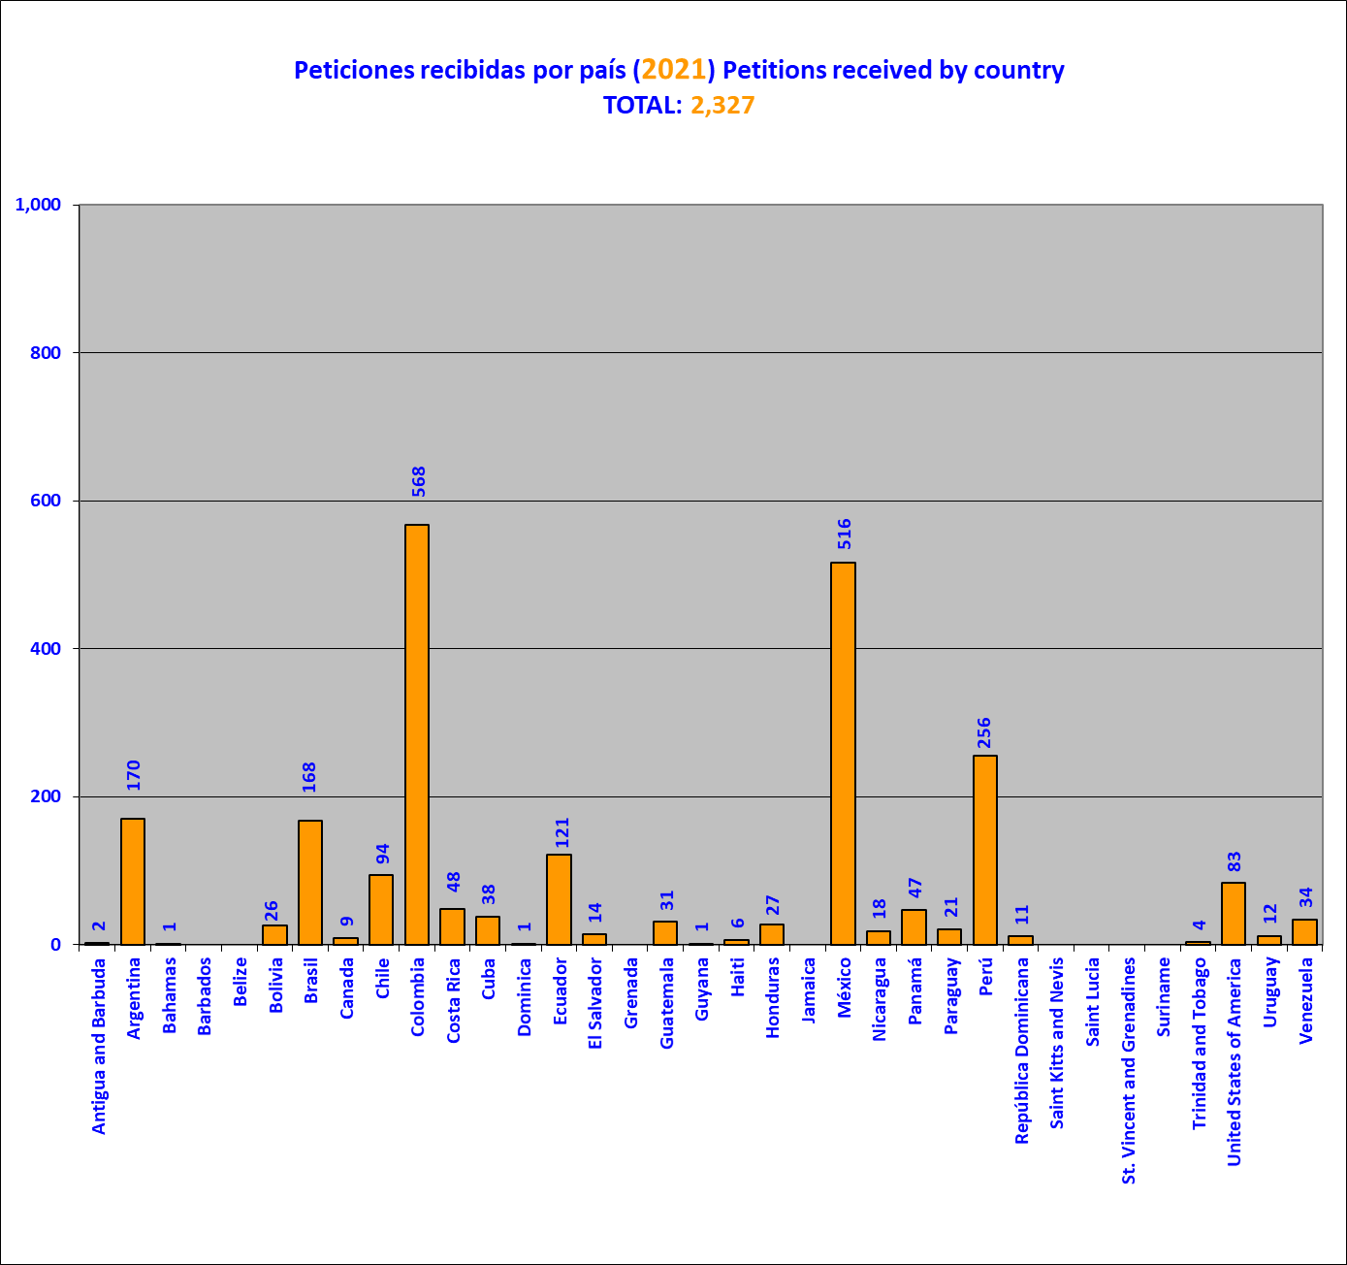
This graph is a snapshot the absolute (gross) number of petitions received at December 31, 2021. As they are examined, they may later be joined or disaggregated. To a lesser, but still possible, extent, new records may be created of petitions lodged in previous years when an involuntary omission of a record is detected, following sufficient checking to confirm it. Likewise, some petitions may be cancelled, if duplicate records are detected. For those reasons, once the examination of petitions lodged in a given year is completed, the number of petitions received may differ slightly from the number originally reported

Petitions received per year

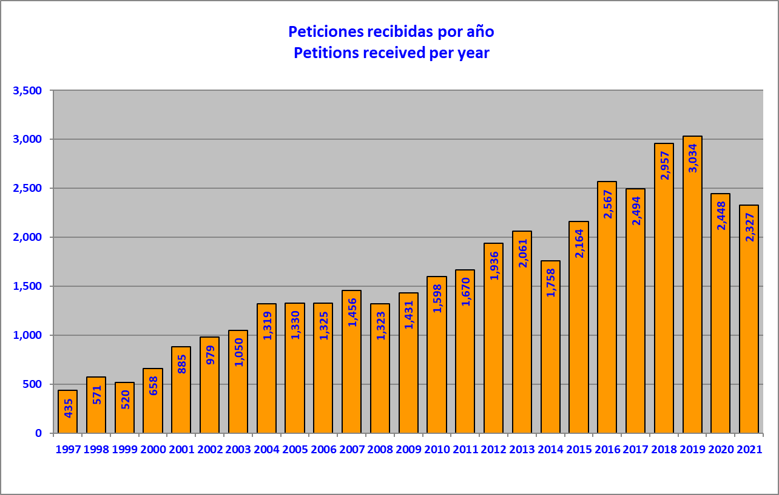

Many of the requests where the requested information is not received are "deactivated" and/or archived. These do not appear in the graphs.

Decisions to open for processing, by country (2021)

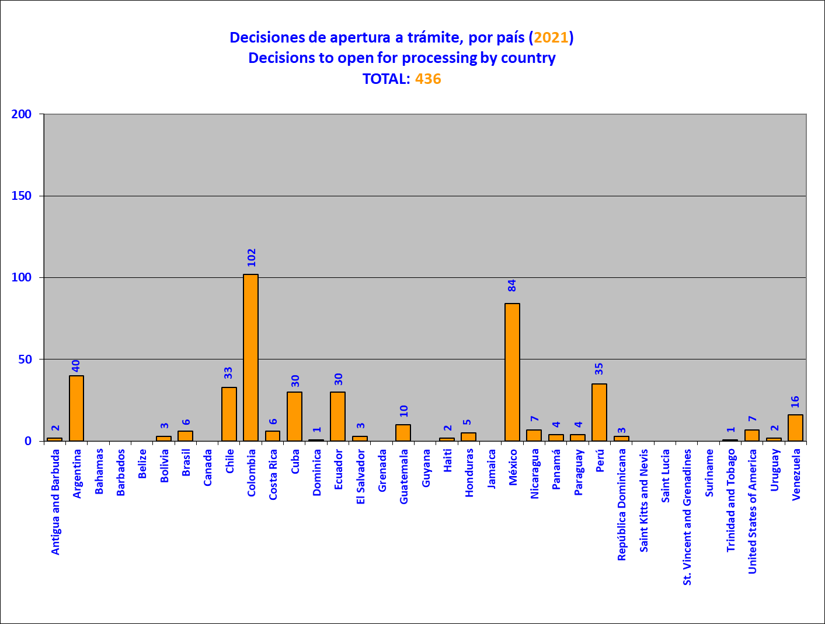

Petitions opened for processing and notified, by country in 2021

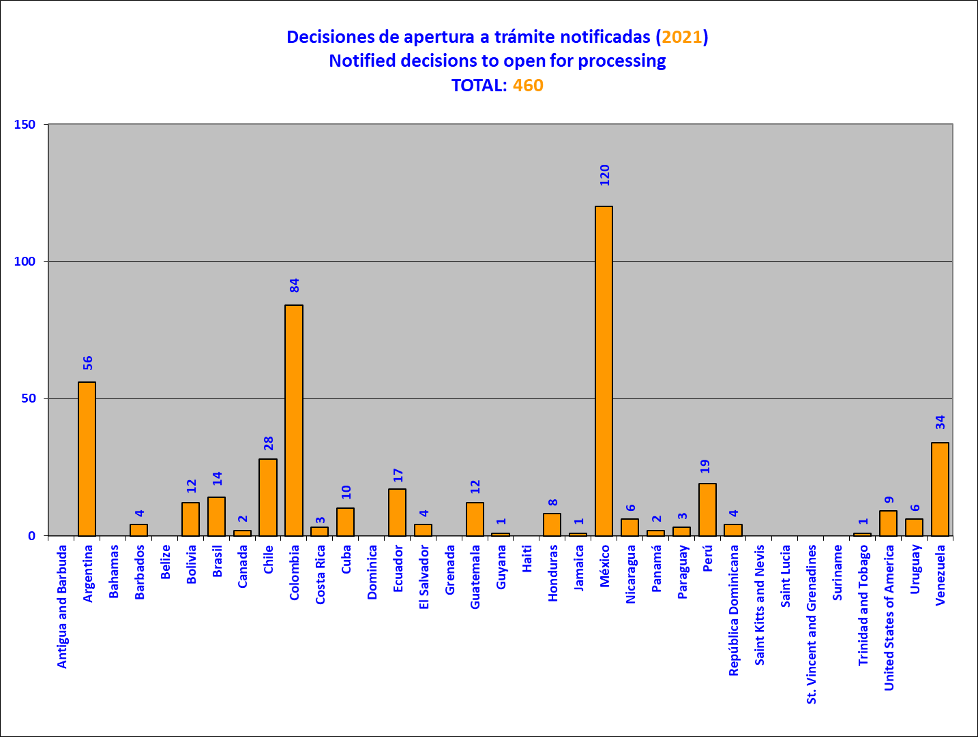
The whole set of petitions reviewed does not correspond only to those received in the year immediately prior to the year covered in the report, because it may include petitions lodged in earlier years and, to a lesser extent, in 2021. Unlike decisions not to open for processing, decisions to open, or begin opening, petitions for processing may not be notified for several years.

Petitions opened for processing, pending notification to the State

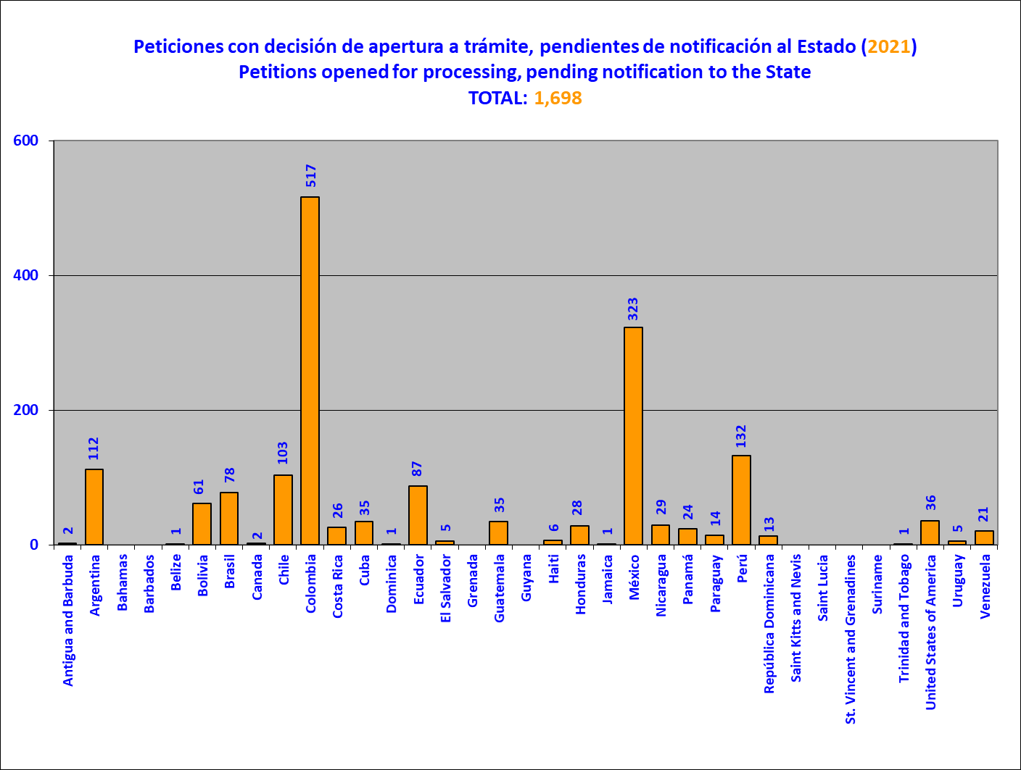
Estas cifras son referenciales, y pueden variar por múltiples circunstancias antes de ser transmitidas al Estado.

Petitions not opened for processing, by country in 2021

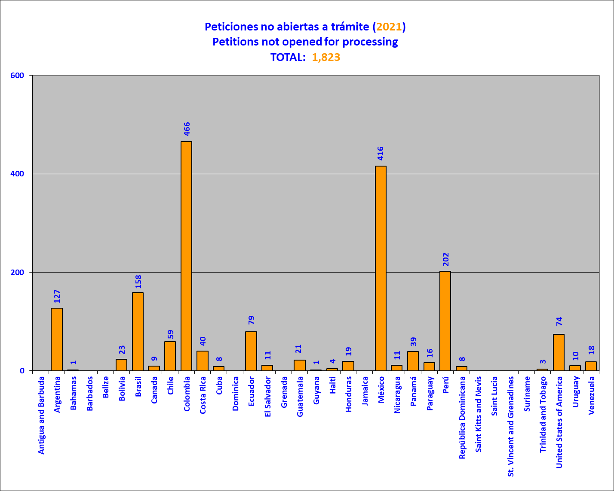

The whole set of petitions reviewed does not correspond only to those received in the year immediately prior to the year covered in the report, because it may include petitions lodged in earlier years.

Decisions taken regarding petitions in the initial review stage in 2021

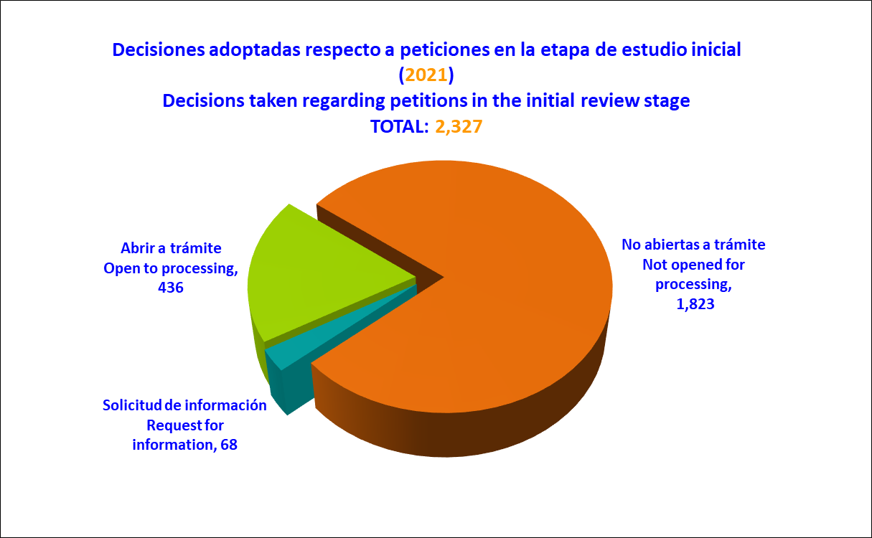

Petitions archived (closed) in 2021, per country on initial review stage

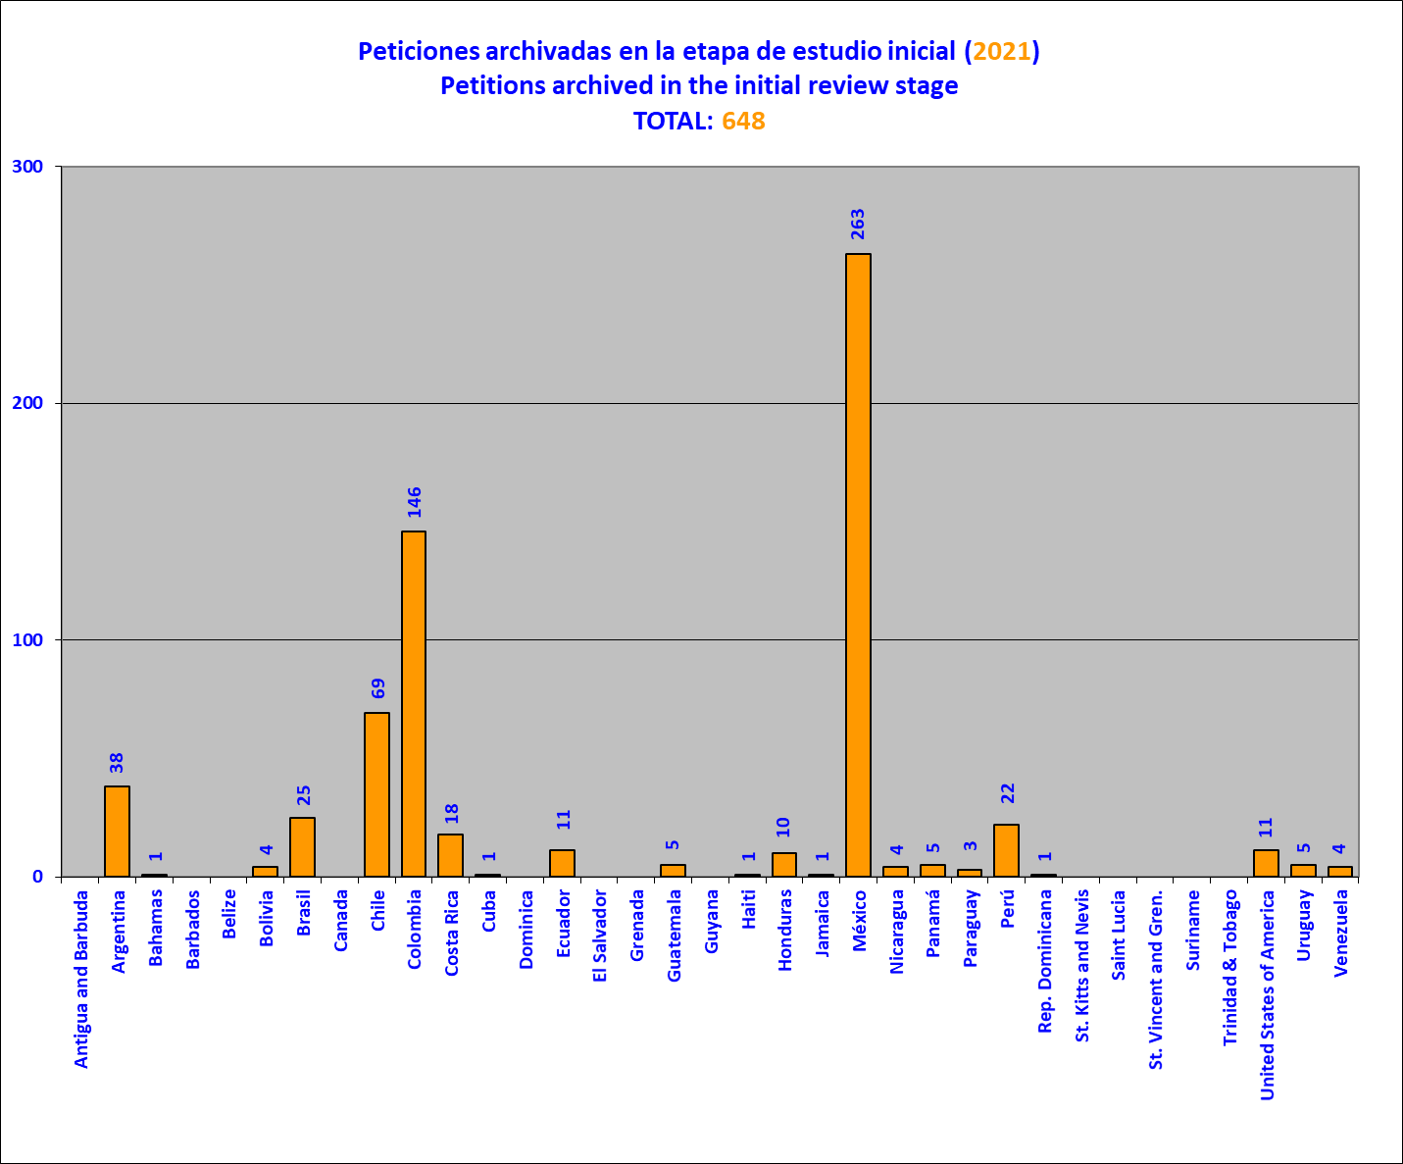

Petitions in admissibility at end of year (2021), by country
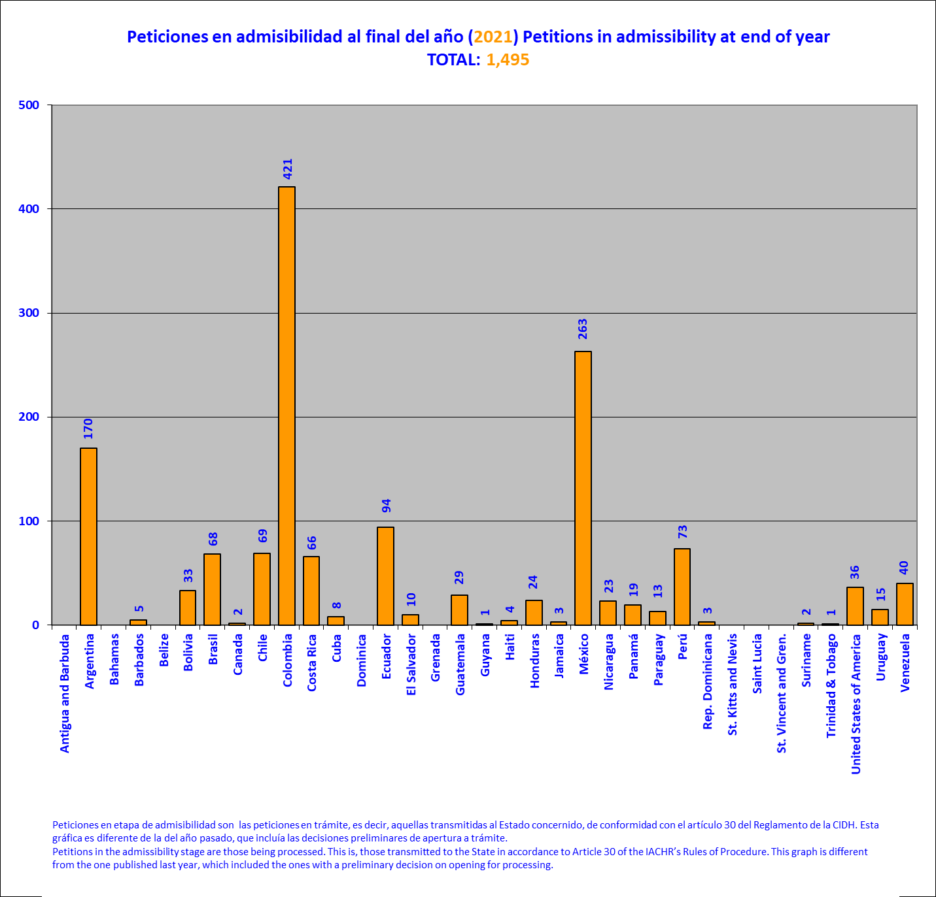
This graph is a snapshot of the current state of the portfolio referred to on December 31, 2021. For the purposes of this report, the expression “petitions in the admissibility stage” refers to pending petitions --that is, those transmitted to the State concerned in accordance with Article 30 of the IACHR Rules of Procedure of the IACHR. Admissibility is the stage in which the IACHR determines whether a petition satisfies the requirements established in Articles 46 and 47 of the American Convention and / or 34 of the IACHR Rules of Procedure, according to the procedure established in Article 48 of the American Convention and / or Articles 30 and 36 of the IACHR Rules of Procedure.

Cases in merits stage at end-of 2021, by country

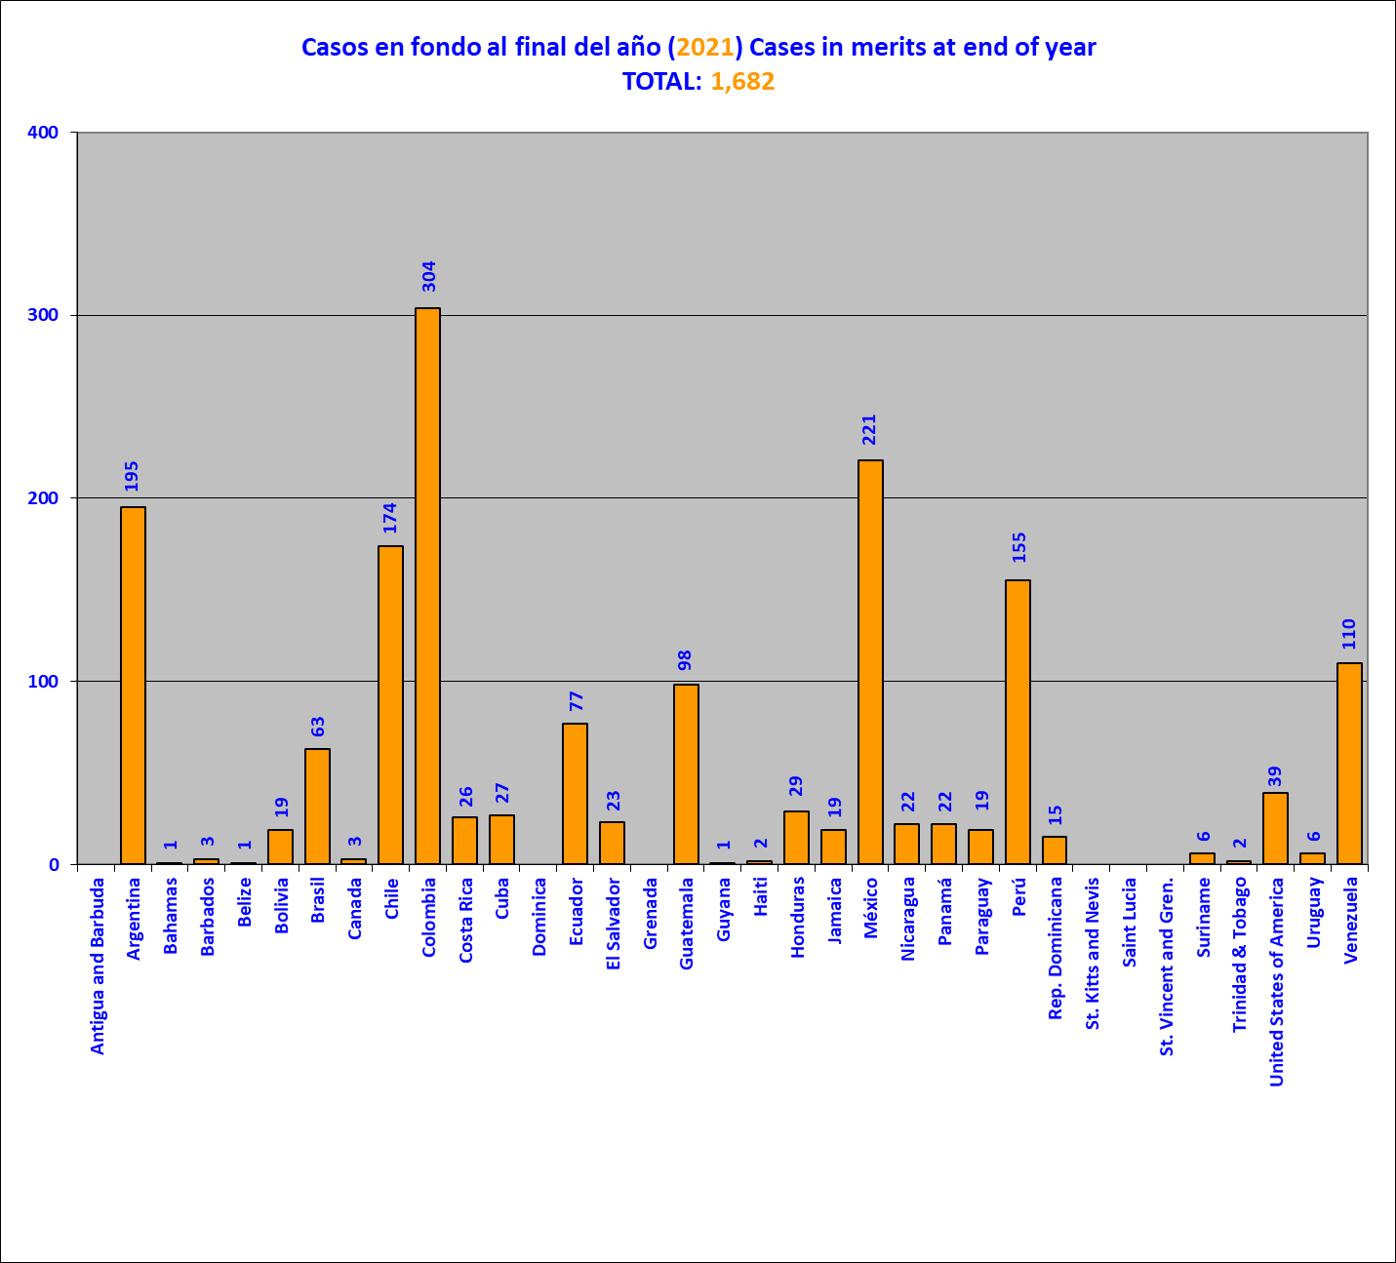

This graph is a snapshot of the state of the above-mentioned portfolio at December 31, 2021. The merits stage is that at which the IACHR decides on the merits of the case pursuant to the procedure established in Articles 48 and 50 of the American Convention and/or Articles 37 to 39, 43, and 44 of the IACHR Rules of Procedure.

Petitions and cases in admissibility and merits (2021)

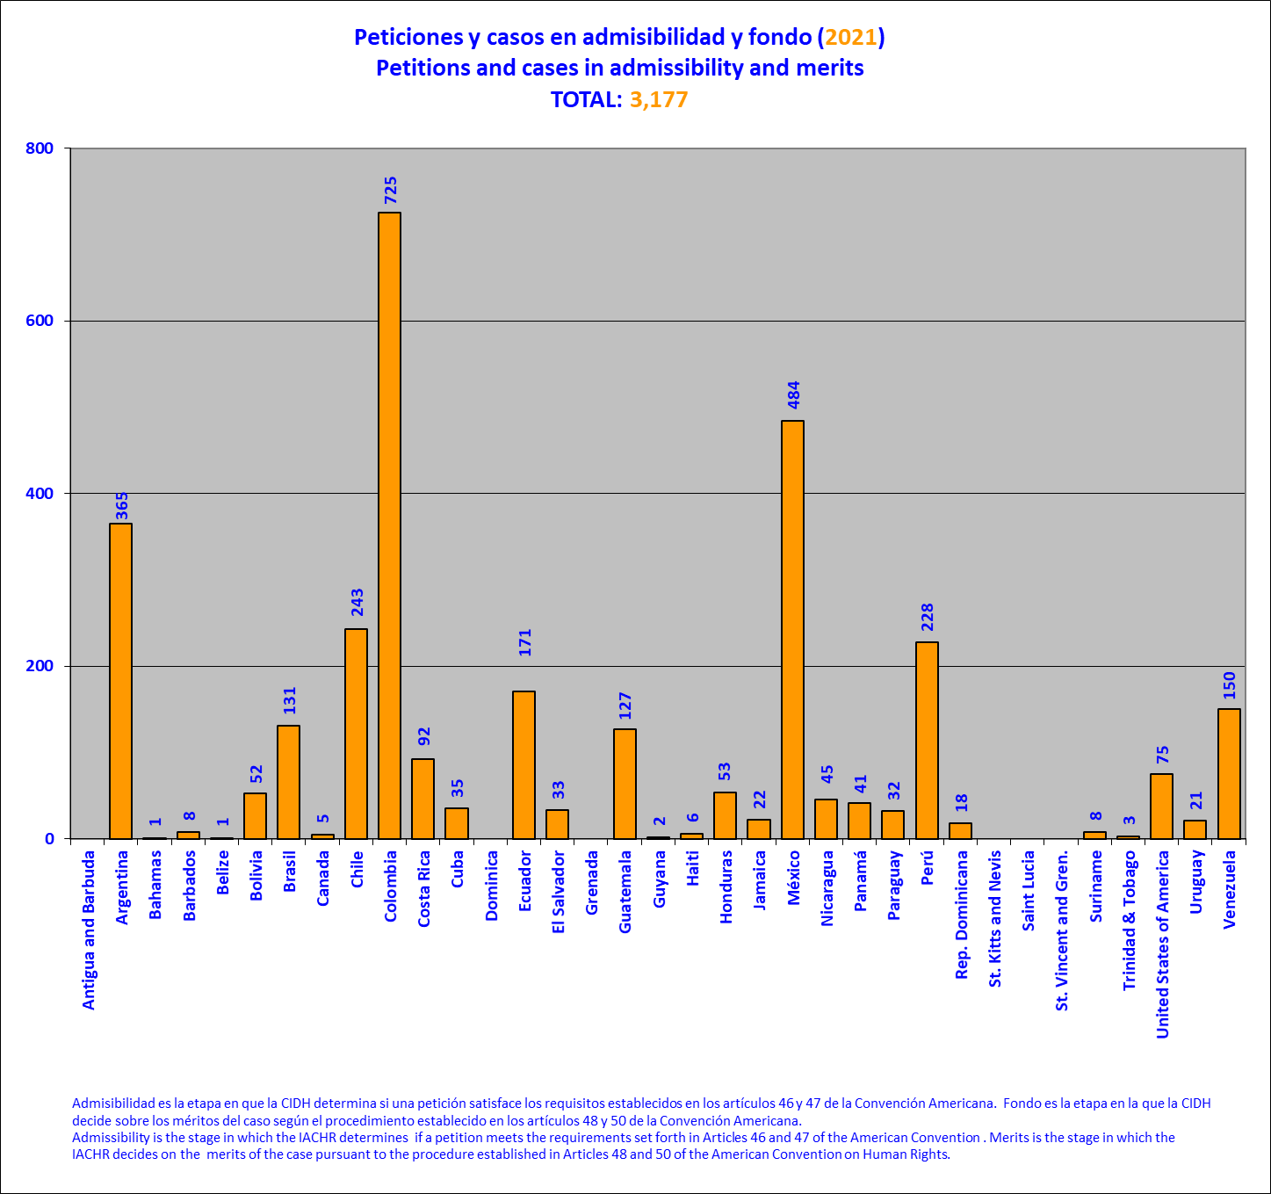

Hearings on cases before the IACHR by country (2021)

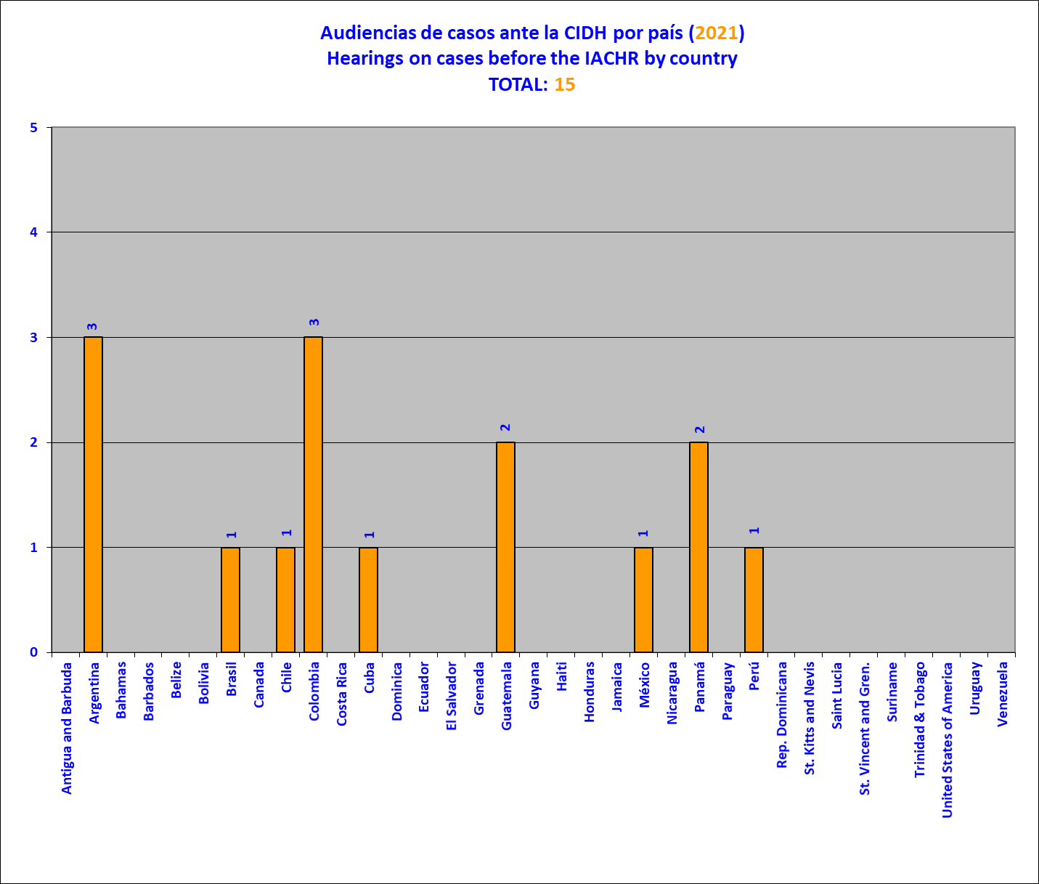

Petitions and cases in friendly settlement procedure by country (2021)

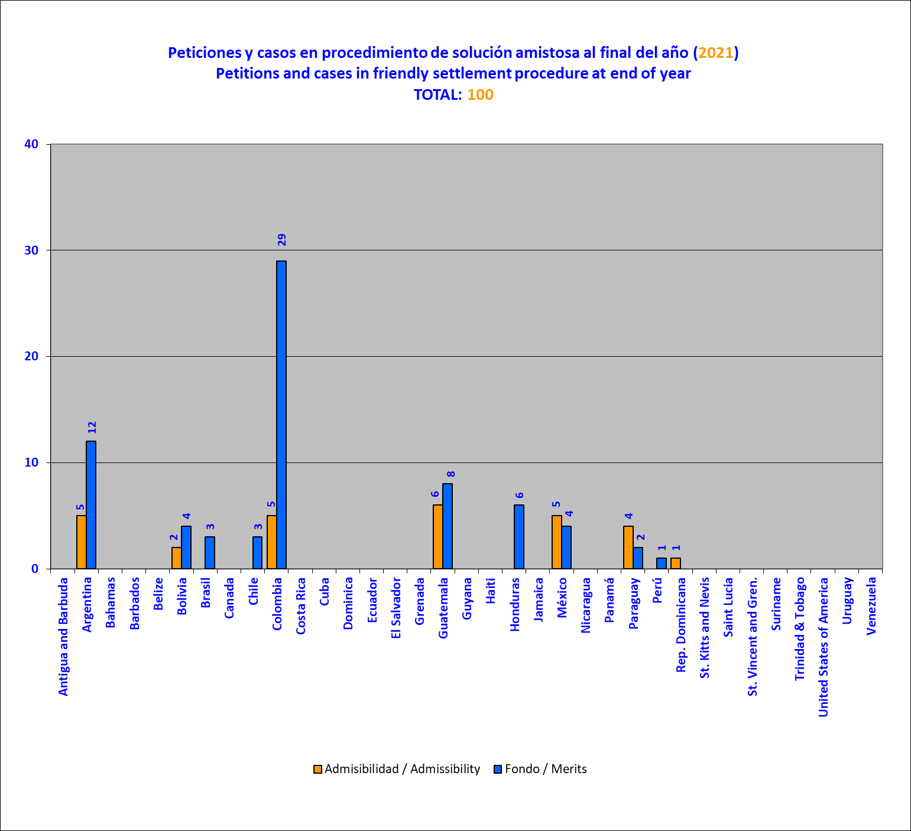

Case docket (admissibility and merits) at the end of each year

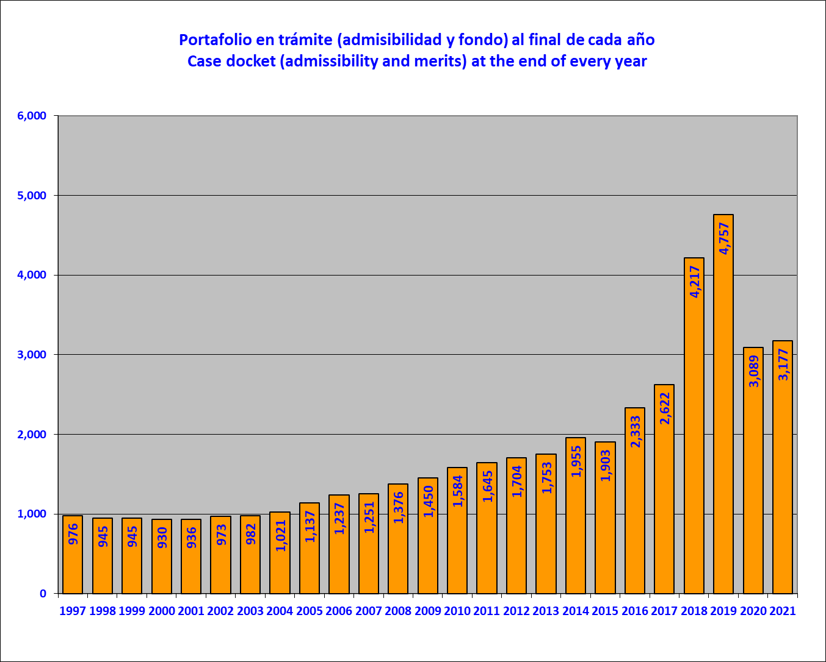

Cases archived (closed), per year

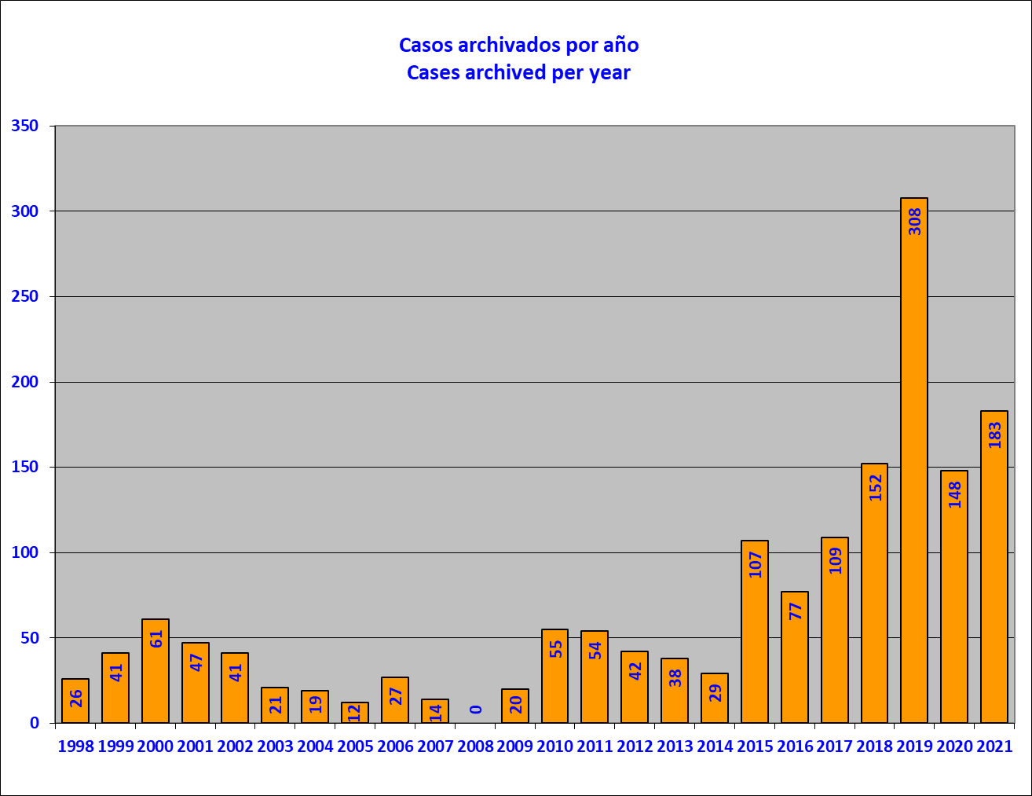

Cases archived (closed) (2021), by country

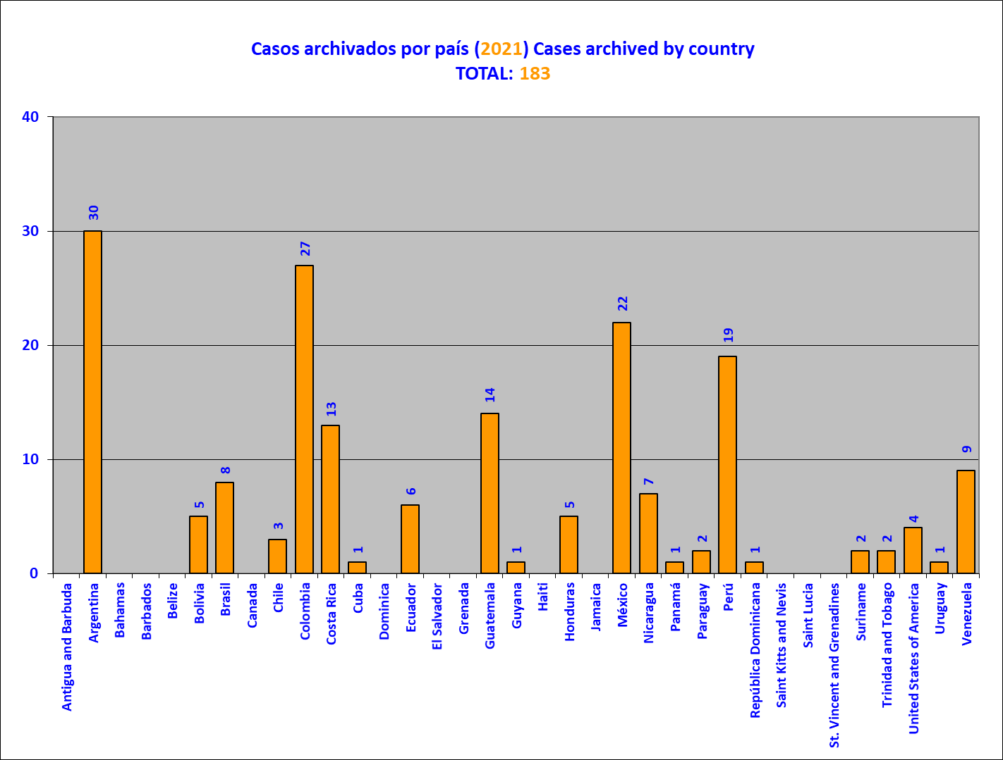

Reports on admissibility adopted per year

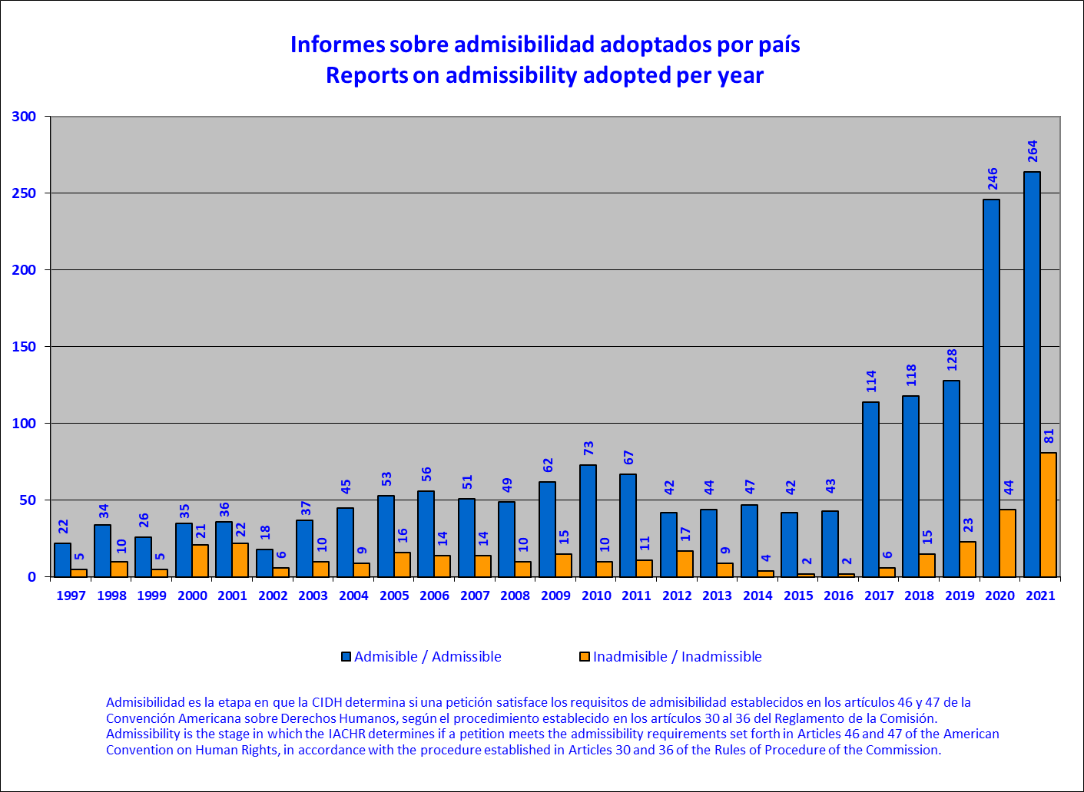

Reports on admissibility adopted, by country (2021)

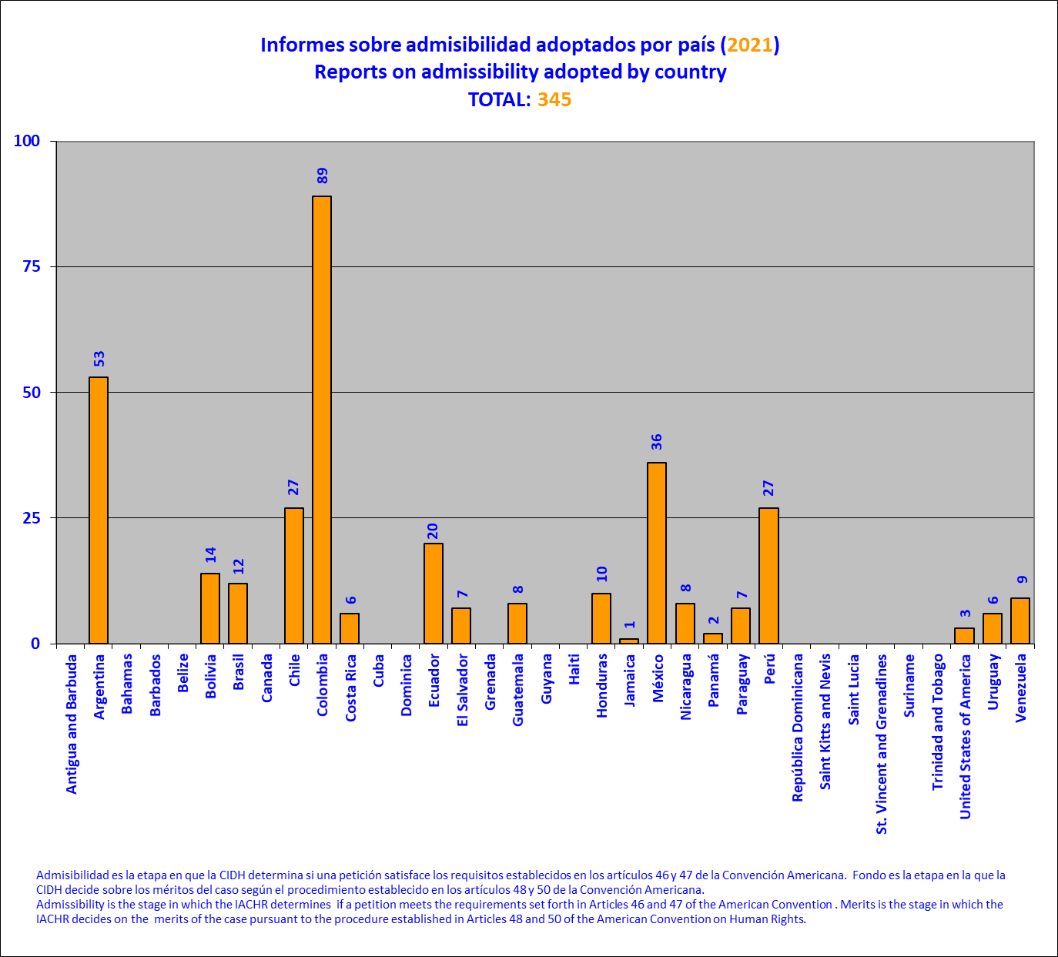

Application of Resolution 1/16, by year

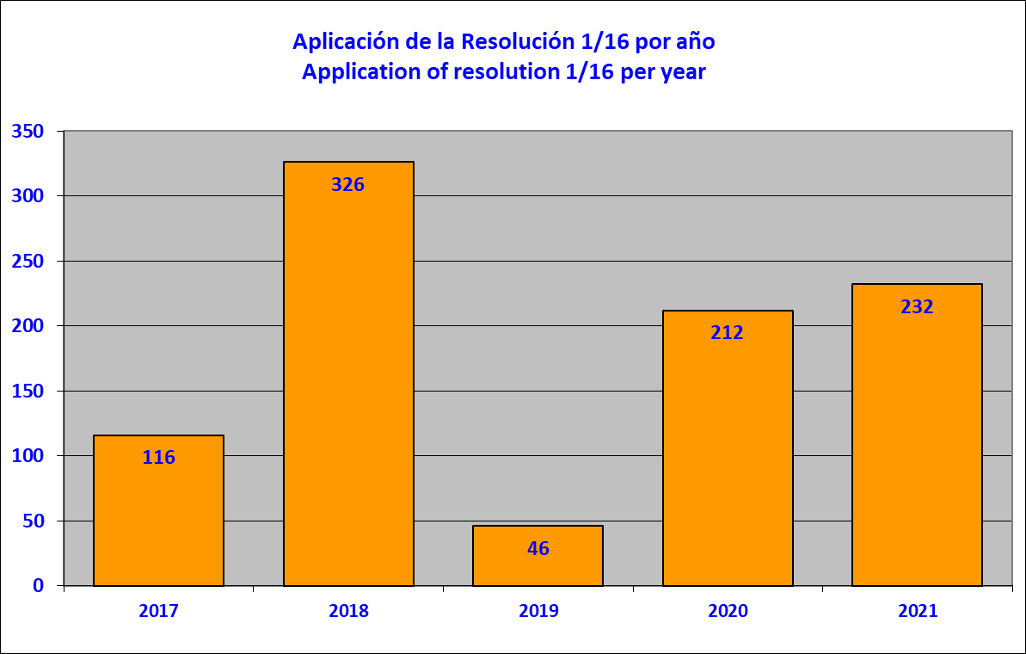

This chart shows the number of petitions at the admissibility stage in which both parties were notified of the application of Article 36.3 of the Rules of Procedure, as envisaged in Resolution 1/16 (adopted on October 18, 2016), by country, during 2021. Application of Resolution 1/16 to a petition at the admissibility stage occurs when one of the exceptional circumstances envisaged in the Resolution is identified and, as a result, treatment of admissibility is deferred until the debate and decision on the merits.

Application of Resolution 1/16, by country (2021)

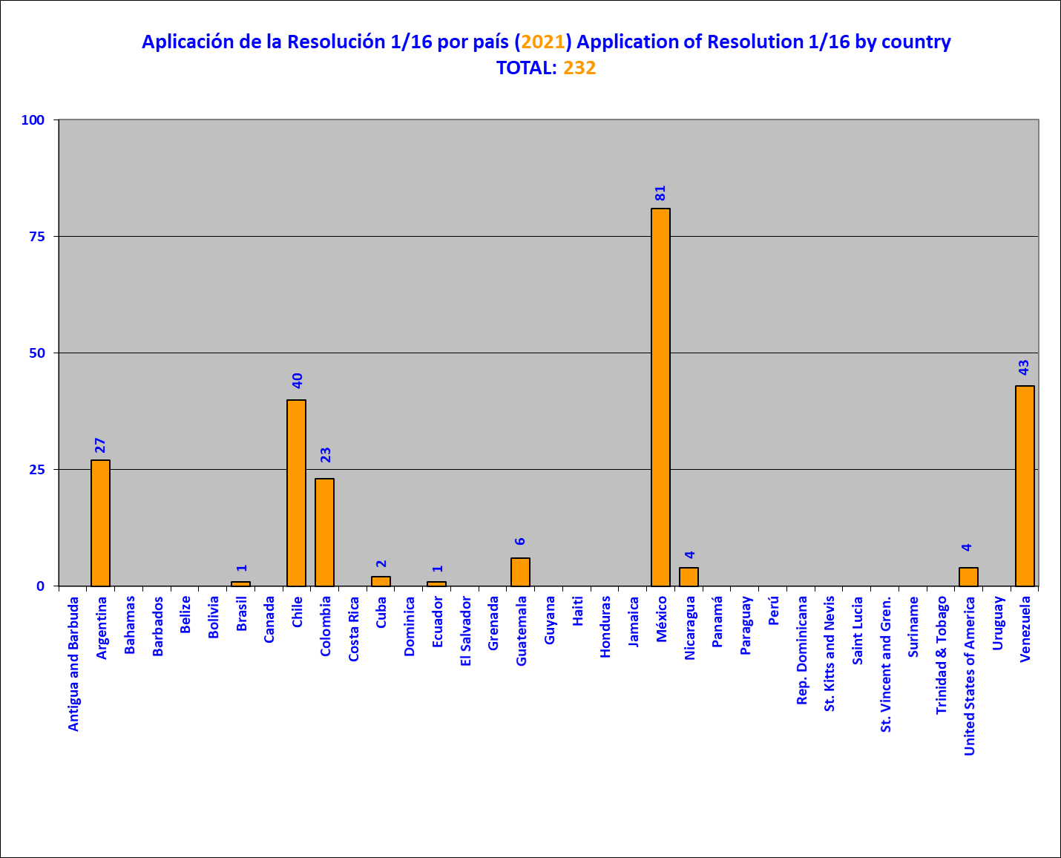

Application of Resolution 1/16 by category

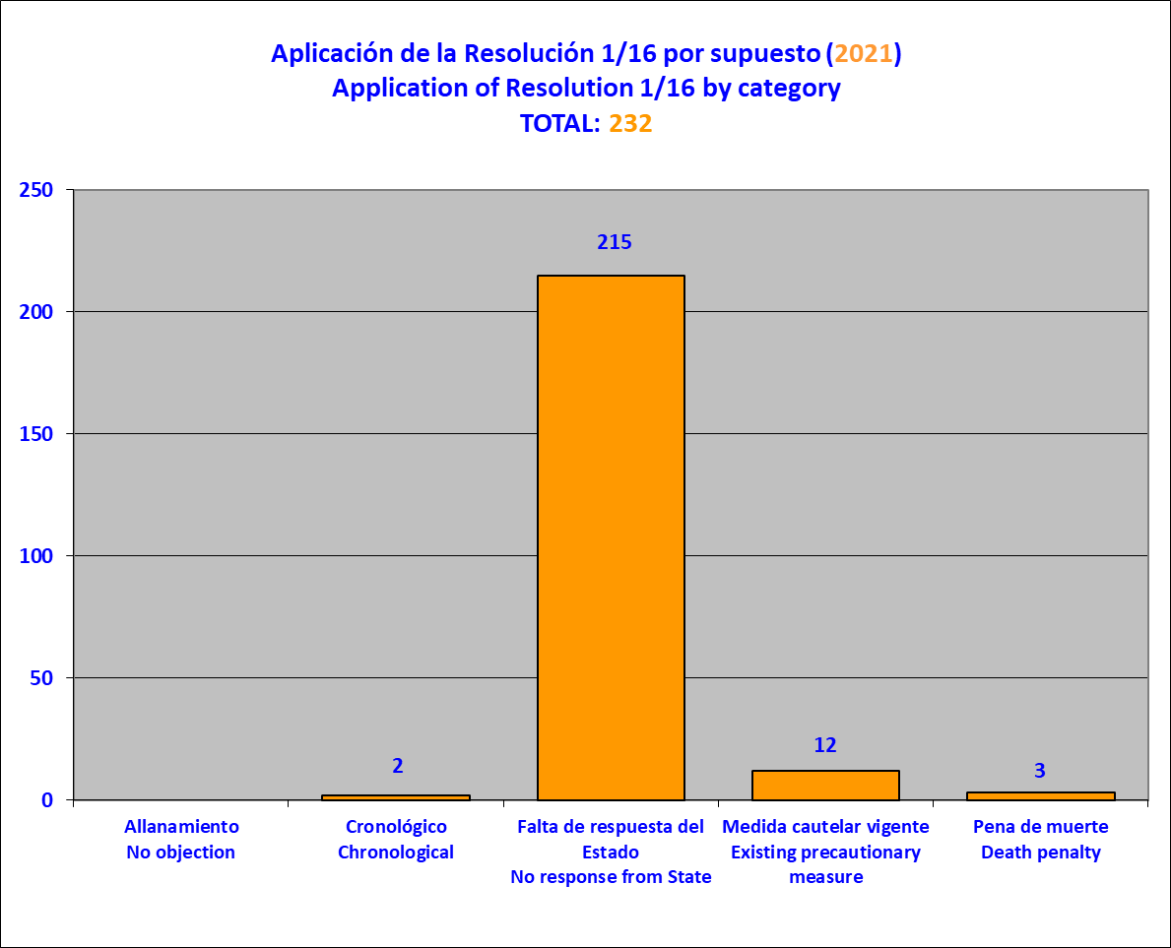

This chart shows the number of petitions at the admissibility stage in which both parties were notified of the application of Article 36.3 of the Rules of Procedure, as envisaged in Resolution 1/16 (adopted on October 18, 2016), by circumstance, during 2021. Application of Resolution 1/16 to a petition at the admissibility stage occurs when one of the exceptional circumstances envisaged in the Resolution is identified and, as a result, treatment of admissibility is deferred until the debate and decision on the merits.

Reports on Friendly Settlement published per year

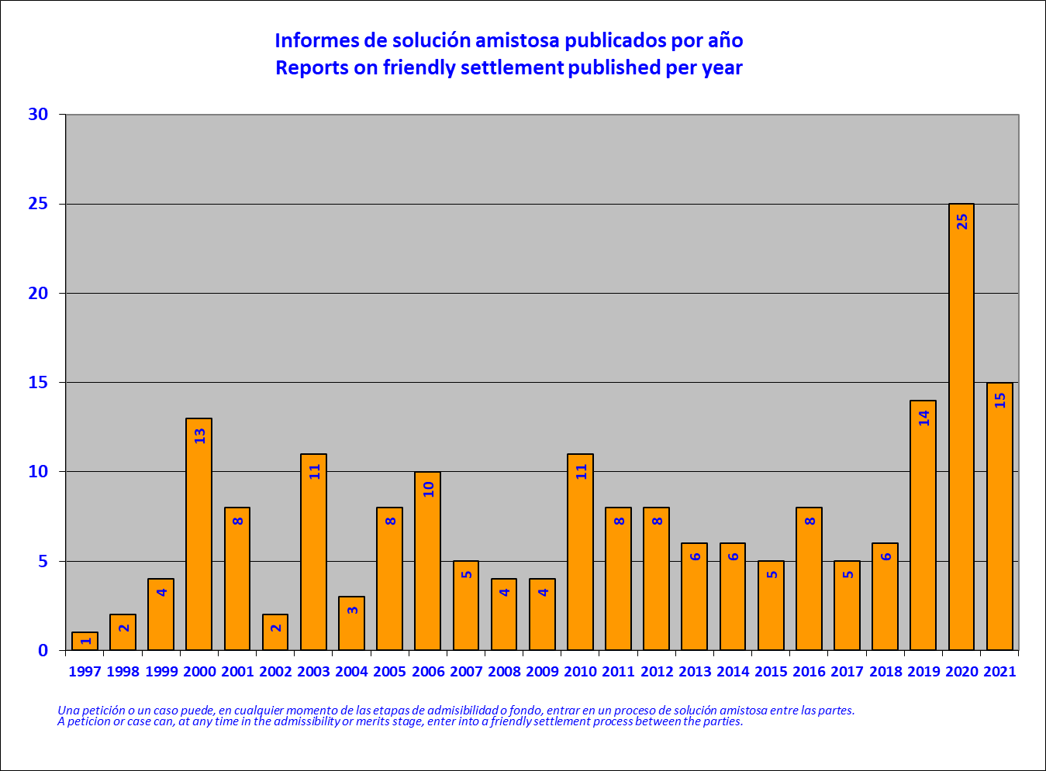

Reports on Friendly Settlement published by country

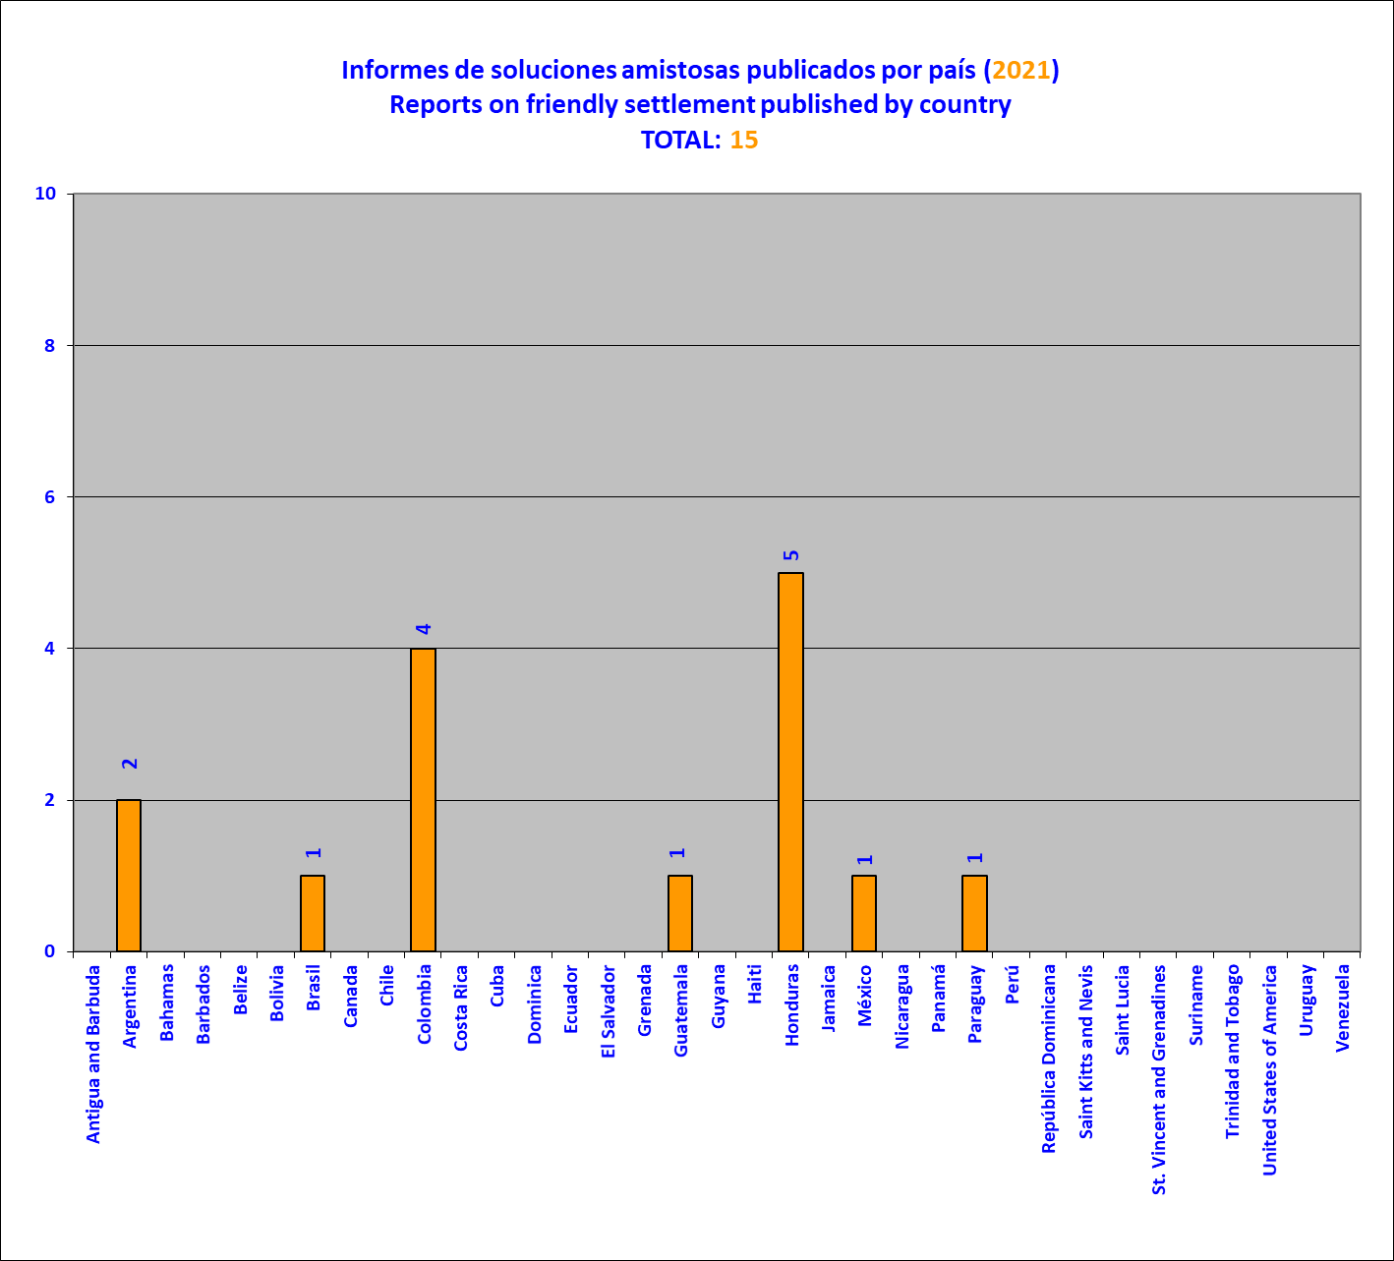

Friendly Settlement agreements signed by country (2021)

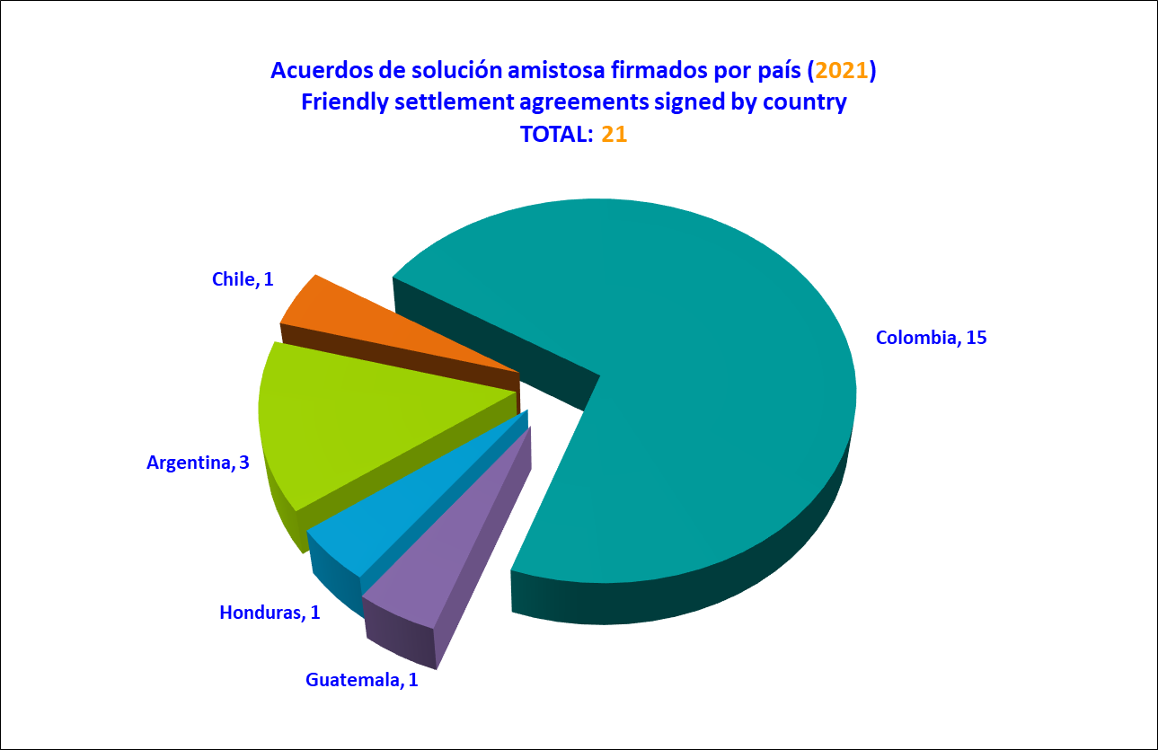

Reports on merits approved per year

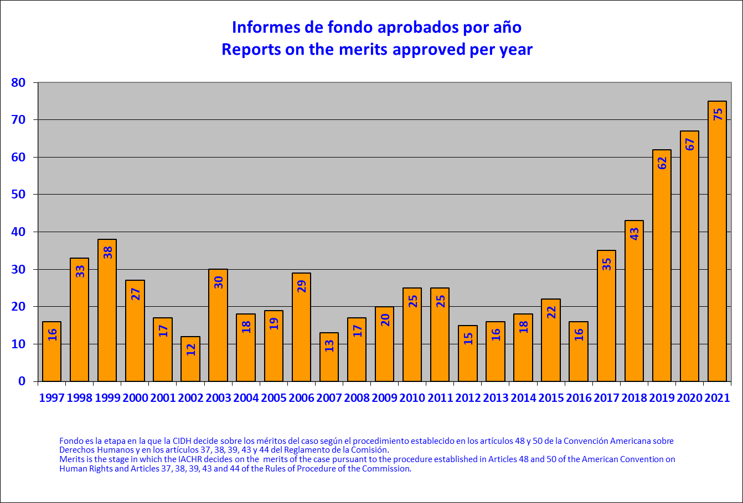

Reports on merits adopted by country (2021)

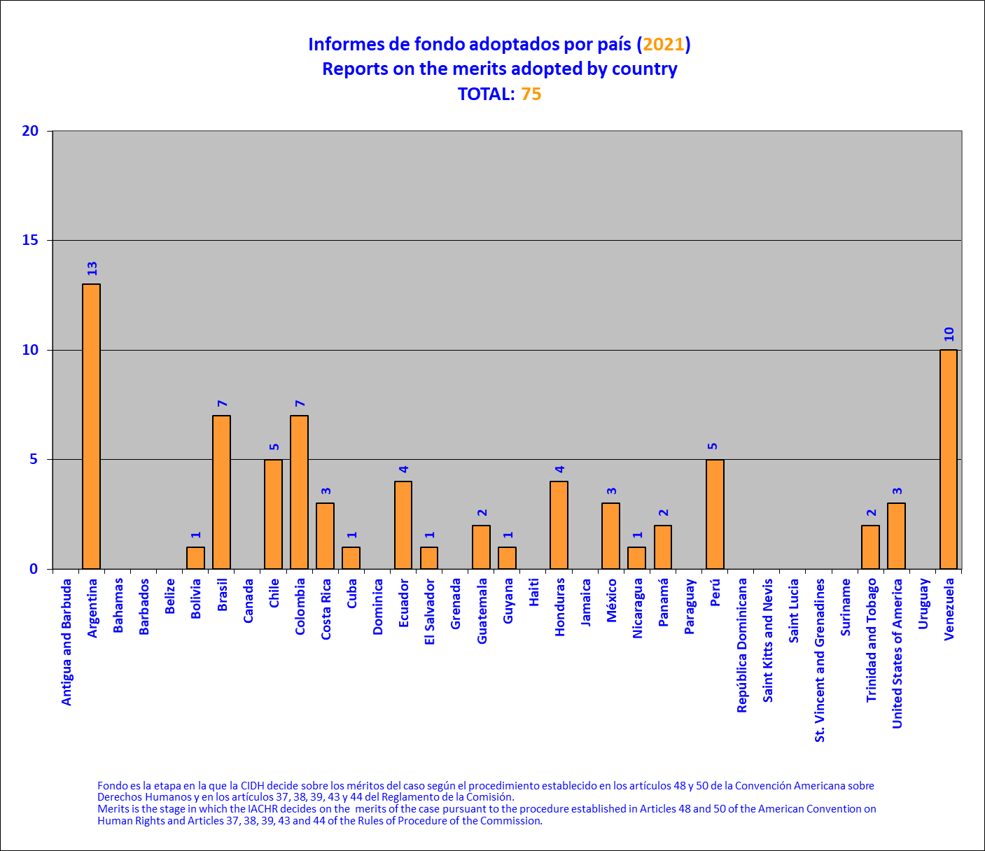

Reports on the merits published by country (2021)

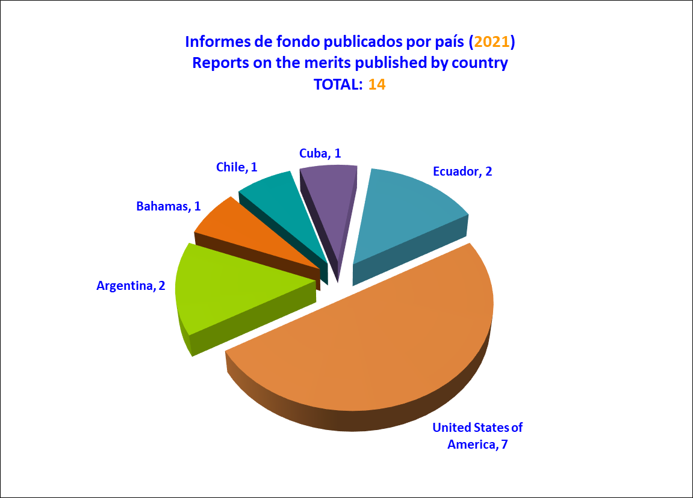

Hearings before the Inter-American court of Human Rights by country

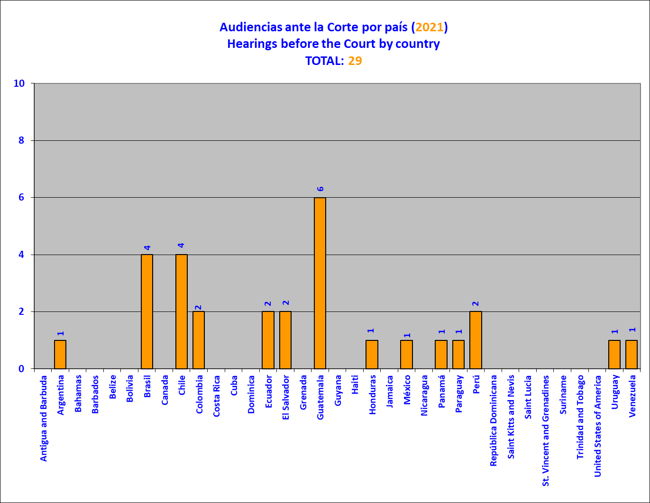

Cases submitted to the Inter-American Court of Human Rights per year

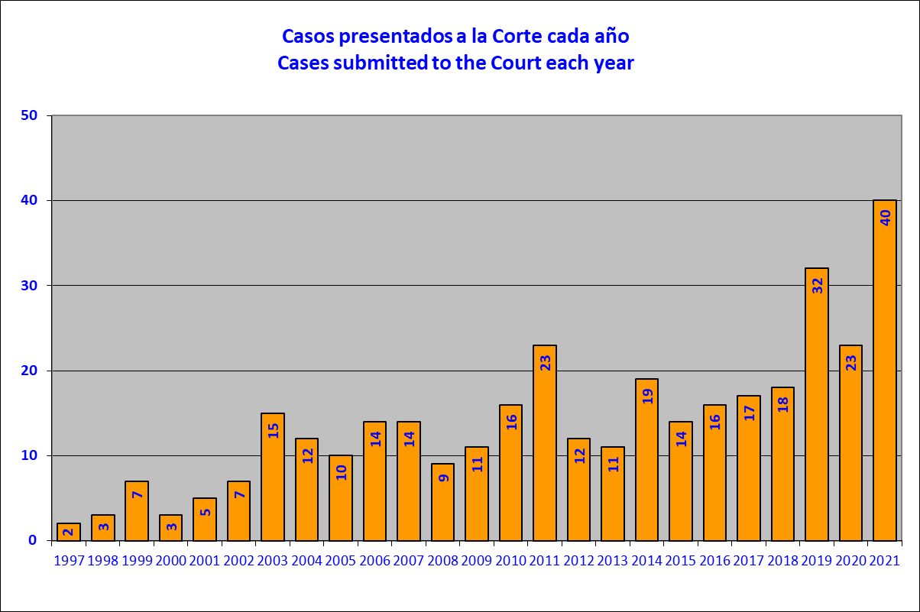

Cases submitted to the Inter-American Court of Human Rights by country (2021)

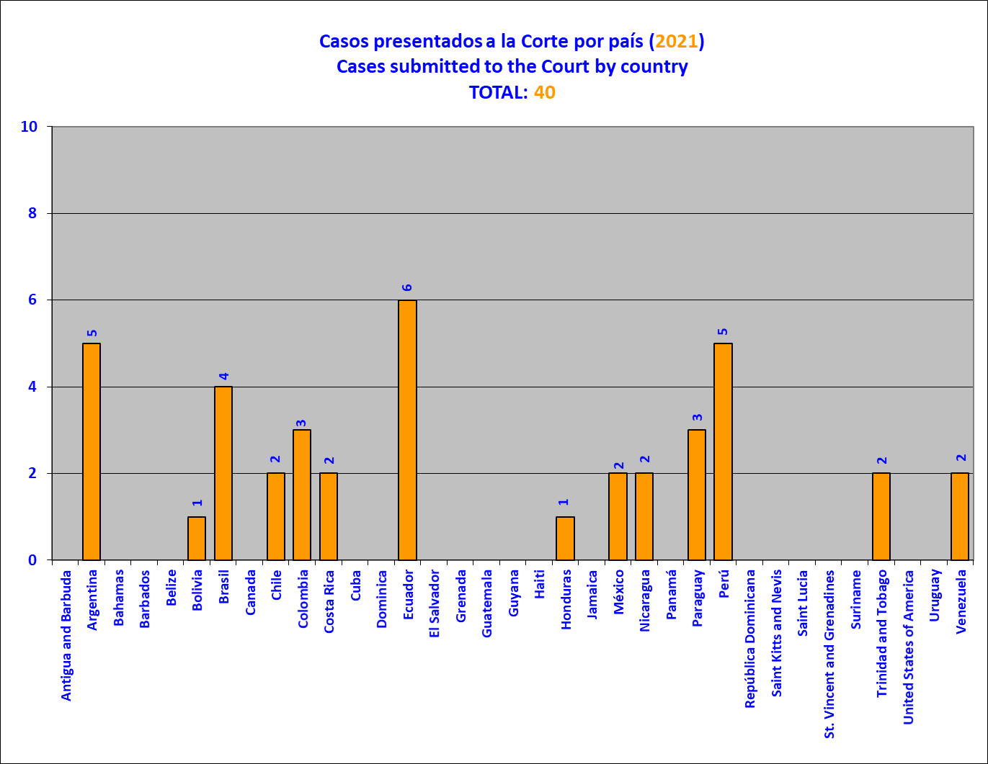

Requests for precautionary measures received per year

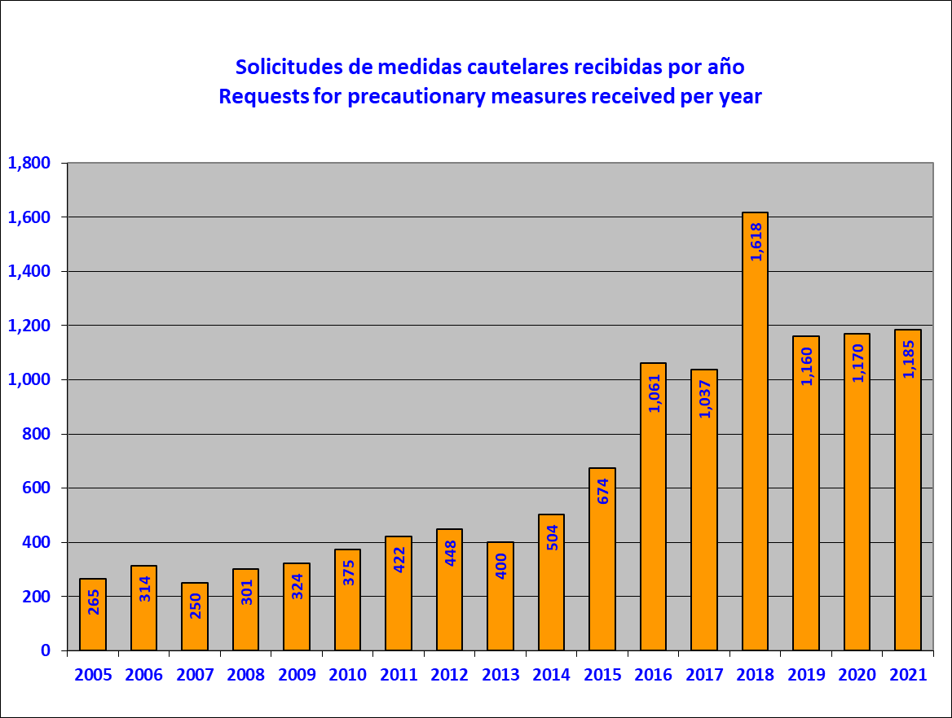

Requests for precautionary measures received by country (2021)

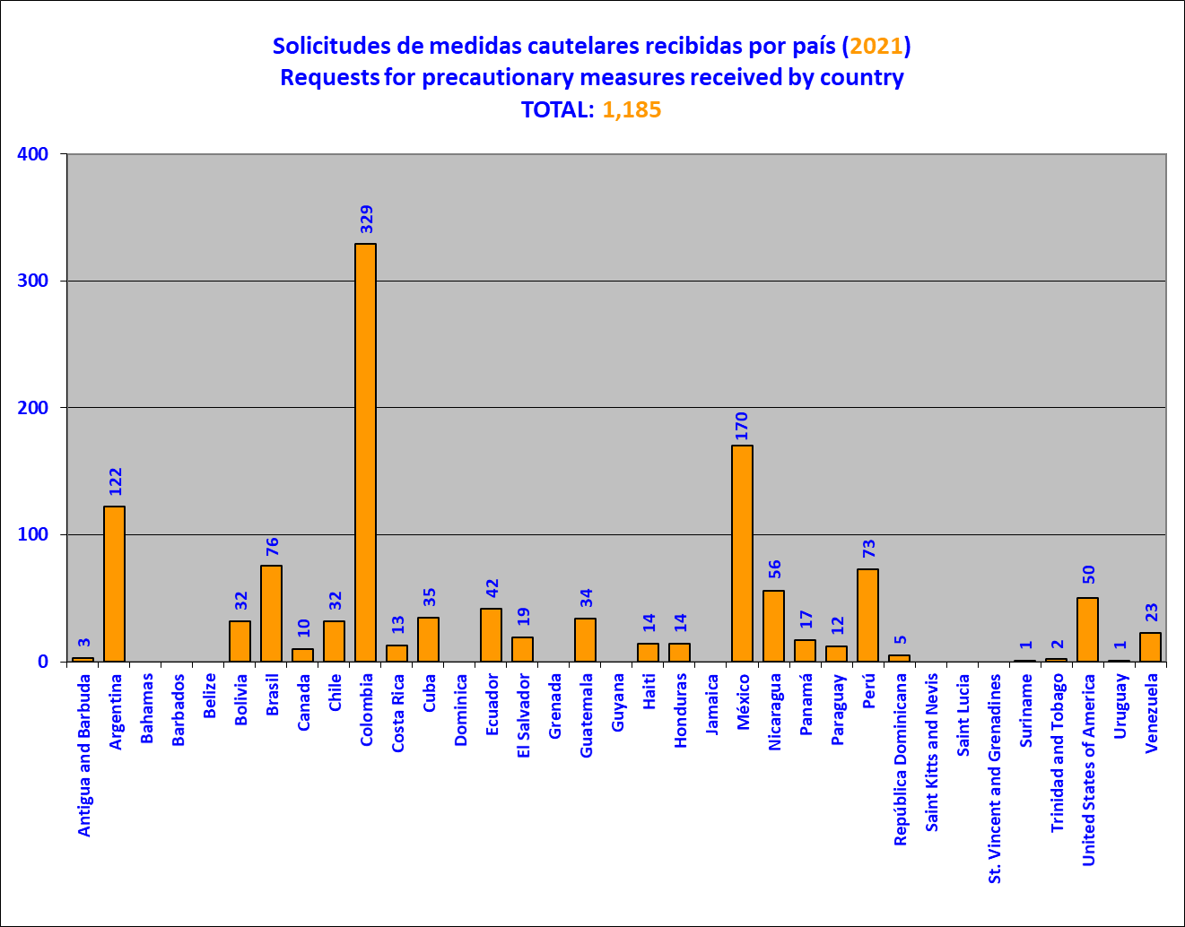

Precautionary measures granted or extended per year

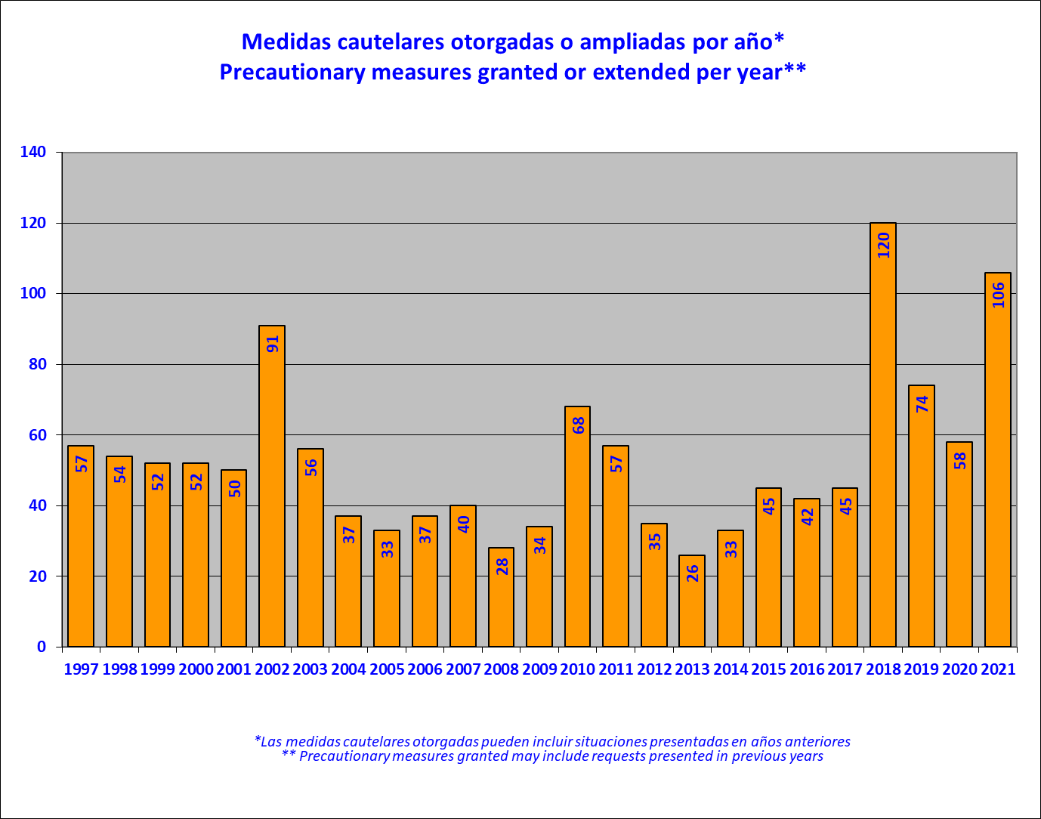

Precautionary measures granted or extended by country (2021)

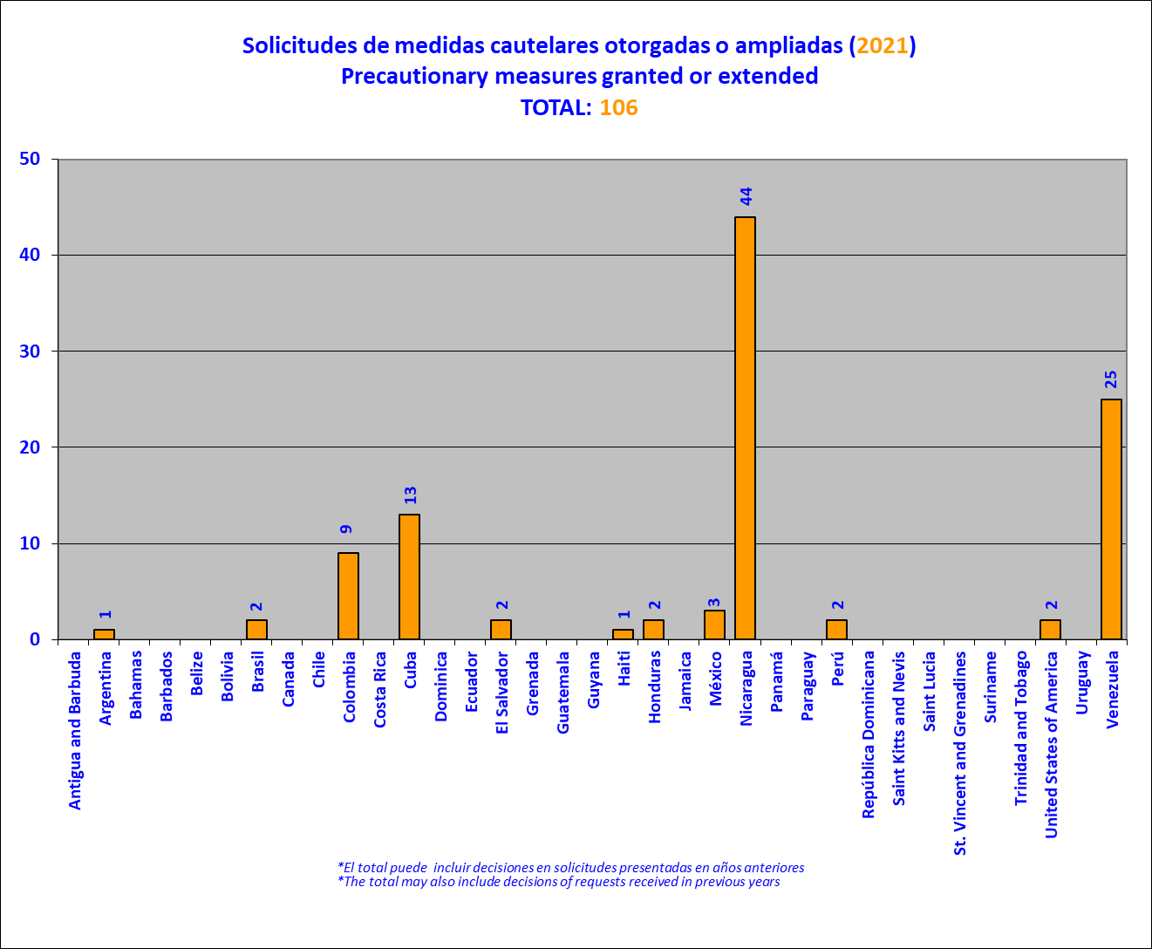

Granting or extension time

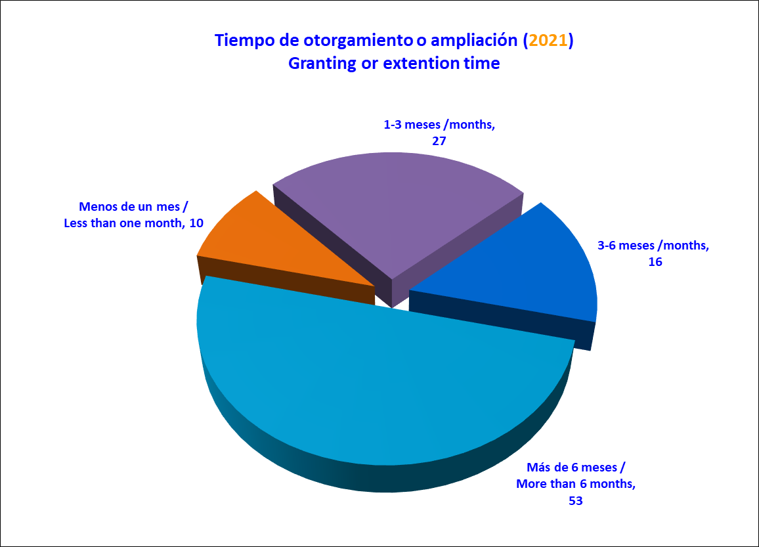

Precautionary measures lifted by country (2021)

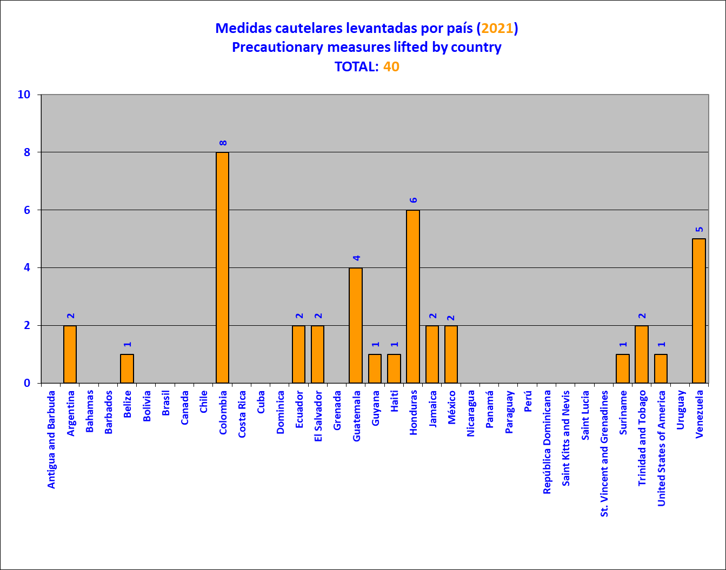

Thematic reports approved per year

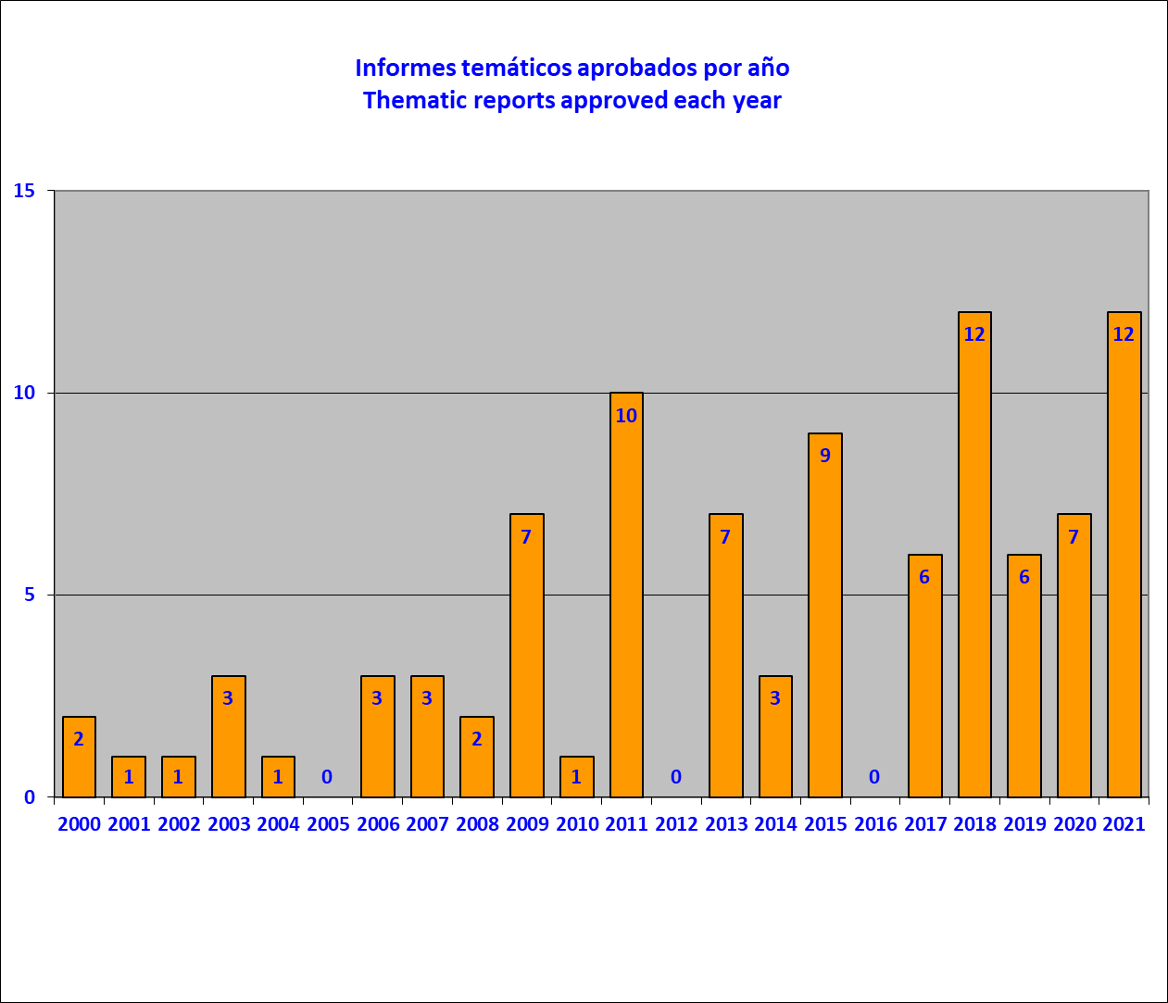

In 2021 the IACHR approved 10 thematic reports and 2 country reports. The thematic reported of the IACHR include other documents and studies.

It should be noted that, in accordance with the provisions of Article 17.2.a of the Commission's Rules of Procedure, Commissioner Esmeralda Arosemena de Troitiño, a national of Panama, did not participate in the debate or in the conclusions of the reports or precautionary measures referring to that country; nor did Commissioners Joel Hernández García in the case of Mexico; Antonia Urrejola Noguera in the case of Chile; Margarette May Macaulay, in the case of Jamaica; Julissa Mantilla in the case of Peru; Stuardo Ralon in the case of Guatemala; or Flávia Piovesan in the case of Brazil.
Cases 11.545 Martha Saire of Honduras; and friendly settlement agreements approved by Reports No. 20/07, 71/07, 20/08 and 22/11.
In this regard, see: Canal CIDH (IACHR Channel) website. Available at: https://www.canalcidh.org/
In this regard see, IACHR Canal. Graciela Ramos Rocha's struggle for justice and decent housing for her family.
In this regard see, IACHR Canal. A peasant woman and mother of seven children, María Mamérita Mestanza was forced to have her tubes tied. Died of postoperative complications one month later.
In this regard see, IACHR Canal. "We have a right to housing. We are not trash."
On September 23, 2021, Commissioner Julissa Mantilla, IACHR Rapporteur for Argentina, participated in the signing of the agreement and acknowledgement of responsibility regarding Petition P-1256-05 Ivana Emilce Rosales of Argentina. Available at: https://www.youtube.com/watch?v=u24ONB4Mhys
On August 3, 2021, Commissioner Joel Hernandez, IACHR Rapporteur for Chile, participated in the signing ceremony of the friendly settlement agreement in Case 12.956 F.S. de Chile.
Commissioner Antonia Urrejola participated in acts of acknowledgment of responsibility in cases in Colombia in her capacity as IACHR Presiding Commissioner and Rapporteur for the country, on the following dates and regarding the following cases: on February 25, 2021, in Case 13,171 Luis Argemiro Gómez; on May 18, 2021, in Case 13.571 Carlos Mario Muñoz Gómez; on August 4, 2021, in Case 13.226 Dora Inés Meneses on October 22, 2021, in Case 13.758, Franklin Bustamante Restrepo; on November 5, 2021, in Petition P-514- 11, Luis Hernando Morera Garzón; and on November 16, 2021, in Petition P-535-17, Luis Gerardo Bermúdez. Available at: ANDJE's YouTube. Also, on November 9, 2021, the Assistant Executive Secretary for the Area of Petitions and Cases of the Executive Secretariat of the IACHR, Marisol Blanchard, participated in a private meeting to acknowledge responsibility with regard to Petition P- 1391-15 Mario Cardona of Colombia.
In this respect, see IACHR, Report No. 42/21, Case 12,961E. Friendly Settlement. Ecar Fernando Zavala Valladares. Honduras. March 20, 2021. See also, IACHR, Report No. 205/21, Case 12,961 J. Friendly Settlement. Faustino Garcia Cárdenas and one other. Honduras. September 4, 2021.
In this respect see, Petition 242-03, Report No. 160/10, Inocencia Luca Pegoraro (Argentina); Case 13,011, Report No. 197/20, Graciela Ramos Rocha and family (Argentina); Petition 245-03, Report No. 39/21, Walter Mauro Yáñez (Argentina); Case 12,957, Report No. 167/18, Luis Bolívar Hernández Peñaherrera (Ecuador); Case 12,961E, Report No. 42/21, Ecar Fernando Zavala Valladares et al. (Honduras); Case 12,961J, Report No. 205/21, Faustino Garcia Cárdenas and one other (Honduras); Case 12,960, Report No. 269/21, Ronald Jared Martínez (Honduras); Case 12,847, Report No. 16/16, Vicenta Sanchez Valdivieso (Mexico); Case 12,627, Report No. 92/17, Maria Nicolasa Garcia Reynoso (Mexico); Case 12,915, Report No. 2/20, Angel Díaz Cruz et al. (Mexico); and Case 12,374, Report No. 85/20, Jorge Enrique Patiño Palacios (Paraguay).
In this respect see Case 12,277, Report No. 136/21, Fazenda Ubá (Brazil); Petition 595-09, Report No. 84/20, Jorge Alberto Montes Gallego and family (Colombia); Case 13,319, Report No. 213/20, William Fernández Becerra and family (Colombia); Case 13,642, Report No. 41/21, Edgar José Sánchez Duarte and family (Colombia); Case 13,171, Report No. 115/21, Luis Argemiro Gómez Atehortua (Colombia); Case 13,571, Report 336/21, Carlos Mario Muñoz Gómez (Colombia); Case 13,758, Report 337/21, Franklin Bustamante Restrepo (Colombia); Case 12,737, Report No. 114/21, Carlos Raúl Morales Catalan (Guatemala); Case 11,562, Report No. 40/21, Dixie Miguel Urbina Rosales (Honduras); Case 11,545, Report No. 204/21, Martha María Saire (Honduras); Case 12,610, Report No. 208/21, Faustino Jiménez Álvarez (Mexico); and Case 12,330, Report No. 206/21, Marcelino Gómez and one other (Paraguay).
The Commission reserves the amounts of economic compensation agreed upon according to the provisions of the ninth clause of the friendly settlement agreement.
In this respect, see press releases of the IACHR on friendly settlements in 2021: IACHR Welcomes Signing of Friendly Settlement for Case 13.171 Luis Argemiro Gómez Atehortua, concerning Colombia, January 29, 2021; IACHR Takes Part in Event Where the State of Colombia Acknowledges Its Responsibility for Case 13.171—Luis Argemiro Gómez Atehortua, February 26, 2021; IACHR Welcomes Full Compliance with 10 Friendly Settlement Agreements in 2020, March 9, 2021; IACHR Congratulates State of Mexico on Full Compliance with Friendly Settlement Agreement on Petition P-1275-04A, Juan Luis Rivera Matus, March 10, 2021; IACHR Congratulates State of Mexico on Full Compliance with the Friendly Settlement Agreement Regarding José Antonio Bolaños Juárez, March 11, 2021; IACHR Congratulates the State of Guatemala for its Full Compliance with the Friendly Settlement Agreement Concerning Fredy Rolando Hernández Rodríguez, March 15, 2021; IACHR Congratulates the State of Colombia on Full Compliance with Friendly Settlement Agreement Regarding Villatina Massacre, March 16, 2021; IACHR Congratulates the State of Peru for its Full Compliance with the Friendly Settlement Agreement Concerning Juan Figueroa Acosta, March 23, 2021; IACHR Announces Publication of Report 39/21, on Petition P-245-03 Walter Mauro Yáñez, Concerning Argentina, and Congratulates State for Full Compliance with Friendly Settlement Agreement, April 21, 2021; IACHR Announces Publication of Report No. 40/21 on Case 11.562, Dixie Miguel Urbina Rosales, concerning Honduras, April 28, 2021; IACHR Announces the Publication of Report 41/21 on Case 13.642 Edgar José Sánchez Duarte and family, Concerning Colombia, April 29, 2021; IACHR Announces Publication of Report No. 42/21 on the case of Ecar Fernando Zavala Valladares and Others, Concerning Honduras, and Congratulates the State on Full Compliance with the Friendly Settlement Agreement, April 30, 2021; IACHR Publishes Report No. 114/21, Concerning Case 12.737 Carlos Morales Catalán, Guatemala, July 9, 2021; IACHR Publishes Report No. 115/21, Concerning Case 13.171 Luis Argemiro Gómez Atehortua, Colombia, July 13, 2021; IACHR Announces Publication of Report No. 136/21 on Fazenda Ubá case, Concerning Brazil, August 9, 2021; IACHR Welcomes Friendly Settlement Agreement Signed in F.S. Case, Chile, August 27, 2021; IACHR Welcomes Signing of Friendly Settlement Agreement for Petition on Ivana Emilce Rosales, Concerning Gender Violence in Argentina, September 24, 2021; IACHR Publishes Friendly Settlement Report on the Sexual Violence Case Concerning Martha María Saire in Honduras, October 5, 2021; IACHR Welcomes Full Compliance with Friendly Settlement Agreement in Case 12.961 J – Faustino García Cárdenas, Honduras, Concerning Judicial Protection and Safeguards, October 6, 2021; IACHR Publishes Report on Case of Faustino Jiménez in Mexico, Concerning Disappearance and Torture, October 13, 2021; IACHR to Publish Friendly Settlement Agreement in Case of Marcelino Gómez and One Other, Paraguay, Concerning Illegal Conscription and Disappearance While in the Custody of the Army, November 2, 2021; IACHR Plans to Publish Friendly Settlement Agreement on the Case of Amanda Graciela Encaje and Family, Concerning the International Responsibility of the Argentine State for the Judiciary’s Failure to Investigate her Murder, November 10, 2021. IACHR publishes the Report on the Ronald Jared Martínez Velásquez Case of Honduras for the disproportionate use of force. December 10, 2021. The IACHR announces the publication of the Report on the 14-year-old Franklin Bustamante Restrepo case of Colombia on extrajudicial execution. December 10, 2021. The IACHR announces publication of the Report on the Carlos Mario Muñoz Gómez of Colombia case on disappearance and extrajudicial execution. December 10, 2021.
In this respect see IACHR, Report No. 204/21, Case 11.545. Friendly Settlement. Martha María Saire. Honduras. September 4, 2021.
In this respect, see, IACHR Channel website. Available at: https://www.canalcidh.org/
In this respect, see IACHR Channel. La lucha de Graciela Ramos Rocha por justicia y una vivienda digna para su familia.
In this respect, see IACHR Channel. Mujer campesina y madre de siete hijos, María Mamérita Mestanza fue obligada a hacerse una ligadura de las trompas. Murió de complicaciones postoperatorias un mes después.
In this respect, see IACHR Channel. "Tenemos derecho a una vivienda. No somos basura."
On September 23, 2021, Commissioner Julissa Mantilla, Rapporteur of the IACHR for Argentina, participated in the ceremony for signing the agreement and recognizing responsibility in respect of Petition P-1256-05 Ivana Emilce Rosales, Argentina. Available at: https://www.youtube.com/watch?v=u24ONB4Mhys
On August 3, 2021, Commissioner Joel Hernández, Rapporteur of the IACHR for Chile, participated in the ceremony for signing the friendly settlement agreement in Case 12.956 F.S., of Chile.
Commissioner Antonia Urrejola participated in acts of recognition of responsibility in cases from Colombia in her capacity as President and Rapporteur of the IACHR for Colombia, on the following dates and in the following matters: on February 25, 2021, in Case 13.171 Luis Argemiro Gómez; on May 18, 2021, in Case 13.571 Carlos Mario Muñoz Gómez; on August 4, 2021, in Case 13.226 Dora Inés Meneses; on October 22, 2021, in Case 13.758, Franklin Bustamante Restrepo; on November 5, 2021, in Petition P-514-11, Luis Hernando Morera Garzón; on November 16, 2021, in Petition P-535-17, Luis Gerardo Bermúdez. Available at: YouTube de la ANDJE. In addition, on November 9, 2021, the Assistant Executive Secretary for the Area of Petitions and Cases of the IACHR Executive Secretariat, Marisol Blanchard, participated in a private recognition of responsibility in respect of Petition P-1391-15 Mario Cardona, Colombia.
The Commission decided to maintain the compliance status categories of its friendly settlement agreement clauses: - Total compliance: a recommendation/ or FSA clause in which the State has begun and satisfactorily completed the measure for compliance. - Partial Substantial compliance: a recommendation/ or FSA clause in which the State has adopted relevant measures for compliance and has provided evidence thereof, but the Commission finds that the measures for compliance thereof have still not been completed. - Partial compliance: a recommendation/ or FSA clause in which the State has adopted some measures for compliance, but it still must adopt additional measures. - Compliance pending: a recommendation/ or FSA clause in which the State has not adopted any measure to comply with the recommendation; or the steps taken have still not produced concrete results; or the measure(s) adopted is/are not relevant to the situation under examination. - Non-compliance: a recommendation/ or FSA clause in which, due to the State’s conduct, it is not possible for the State to comply, or the State has expressly advised that it will not comply with the measure.
The Commission decided to maintain the traditionally used categories of comprehensive examination of petitions and cases, which are: - Total compliance: those cases in which the State has fully complied with all of the recommendations / or FSA clauses published by the IACHR. The Commission considers as total compliance, any recommendation or FSA clause in which the State has begun and satisfactorily completed the measures for compliance. - Partial compliance: those cases in which the State has partially complied with the recommendations / or FSA clauses published by the IACHR, either by having complied with only one or some of the recommendations or FSA clauses, or through incomplete compliance with all of the recommendations or FSA clauses; those cases in which the State has fully complied with all of the recommendations or FSA clauses published by the IACHR except for one of them, with which it has been unable to comply. - Compliance pending: those cases in which the IACHR considers that there has been no compliance with the recommendations/ or FSA clauses published by it, because no steps were taken to that end; or the steps taken have still not produced concrete results; because the State has expressly indicated that it will not comply with the recommendations or FSA clauses published by the IACHR; or the State has not reported to the IACHR and the Commission has no information from other sources to suggest otherwise.
The percentage of compliance was calculated taking into consideration the total number of measures established in each agreement as a 100%, and the number of clauses that have been totally complied with.
See IACHR, Annual Report 2008, Chapter III, Section D: Status of Compliance with IACHR Recommendations, paras. 38-40.
See IACHR, Annual Report 2019, Chapter II, Section G. Friendly Settlements. Pursuant to Articles 42 and 48 of its Rules of Procedure, the Commission decided, at the request of the petitioning party, to end monitoring of compliance with the friendly settlement agreement and close the matter. The IACHR considers that the State failed to comply with the justice measure embodied in the friendly settlement agreement.
See IACHR, Annual Report 2015, Chapter III, Section D: Status of Compliance with IACHR Recommendations, para. 114.
See IACHR, Annual Report 2011, Chapter III, Section D: Status of Compliance with IACHR Recommendations, paras. 159-164.
See IACHR, Annual Report 2013, Chapter III, Section D: Status of Compliance with IACHR Recommendations, paras. 165 – 175.
See IACHR, Annual Report 2016, Chapter II, Section D: Status of Compliance with Recommendations and Friendly Settlements in individual cases, paras. 194-205.
See, IACHR, Annual Report 2014, Chapter II, Section D: States of Compliance with the Recommendations of the IACHR, paras. 173-181.
See IACHR, Annual Report 2012, Chapter III, Section D: Status of Compliance with IACHR Recommendations, paras. 180-183.
See IACHR, Annual Report 2013, Chapter II, Section D: Status of Compliance with IACHR Recommendations, paras. 225-252.
See IACHR, Annual Report 2018, Chapter II, Section G. “Status of Compliance with the Recommendations Issued by the IACHR in Merits Reports and Friendly Settlement Agreements Approved by the IACHR.”
See IACHR, Report No. 39/21, Petition 245-03. Friendly Settlement. Walter Mauro Yañez. Argentina. March 19, 2021.
See IACHR, Annual Report 2018, Chapter II, Section G. “Status of Compliance with the Recommendations Issued by the IACHR in Merits Reports and Friendly Settlement Agreements Approved by the IACHR.”
See IACHR, Annual Report 2009, Chapter III, Section D: Status of Compliance with IACHR Recommendations, paras. 109-114.
See IACHR, Annual Report 2009, Chapter III, Section D: Status of Compliance with IACHR Recommendations, paras. 115-119.
See IACHR, Annual Report 2009, Chapter III, Section D: Status of Compliance with IACHR Recommendations, paras. 120-124.
See IACHR, Friendly Settlement Report No. 103-14, Case 12.350, (M.Z. Bolivia), dated November 7, 2014. See IACHR, Annual Report 2015, Chapter II, Section D: Status of Compliance with IACHR Recommendations, paras. 290.
See IACHR, Annual Report 2008, Chapter III, Section D: Status of Compliance with IACHR Recommendations, paras. 162-175.
See IACHR, Annual Report 2007, Chapter III, Section D: Status of Compliance with IACHR Recommendations, paras. 187-190.
. See IACHR, Annual Report 2007, Chapter III, Section D: Status of Compliance with IACHR Recommendations, paras. 191-194.
See IACHR, Annual Report 2010, Chapter III, Section D: Status of Compliance with IACHR Recommendations, paras. 298-302.
See IACHR, Annual Report 2010, Chapter II, Section D: Status of Compliance with IACHR Recommendations, paras. 303-306.
See IACHR, Annual Report 2011, Chapter II, Section D: Status of Compliance with IACHR Recommendations, paras. 337-345.
See IACHR, Annual Report 2011, Chapter II, Section D: Status of Compliance with IACHR Recommendations, paras. 346-354.
See IACHR, Annual Report 2012, Chap II, Section D: Status of Compliance with IACHR Recommendations, paras. 408-412.
See IACHR, IACHR, Report No. 37/19, Case 12.190. Friendly Settlement. José Luis Tapia and Other Members of the Carabineros. Chile. April 16, 2019.
See IACHR, Annual Report 2019, Chapter II, Section G. Status of compliance with IACHR recommendations issued in merits reports and friendly settlement agreements approved by the IACHR.
See IACHR. Annual Report 2020. Chapter II. Section F. Negotiation and Implementation of Friendly Settlement Agreements. Available on: https://www.oas.org/en/iachr/docs/annual/2020/Chapters/IA2020cap2-en.pdf
See IACHR. Annual Report 2020. Chapter II. Section F. Negotiation and Implementation of Friendly Settlement Agreements. Available on: https://www.oas.org/en/iachr/docs/annual/2020/Chapters/IA2020cap2-en.pdf
See IACHR, Annual Report 2010, Chapter III, Section D: Status of Compliance with IACHR Recommendations, paras. 329-333.
See IACHR, Annual Report 2010, Chapter III, Section D: Status of Compliance with IACHR Recommendations, paras. 339-344.
See IACHR, IACHR, Report No. 71/19, Case 12.942 Friendly Settlement. Emilia Morales Campos. Costa Rica May 15, 2019.
See IACHR, Annual Report 2020, Chapter II, Section F. Friendly Settlements. Pursuant to Articles 42 and 48 of its Rules of Procedure, the Commission decided, at the request of the petitioning party, to end monitoring of compliance with the friendly settlement agreement and close the matter. The IACHR considers that the State failed to comply with the justice measure embodied in the friendly settlement agreement.
See IACHR, Annual Report 2020, Chapter II, Section F. Friendly Settlements. Pursuant to Articles 42 and 48 of its Rules of Procedure, the Commission decided, at the request of the petitioning party, to end monitoring of compliance with the friendly settlement agreement and close the matter. The IACHR considers that the State failed to comply with the justice measure embodied in the friendly settlement agreement.
See IACHR, Annual Report 2008, Chapter III, Section D: Status of Compliance with IACHR Recommendations, paras. 283-286.
See IACHR, Annual Report 2020, Chapter II, Section F. Friendly Settlements. Pursuant to Articles 42 and 48 of its Rules of Procedure, the Commission decided, at the request of the petitioning party, to end monitoring of compliance with the friendly settlement agreement and close the matter. The IACHR considers that the State failed to comply with the justice measure embodied in the friendly settlement agreement.
See IACHR, Annual Report 2020, Chapter II, Section F. Friendly Settlements. Pursuant to Articles 42 and 48 of its Rules of Procedure, the Commission decided, at the request of the petitioning party, to end monitoring of compliance with the friendly settlement agreement and close the matter. The IACHR considers that the State failed to comply with the justice measure embodied in the friendly settlement agreement.
See IACHR, 2019 Annual Report, Chapter II, Section F. Status of Compliance with the Recommendations Issued by the IACHR in Merits Reports and Friendly Settlement Agreements Approved by the IACHR. Pursuant to Articles 42 and 48 of its Rules of Procedure, the Commission decided, at the request of the petitioning party, to end monitoring of compliance with the friendly settlement agreement and close the matter. The IACHR considers that the State failed to comply with the justice measure embodied in the friendly settlement agreement.
See IACHR. Annual Report 2020. Chapter II. Section F. Negotiation and Implementation of Friendly Settlement Agreements. Available on: https://www.oas.org/en/iachr/docs/annual/2020/Chapters/IA2020cap2-en.pdf Pursuant to Articles 42 and 48 of its Rules of Procedure, the Commission decided, at the request of the petitioning party, to end monitoring of compliance with the friendly settlement agreement and close the matter. The IACHR considers that the State failed to comply with the justice measure embodied in the friendly settlement agreement.
See IACHR, Annual Report 2020, Chapter II, Section F. Friendly Settlements. Pursuant to Articles 42 and 48 of its Rules of Procedure, the Commission decided, at the request of the petitioning party, to end monitoring of compliance with the friendly settlement agreement and close the matter. The IACHR considers that the State failed to comply with the justice measure embodied in the friendly settlement agreement.
See IACHR, Annual Report 2018, Chapter II, Section G. “Status of Compliance with the Recommendations Issued by the IACHR in Merits Reports and Friendly Settlement Agreements Approved by the IACHR.” At the request of the petitioner, the Commission decided, in accordance with Articles 42 and 48 of its Rules of Procedure, to conclude its monitoring of compliance with the friendly settlement agreement and to close the matter. The IACHR considers that the State did not comply with the justice measure set forth in the friendly settlement agreement.
See IACHR, Annual Report 2020, Chapter II, Section F. Friendly Settlements. Pursuant to Articles 42 and 48 of its Rules of Procedure, the Commission decided, at the request of the petitioning party, to end monitoring of compliance with the friendly settlement agreement and close the matter. The IACHR considers that the State failed to comply with the justice measure embodied in the friendly settlement agreement.
See IACHR, Annual Report 2018, Chapter II, Section G. “Status of Compliance with the Recommendations Issued by the IACHR in Merits Reports and Friendly Settlement Agreements Approved by the IACHR.” At the request of the petitioner, the Commission decided, in accordance with Articles 42 and 48 of its Rules of Procedure, to conclude its monitoring of compliance with the friendly settlement agreement and to close the matter. The IACHR considers that the State did not comply with the justice measure set forth in the friendly settlement agreement.
See IACHR, 2019 Annual Report, Chapter II, Section G. Status of Compliance with the Recommendations Issued by the IACHR in Merits Reports and Friendly Settlement Agreements Approved by the IACHR. Pursuant to Articles 42 and 48 of its Rules of Procedure, the Commission decided, at the request of the petitioning party, to end monitoring of compliance with the friendly settlement agreement and close the matter. The IACHR considers that the State failed to comply with the justice measure embodied in the friendly settlement agreement.
See IACHR, Annual Report 2020, Chapter II, Section F. Friendly Settlements. Pursuant to Articles 42 and 48 of its Rules of Procedure, the Commission decided, at the request of the petitioning party, to end monitoring of compliance with the friendly settlement agreement and close the matter. The IACHR considers that the State failed to comply with the justice measure embodied in the friendly settlement agreement.
See IACHR, Annual Report 2020, Chapter II, Section F. Friendly Settlements. Pursuant to Articles 42 and 48 of its Rules of Procedure, the Commission decided, at the request of the petitioning party, to end monitoring of compliance with the friendly settlement agreement and close the matter. The IACHR considers that the State failed to comply with the justice measure embodied in the friendly settlement agreement.
See IACHR, Annual Report 2020, Chapter II, Section F. Friendly Settlements. Pursuant to Articles 42 and 48 of its Rules of Procedure, the Commission decided, at the request of the petitioning party, to end monitoring of compliance with the friendly settlement agreement and close the matter. The IACHR considers that the State failed to comply with the justice measure embodied in the friendly settlement agreement.
See IACHR, Annual Report 2020, Chapter II, Section F. Friendly Settlements. Pursuant to Articles 42 and 48 of its Rules of Procedure, the Commission decided, at the request of the petitioning party, to end monitoring of compliance with the friendly settlement agreement and close the matter. The IACHR considers that the State failed to comply with the justice measure embodied in the friendly settlement agreement.
See IACHR, Annual Report 2020, Chapter II, Section F. Friendly Settlements. Pursuant to Articles 42 and 48 of its Rules of Procedure, the Commission decided, at the request of the petitioning party, to end monitoring of compliance with the friendly settlement agreement and close the matter. The IACHR considers that the State failed to comply with the justice measure embodied in the friendly settlement agreement.
See IACHR, Annual Report 2018, Chapter II, Section G. “Status of Compliance with the Recommendations Issued by the IACHR in Merits Reports and Friendly Settlement Agreements Approved by the IACHR.” At the request of the petitioner, the Commission decided, in accordance with Articles 42 and 48 of its Rules of Procedure, to conclude its monitoring of compliance with the friendly settlement agreement and to close the matter. The IACHR considers that the State did not comply with the justice measure set forth in the friendly settlement agreement.
See IACHR, Annual Report 2018, Chapter II, Section G. “Status of Compliance with the Recommendations Issued by the IACHR in Merits Reports and Friendly Settlement Agreements Approved by the IACHR.” At the request of the petitioner, the Commission decided, in accordance with Articles 42 and 48 of its Rules of Procedure, to conclude its monitoring of compliance with the friendly settlement agreement and to close the matter. The IACHR considers that the State did not comply with the justice measure set forth in the friendly settlement agreement.
See IACHR. Annual Report 2020. Chapter II. Section F. Negotiation and Implementation of Friendly Settlement Agreements. Available on: https://www.oas.org/en/iachr/docs/annual/2020/Chapters/IA2020cap2-en.pdf Pursuant to Articles 42 and 48 of its Rules of Procedure, the Commission decided, at the request of the petitioning party, to end monitoring of compliance with the friendly settlement agreement and close the matter. The IACHR considers that the State failed to comply with the justice measure embodied in the friendly settlement agreement.
See IACHR, Annual Report 2018, Chapter II, Section G. “Status of Compliance with the Recommendations Issued by the IACHR in Merits Reports and Friendly Settlement Agreements Approved by the IACHR.” At the request of the petitioner, the Commission decided, in accordance with Articles 42 and 48 of its Rules of Procedure, to conclude its monitoring of compliance with the friendly settlement agreement and to close the matter. The IACHR considers that the State did not comply with the justice measure set forth in the friendly settlement agreement.
See IACHR. Annual Report 2020. Chapter II. Section F. Negotiation and Implementation of Friendly Settlement Agreements. Available on: https://www.oas.org/en/iachr/docs/annual/2020/Chapters/IA2020cap2-en.pdf Pursuant to Articles 42 and 48 of its Rules of Procedure, the Commission decided, at the request of the petitioning party, to end monitoring of compliance with the friendly settlement agreement and close the matter. The IACHR considers that the State failed to comply with the justice measure embodied in the friendly settlement agreement.
See IACHR, Annual Report 2020, Chapter II, Section F. Friendly Settlements. Pursuant to Articles 42 and 48 of its Rules of Procedure, the Commission decided, at the request of the petitioning party, to end monitoring of compliance with the friendly settlement agreement and close the matter. The IACHR considers that the State failed to comply with the justice measure embodied in the friendly settlement agreement.
See IACHR, Annual Report 2020, Chapter II, Section F. Friendly Settlements. Pursuant to Articles 42 and 48 of its Rules of Procedure, the Commission decided, at the request of the petitioning party, to end monitoring of compliance with the friendly settlement agreement and close the matter. The IACHR considers that the State failed to comply with the justice measure embodied in the friendly settlement agreement.
See IACHR, Annual Report 2020, Chapter II, Section F. Friendly Settlements. Pursuant to Articles 42 and 48 of its Rules of Procedure, the Commission decided, at the request of the petitioning party, to end monitoring of compliance with the friendly settlement agreement and close the matter. The IACHR considers that the State failed to comply with the justice measure embodied in the friendly settlement agreement.
See IACHR, Annual Report 2020, Chapter II, Section F. Friendly Settlements. Pursuant to Articles 42 and 48 of its Rules of Procedure, the Commission decided, at the request of the petitioning party, to end monitoring of compliance with the friendly settlement agreement and close the matter. The IACHR considers that the State failed to comply with the justice measure embodied in the friendly settlement agreement.
See IACHR, Annual Report 2020, Chapter II, Section F. Friendly Settlements. Pursuant to Articles 42 and 48 of its Rules of Procedure, the Commission decided, at the request of the petitioning party, to end monitoring of compliance with the friendly settlement agreement and close the matter. The IACHR considers that the State failed to comply with the justice measure embodied in the friendly settlement agreement.
See IACHR. Annual Report 2020. Chapter II. Section F. Negotiation and Implementation of Friendly Settlement Agreements. Available on: https://www.oas.org/en/iachr/docs/annual/2020/Chapters/IA2020cap2-en.pdf
See IACHR, Annual Report 2013, Chapter II, Section D: Status of Compliance with IACHR Recommendations, paras. 879-885.
See IACHR. Annual Report 2020. Chapter II. Section F. Negotiation and Implementation of Friendly Settlement Agreements. Available on: https://www.oas.org/en/iachr/docs/annual/2020/Chapters/IA2020cap2-en.pdf
See IACHR, Friendly Settlement Report No. 124/12, Case 11.805 (Carlos Enrique Jaco), dated November 12, 2012.
See IACHR, Annual Report 2014, Chapter II, Section D: Status of Compliance with IACHR Recommendations, paras. 956-960.
See IACHR, Report No.101/19, Case 12.961 C. Friendly Settlement. Marcial Coello Medina and Others., Honduras. July 13, 2019.
See IACHR, Report No.104/19, Case 12.961 D. Friendly Settlement. Jorge Enrique Valladares Argueñal and Others, Honduras. July 13, 2019.
See IACHR, Report No. 105/19, Case 12.961 A. Friendly Settlement. Bolívar Salgado Welban and Others. Honduras. July 28, 2019.
See IACHR. Annual Report 2020. Chapter II. Section F. Negotiation and Implementation of Friendly Settlement Agreements. Available on: https://www.oas.org/en/iachr/docs/annual/2020/Chapters/IA2020cap2-en.pdf
See IACHR. Annual Report 2020. Chapter II. Section F. Negotiation and Implementation of Friendly Settlement Agreements. Available on: https://www.oas.org/en/iachr/docs/annual/2020/Chapters/IA2020cap2-en.pdf
See IACHR, Report No. 42/21, Case 12.961 E. Friendly Settlement. Ecar Fernando Zavala Valladares, Honduras. March 20, 2021
See IACHR, Report No. 205/21, Case 12.961 J. Friendly Settlement. Faustino Garcia Cárdenas and other. Honduras. Honduras. September 4, 2021.
See IACHR, Report No. 269/21, Case 12.960. Friendly Settlement. Ronald Jared Martínez et al. Honduras. October 5, 2021.
See IACHR, Annual Report 2007, Chapter III, Section D: Status of Compliance with IACHR Recommendations, paras. 552-560.
See IACHR, Annual Report 2007, Chapter III, Section D: Status of Compliance with IACHR Recommendations, paras. 561-562.
See IACHR, Annual Report 2012, Chapter III, Section D: Status of Compliance with IACHR Recommendations, paras. 833-844.
See IACHR, Annual Report 2019, Chapter II, Section G. Status of compliance with IACHR recommendations issued in merits reports and friendly settlement agreements approved by the IACHR.
See IACHR, Annual Report 2012, Chapter III, Section D: Status of Compliance with IACHR Recommendations, paras. 876-881.
See IACHR, Annual Report 2011, Chapter III, Section D: Status of Compliance with IACHR Recommendations, paras. 982-987.
See IACHR, Friendly Settlement Report No. 68/12, Petition 318-05, (Gerónimo Gómez López vs. Mexico), dated July 17, 2012.
See IACHR, Annual Report 2018, Chapter II, Section G. “Status of Compliance with the Recommendations Issued by the IACHR in Merits Reports and Friendly Settlement Agreements Approved by the IACHR.”
See IACHR, Annual Report 2019, Chapter II, Section G. Status of compliance with IACHR recommendations issued in merits reports and friendly settlement agreements approved by the IACHR.
See IACHR, Report No. 43/19, Case 13.408. Friendly Settlement. Alberto Patishtán Gómez, Mexico, April 30, 2019.
See IACHR. Annual Report 2020. Chapter II. Section F. Negotiation and Implementation of Friendly Settlement Agreements. Available on: https://www.oas.org/en/iachr/docs/annual/2020/Chapters/IA2020cap2-en.pdf
See IACHR. Annual Report 2020. Chapter II. Section F. Negotiation and Implementation of Friendly Settlement Agreements. Available on: https://www.oas.org/en/iachr/docs/annual/2020/Chapters/IA2020cap2-en.pdf
See IACHR, Report No. 42/16, Case 12,848. Friendly Settlement. Mrs. N. Panama. September 25, 2016.
See IACHR, Annual Report 2014, Chapter II, Section D: Status of Compliance with IACHR Recommendations, paras. 1101-1105.
See IACHR, Annual Report 2005, Chapter III, Section D: Status of Compliance with IACHR Recommendations, paras. 332-335.
See IACHR, Annual Report 2005, Chapter III, Section D: Status of Compliance with IACHR Recommendations, paras. 336 and 337.
See IACHR, Annual Report 2019, Chapter II, Section G. Status of compliance with IACHR recommendations issued in merits reports and friendly settlement agreements approved by the IACHR.
See IACHR, Annual Report 2013, Chapter III, Section D: Status of Compliance with IACHR Recommendations, paras. 1094 and 1107.
See IACHR, Annual Report 2007, Chapter III, Section D: Status of Compliance with IACHR Recommendations, paras. 613-616.
See IACHR, Friendly Settlement Report No. 69/14, Case 12.041 (M.M. vs. Peru), dated July 25, 2014.
See IACHR, Annual Report 2018, Chapter II, Section G. “Status of Compliance with the Recommendations Issued by the IACHR in Merits Reports and Friendly Settlement Agreements Approved by the IACHR.”
See IACHR, Annual Report 2018, Chapter II, Section G. “Status of Compliance with the Recommendations Issued by the IACHR in Merits Reports and Friendly Settlement Agreements Approved by the IACHR.”
See IACHR, Annual Report 2018, Chapter II, Section G. “Status of Compliance with the Recommendations Issued by the IACHR in Merits Reports and Friendly Settlement Agreements Approved by the IACHR.”
See IACHR. Annual Report 2020. Chapter II. Section F. Negotiation and Implementation of Friendly Settlement Agreements. Available on: https://www.oas.org/en/iachr/docs/annual/2020/Chapters/IA2020cap2-en.pdf
See IACHR, Friendly Settlement Report No. 31/12, Case 12,174 (Israel Gerardo Paredes Acosta vs. Dominican Republic), dated March 20, 2012.
See IACHR, Annual Report 2012, Chapter III, Section D: Status of Compliance with IACHR Recommendations, paras. 1033-1039.
See IACHR, Report No. 103/19, Petition 1224 07. Friendly Settlement. David Rabinovich. Uruguay. July 16, 2019.
See IACHR, Annual Report 2018, Chapter II, Section G. “Status of Compliance with the Recommendations Issued by the IACHR in Merits Reports and Friendly Settlement Agreements Approved by the IACHR.” The Commission notes the lack of progress in compliance with the friendly settlement agreement since its approval. Therefore, on January 8, 2019, the IACHR decided, in accordance with Articles 42 and 48 of its Rules of Procedure, to conclude its monitoring of compliance with the friendly settlement agreement and to close the matter. The IACHR considers that the State did not comply with any of the measures set forth in the friendly settlement agreement and therefore compliance with it is pending.
IACHR, Impact of the Friendly Settlement Procedure. Second Edition. OEA/Ser.L/V/II.167. Doc. 31. March 1, 2018. Original: Spanish. 2018. Para. 275.
IACHR, Impact of the Friendly Settlement Procedure. Second Edition. OEA/Ser.L/V/II.167. Doc. 31. March 1, 2018. Original: Spanish. 2018. Para. 289.
Case 12.007, Report No. 110/01, Pompeyo Carlos Andrade Benítez (Ecuador) and Petition 133-04, Report No. 99/05, José Miguel Mérida Escobar (Guatemala).
Vienna Convention on the Law of Treaties, U.N. Doc. A/CONF.39/27 (1969), Article 26: "Pacta sunt servanda". Every treaty in force is binding upon the parties to it and must be performed by them in good faith.
Joint Press Release P-1193-CA was issued on February 22, 2001 during the 110th Regular Session of the Inter-American Commission on Human Rights (IACHR).
Case 11.031, Report Nº 111/00, Pedro Pablo López González et al. (Perú); Cases 10.247 y otros, Report Nº 101/01, Luis Miguel Pasache Vidal et al. (Perú); Case 11.099, Report Nº 112/00, Yone Cruz Ocalio (Perú).
In its 2018 Annual Report, the IACHR Reportd the OAS General Assembly that on April 10, 2019, the IACHR notified the parties of its decision, based on Article 48 of its Rules of Procedure, to stop monitoring compliance with the merits report and to close the case. IACHR, Annual Report 2018, Chapter IV, Follow-up Factsheet of Report No. 83/09. Case of Horacio Aníbal Schillizzi, para. 7.
See IACHR, Annual Report 2008, Chapter III, Section D: Status of compliance with the recommendations of the IACHR, paras. 216-224.
See IACHR, Annual Report 2016, Chapter II, Section D: Status of compliance with the recommendations and friendly settlements of the IACHR, paras. 602-614.
See IACHR, Annual Report 2009, Chapter III, Section D: Status of compliance with the recommendations of the IACHR, paras. 274-280.
See IACHR, Case 12.393, Report No. 44/17, James Judge (Ecuador), paras. 115-116 (only available in Spanish).
See IACHR, Annual Report 2016, Chapter II, Section D: Status of compliance with the recommendations and friendly settlements of the IACHR, paras. 1685-1708.
See IACHR Annual Report 2012, Chapter III, Section D: Status of compliance with the recommendations of the IACHR, paras. 904-908.
See IACHR Annual Report 2005, Chapter III, Section D: Status of compliance with the recommendations of the IACHR, paras. 928-935.
See IACHR Annual Report 2005, Chapter III, Section D: Status of compliance with the recommendations of the IACHR, paras. 185-186.
See IACHR, Annual Report 2010, Chapter III, Section D: Status of compliance with the recommendations of the IACHR, paras. 1020-1127.
It is important to consider that this percentage is calculated based on the 114 cases on which, in 2021, the IACHR requested information in the framework of monitoring published merits reports. The number of these cases increased compared to 2021, given that 11 new merits reports entered the follow-up stage and, in addition, the follow-up of 3 cases was incorporated into a new follow-up file regarding Press Release P-1193- AC (Peru).
It should be noted that the follow-up of the cases included in this Joint Press Release involves 159 merits reports published by the IACHR.
During 2021, the IACHR held working meetings within the framework of its 181st and 182nd Periods of Sessions, and also outside these periods. These meetings were held in relation to the following cases: Case 12,254, Report No. 24/17, Víctor Hugo Saldaño (United States); Joint Press Release P-1193-CA, 159 merits reports included in paragraphs C and D (Peru); Case 12,469, Report No. 56/10, Margarita Barbería Miranda (Chile); Case 10.455, Report No. 45/17, Valentín Basto Calderón (Colombia); Case 12.228, Report No. 117/09, Martín de Campo Dodd (Mexico).
Case 11.565, Report No. 53/01, González Pérez Sisters (Mexico).
It should be noted that the table included above regarding the follow-up files of published background reports comprises a total of 124 cases. This table indicates that there are a total of 123 cases, and not 124, because it excludes those from Joint Press Release P-1193-CA (Peru). In this regard, it should be reiterated that this communication was not considered in this table since the IACHR has not yet determined levels of compliance with the reports contained in said communication.
Case 12.324, Report No. 66/12, Rubén Luis Godoy (Argentina), recommendation 3; Cases 12.067, 12.068 and 12.086, Report Nº 48/01, Michael Edwards, Omar Hall, Brian Schroeter and Jeronimo Bowleg (Bahamas), recommendation 2; Case 12.265, Report Nº 78/07 Chad Roger Goodman (Bahamas), recommendation 2; Case 12.231, Report No. 12/14, Peter Cash (Bahamas), recommendation 5; Case 12,799, Report No. 48/16, Miguel Ángel Millar Silva et al. (Radio Estrella del Mar de Melinka) (Chile), recommendations 1 and 2, and clause 1 of the compliance agreement; Case 11.656, Report No. 122/18, Marta Lucía Álvarez Giraldo (Colombia), recommendation 3; Case 11,565, Report No. 53/01, González Pérez Sisters (Mexico), recommendation 2.
Cases 12.067, 12.068 and 12.086, Report Nº 48/01, Michael Edwards, Omar Hall, Brian Schroeter and Jeronimo Bowleg (Bahamas), recommendations 5 and 6; Case 12.265, Report No. 78/07 Chad Roger Goodman (Bahamas), recommendations 3 and 4; Case 12,513, Report No. 79/07 Prince Pinder (Bahamas), recommendation 2; Case 12.231, Report No. 12/14, Peter Cash (Bahamas), recommendations 4 and 9; Case 12.332, Report No. 31/20, Margarida Maria Alves and relatives, recommendation 4; Case 11,771, Report No. 61/01, Samuel Alfonso Catalán Lincoleo (Chile), recommendations 1 and 2; Case 11.725, Report Nº 139/99, Carmelo Soria Espinoza (Chile), recommendation 3; Case 10,780, Report No. 25/20, Carlos Arturo Betancourt Estrada et al. (Colombia), recommendation 2; Case 12.562, Report Nº 81/10, Wayne Smith, Hugo Armendariz and others (United States), recommendation 4; Case 12.864, Report No. 53/13, Iván Teleguz (United States), recommendation 2; Case 13,356, Merits Report No. 200/20, Nelson Iván Serrano Sáenz (United States), recommendation 4; Case 11,625, Report No. 4/01, María Eugenia Morales de Sierra (Guatemala), clauses d and n of the compliance agreement; Case 11.382, Report No. 57/02, Finca “La Exacta” (Guatemala), recommendation 1.
It should be noted that the chart listing the follow-up files included earlier in this chapter comprises 124 cases. However, the count relative to the levels of compliance with the recommendations made in this section excludes the cases of the Joint Press Release P-1193-CA (Peru) given that the record prepared by the IACHR in 2021 is a tool aimed to facilitate the systematization of follow-up information and the levels of compliance have not yet been determined. This exclusion explains why a total of 123 cases are named here.
The initial review determines what the matter is about and evaluates its degree of urgency, enabling the Commission to prioritize situations of higher risk. This is distinct from the legal review of the matter, which is the technical analysis of whether a request meets the regulatory requirements for granting a precautionary measure.
The Commission reminded the parties that a new request for precautionary measures can be filed.
The deadline includes the time of the initial review of the requests, the transfer of information between the parties, the preparation of a draft Resolution, and consultation with the IACHR Commissioners. When extremely urgent situations are involved, some requests are processed and decided on in a matter of days, even in 24 hours.
IACHR, Press Release 201/20 - IACHR Reports Implementation of Resolution 2/2020 on Strengthening of the Monitoring of Precautionary Measures in Force, of August 17, 2020.
IACHR. Public hearing in the 180th POS. MC-563-20 Pueblo Yanomami y Ye'kwana; MC-679-20 Pueblo Munduruku; MC-754-20 Pueblo Guajajara y Awá. July 1, 2021; IACHR Public hearing in the 180th POS [Spanish]. MC 51.15 - Pueblo indígena Wayuu Asentado en el Departamento de la Guajira. June 29, 2021. IACHR. Public hearing in the 182nd POS. MC 693-18, MC 1606-18, MC 399-19, MC 366-21 - Radio Darío, Confidencial, and La Costeñísima regarding Nicaragua.
IACtHR. Public Hearing in the140th POS. Cases of Garífuna Communities of Triunfo de la Cruz and Punta Piedra v. Honduras. March 4, 2021.
IACtHR. Public Hearing in the 141st POS. Matter of Members of the Nicaraguan Center and Permanent Commission on Human Rights in reference to Nicaragua. May 6, 2021.
IACtHR. Public Hearing in the 141st POS. Case of Vélez Loor v. Panama. May 6, 2021.
IACtHR. Public Hearing in the 142nd POS. Matters of Unidad de Internación Socioeducativa, Complejo Penitenciario de Curado, Complejo Penitenciario de Pedrinhas, and Instituto Penal Plácido de Sá Carvalho. June 2, 2021.
IACtHR. Public Hearing in the 142nd POS. Matter of Members of the Choréachi Community in reference to Mexico. June 11, 2021.
IACtHR. Public Hearing in the 143rd POS. Request for Provisional Measures in the Case of Valenzuela Ávila and the Case of Ruíz Fuentes and other v. Guatemala. August 27, 2021.
IACtHR. Public Hearing in the143rd POS. Urgent Measures. Matter of Juan Sebastián Chamorro et al. in reference to Nicaragua. August 27, 2021.
IACHR. Press Release 156/21. The IACHR requests that the Inter-American Court adopt provisional measures on behalf of Juan Chamorro, José Aguerri, Félix Maradiaga, Violeta Granera, and family, due to extreme risk in Nicaragua. June 23, 2021
IACtHR. Matter of Juan Sebastián Chamorro et al. with respect to Nicaragua. Provisional Measures. Resolution of the Inter-American Court of Human Rights. June 24, 2021.
IACHR. Press Release 181/21. The IACHR requests that the Inter-American Court extends provisional measures to Daisy Tamara Dávila Rivas and her family due to a situation of extreme risk in Nicaragua. July 16, 2021.
IACtHR. Matter of Sebastián Chamorro et al. with respect to Nicaragua. Adoption of Urgent Measures to the benefit of Daisy Tamara Dávila Rivas and her immediate family in the framework of the provisional measures adopted in the matter of Juan Sebastián Chamorro et al. in reference to Nicaragua. Resolution of the President of the Inter-American Court of Human Rights of July 19, 2021.
IACHR. Press Release 220/21. The IACHR Asks Inter-American Court of Human Rights to Extend Temporary Protection Measures on behalf of Lesther Lenin Alemán Alfaro and Freddy Alberto Navas López and their Families, Given the Extreme Risks they Face in Nicaragua. August 25, 2021.
IACtHR. Matter of Juan Sebastián Chamorro et al. with regard to Nicaragua. Ratification, expansion and monitoring of provisional measures. Resolution of the Inter-American Court of Human Rights of September 9, 2021.
IACHR. Press Release 242/21. IACHR asks Inter-American Court to extend provisional measures on behalf of communities of Miskitu indigenous people in Nicaragua. September 17, 2021.
IACtHR. Matter of Members of the Miskitu Indigenous Peoples of the North Caribbean Coast regarding Nicaragua. Extension of Provisional Measures. Resolution of the Inter-American Court of Human Rights of October 14, 2021.
IACHR. Press Release 285/21. IACHR Asks Inter-American Court of Human Rights to Extend Temporary Protection Measures on behalf of Cristiana Chamorro and 14 Other Individuals Who Face Extreme Risks in Nicaragua. October 29, 2021.
IACHR Court. Case of Juan Sebastián Chamorro et al. v. Nicaragua. Extension of Provisional Measures. Order of the Inter-American Court of Human Rights of November 4, 2021.

